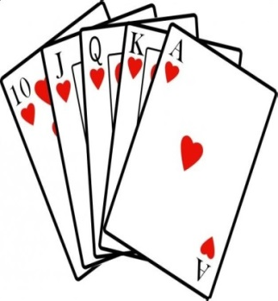  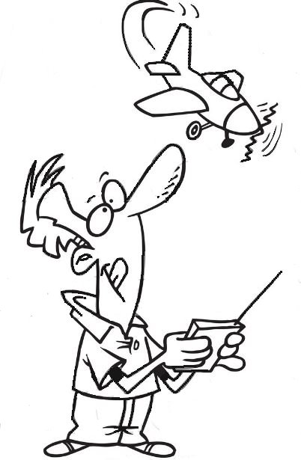

**POKER FLY**

**Rules**

Three (3) decks of cards will be mixed together in a box.

Contest will start at 9:30 am and run until 1:00 pm. You can join in anytime during this time.

When you pay your $2.00 ante you will draw 3 cards.

After each of your next two flights you will draw 1 additional card until you have a total of 5 cards.

*NOTE:*  A flight will consist of any type of aircraft flown for any duration.

If you want, you can make three additional flights putting a card from your hand back in the box and drawing a replacement. Fly as many times as you want but only exchange 3 cards.

At 1:00 pm, the best hand wins the pot.

Please return all cards to the box at the end so that we can use them again in the future.