CANDLE TALK
2015 – May 8th – Volume 3 23(Posteed
THANK YOU
"Coming together is a beginning. Keeping together is progress. Working together is success." --Henry Ford
Last week, Jeremy Lowe took the day off. In stepped Cameron Bonmon and Monet Robinson, the collaboration of these two individuals kept the Inventory area moving without incident – this even with new personnel coming on-board during the week, as well as added jewelry to each order. I say, thank you and kudos to these two! Least not forget, Bobby Devine, he has been a GOTO person since I joined JIC a few weeks ago. The heart of Team JIC is the make-up of individuals like these three folks. In the spirit of Henry Ford whose quote is listed above I think if we keep this in the back of our mind who’s to say JIC can’t be the next big thing? Ford Motor Company’s first plant in Louisville was right across the street from U of L on South Third Street in 1913. What will JIC look like in five years, ten years, fifteen years…? Your attendance, commitment, and teamwork will dictate that outcome. Keep up the great work, everyone!

OVERTIME
- Week of May 11 – 16, 2015 All departments plan to work overtime each day with the exception of dayshift Production *I think most folks realize I plan to put the plant on notice each week versus the previous twenty-four notice. That said, everyone has done an awesome job this week and if the trend continues I don’t see us working overtime everyday next week. I will keep you apprised of any updates – thanks Darryl

MORE CANDLES IN PRODUCTION
- Clamshell and wick build-up operation has been moved to the candle labeling area. This move allowed us to gain three additional tables for pouring capability; we need to add another 6 foot and 4 table to yield a total of 4.25 tables which is a ten percent increase in production capability.*Tables have been ordered and should arrive anytime now.

DELIVERY
- Literally, we had a “delivery”; All - welcome our youngest member to the JIC family.

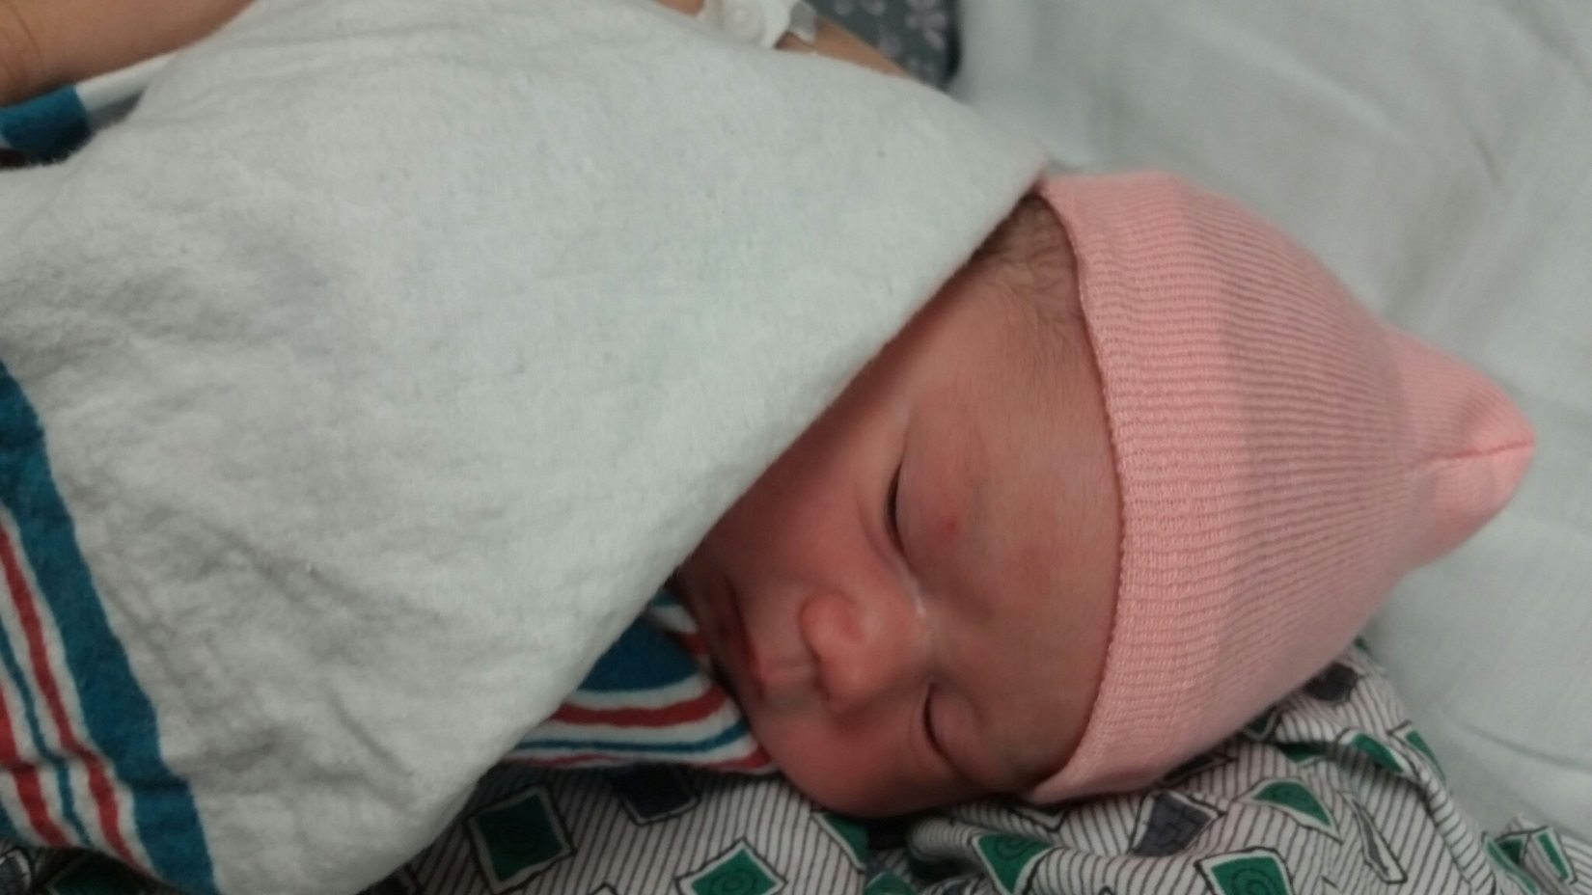
Leighton Marie, daughter of Megan Dover, Customer Service

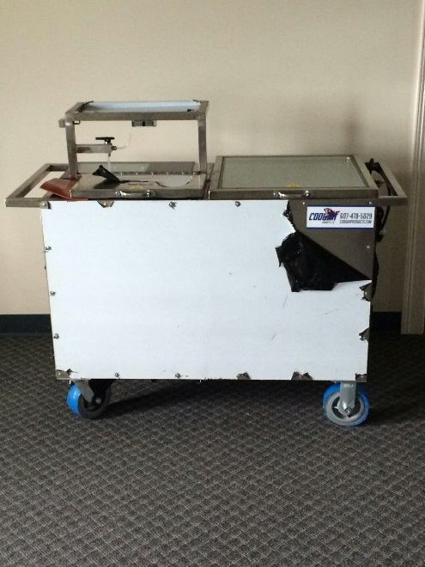
Also welcome the offspring of “Bertha and Bartholomew Pour”. The little bundle of joy has no name yet though. $25 to the person who comes up with the name chosen by (blind vote): Micah, David, Kevin and Darryl – Here is how it works. All employees allowed one name entry. Give to Abby or Megan who will submit your suggested name but keep your name hidden. We will vote on the name. In the event the same name is submitted, those preliminary winners names will be put in a hat and the winner of the contest will be selected. Contest begins 8th and ends on May 13th

JIC HAPPENINGS
- Visitors are coming. Several sales reps were on-site this week. We always welcome visitors and I greatly appreciate everyone for working on keeping their areas clean. Shout out to the following individuals who came in early to help with finishing touches: Yanosy Garcia, Javier Arreguin, Cameron Bonmon, Dan (DJ) Moore, Esther Suarez, and Jonathan Cooper
- Break room status – ten chairs have been added for a total of twenty one. Thank you for your patience! We will continue to monitor the situation and will always consider ideas to make your break and lunch periods more comfortable
- Negative comments in the workplace: This is a great place to work, remember, if you think you have something negative to say about the company or someone I find it to be a good practice to say the first ten words to yourself before speaking out loud. Its’ TEAM JIC – Questions see Darryl *second print
- RECEIVING – I appreciate everyone going to the overhead door to receive shipments but my preference is that Bobby Devine receive ALL shipments unless I designate an alternate. We had been waiting on an item, which was received by someone but it was just laid on a table. Typically, Bobby is the person that is being questioned about what is received. In a nutshell, you wouldn’t think it would be fair if you were pulled over for speeding and the officer was asking you why you were driving so fast but in this case you were a passenger in the vehicle.
- SANITATION – Again, thanks to everyone who helped get the place a little cleaner than the norm for this week’s open house. Sales reps and customers are the reason why we are here and we certainly should roll out the red carpet and extend the royal treatment. But, I happen to think each and every one of you are special and deserve the royal treatment. Let’s build off this weeks’ open house and be mindful of our work areas and make sure your area is neat and tidy throughout the day and especially before you go home. Give each other the royal treatment. As we expand, no one wants to come in after someone and clean their mess up. Thank you for your understanding. And remember, I may be firm sometimes but Team JIC is YOU and I think you are awesome….Darryl
- JEWELRY DEPARTMENT – We will be reviewing the current work arrangements and make the necessary changes to ensure that ergonomic shortfalls are corrected. Thanks for your patience. Darryl

