9TH ANNUAL BAZAAR REGISTRATION FORM
SATURDAY, JUNE 8TH, 2019
FROM 9AM-2PM
HOLY SPIRIT LUTHERAN CHURCH
1220 BAYSHORE ROAD, VILLAS, NJ 08251
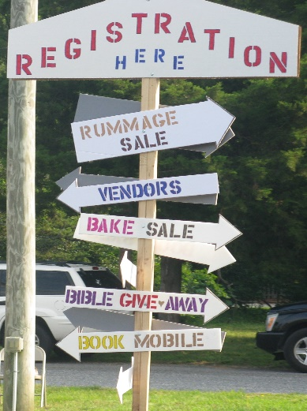
Set-up Starts at 7AM, RAIN OR SHINE EVENT, with No Scheduled Rain Date.
Bring your own Tents, Displays, & Tables, as there are None Available for Rent.
There are No Electric Sites Available for Rent.
$25 Fee for Merchandise Vendors, 15% of Daily Sales from Food Vendors.
Fees are Non-Refundable, & are due by Friday, May 31st. No Late Registrations.
12ft x 15ft Space Provided to All Vendors, other than special exceptions.
Food Vendors Must Display Food Handler or Health Certificates at All Times.
Please make checks payable to Holy Spirit Lutheran Church.
We Strongly Discourage Early Break-Downs.
Questions or Concerns contact Vince at 412-225-0287 or at vpie8282@gmail.com
- - - - - - - - - - - - - - - - - - - - - - - - - - - - - - - - - - - - - - - - - - - - - - - - - - - - - - - - - - - - - -
I realize if I cancel my registration, I will not be issued a refund. I release Holy Spirit Lutheran Church, its Employees, Volunteers, & Bazaar Committee from all responsibility in the event of personal injury, accident, or theft of merchandise.

NAME: ___________________________PHONE: ____________________

ADDRESS: _____________________________________________________

CITY: ________________________ST: _____________ZIP: _____________

EMAIL: _______________________________________________________

MERCHANDISE/FOOD: _________________________________________

SIGNATURE: __________________________________________________

