**“Congratulations**

**Next Step Dance!**

**You have been selected**

**to perform with**

**Spirit of America in the**

**92nd Macy's Thanksgiving Day Parade in New York City!”**

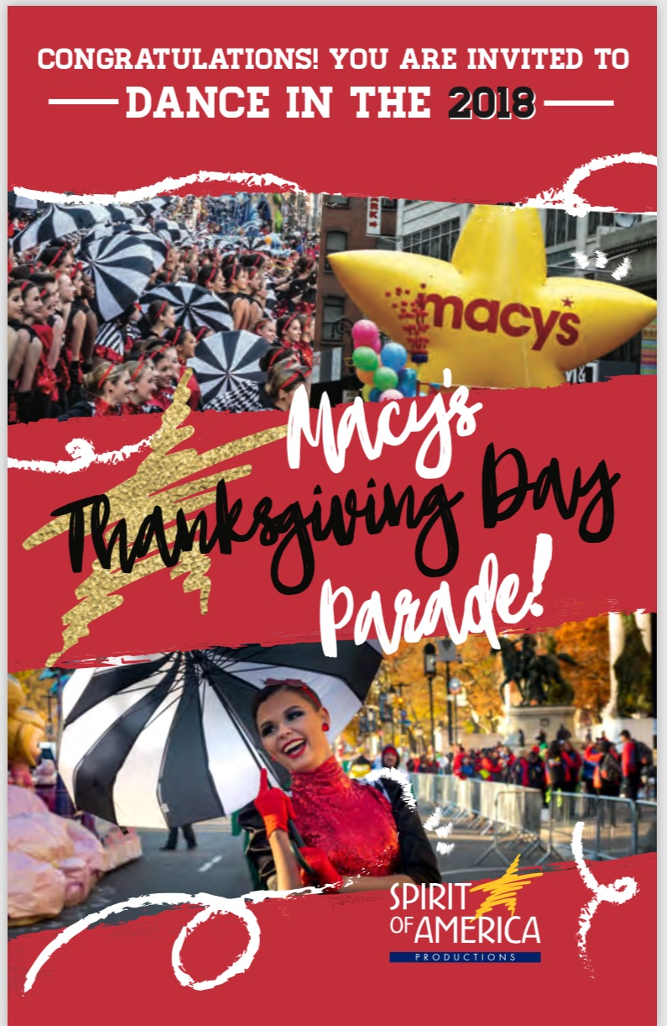

**Watch for our Senior Competition team**

**Thanksgiving Day 2018!**

C:\Users\Stephanie\Pictures\Microsoft Clip Organizer\j0416014.wmfC:\Users\Stephanie\Pictures\Microsoft Clip Organizer\j0416014.wmfC:\Users\Stephanie\Pictures\Microsoft Clip Organizer\j0416014.wmf

**INSPIRATION** C:\Users\Stephanie\Pictures\Microsoft Clip Organizer\j0416014.wmf

Be **Fearless** in the Pursuit

of what sets your

**Soul** on **Fire**.

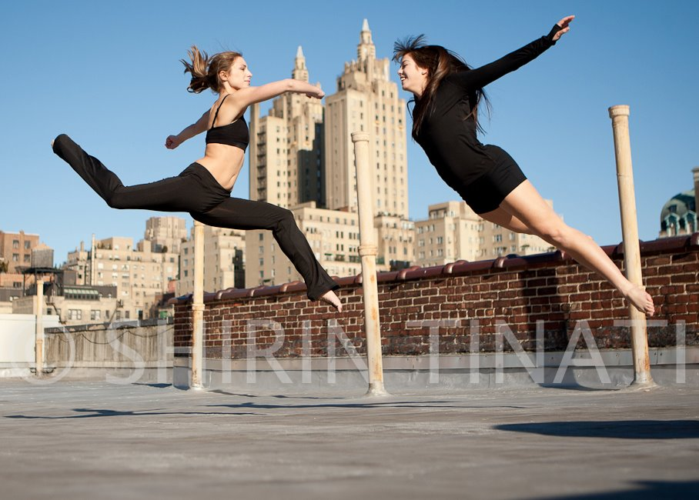

**#class of the month** C:\Users\Stephanie\Pictures\Microsoft Clip Organizer\j0416014.wmf

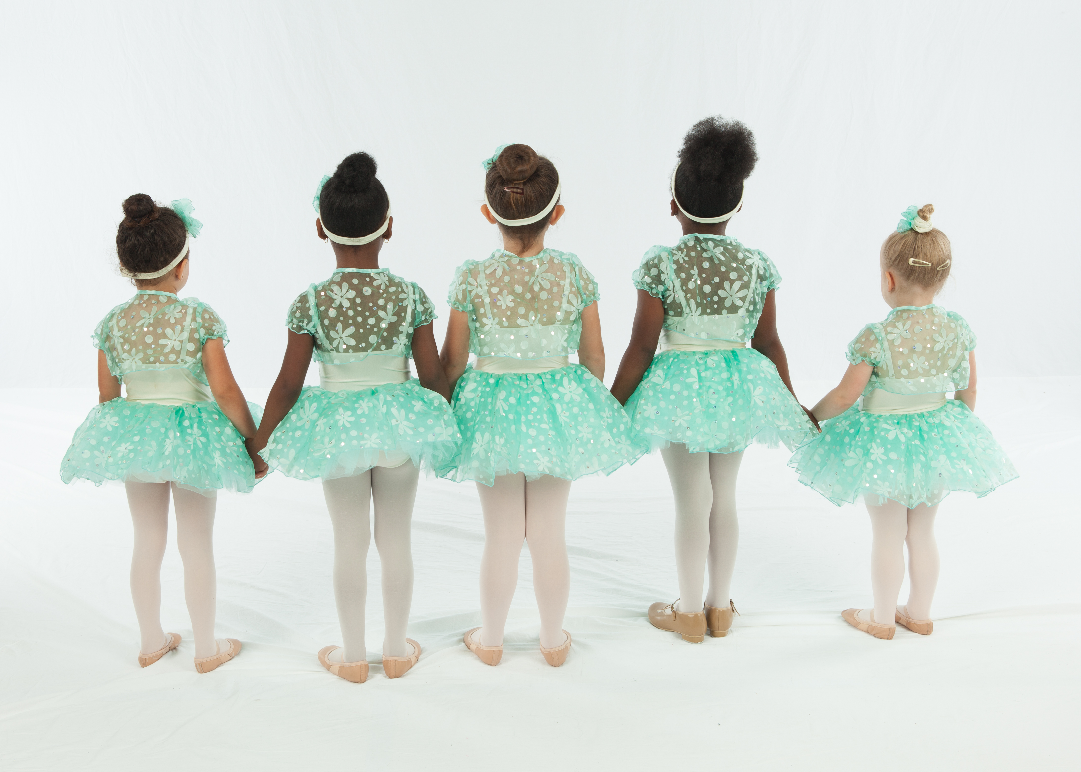

***OUR YOUNGEST DANCERS***

During the month of March our youngest dancers will celebrate Princesses & Superheroes each week at NSD! Check emails to see if your dancer’s class is participating.

**2018 SUMMER CLASSES & CAMPS**



Our summer class schedule will be up this month and ready for registration. Continue to check emails so you will know when they go LIVE! We added some fun morning and afternoon camps to the day based on our survey of current students. Take a look and pick out what your dancer would enjoy. Summers are great for concentrating on technique and working on those turns or trying something different just to see what else might interest you for fall. We also offer private lessons during the summer with our staff. One on one time is a great way to advance your current skill set and learn new choreography. See you during our #nsdSummerSizzle!

C:\Users\Stephanie\Pictures\Microsoft Clip Organizer\j0416014.wmf C:\Users\Stephanie\Pictures\Microsoft Clip Organizer\j0416014.wmf

Steppin’ into MARCH 2018 with Next Step Dance

[**www.thenextstepnc.com**](http://www.thenextstepnc.com)

**7712 Sossamon Lane, NW Concord, NC 28027 (704) 786-7837 nsdcalendar@gmail.com**

**OPEN HOUSE**

Thinking ahead to summer activities or even Fall 2018? Have a friend or relative interested in dance? Have a younger sibling that will be old enough for our Tiny Steppers program? Find out schedules and all the important stuff at our Open House on Saturday, May 19th, 2018 from 10:00am-1:00pm. There will be classes to tryout and informational sessions to learn more about Next Step Dance and what is happening with us for the rest of 2018.

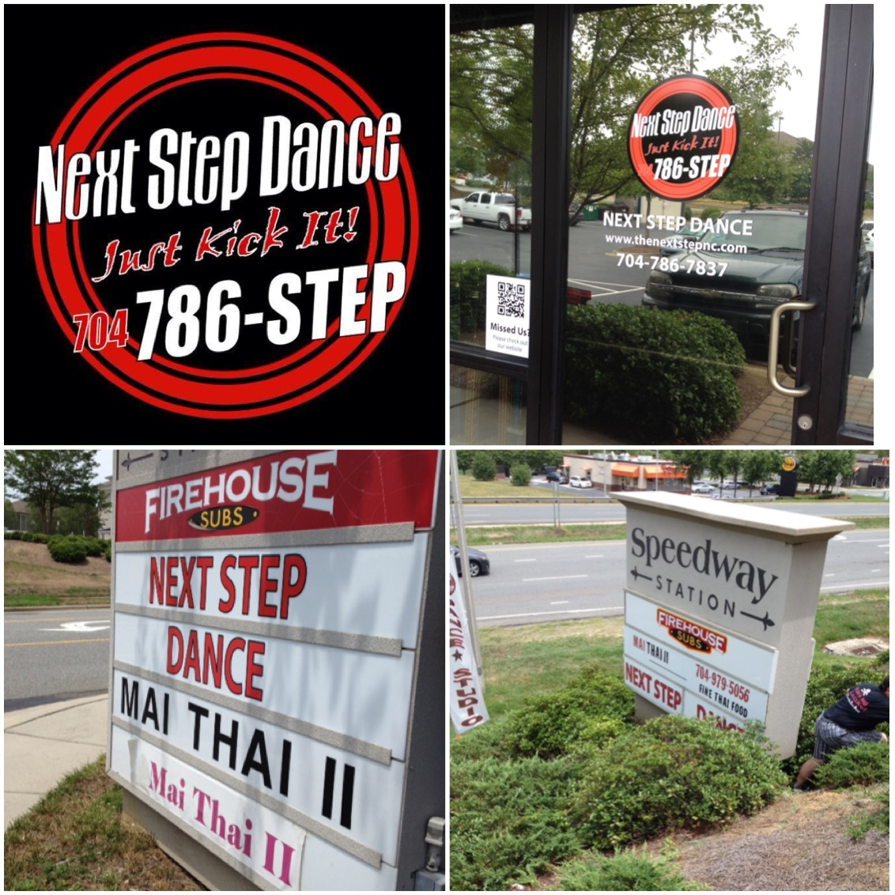

**SAVE THE DATE** C:\Users\Stephanie\Pictures\Microsoft Clip Organizer\j0416014.wmf

March 11- Daylight Savings Time

**March 17- Wear green**



Shoe orders take approximately 1-week for delivery and some we have in stock!

REMEMBER TO JOIN US ON

Facebook, Twitter, & Instagram!