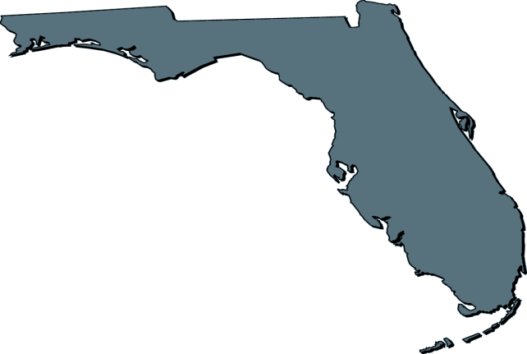

Contractors, Inc.
SW

4638 SE 15th Ave Cape Coral, FL 33904 ph: 239-340-2594

Lic.# CGC1506705 swflcontractorsinc@yahoo.com www.swflcontractorsinc.com

PRICE LIST
Wind Mitigation $250.00
Four Point Inspection $250.00
Single Family Home Inspection $250.00
Duplex Home Inspection $350.00
Home Inspection with Wind Mitigation $400.00
Roof Certification $150.00
Mold Assessment (Contact for Estimate)
For New Construction, Remodeling, Residential and Commercial call for estimate.

S.W. FL. Contractors, Inc. Qualifications
State Certified General Contractor since 2003
State Certified Roofing Contractor since 2004
FL Licensed Home Inspector
Citizens Trained Wind Mitigation Inspector
Licensed Mold Assessor and Mold Remediation
EPA Lead Certified Lead Based Paint RRP

