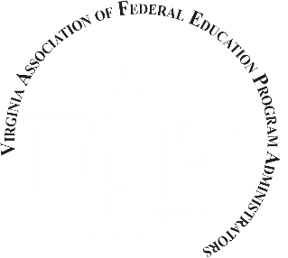

TO: VAFEPA Board Members and Federal Program Coordinators
FROM: Ernestine Scott, VAFEPA Scholarship Co-Chairperson
SUBJECT: 2019 NAFEPA/VAFEPA Scholarship Program
Virginia Association of Federal Education Program Administrators (VAFEPA) is proud to announce two scholarship opportunities scholarship for Virginia students: the VAFEPA state scholarship and the NAFEPA national scholarship. As discussed during our December VAFEPA meeting, Board members from each of our eight regions along with other federal program coordinators are asked to distribute the VAFEPA/NAFEPA scholarship application packet to high schools and other interested persons in their region. The VAFEPA Scholarship Committee will select two applicants to receive the VAFEPA scholarship of $500.00 each. We will submit the two Virginia scholarship recipients for the NAFEPA scholarships (see attached application). In order to eligible for the VAFEPA/NAFEPA scholarships, students must be in their senior year, and currently enrolled in a public or charter school in one of our eight regions.
The National Association of Federal Education Program Administrators (NAFEPA) will select four (4) $2,500.00 scholarships recipients from nationwide applicants (see attached application instructions).
Each application must have the signature of the VAFEPA Board member in their region. The application checklist and space for your signature is on the second page of the application. This step cannot be overlooked. Our state can only submit two applicants for the NAFEPA scholarship. Final judging of all state applicants for the NAFEPA Scholarships will be done at the national level. If a Virginia student is selected to receive one of these scholarships, they will be contacted by the NAFEPA Scholarship committee.
Please distribute the attached application form to eligible and interested persons in your school district. As indicated on the application, the amount of each scholarship will be made payable to the institution of choice, only after a letter is received from the institution verifying the student is enrolled.
The completed application for the student(s) must be submitted by January 16, 2019 to Ernestine Scott electronically at escotto9221@gmail.com or by mail to:
Ernestine H. Scott, VAFEPA Scholarship Committee,
12214 Sylvan Ridge Place
Chesterfield VA 23838

DEADLINE: January 16, 2019 (No extensions will be granted)
If you have any questions regarding this process, please contact Ernestine Scott at (804) 304-7979 or Cheryl Bostick at (804) 780-7791.
Attachments:
- NAFEPA Scholarship Program Outline and Process
- NAFEPA Scholarship Application Form

