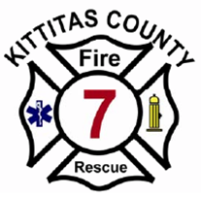
KITTITAS COUNTY FIRE & RESCUE 7
123 East First Street, Cle Elum, WA 98922
Phone 509.674.5371 Fax 509.674.7263
Email - office@kcfd7.com
“Neighbors helping Neighbors”

Goat Peak Ranch HOA,
I inspected Big Horn Way last Friday before drafting this letter. What concerns me the most is the density of the canopy adjacent to the side of the road. As an experienced Wild-land Firefighter and the Fire Chief responsible for fire protection, it scares me to think that home-owners may not be able to escape a fast moving fire.
My highest priority is Life Safety, for both you the homeowner and the firefighters trying to safely enter the area.
As I drove around Nelson Creek Road, I noticed a large Fire-Wise project. They had thinned and cut back the brush on a relatively large parcel. You can tell by looking at that property, that cutting back 20' along side of Big Horn Way would make a significant difference. Limbing up trees and removing brush would look nice and add significantly to your overall safety and assist the firefighter in gaining access to you and your home.
Now is a good time to consider becoming a Fire Adapted Community.
Suzanne Wade with the Conservation District may be able to assist with planning and financial help. Her contact information is: suzanne-wade@conservewa.net
Sincerely,
Russ Hobbs, Chief
Kittitas County Fire District 7
509-607-0515

