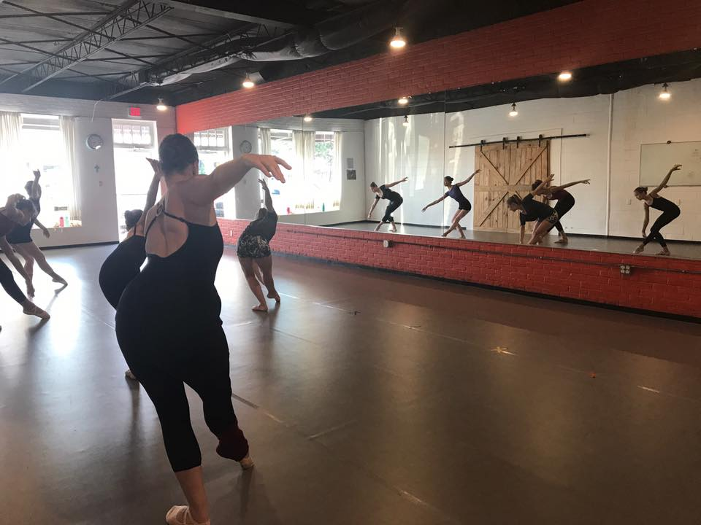  JUNE/JULY ‘18  SUMMER WORKSHOPS AT BLUEBIRDS  Great Summer Dance Workshops for Dancers of All Levels!  Want to continue your dance training during the summer? Interested in trying out a class at Bluebirds? If your answer is YES, then our Summer Workshops are made for YOU! Bluebirds Ballet will be offering 6-week workshops (June 11th-July 26th) in:  - Advanced or Intermediate Ballet/Pointe, Modern, Jazz  - Teen and Adult Ballet  - Preschool Dance  - Acrobatic Movement  - Boy’s Movement  - Plié with your Bébé (Parent/Tot) | Advanced or Intermediate Ballet/Pointe, Modern, Jazz  ────  Plié with your Bébé  ────  Boy’s Movement  ────  Preschool Dance  ────  Teen and Adult Ballet  ────  Acrobatic Movement  Bluebirds ballet academy  1007 East St. Mary Blvd., Lafayette, LA 70503  337-322-3520  www.bluebirdsballetacademy.com
Summer Workshop Information
Advanced Ballet/Pointe, Jazz and Modern: Monday-Thursdays from 1:30-3:30 pm, June 11th-July 26th. Ages 12+. Full Workshop: $400; June or July: $240; Weekly: $90; Per Class: $25.
Intermediate Ballet, Jazz and Modern: Mondays and Wednesdays from 1:30-3:30 pm, June 11th-July 25th. Ages 10+. Full Workshop: $200; June or July: $120; Weekly: $45; Per Class: $25.
Adult and Teen Ballet: Mondays and/or Wednesdays from 6:30-7:45 pm, June 11th-July 25th. This class is perfect for those brand new to ballet, dancers wanting to return to ballet, or intermediate students who want a great ballet workout. Full Workshop: $150; Monday or Wednesday (Once a Week) Workshop: $90; Per Class: $15.
Preschool Dance: Wednesdays from 5:30-6:30 pm, June 13th-July 25th. Ages 2+. Full Workshop: $90. Pre-ballet, creative movement and tumbling for your little one!
Acrobatic Movement: Wednesdays from 4:30-5:30 pm, June 13th-July 25th. Ages 7+. Full Workshop: $90.
Boys Movement: Mondays 5:30-6:30 pm, June 11th-July 25th. Ages 6+. This one is for BOYS ONLY! Stretching, conditioning, acrobatic/tumbling technique, movement geared to building boys' strength and coordination.
Plié with your Bébé (Parent/Tot): Mondays from 4:30-5:30 pm, June 11th-July 25th. Ages 1-3. Come dance and play with your tot! A creative movement class intended to make your child's first dance experience stress-free and FUN!
Class sizes are LIMITED so please REGISTER EARLY! Checks payable to Bluebirds Ballet Academy. Call 337-322-3520 or email jasmine_bertrand@yahoo.com for more info!
To register, please return the form on the next page along with your payment.

SUMMER 2018 WORKSHOP REGISTRATION FORM:
Student's Last Name: _____________________________________________
Student's First Name: _____________________________________________
Age:_________________ Allergies:______________________________________________

Parent's Name:______________________________________________________________

Phone #1:________________________ Phone #2:_________________________________

Email Address:_____________________________________________________________

Mailing Address: _________________________________________________________
City: _______________________ State: ___________ Zip Code: _______________
EMERGENCY CONTACT INFORMATION
Name: _______________________________________________________________________
Home Phone: _____________ Work Phone: ________________ Cell Phone: _______________
Physician: ______________________________________ Office Phone: ___________________
Preferred Hospital in case of emergency: ____________________________________________
PLEASE CHECK OFF WORKSHOP(S):
____Advanced Ballet/Pointe, Jazz and Modern:
___Full Workshop ___June ____July ____Weekly
____Intermediate Ballet, Jazz and Modern:
___Full Workshop ___June ____July ____Weekly
____Adult and Teen Ballet:
___ Full Workshop ___ Monday ___Wednesday
____Preschool Dance
____Acrobatic Movement
____Boys Movement
____Plié with your Bébé (Parent/Tot)
Attire: Female dance students may wear any color one-piece leotard, tights, and appropriate dance shoes. Adult dance students may wear dance attire of any color or comfortable exercise clothing and ballet slippers. Acrobatic movement and male dance students may wear well-fitted exercise clothing or dance clothing.
Waiver: "I understand that there is a risk of personal injury associated with dance classes and performances. I represent that the above-named Student, _______________________, is in good health and is physically capable of participating in dance classes and performances. On behalf of myself and the above-named Student, I hereby waive and release any claim against Bluebirds Ballet Academy, its employees, contractors, and landlord, arising out of personal injury occurring in connection with classes, performances or otherwise occurring in or around Bluebirds Ballet Academy's dance studio or other location of classes or performances. I accept responsibility for obtaining appropriate accident, health and hospitalization insurance to cover the Student in the event of personal injury. In the event of an injury or other medical emergency and I cannot be reached, I authorize Bluebirds Ballet Academy to seek any medical assistance reasonably required and agree to be responsible for any medical expenses incurred on behalf of the student."
Media Release: “I understand that photography and/or video may be taken of my child during Summer Workshop and I give Bluebirds Ballet Academy permission to use Student’s image for advertising, social media or other such legitimate business purposes.”
Please sign below, indicating your agreement to the Policies set forth above.
Parent's/Guardian's signature or Student's signature (if 18 years or older): ______________________________________________________________________________
Printed Name: __________________________________________________________________

Please return this form to:
Bluebirds Ballet Academy
1007 East St. Mary Blvd.
Lafayette, LA 70503

