Texas History with Mr. Brown Name ____________________ Period _____
Spanish Missions
Objectives for students
1) To explain the significant role that Spanish missions played in the early history of Texas and the Southwest.
2) To describe the psychological and cultural factors that led the Coahuiltecan (Kwa-weel-tekens) Indians to accept mission life.
3) To explain the role irrigation systems, such as acequias (ah-SAY-key-ahs), played in the development of Texas farmland and other arid areas.
4) To investigate the early religious history of their own community.
Spanish Influence in Texas
Most Americans know the clarion call "Remember the Alamo!" and have a hazy recollection that the "fort" originally had been built as a Spanish mission. What is less well known outside the Southwest is that the Mission San Antonio de Valero--the Alamo--was only one of a chain of missions strung along the San Antonio River. Established between 1718 and 1731, these missions were built not only to spread the faith of the conquistadors, but also to serve multiple foreign policy objectives for the Spanish government.
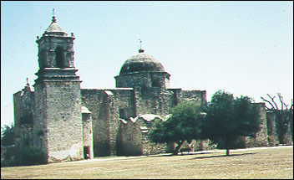(Photo by Beth Boland)
The famous Alamo is now a state historic site under the stewardship of the Daughters of the Republic of Texas and serves primarily as a reminder of the Texas Revolution of 1835-36. The other San Antonio River missions--Concepcion, San José, San Juan, and Espada--with some surrounding lands, constitute San Antonio Missions National Historical Park. By cooperative agreement with the Archdiocese of San Antonio, the mission churches remain active places of worship. Their importance, however, reaches far beyond their religious significance.
Missions were a major part of Spain's plan to establish and manage a colonial frontier in what is now the American Southwest. Settlement of this frontier has had significant and far-reaching effects on the development of the United States, both politically and culturally, effects that continue to be felt today. The missions were directly involved in the military, religious, and cultural development of the Texas frontier, and they influenced policymaking across the entire Southwest. The contribution of the missions to agriculture and commerce–they strongly influenced the development of the cattle industry–was of critical importance to the growth of the state of Texas and the San Antonio region. The mission buildings constitute a unique record of the architecture, art, and sculpture of the Spanish colonial period in Texas.

Questions for Map 1
1. Examine the location of the missions. What do their locations have in common? Why do you think that this was important?
2. Compare the dates of the first established mission, presidio (military town or encampment), and village with the dates of the first mission in the San Antonio River area. Why do you think the later missions were built in a more central part of Texas?

Questions for Map 2
1. Measure the distances between the missions. Why do you think they were located so closely together? (Additional information is provided in Reading 1.)
2. Map 2 is a recent view of the area around the missions. How do the street names reflect the history of San Antonio, Texas, and the United States?

Reading 1: The San Antonio Missions and the Spanish Frontier
Spain's expulsion of the Moors and its decision to support Columbus's voyage of discovery, both of which took place the same year, opened a new world of possibilities. In the Americas, Spain soon began to use its soldiers to extend its domain, find wealth, and spread the Catholic faith.
After Cortes's conquest of Mexico in 1519, the Spanish moved north in search of further riches and potential converts. Though they failed to find gold and silver as they had farther south, in present-day Arizona and New Mexico they established missions to work with peaceable American Indians and presidios (forts) to control hostile ones.
In the late 1600s the French, already in Canada, explored the Mississippi River to the point where it emptied into the Gulf of Mexico. This expansion posed a threat to Spain's territory and Spain responded by extending its settlements into what is now Texas, thereby creating a buffer between the wealth of Mexico and French Louisiana.
The Spanish established themselves in Texas by using the same system they had established in Arizona and New Mexico. Through missions, presidios, and an adjoining civilian community (a villa), missionaries and soldiers Christianized and Hispanicized the native population. The Spanish hoped that with the help of these now-loyal Indians a relatively small number of men would be needed to defend the empire's frontier. Though created to observe and control French colonies in the Mississippi Valley and central Gulf coast, these operations later opposed other rivals. Between 1763 and 1776, the main challenge came from the English and their Indian allies; after 1776, from the United States and the Comanches.
One base for Spanish missionary and military operations in Texas developed around San Antonio. Two missions and a presidio were established in the San Antonio River valley between 1718 and 1720, and the Spanish added three new missions in the valley in 1731. A single presidio protected the five missions, which were closely grouped for two important reasons. First, the fields required irrigation and a system could only be set up along the valley's upper ten miles. Second, the threat of attack from northern Indians was constant, and the missions needed to be near the presidio and each other for mutual protection.
The missions were important to agricultural production. Each had a ranch for raising the sheep, goats, and cattle that supplied necessities like meat, wool, milk, cheese, and leather. The entire cattle industry, from ranching to the driving of cattle across long distances to markets, was developed in Mexico during the two centuries prior to the establishment of San Antonio. Spanish ranching as it was practiced in Texas formed the basis for the American cattle industry, which drew many of its original cattle from the mission herds. The Spanish also brought to the San Antonio valley a specialized method of farming that used irrigation. This system, which was extended by later settlers, was the foundation of the San Antonio economy for more than a century; portions of mission-built irrigation systems are still in use today in San Antonio and other parts of Texas.
The mission contributed to the economy in other ways. It established necessary industries such as weaving, iron working, and carpentry; these were important to the maintenance of the entire military and political structure of the eastern portion of the Spanish American frontier. Mission-trained artisans and workers provided a principal source of labor and finished goods in a region at the far end of a long and expensive supply line reaching up from the south.
Today the San Antonio missions are among the few relatively intact examples of the colonial missions in the Southwest. They contribute to the general architectural record of this era as well as offer examples of building styles from every period of the missions' history. A wide range of sculptural and painted decoration survives, illustrating how these arts developed on the frontier.

Questions for Reading 1
1. Why did the Spanish establish missions in Texas?
2. Why were the missions located so closely together? (Refer to Map 2 and compare your earlier suggestions with the reasons given in the reading.)
3. What agricultural system did the Spanish bring to the San Antonio valley? What other products came from the missions?
4. Why would the architectural design of the missions change over time?
Reading 2: The Spaniards and the Indians
A mission brought together two distinct groups of people. The missionaries came from Spain via training schools in Mexico and were Franciscans, an order of priests who had taken a vow of poverty in order to devote themselves to learning, brotherhood with all living creatures, and spreading the word of God.
In Texas the Franciscans mainly encountered bands of hunter-gatherers called Coahuiltecos or Coahuiltecans (kwa-weel-tekens). These bands ranged through what is now the Mexican state of Coahuila into South Texas. They moved from one traditional campsite to another, following the seasons and herds of migrating animals. Since the environment in which they lived was often difficult, mainly because of a lack of rainfall, the Coahuiltecans lived precariously because they rarely had a sure food supply. Though they sometimes warred against one another, all faced threats from more formidable adversaries such as the Apache and, later, the Comanche. These tribes had become mobile raiders by taking advantage of the herds of wild horses that had developed from runaways from Spanish settlements.
The Coahuiltecans were tattooed and wore a breechcloth or hide skirt, fiber sandals, and, in bad weather, a cloak of animal hide. Animal teeth, bones, feathers, stones, and seeds were worn as jewelry and sometimes woven into their intricately braided hair. Shelter consisted of small temporary huts of brush or grass, sensible structures given their way of life and the climate of the area over which they ranged.
These hunter-gatherers were willing to become part of the mission system for a number of reasons. The irrigation system promised a more stable supply of food than they normally enjoyed. Diseases brought by Europeans had depleted their numbers, making the Coahuiltecans even more vulnerable to their now-mobile enemies. The presidio, however, offered much greater protection.
Though routines did vary, the missions shared a number of practices. The missionaries, along with lay helpers and usually no more than two soldiers and their families, instructed the natives in the Catholic faith and in the elements of Spanish peasant society. The Indians learned various trades, including carpentry, masonry, blacksmithing, and weaving; they also did a great deal of agricultural work.
Since mission society lasted more than 100 years, no single description can cover the entire experience. It is possible, though, to depict some of its most important elements. Religion was the most important factor in shaping the day. At dawn the church bells rang, calling the people to morning prayer, which was followed by religious instruction. At noontime the bells tolled again to assemble everyone for more prayer, and in the evening there was another service and more instruction.
What happened the rest of the day varied from person to person. Many of the men were led to the fields or to military drills by a missionary or a soldier, while others remained in the compound to work in one of the shops weaving, candle making, woodworking, or engaging in other crafts. Women and older girls often made pottery or baskets, though others prepared food or caught fish in the nearby river. Children spent their days in a number of ways: helping the adults, gathering under a tree for Spanish lessons, playing games with each other. At noontime, everyone came together to eat the day's largest meal, which was followed by the rest period known as a siesta. They remained inside for the hottest part of the day, then returned to their duties until early evening. They would have a light meal before the last service of the day, then enjoy some relaxation. Some would spend the evening dancing and singing, while others played games.
The native population reacted to the mission system in a number of ways. Some of them participated fully, mixing their traditions with those of Spain to create a new Hispanicized and Christianized culture. The Spanish then called them gente de razón, or rational, reasonable people, like the Spaniards themselves. Other Indians moved in and out of the missions, choosing to return to more familiar surroundings during a season when the natural environment was rich with food. Some Indians refused to join at all, continuing to live in their traditional ways.
In the 1790s, the missions began to change. At that time secularization--turning the settlements into civil rather than religious communities--began. The Spanish government withdrew its financial support and ordered mission lands and livestock to be divided among the mission Indians who had been converted to Christianity. Only one of the San Antonio missions, Mission San Antonio de Valero (now known as the Alamo) was fully secularized. The other four, which are now part of the San Antonio Missions National Historical Park, were only partially secularized. Here the populations elected their community officials, but missionaries remained to act as parish priests. In 1824, after Mexico achieved independence from Spain, the remaining missions were fully secularized and all missionaries left the area. Though the buildings then fell into decline, in the 1930s restoration began. Today the four missions within the park serve as parish churches, and all five San Antonio missions are open to the public.
Questions for Reading 2
1. What features of the Coahuiltecans' way of life made them interested in participating in mission life?
2. What is a gente de razón? What does that phrase say about how the Spanish viewed the native population?
3. How would someone of your age spend a typical day at a San Antonio mission?
4. Do you believe mission Indians retained much of their original culture? Why or why not? How could you find out?

Visual Evidence
Drawing 1: Plan of Mission San José. 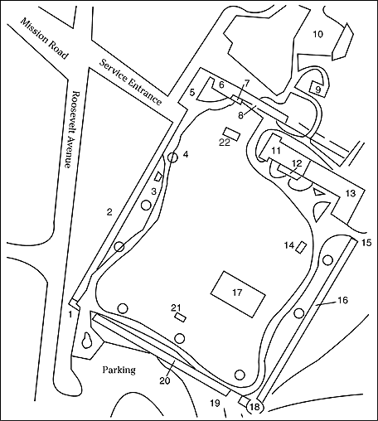
(Adapted from Missions Education Committee, San Antonio Missions National Historical Park: A Guidebook, San Antonio: Junior League of San Antonio, 1986)
Drawing 1: Key
1. Entrance Station  2. Indian Quarters (west wall)  3. West Well  4. Oven  5. Granary  6. Spanish Residence/Casa Real  7. Grape Arbor  8. Archway  9. Flour Mill  10. Amphitheater  11. Church Front Entrance | 12. Sacristy  13. Convento and Portería  14. East Well  15. East Gate  16. Indian Quarters  17. Ruins (east wall)  18. Bastion (southeast)  19. Southeast Gate  20. Indian Quarters  21. South Well  22. Cemetery Plot

Photo 1: Mission San José.
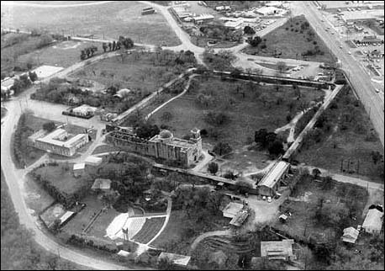(National Park Service)
Questions for Photo 1 & Drawing 1
1. Locate the different structures on Map 3. Which buildings do you think were most important to the operation of the mission? Why?
2. Do you think that Mission San José was designed to be self-sufficient? Why or why not?
3. Try to match some of the structures keyed on Map 3 to the photo.
4. What do the remaining buildings tell us about the technology of the people who lived there? How do the buildings indicate the region's climate?

Photo 2: Mission San José Church.
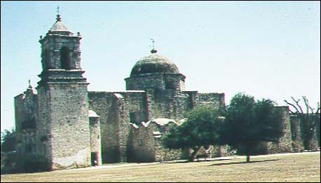(Photo by Beth Boland)

Photo 3: Main entrance, Mission San José Church.
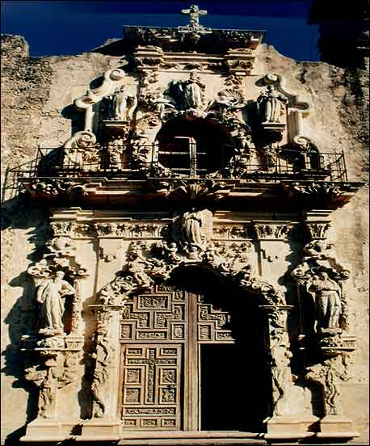(San Antonio Missions National Historical park)
The San José church is a fine example of the baroque style of architecture that was popular in Spain and other European countries at the time the Franciscans settled in what is now Texas.
Questions for Photos 2 & 3
1. What does the size of the church indicate about the role religion played in daily life at the mission?
2. Why might the Franciscans have wanted buildings with such decorative detail on the Spanish frontier?
3. What does the entrance indicate about Spanish culture?

Photo 4: Convento Garden, Mission San José.
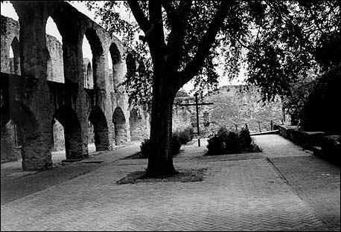(National Park Service)
The convento, also called the friary, was the place where the Franciscan friars lived.
Questions for Photo 4
1. How might the friars have used the garden and a covered walkway called a portería (pour-teh-REE-ah)?
2. What does the portería tell us about Spanish culture?
Photo 5: Espada Aqueduct and Acequia.
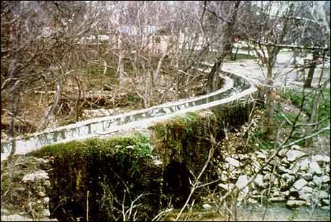(San Antonio Missions National Historical Park)
The dry climate of southwest Texas made irrigation crucial for growing the crops that would determine the success of a new mission. Around San Antonio the Spanish used what was known as acequias (ah-SAY-key-ahs), a system of ditches that the Moslems had introduced to Spain. Missionaries and Indians built seven gravity-flow ditches, five dams, and an aqueduct in order to distribute water from the San Antonio River over a 15-mile network that covered 3,500 acres of land.
Questions for Photo 5
1. Using Map 2, locate the Espada Aqueduct.
2. Why would the system have been an important part of mission life in San Antonio?

Putting It All Together
The four missions located within the San Antonio Missions National Historical Park had many things in common: they brought within their control nearby Indians who, in return for accepting religious instruction, were taught modern technological skills and the ways of life necessary for meeting the ruling Spaniards on their own terms. They were also protected from other, more aggressive tribes in the region. The routine established at the several missions was similar. All Indians were expected to work at a variety of tasks such as farming, ranching, and carpentry. Each mission traded or sold goods to the nearby villa and presidio, sometimes making great profits on foodstuffs and cattle (some 3,000 in a typical herd), which were raised mainly for their hides. The following activities explore the impact of Spanish colonization in more depth.

