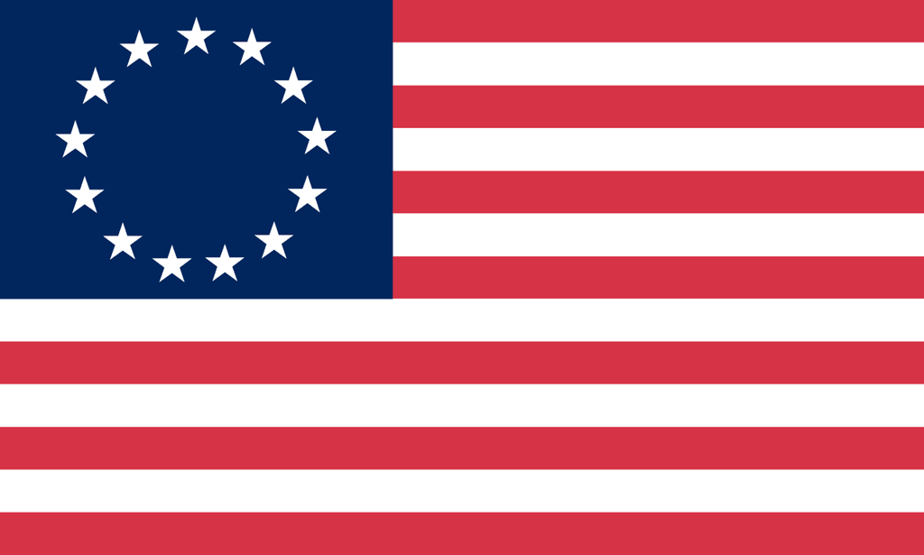U.S. History with Mr. Brown Name _______________________________ Period _____
Sons of Liberty Protest Poster
Directions: Many of the protesters who are on the news today are holding protest signs to get their message out. Imagine you are a member of the Sons of Liberty in 1775. In the space below design a protest sign that protests against any of the events, laws, taxes, or acts from the Road to the American Revolution. Be sure to use pictures and slogans. If you have time design a second poster on the back.

