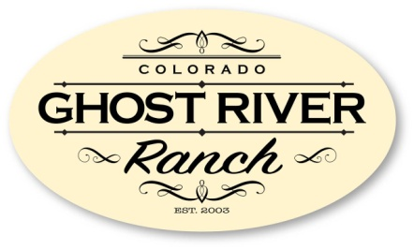

Huerfano County Assessor
401 Main St., Ste 205
Walsenburg, CO 81089

RE: Grazing Lease Authorization for Ghost River Ranch Property Owners Association

I/We, ________________________________________________________________________,
as registered owner(s) of Lot(s) __________________ within the Ghost River Ranch development, do hereby authorize the GRR Board of Directors (BoD) to lease and administer the grazing rights associated with said lot(s).

This authorization shall remain in effect until terminated by me/us, in writing, to the GRR BoD or the property is sold or otherwise transferred to another individual, individuals or entity. I/We agree to maintain access to the property in accordance with the terms contained within the grazing lease.

All owners/co-owners must sign and date.

________________________________________ ____________________
Signature Date

________________________________________
Printed Name

________________________________________ ____________________
Signature Date

________________________________________
Printed Name

Ghost River Ranch Property Owners Association
www.GhostRiverRanchPOA.com

