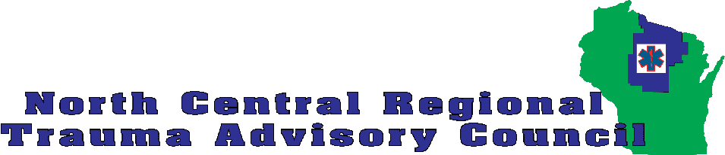

Hospital Trauma Education Funding Application
Additional funding to support course registration fees for trauma-related education for hospital personnel has been provided to each RTAC for fiscal year 2024-25. The funding is only available as reimbursement and applicants must provide proof of payment and successful completion of the course before reimbursement will be issued. The course must be completed before June 30, 2025. Receipts and certificate of completion must be submitted to the NCRTAC by July 15, 2025. No expenses other than registration will be reimbursed. The maximum reimbursable registration fee is listed below with each course available.
Due to the limited amount of funding available for each course, the NCRTAC will accept applications and award available seats on every other Monday (beginning 11/18/24). A sub-committee of the NCRTAC Executive Council will award seats if more applications are received than seats available. Individuals interested in more than one course, may be awarded their first choice course per the schedule above but awards of seats for additional courses will not occur until after February 1, 2025.
Once notified of a successful application, the applicant may register and pay for the course. Applicants are responsible for identifying a course, registering for the course and paying the course registration fee.

Name: ________________________________________________________________
Role/position: _______________________________________________________
Hospital: _____________________________________________________________
Email: ________________________________________________________________

Course Applying For:
[ ] AAAM AIS 15 Coding Course from AAAM - $750 – https://www.aaam.org/abbreviated-injury-scale-ais/take-a-class/ais15-virtual-online/
[ ] TOPIC/Rural TOPIC course from STN - $400 - https://www.traumanurses.org/topic
[ ] OPTIMAL from STN - $400 - https://www.traumanurses.org/optimal
[ ] Trauma Program Management Course from ATS - $580 - https://www.amtrauma.org/page/Courses
[ ] Trauma Registry Professional Course from ATS - $690 - https://www.amtrauma.org/page/Courses
[ ] Trauma Medical Director Course from TCAA - $1,395 - https://www.traumacenters.org/page/TMDCourse
Date(s) of course you will be attending: __________________________________________________
If requesting funding for more than one course, indicate your preferred course.
NOTES:
- STAC has encouraged RTACs to prioritize funding to hospitals that are classified as level III or IV, and those intending to classify as level III or IV. Staff from higher level facilities as well as unclassified facilities are also eligible.
- Funds that are not awarded by March 15, 2025 may be transferred to other regions.

Return application to:
Michael Fraley
NCRTAC Coordinator
Michael.Fraley@NCRTAC-WI.org
715-892-3209

STAFF USE
Application received:
Funds awarded: ____ Y _____ N Date notified:
Receipt and certificate of completion received:
Payee and address information:

Reimbursement requisition to fiscal agent:

