***Pleasant Township Board of Trustees Meeting Highlights***

**Date _October 8, 2024______________ Next Resolution No._ 71—10-8-2024_ _**

* **Call to Order -- The meeting tonight will also be on WebEx.**
* **Please stand for a moment of silence. --Pledge of Allegiance--Roll Call**
* **Visitors –**
* ***Hanna Poling*** with the Southwest Messenger via WebEx.
* ***Pete Griggs,*** Township Legal Counsel
* **Minutes to approve**- No minutes
* **Financial Reports** – Motion to pay expenditures.
* ***Department Reports***
* **Franklin County Sheriff’s Dept-Community Liaison, Deputy Adkins, 1120- Cell: 614-809-5843**

09/24/2024 through 10/08/2024

Total Calls for Service/Self-Initiated Runs: 155

Total Reports Taken: 27

Total Arrests/Citations: 9

Burglaries: 0

Traffic Crashes: 15

Medic Runs: 19

Thefts: 7

Missing Persons: 1

Stolen Vehicles: 5

Suspicious Persons/Vehicles: 10

Vandalism: 0

Traffic Offenses: 18

Motorcycle/ATV/Bike Complaints: 1

Deputies have responded to 7 different calls to vehicle break-ins during the last two weeks. Most of these incidents occur during the overnight hours. Items such as power tools and firearms have been taken. This is a reminder to lock your vehicles and not leave valuable items in them.

There is an ongoing investigation regarding noise complaints and traffic issues on Harrisburg and Georgesville Road. Deputies are working with Franklin County Zoning Enforcement to help address this issue. I am meeting with Kelsey Shires from FC Economic Development on Thursday to investigate the ongoing issue on Harrisburg-Georgesville Rd.

* **Road Department****- Greg Gieger for Robert**
* Gay road ditch-started but had to stop because the truck broke down.
* Truck 22 transmission line
* Truck 20 wiring harness
* Fall clean up
* 1 burial
* *Any updates on Gay Rd. about repairs due to heavy rains washing the roadway and gravel away. (meeting on 8-8-23 we said we’d keep it on the agenda till resolved in some way.)*
* **Fire Dept. – Chief Whiting via WebEx**
* *(Paula has taken care of this)* Paula received an email for a past due for the insurance policy for the fire dept.

Part of the email---

Yes, this was first sent by email on 7/1/2024

Yes, we are still located at 6500 Taylor Road- Suite C-Blacklick- -Dropping it off would be the best to be sure Provident receives it by 10/16/2024. I’m not in on Wednesday so if no one is in our office, you can take the check across the hall to the OTA, they will make sure I get it on Thursday.

I will note the file that payment is on its way.

Thank You, Michelle Oneill

Ohio Pools Processing Specialist

Acrisure

6500 Taylor Road Suite C, Blacklick, OH 43004

* **Vehicles**

-E231- Replaced several door sensors that went bad.

-Engine 231, 232 and Tanker are tentatively scheduled for pump testing this week.

-Medic 231, still at Braun being repaired.

* **Station**

-Repairs were made to shower doors in firefighter’s restroom.

-Grove City IT is in the process of installing new phone in the day room that went bad.

-Replaced several light fixtures in the firehouse and flood light on the exterior of the building.

* **Department**

-This is fire prevention week. Crews will be at Darbydale Elementary on Friday 11th to meet with the students.

- Medic school is still on going

* **Old Business**- None
* **New Business –**
* Received an email from Bryan Clark, Deputy Director with the City of Columbus about a Big Darby Accord jurisdictional meeting they are convening. He will follow up with more details about the meeting on Thursday, October 24, 2004, from 9am-12pm. They only want one trustee because of the Sunshine Law to attend and will brief the others. I said I would attend but if someone else would like to that’s ok with me.
* Ed and Randi attended an Auditor’s Office Fraud Seminar.
* 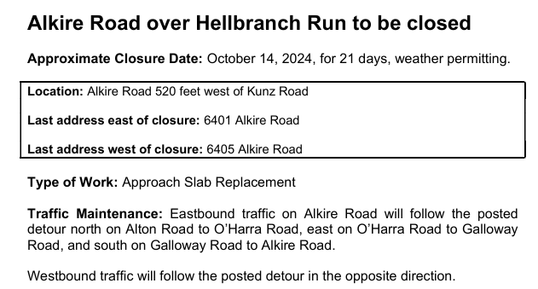**Announcements-**
* 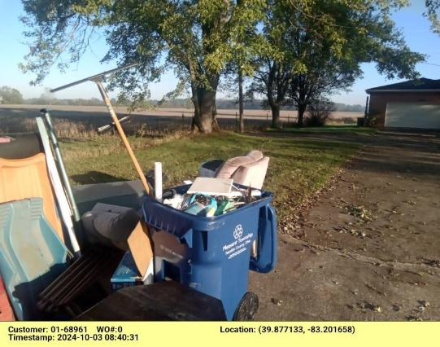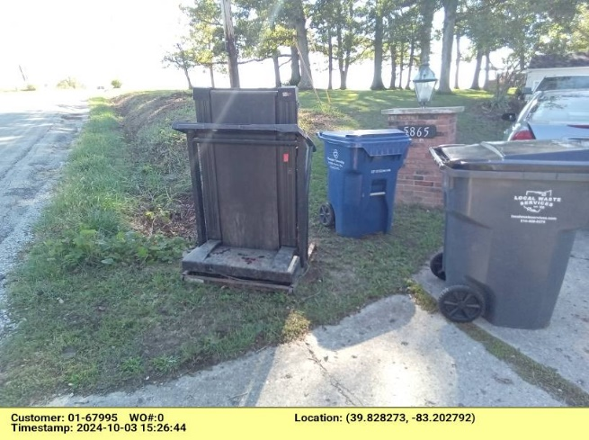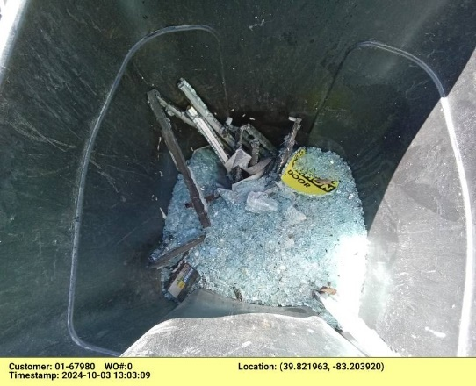 The following is a review from Local Waste for last week’s trash pick-up.

The recycling was not serviced at the time of arrival due to being contaminated with trash. A work order has been placed for a team member to return as soon as possible to service the toter as trash this week.

The treadmill is too heavy for service and will need to find different means of disposal.

**Clerk Updates- Paula**

A work order has been placed for a team member to return as soon as possible to collect the toter of glass.



* Miscellaneous correspondence
* Is the retro pay caught up?- done for pay today except for two employees who had pay increases
* Do we have the check ready to sign for the HSA?-one persons account is pending, waiting to make sure glitches are worked out. Paula and Chief Whiting are the only two with payroll deductions and there have been a few glitches. Lengthy discussion took place. Nancy made resolution 71 to transfer $54,000 from regular checking to HSA account to fund the 15 employee accounts. Roll call vote, Randi and Nancy – yes, Ed abstained due to his vote on the contract. Discussion about when to get this done, Paula said she will schedule it tomorrow, Pete told her to email Nancy the confirmation.
* **Speaker Sheets-** (come to the podium to be heard on WebEx)

Alicia Gieger had questions about procedures/policies to educate herself how the township works.

Glenda Sheets expressed her views about the recent firefighter contract and levy.

Ken Yarnell toured SWACO over the weekend. He encouraged trustees and all to educate themselves on the biodigester that might possibly come to the area. Also wanted to know why we do not have written minutes. Paula explained from her research that the tapes are sufficient. Pete, the township legal counsel, said he represents most of the townships in this area and they all have minutes within one or two meetings.

* **Executive Session if needed-**

“I move to go into Executive Session according to Ohio Revised Code Section 121.22 (G)( 3 ) for the purpose of discussing pending litigation with our legal counsel _. Do I have a second?” ROLL CALL VOTE

Reconvene

Under the Ohio Revised Code Section 121.22(G), I move to come out of Executive Session, do I have a second? ROLL CALL VOTE

* **Adjourn**