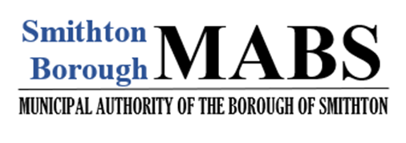

Phone (724) 872-5412
Email: mabs615@verizon.net

AUTHORIZATION AGREEMENT FOR AUTOMATIC PAYMENT DEDUCTION

Fill complete this form and return, along with a voided check to, the Municipal Authority of the Borough of Smithton, PO Box 342, Smithton, PA 15479.

I (we) hereby authorize Municipal Authority of the Borough of Smithton, herein after called MABS, to debit the Checking Account indicated below on the 10th of each month. If the 10th falls on a weekend or a holiday, my account will be debited on the next business day. I (we) acknowledge that the authority will remain in effect until I have (or either of us) cancel in writing.

Financial Institution ____________________________________________________________________

Branch ______________________________________________________________________________

City __________________________________________ State ___________ Zip ___________________

Routing Account
Number __________________________________ Number ___________________________________

This authorization is to remain in full force and effect until MABS has received written notification from me (or either of us) of its termination in such time, and in such manner as to afford MABS and Financial Institution a reasonable opportunity to act on it.

Name(s) please print _____________________________________________________________________

Signature(s) __________________________________________________________________________

