SPECIAL MEETING
DECEMBER 29, 2020

A Special Meeting (The End of the Year Meeting) of the Town Board of the Town of Hampton, County of Washington and the State of New York was held at the Town Hall and via Zoom, 2629 State Route 22A, Hampton, New York on the 29th day of December 2020.

Due to the Corona Virus, occupancy inside the Town Hall is limited at this time. Supervisor O’Brien did provide a link to join the meeting via Zoom.

PRESENT: David K. O’Brien------------Supervisor
Tamme Taran----------------Councilwoman - via Zoom
Donald Sady-----------------Councilman
Andrea Sweeney------------Councilwoman - via Zoom
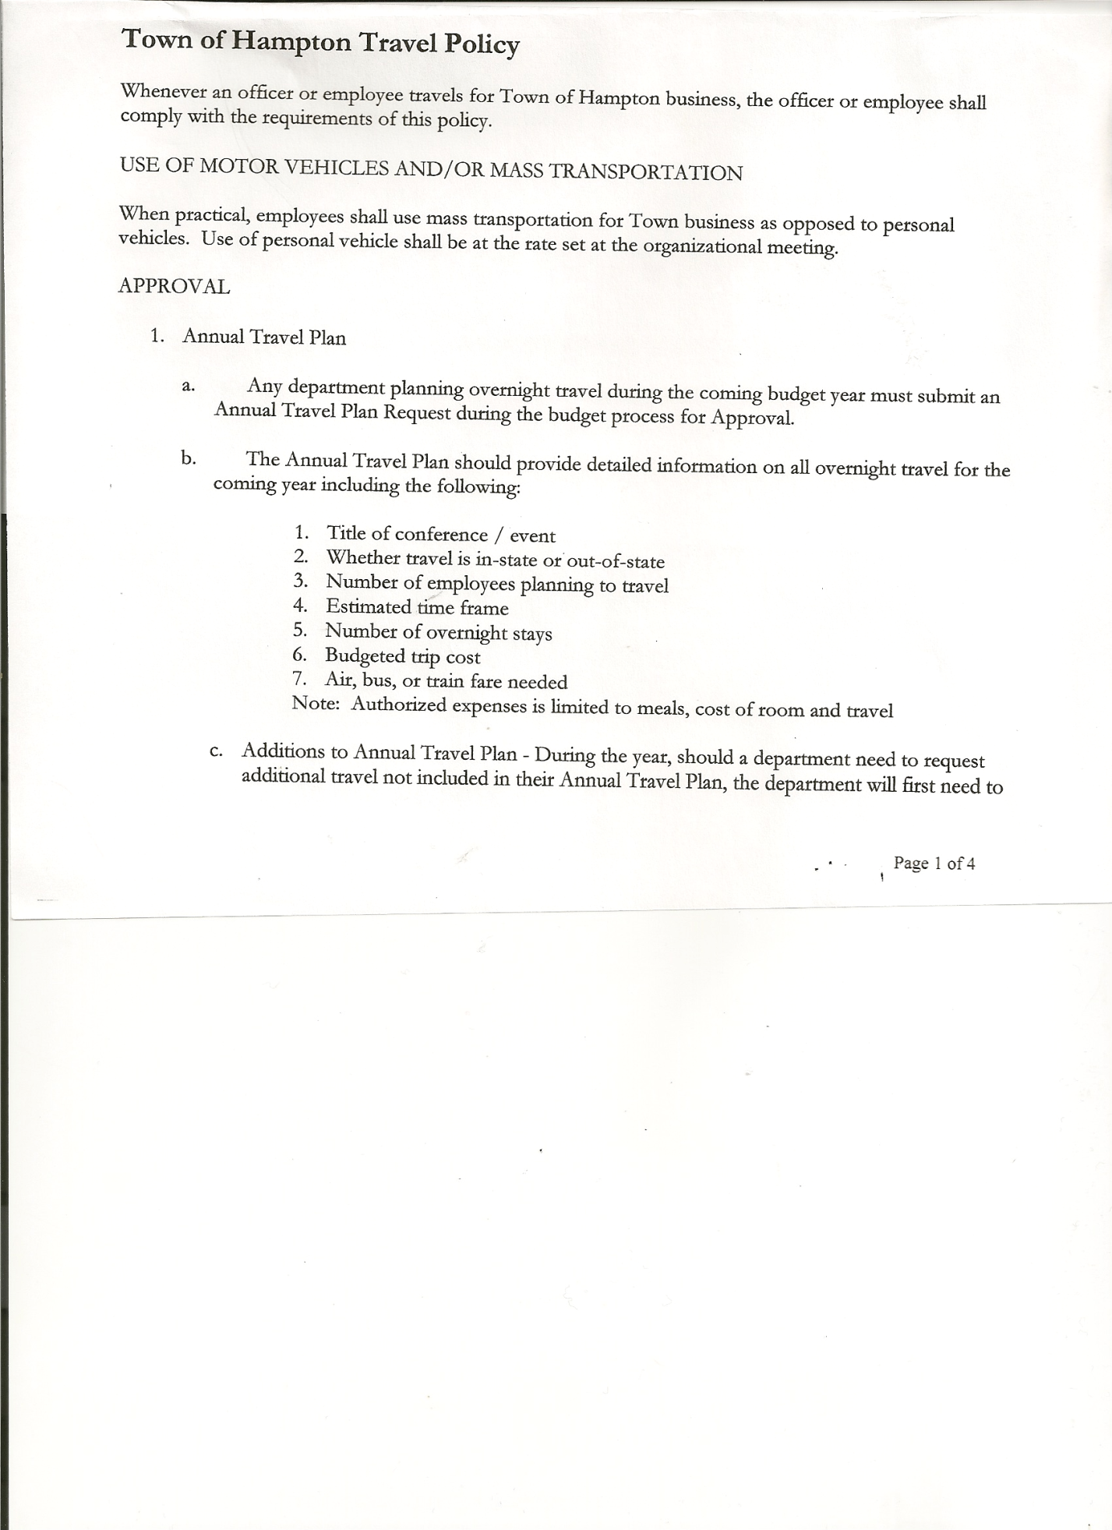
Michael Pietryka------------Councilman
Rebecca Jones---------------Town Clerk - via Zoom
Camilla Shaw----------------Tax Collector/Deputy Town Clerk – via Zoom
Herbert Sady, Jr.-------------Highway Superintendent - via Zoom

Planning Board Member(s): Bonnie Hawley and Matthew Pratt (via Zoom)

The Special Meeting was called to order by Supervisor O’Brien at 7:00pm, followed by the Pledge of Allegiance. Location of Fire Exits were given. Quorum of board members present.

RESOLUTION NO. 103-2020
AUDIT OF CLAIMS
On a motion of Councilwoman Taran, seconded by Councilman Sady, the following resolution was ADOPTED:
By Roll Call Vote: Supervisor O’Brien AYE
Councilman Sady AYE
Councilwoman Taran AYE
Councilman Pietryka AYE
Councilwoman Sweeney AYE
RESOLVED that the bills have been reviewed by the Town Board and are authorized for payment in the following amounts.
General Fund No. 127 through No. 128 $270.99
Highway Fund No. 126 $205.84
Total both funds $476.83

TOWN BOARD MEETING
DECEMBER 29, 2020 PAGE 2

RESOLUTION NO. 104-2020
EXTEND EXEMPTION STATUS

TOWN OF HAMPTON

Resolution #104

ADOPTS PROVISIONS OF EXECUTIVE ORDER 202.83 SUSPENDING THE REQUIREMENTS OF RENEWAL APPLICATIONS AS A CONDITION TO GRANTING EXEMPTIONS UNDER SECTIONS 459-C AND 467 OF
THE REAL PROPERTY TAX LAW

Councilwoman Andrea Sweeney offered the following resolution,
which was seconded by Councilwoman Tamme Taran

WHEREAS, the Governor of the State of New York by Executive Order No. 202 dated March 7, 2020, declared a state disaster emergency for the entire State of New York; and

WHEREAS, both travel-related and community contact transmission of COVID-19 have been documented in New York State and are expected to continue; and

WHEREAS, pursuant to Section 29-a of Article 2-B of the Executive Law, New York State Governor Andrew Cuomo did issue Executive Order 202.83 dated December 18, 2020, 2020, which authorized, by local option, the governing body, to adopt the provisions of that Executive Order 202.83, which temporarily suspends or modifies, subdivisions 7, 7-a and 8 of section 459-c of the Real Property Tax Law and subdivisions 5, 5-a, 5-b, 5-c and 6 of section 467 of the Real Property Tax Law.

NOW THEREFORE BE IT RESOLVED, that pursuant to Executive Order 202.83 issued by New York State Governor Andrew Cuomo on December 18 , 2020, the Town Board of the Town of Hampton hereby adopts, as a local option, the suspension of subdivisions 7, 7-a and 8 of section 459-c of the Real Property Tax Law and subdivisions 5, 5-a, 5-b, 5-c and 6 of section 467 of the Real Property Tax Law; and be it further

RESOLVED, that the Board of Assessors are hereby directed to grant exemptions pursuant to such sections on the 2021/2022 assessment roll to all property owners who received that exemption on the 2020/2021 assessment roll, thereby dispensing with the need for renewal applications from such persons, and further dispensing with the requirement for the Board of Assessors to mail renewal applications to such persons; and, be it further

TOWN BOARD MEETING
DECEMBER 29, 2020 PAGE 3

RESOLVED, that the Town Clerk is hereby directed to forward a copy of this resolution to the Board of Assessors and the Office of the Town Attorney; and be it further

RESOLVED, that all Town Hall Departments may review and obtain a copy of this resolution from the electronic storage device and if needed, a certified copy of same may be obtained from the Office of the Town Clerk.

DATED: December 29, 2020
THE VOTE
Sady Yes Sweeney Yes
Taran Yes Pietryka Yes
O’Brien Yes
The Resolution Was
Thereupon Duly Declared Adopt

Discussion that this does not apply to Star exemptions

Supervisor O’Brien sent a Tax rate comparison chart for the last few years and a chart of rates for various towns in the County to the members of the Board by email. 2021 County tax is up by 3%, Town 6.64%, Fire District #1 1.27% and Fire District #2 1.89%

RESOLUTION NO. 105-2020
CLOSE THE BOOKS FOR 2020
On a motion of Councilman Sady, seconded by Councilwoman Taran, the following resolution was ADOPTED
By Roll Call Vote: Supervisor O’Brien AYE
Councilman Sady AYE
Councilwoman Taran AYE
Councilman Pietryka AYE
Councilwoman Sweeney AYE
RESOLVED, to Close the Books for 2020.

RESOLUTION NO. 106-2020
UNDERTAKING FOR HIGHWAY WORK PERMITS
On a motion of Councilman Sady, seconded by Councilwoman Taran, the following resolution was ADOPTED:
By Roll Call Vote: Supervisor O’Brien AYE
Councilman Sady AYE
Councilwoman Taran AYE
Councilman Pietryka AYE
Councilwoman Sweeney AYE

TOWN BOARD MEETING
DECEMBER 29, 2020 PAGE 4

RESOLVED, that the Town approved the signing, by the Highway Superintendent, of the Undertaking for the benefit of the New York State Department of Transportation in connection with work affecting State highways.

RESOLUTION NO. 107-2020
USE OF TOWN HALL
On a motion of Councilman Pietryka, seconded by Supervisor O’Brien, the following resolution was ADOPTED:
By Roll Call Vote: Supervisor O’Brien AYE
Councilman Sady ABSTAIN
Councilwoman Taran AYE
Councilman Pietryka AYE
Councilwoman Sweeney AYE
RESOLVED that Cristen Zekus can use the Town Hall for a birthday party on Saturday, January 16, 2021.

Discussion began about the possibility of changing from an Elected Highway Superintendent to an Appointed one. Pros and Cons were discussed, as well as the procedure if a Special Election (Referendum) is called in April or May and how to hold Public Hearings for input of the citizens during this time of quarantine.

A request was made by Matt Pratt for a list of past Highway Superintendents which Camilla Shaw will send to him.

RESOLUTION NO. 108-2020
MEETING ADJOURNED
On a motion of Councilman Sady, seconded by Councilwoman Taran, the following resolution
was ADOPTED:
By Roll Call Vote: Supervisor O’Brien AYE
Councilman Sady AYE
Councilwoman Taran AYE
Councilman Pietryka AYE
Councilwoman Sweeney AYE
RESOLVED that the meeting adjourned at 7:55pm.

Respectfully submitted,

Rebecca S. Jones, RMC
Town Clerk

