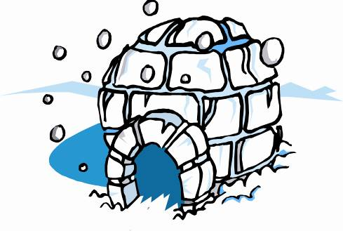
KAUL REFRIGERATION, INC.
1010 SOUTH SPRING STREET
P.O. BOX 415 BEAVER DAM, WI 53916
PHONE: 920-885-9721 FAX: 920-885-9029

Career Opportunities

Job Overview:

Kaul Refrigeration has open positions for general laborers and a service technician, specializing in mechanical refrigeration. General Labors will have the opportunity to work their way up to becoming a certified service technician. Service technicians will receive a wage increase as well as have use of a company vehicle to account for On Call duties.

Position Responsibilities:

- Laborers will be responsible for carrying equipment to job sites and provide an extra set of hands to the technicians.
- Duties include the ability to run pipe, solder pipe, install new walk in panels, wash out condensers, as well as many other miscellaneous jobs.
- Perform diagnostics on commercial refrigerators/freezers and A/C units.
- Coordinate inventory items and employee time allocated to jobs with customer invoices.
- Service Tech’s must be available for On Call duties afterhours and on weekends per schedule.
- Must work well with others and have a solid work ethic.

Requirements:

- High school diploma or equivalency.
- Valid driver’s license.
- Refrigerant license is a plus.
- Electrical experience is beneficial, along with automotive or construction skills.

Benefits:

- Group health insurance.
- Life insurance.
- Simple IRA with company match (up to 3%).
- Vacation time
- Bonus program.
- A work vehicle.

How to Apply:

Feel free to stop in and pick up an application, email your resume to junior@kaulrefrigeration.com, or simply mail your resume to the P.O. address listed above.

