Francis L. Horne, Sr.

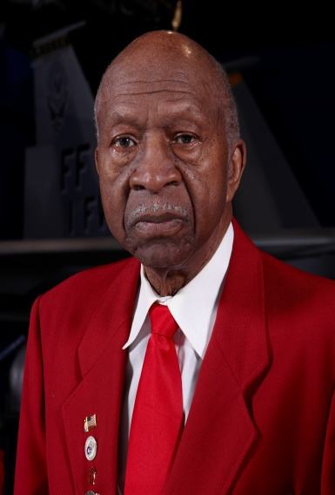
Mr. Francis L. Horne , Sr. was born in West Palm Beach, Florida on 24 February 1922. Upon completion of high school, he replied to a newspaper ad stating it was looking for Pilots to comprise the Army Air Corps. Mr. Horne initially received a letter stating he had been
accepted to take the test and to proceed to Morrison Field (now Palm Beach International Airport). After arriving at Morrison Field, Mr. Horne saw there were only 18-candidates taking the test and only two were Negroes. After being told to take the test separate from the White candidates, the other Negro candidate tore up his test and left the test area.

Mr. Horne stayed and suffered the indignity of being told by the test Instructor after he looked at his test for 3-seconds, “sorry boy, better luck next time!” Of course, Mr. Horne was devastated; but he enlisted in the Army Air Corps on 9 July 1942 and was sent to Tuskegee Army Air Field in Tuskegee, Alabama, to serve as a Private First Class Aircraft Mechanic's Helper and Aircraft Radio Repairman. His job was to keep P-40 and AT-6 aircrafts flying and radios fully operational and capable of meeting mission objectives.

At the conclusion of World War II and after having attained the rank of Sergeant, Sergeant Horne left active duty and entered Hampton Institute (now Hampton University) and joined the Army Reserve Officers Training Corp (ROTC). After graduating from Hampton Institute, 2nd Lieutenant Horne was awarded a Bachelor of Science Degree in Vocational Industrial Education. In August 1951, during the Korean Conflict, he was recalled to active duty and remained on active military duty until his retirement in October 1969 as a Lieutenant Colonel. His civilian education includes graduate studies at Hampton Institute, Old Dominion University, University of Maryland and Virginia Tech. His military education included completion of the Advance Radio Operator-Mechanic Course; Scott Air Force Base, Illinois Air Defense Artillery School; the Associate Air Defense Artillery Officers Advance Course, Ft. Bliss, Texas; Army Intelligence School, Europe; Chemical Warfare School, Europe; Industrial College of the Armed Forces, Ft. McNair, VA. Also, he and 4-other Tidewater Chapter – Tuskegee Airmen, Inc. Documented Original Tuskegee Airmen (DOTA) received Honorary Doctorate Degrees in Humane Letters (2012) from Old Dominion University.

Colonel Horne’s awards included the Good Conduct Medal, World War II Victory Medal, National Defense Medal, and the Army Commendation Medal. As a DOTA, Colonel Horne and other DOTAs as a group, received the Congressional Gold Medal at the US Capitol on 29 March 2007 when President Bush conferred this distinct honor on all of the individuals who participated in the Tuskegee Airmen Program. For 10-plus years, Colonel Horne served as the Chapter’s Speakers Bureau Chairman and entertained over 200-speaking engagement requests. He was married to the former Carrie Broxton Wynder. Colonel Horne and his wife resided in Hampton, Virginia for many years. They relocated to the great state of Pennsylvania and while there, he joined the Lonely Eagle Chapter on January 8, 2014. They are survived by two adult children. To learn more about Colonel Horne, the Tidewater Chapter’s Speakers Bureau and other activities that he participated in, please visit the Tidewater Chapter’s Website at the following location: www.TAI-TidewaterChapter.Com.

