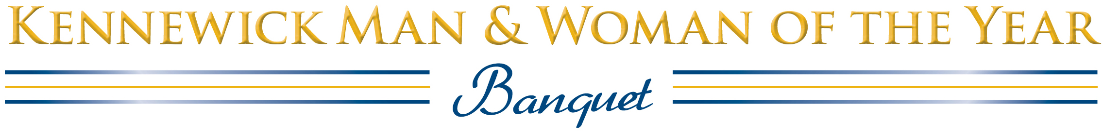

2022 Sponsorship Opportunities
Honoring the 2020 and 2021 Kennewick Man and Woman of the Year

Monday June 13, 2022 • Three Rivers Convention Center • Public Reception 6:00 p.m.

This event will be held in person with appropriate Covid safety protocols in place. It is our expectation that each attendee will have been vaccinated and will attend at their own risk.

Presenting Sponsor: One only— $1500
Sun Pacific Energy
You will receive name sponsor mention on all of the printed and electronic material that supports this event—a link on the official Web page, www.kmwoy.com, invitations, the evening’s keepsake program, and on those all-important nomination forms. Your logo and/or URL will appear wherever possible. Your Presenting Sponsorship will include a table for eight located in the front of the room, four invitations for your special guests to the pre-event honoring past women and men of the year, and the right to place a banner next to the podium.

Sustaining Sponsors: Six only—$500

This sponsorship includes a table for eight, best possible placement. You will also be recognized by name from the podium and in the keepsake program, and your logo will be prominently displayed in the banquet room.

Reception Sponsor: One only—$700
Kennewick Past Men of the Year Club
Your organization will be the sole sponsor of pre-event and public receptions honoring past Kennewick Men and Women of the Year. In addition, your name and logo will appear in the keepsake program.

Table Sponsors: 8 tickets included—$450

Your table for eight will receive the best possible placement. It will also display a sign indicating your sponsorship. You will be recognized from the podium and in the keepsake program.

Special Reserved Table Recognition: $75 (Tickets must be purchased separately.)
This recognition is for organizations or individuals who want to sponsor a reserved table for eight people who have already purchased individual tickets. You will be recognized in the keepsake program, and with a sponsor sign on the table.

To reserve your sponsorship:
Kirk Williamson at 509-539-2036
Fax: 509-491-1291
E-mail: kennewickmen_women@charter.net

Produced by:
Soroptimist International of Pasco-
Kennewick & Kennewick Past Men of the Year Club

Kennewick Man & Woman of the Year
2022 Banquet Sponsor Reservation

Please reserve the following Sponsorship(s):

_____ SUSTAINING SPONSORSHIP (Includes 8 meals) $500
Please include the names of your guests below.

_____ TABLE SPONSORSHIP (includes 8 meals) $450
Please include the names of your guests below.

_____ SPECIAL RESERVED TABLE (meals must be purchased separately) $75
Please include the names of your guests below.

How would you like your organization’s name to appear in the keepsake program?

__________________________________________________________________________

Credit or Debit Card Number: _________________________________________________
Expiration Date: _____________ CVV (back of card): __________ Billing Zip: _________
Billing Contact person: ____________________________________________

Mailing address: ____________________________________________

City, State, Zip: ____________________________________________

Best daytime telephone: ____________________________________________

Email: ____________________________________________

Reservations are due and must be paid by Monday, June 6, 2022

Please email this form to: kennewickmen_women@charter.net
Fax: 509-491-1291
Questions: 509-987-5822
This event will be held in person with appropriate Covid safety protocols in place. It is our expectation that each attendee will have been vaccinated and will attend at their own risk.

This meal is not gluten-free. To request vegetarian or gluten-free, please note here:
1. | MENU  Salad  Chicken Marsala  Buttery Mashed Potatoes  Seasonal Vegetables  Assorted desserts  Coffee, Iced tea, Water  no-host bar
2.
3.
4.
5.
6.
7.
8.
9.
10.

