My Story: Traveling Appaloosas
by Cheryl Palmer

I have always been horse crazy even as a young girl. My parents thought it was just a passing fancy. My father promised me a horse if I graduated from college with a teaching credential. I stuck my credential under his nose but I didn’t need him to buy me a horse. My husband, Clif, and I bought 2 foundation bred mares that we rode on the weekends. This was back in the 1960’s. We were busy with our careers and family and just occasionally showed our horses at small local horse shows that didn’t require professional trainers and expensive clothes and tack. We decided in 1987 to go on our first Chief Joseph ride. We hooked up with Marge Carmen, a seasoned veteran and a trail scout on the ride. She was tough as nails and very horse savvy and offered to trailer our horses to and from the ride. That segment of the ride started in Cooke City, MT and ended near Powell, Wy.

Our horses by this time were in their twenties and I figured I could find someone on the ride who could direct us to some breeders for much needed replacements. I was shocked at all the horses I saw on the ride, there being over 200 horses. Most didn’t look like our old foundation Appaloosas that I grew up with in the 60’s. I asked what happened. I was told they have been replaced with the new modern models. The old ones are gone; they have disappeared off the face of the earth. Some even went to slaughter houses I was told. I was raised with the more robust, rugged, bigger headed, longer ears, heavier legs and feet of the earlier Appaloosa. I didn’t care for what I saw which was the more modern version of what the ideal Appaloosa was supposed to be with it’s more bunchy muscled body, small dainty head and ears, and more overall refined appearance. I loved and yearned for the older type that had the more rugged body build.

Don Ulrich and his son just happened to be on this particular Chief Joseph Ride in 1987. I watched their loud colored leopard horses glide over the terrain taking everything in stride. These were the only old line foundation horses I noticed on the ride and we followed the Ulrich’s to their ranch as the ride ended practically in their own back yard near Powell, Wy. I quickly picked out 2 or more beautiful leopard mares for our replacements. Mr. Ulrich told us they would cost two or three. I knew what he meant by the two or three but my husband didn’t. He assumed they were for sale for two or three hundred dollars apiece and told me I could pick out four for that price. When I informed him how much they really were he stuffed me in the truck and we sped away. These two to three thousand dollar horses were not in our budget! It took me two months to wear him down and to have these beautiful leopard horses delivered from Mr. Ulrich’s ranch to my home in Grass Valley, CA. We bought two mares and they were in foal so we actually ended up with four. A few years later during the Ulrich dispersal sale in 1990 we bought three more. Now we had a herd!

I want to back up and tell you some history most people may not know about the so called Ulrich horses and where they originated from before Mr. Ulrich bought them. Ralph and Helen Brown had a big spread in Broadview, MT near Billings and the ranch was called the Timberline Ranch and was know as the Leopard Appaloosa capital of the world. They purposely bred leopard to leopard as this was their chosen color pattern and these horses were rarely out crossed. Ralph Brown leased a leopard stallion named Candy #320 from Margaret (Farnsworth) Besecker and from this stallion he produced many leopard offspring and in particular a stallion called Navajo’s Candy, a bay leopard. This blood line plus the two leopard mares that he bought from Charlie Peterson, by Simcoe Sarcee, a national champion halter stallion bought by Charles Peterson for the unheard of price then of $5,000. Another leopard line that played a role in their leopard mix was the Morgan leopard line bred into the herd by Dan Morgan who lived in the area and was a shirttail relative of the Browns. There were a few other not so famous leopard lines used off and on like the Dun Roven Chelsea Image line which was quickly abandoned by them as he proved not to be a consistent color producer and some of his offspring were lacking in disposition. Dun Roven Chelsea Image was sold to Alice Pratt’s ranch in Oregon and I later bought him indirectly from her.

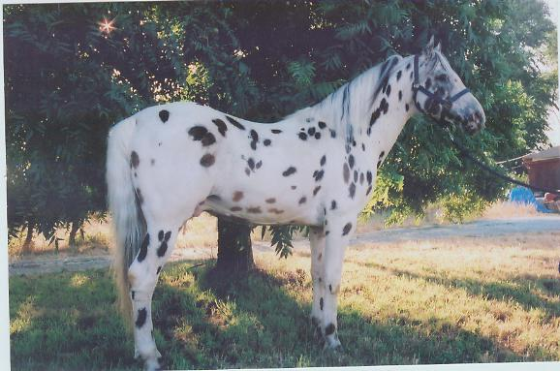
Dun Roven Chelsea Image

The Brown’s had one of their dispersal sales in the 1960’s and this is where Mr. Ulrich bought most of his herd from the Timberline leopards and put his name on them. Through astute advertising in the Appaloosa Journal in the 1970s and 1980’s he made the Ulrich leopard horses a house hold name among Appaloosa people. He used beautiful photos with breath taking scenery with the backdrop of the Rimrock bluffs of his ranch near Powell, Wyoming. He used the catch phrases of “Appaloosa to Appaloosa” and “The best to the best” to promote his leopard Appaloosas. Many people may not have liked these old fashioned pure bred foundation Appaloosa’s but looked forward to Mr. Ulrich’s witty advertisements in the Journal to see what he would come up with next. The most famous photos that he produced was called the “Stampede” used by the Appaloosa Journal for advertising.

We loved our spotted leopards and they were the talk of the community with their flashy loud colored spots. They were wonderful to ride with their quiet kind dispositions and unflappable manner. My husband and I would argue over who was going to ride Ulrich Kitten III our favorite riding mare. She was my once in a lifetime horse. Kitten was a small black scrubby leopard mare. She was very self sufficient, extremely sure footed and a confident mare, not afraid of anything and a blast to ride. People dropped their jaws to the floor when they saw her move, as she could not only travel fast at a walk but she was smooth and efficient She had this peculiar gait I dubbed as a fast forward walk.
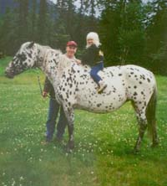
Ulrich Kitten III
Kitten could out walk anything or any horse around. Kitten didn’t care if she ended up miles ahead of everyone else and we would have to wait for others to catch up. We took her on lots of trail rides with others and she was always the center of conversation among riding groups. People were always offering to buy this exceptional traveling trail horse. At one point we were offered over $10,000 for her. That stopped us in our tracks. We struggled with the possible decision of selling her – but she was our prize horse, our special gifted gaited Indian Shuffler. Even Pam Myers, who helped organize the Walkaloosa Horse Association, wanted to buy and own her.

My husband didn’t know much about riding (and still doesn’t!) but he is a very intelligent person who sized up Ulrich Kitten III and proclaimed her as his riding horse. He said he felt safe and refreshed when he rode her and not all beaten up and jostled in the saddle. We had a huge waiting list now for her foals that we could never fill and people came from all over the country to ride her. She caused such a sensation and interest that I vowed I would find out where this gait came from and started a long quest of inquiry. We discovered from gaited experts that Ulrich Kitten III had the true and rare Indian Shuffle gait. She never, ever trotted – just gaited and with tremendous speed. She did a consistent Fox Trot gait but could do a whole range of gaits. She was actually multi-gaited. Where did all this come from? In my research, I contacted Carol Mulder who is an authority on Arabians. She told me that Alyf, a registered Arabian, was a strong ambler and this horse is prominent in Kitten III bloodlines. She said Alyf could gait without effort and could stay in gait beside horses doing a full gallop. This stallion was personally ridden by Carol at the famous Kellog Arabian Ranch. Kitten III also goes back to Kamiak Princess (T755) out of Kamiak Trixie, a full sister to Toby I. Another gaited link is Candy 320. According to Pat Sunstrom (granddaughter of Margarent Farnsworth Besecker) a few of Candy 320”s offspring were gaited. Another source is Kitten III’s Morgan ancestry going back to some gaited Morgans. One in particular is General Gates, a known prolific producer of gaited Morgans in his day. I’m still researching the Rakush bloodline but have reached a dead end although I know that gaited genes exist in Rukush’s line.

Mr. Ulrich had also noticed this little shuffle gait in a few of his leopard horses and wanted to develop this trait in his herd but died before he ever figured out where it came from or how to really develop it. Pete Smith, Mr. Ulrich’s trainer noticed it in Ulrich’s Jungle Matt. I found that most of the Ulrich Rakush’s offspring consistently were gaited. I don’t know if Ulrich Rakush himself was gaited or not but he sure produced it. He is dead now as are most of his offspring. Ulrich Kavalier, also now deceased, was by Ulrich Rakush, and out of my beautiful Ulrich Kitten III, and was probably one of the most gaited stallions. He, like his mother, my Ulrich Kitten III, was multi-gaited and his preferred gait was also the Fox Trot. I took a video of him gaiting with Milton Decker’s trainer and this gait was verified by gaited experts that he was indeed a strong wired gaited horse.

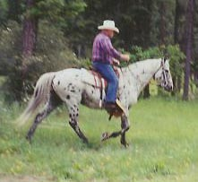
Ulrich Kavalier gaiting

Some History: After the Nez Perce war in 1877 however, the Appaloosa horse, the prize of the Nez Perce Indians, were decimated and scattered hither and yon. The few that remained in pockets were bred to other types and the gaited instinct that some original Appaloosas had slowly died out. A hand full of concerned men gathered up some strays and started our Appaloosa club in 1938. Most people do not know that our club in it’s early days from 1938 through the 1970’s was opened up to out crossing to many other recognized registered breeds to build up the numbers of this new fledgling breed. Our ApHC got off to a very slow start, mainly because there was such a lack of Appaloosas around and partly because of World War II. The Appaloosas that were left had only their pattern coats to identify them as Appaloosas. Their appearance and characteristics became the standard for registration. However some breeders never outcrossed. The 7 breeds that you could out cross your Appaloosa to during that period were as follows:
Morgan’s (AMHA) (Most early Morgan’s were a good source of gaited genes); Saddlebreds ASBA (a good source of gaited genes as this breed is 5 gaited)
Standardbreds, a gaited breed
Tennessee Walkers, TWH, gaited genes
Arabians, mostly ungaited except for some few Arabian lines that were gaited
Thoroughbreds, mostly ungaited
Quarter Horses, mostly ungaited.

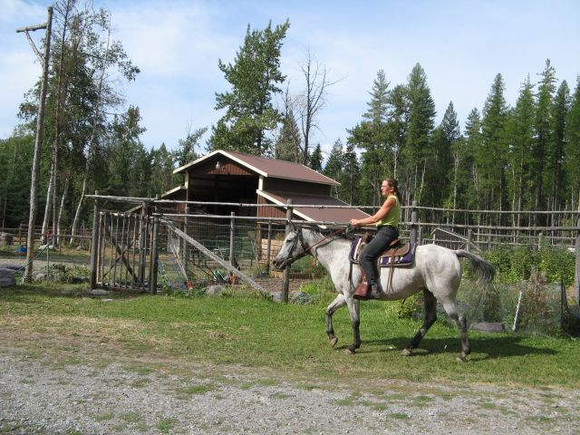
Shuffle Queen showing off her fox trot shuffle gait. Quinta Joe bloodlines.

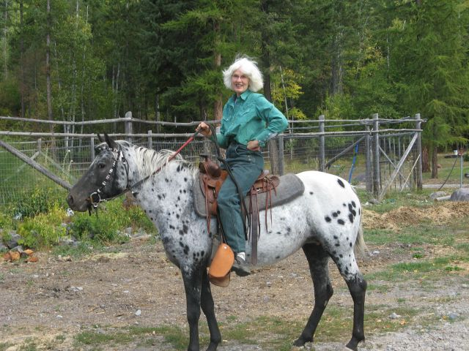
Blue Mocassin, shuffler, Ulrich and Cowboy Jack breeding

The breeding of our Appaloosa to gaited breeds brought back and reinforced the natural gaitedness of our original Spanish descended Appaloosa. These gaited breeds or types themselves were also derived from the original Spanish blood in addition to Canadian Pacer and Narragansett pacer blood. By breeding our Appaloosas to these strongly gaited developed breeds is where this gaited trait comes from. It has strengthened what the Appaloosa had in its original form – the Spanish Mustang. These original Spanish horses played a huge part in the development of the Paso Fino, Peruvian, and other gaited breeds that we know today. These horses as well as our original Appaloosas had what I call the Traveling body build or the Spanish Colonial body types – longer gaskins, steeper croups, strong rounded loins, and thrifty body builds for long distance traveling. This is gaited conformation. Dr. Cothran and Gala Argent, with their DNA origin studies of the Appaloosa, believe that the Appaloosa may have also originated from Russian explorers.
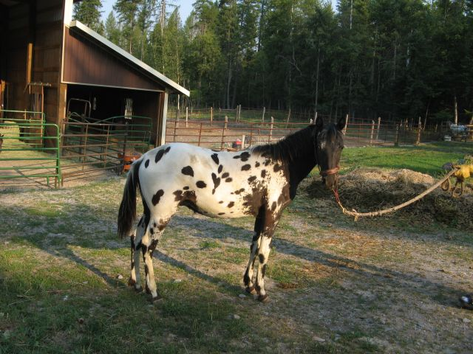
Toby Sioux Bear, by Redneck-gaited yearling

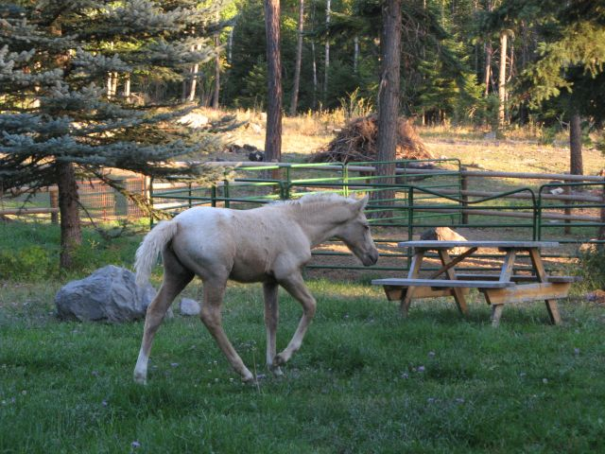
Shuffle Feather doing her shuffle gait, by Redneck

The gait should be considered one more aspect of the Appaloosas versatility. The gait is a trait that came from the roots of the Appaloosa breed and is in it’s history. Heritage is defined as something handed down from one’s ancestors. The Appaloosa horse came from the Spanish mustang also called the Colonial Spanish horse. Today it is estimated that only 10 to 15% of Spanish Mustangs are still gaited.

People are always asking me how to develop this gaited trait, the Indian Shuffle. The answer is very basic. Just find two strongly gaited Appaloosas and bred them to each other. When asked which bloodlines we should concentrate on, I say the ones that have the most recent infusion of gaited blood.

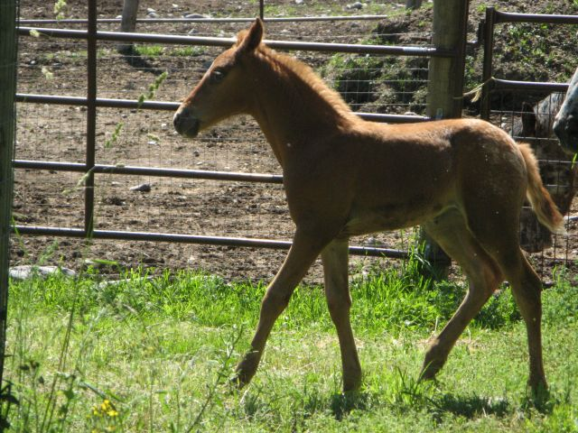
Shuffle Star with her shuffle conformation by Redneck

This is my story and I’m sticking to it! Most of these shuffling horses and foals I have produced from the Ulrich Kitten III line. I want to pay tribute to this outstanding mare who has brought back and helped to revive the Indian shuffle. Neemeepoos Redneck was the springboard for my gaited program. He is the grandson of Ulrich Kitten III and so far has produced 100% shuffling foals. I have developed a nice gene pool for those who like and appreciate this ambling trait in the Appaloosa. You don’t have to be old or young to ride a “gaited” Appaloosa – just smart.
Rainfire, son of Redneck, yearling with the gaited conformation
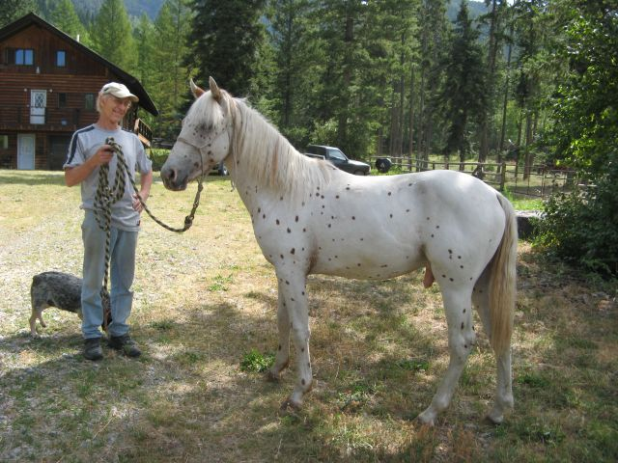

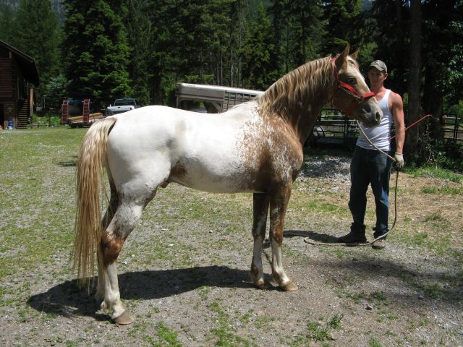
Neemeepoos Redneck, grandson of Ulrich Kitten III – Outstanding gaited stallion
Possibly the most gaited ApHC Appaloosa in the world!

Cheryl Palmer
Sept. 2010

