SAMANTHA galarza  samgalarza611@gmail.com  551-208-0828  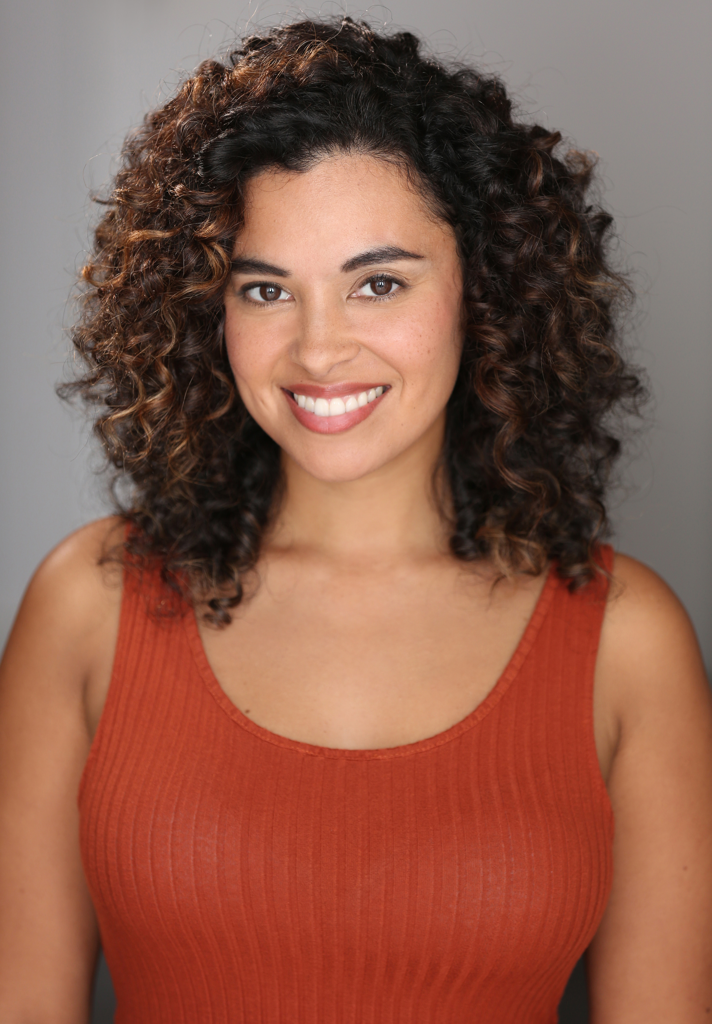  Samantha Galarza is a queer, Puerto Rican, SAG-AFTRA actress, writer, performance artist, educator, podcaster, and director. Ultimately a storyteller, her dream is to bridge the gap between mainstream media and progressive “de-colonial” political art. Her work interweaves personal narratives of queer identity, internalized and systemic anti-black racism, generational trauma, migration, gender-based violence, and substance abuse, with policies that disproportionately affect marginalized communities. She’s been published in award winning anthologies and has performed internationally. She is co-foundeder & co-host of the bilingual queer femme Latinx centered podcast Latinas en Queerantine and co-founder of the queer performance-art collective A Beautiful Desperation.  PERFORMANCE ART  Dixon Place- Manhattan NY:  Accented Gal  Self Love Confessions  Abrons Art Center- Manhattan NY:  Pulse  Take Me to Your River  The New School- Manhattan NY:  Don’t Mess with my Tootie  JACK- Brooklyn NY:  Overcoming  Lutheridge Cnference Center- Arden, NC:  Pink Ribbons  Brooklyn Arts Exchange- Brooklyn, NY:  Brain Poison Heirlooms  Nuyorican Poets Café- Manhattan, NY  Misogynistic Stench  Bowery Poetry Club- Manhattan, NY:  I’m Not your Mofo’ Ally  Branded Saloon- Brooklyn, NY:  I’m Not your Mofo’ Ally  La Sala Rossa- Montreal, QB:  Bare Bones Unbound  (collaboration w/Naty Tremblay)  SP Escola de Teatro- Sao Paolo, Brazil:  Gender Cost(a)  (collaboration w/Naty Tremblay)  Tranzac Club- Toronto, ON:  “Bare Bones Unbound”  (collaboration w/Naty Tremblay)  La Mama Experimental Theatre-  Manhattan, NY:  “I’m Not you Mofo’ Ally”  “Awaken, Sleeping Dummies”  Panoply Performance Laboratory- BK, NY:  “Jam it Out”  Queens Museum of Art- Queens, NY:  “Awaken, Sleeping Dummies”  Mexico City, MX-  “Those Girls”  (in collaboration with Carol Montealegre)  TELEVISION/FILM  Who is Shinobi Redeye| BLC Compound Prod  Role: Calypso  Law & Order SVU | NBC Universal Television  Role: Gina  Dead of Night |NBC Peacock Productions  Role: Laura  Hip Hop High | Z Man Film Company  Role: Alex  Pebble of Love in the Shoe of My Life | Dir. Hossein Keshavarz  Role: Pilar  The Lady’s Man| Now is the Time Prod.  Role: Amy  528 New York | Minty Productions  Role: Kate  Naked Brothers Band | Naked Bros Prod.  Role: Fan talking about the group  Bringing Out the Dead | Axium Ent.  Crying Scene w/Nick Cage  Theo’s Crush | Dir. Steve Sole  Role: Tyla  THEATER  Lincoln Center Education:  My Two Grandfathers  Role: Mom and Mostly True  Organs of State Company:  American Passover”  Role: The Wise One  VPA Theatre Company:  Rumors  Role: Cassie  Twelve Angry Jurors  Role: Juror #10  Downtown  Role: Saskia  Dear Maudie  Role: Blanca  Little Shop of Horrors  Role: Skipsnit  DIRECTOR  Eddie’s Perejil  Presented at:  4th Street Theatre – Manhattan, NY  Brown University- Providence, RI  New York University- Manhattan, NY  Duke University- Durham, NC  Carol Morgan School- Santo Domingo, DR  Alianza Dominican Cultural Center-  Manhattan, NY  Rutgers University- New Brunswick, NJ  The College of New Jersey-Ewing, NJ  John Jay College- Manhattan, NY  Providence College-Providence, RI  Syracuse University-Syracuse, NY  University of South Carolina- Columbia, SC  Hostos College- Bronx, NY  Dance of the Pillow Queen: Hungry Ghost  (Redux! Submerge Series)  Presented at:  Brooklyn Arts Exchange- Brooklyn, NY  PERFORMANCE/ACTING TRAINING  Cold Reading; Scene Study, Monologue  Private Instruction- LA, NYC  Instructed by Gregory Sims, Bob Luke , Bobi Beige  Scene Study; Improvisation; Commercial  Actors Connection, SAG-AFTRA Foundation- NYC  Instructed by Rob Decina, Jon Goracy, Clint Alexander,  Judy Henderson, Jenny Ravitz, & Barry Shapiro  Auditioning for the Camera; Film Acting  HOLA Fabrica- NYC  Instructed by Tony Plana, Charles Carrol  Singing (Mezzo-Soprano)  Private Instruction- NYC  Instructed by Robert Marks, Yumi Tosha  Queer Performance Methodologies,  Needing it All |Helix Queer Performance Network-NYC  Instructed by Dan Fishback (2013 cohort)  Theatre of the Oppressed, Methods in Performance + Politics  EMERGENYC, Hemispheric Institute- NYC  Instructed by George Emilio-Sanchez (2012 cohort, https://emergenyc.org/)  Public and Archaeological Interventions, Installations & Jams  La Pocha Nostra- Oaxaca, Mexico  Instructed by Guillermo Gomez-Pena (2012 cohort) |  | Experience  creative arts team  Assistant Program Director (Promotion) | CASA @ CUNY- Manhattan,  Sept 22’-Present  - Conceptualize curriculum arcs for various residency lengths and aid Actor Teachers with strengthening session plans for each residency  - Devise & facilitate all AT trainings and monthly intensives.  - Observe in-class facilitation of ATs & provide constructive feedback  - Creatively plan how to form new partnerships with schools of interest & source funding to provide services with Prog. Dir. And Exec. Dir.  - Make logistical decisions with CASA partners about how our program will be run at each site depending on needs and pair ATs accordingly  Curriculum Specialist (Promotion)| Aug. 21’- Aug. 22’  - Co-designed a Devised Theater Curriculum Arc for Actor Teachers to implement as guides for residencies in NYC public schools  - Customized Games/Activity Catalogue separated into categories (exploring power dynamics, devising, storytelling, focus, rhythm, etc.) depending on the goal(s) of the session.  - Ran weekly planning sessions and monthly training intensives to strengthen the facilitation skills of Actor Teachers  - Supported Actor Teachers with strategies to problem-solve facilitation issues as they came up  - Created system for cross-school “twinning” sessions and step by step facilitation handbook  Actor Teacher | (for 3 separate programs within Creative Arts Team)  Cultural Afterschool Adventures (CASA): September 16’-June 21’  - 12 week residencies with NYC students in 2nd-8th grade that help them build community, theater literacy/skills (i.e. improv, creative writing, character development, movement) and have dialogue in which they can voice their views about the world and use those ideas as a starting point for the creation of original theater pieces to be shared with an audience  - 24 week residencies with 9-12th graders that focus on the use and creation of spoken word poetry to reflect issues, beliefs, and personal life experiences; discuss social issues affecting their lives and analyze the way pop culture and institutions either reinforce or push against the status quo  Sound Thinking (summer program): July 18’  - Supported cohort of 50 female identified 11th and 12th grade students interested in careers in music to navigate the music industry by building curriculum and facilitating daily workshops focused on self-esteem, self-care, and self-advocacy  - Built a strong community of women who felt confident enough to ask questions and take risks; build trust and keep it by establishing a culture of affirmation; identify the areas they needed growth in and come up with innovative, fun ways for them to practice skills they were lacking without it feeling like work; examine how privilege and an intersection of varying identities affects how we experience the world  College and Adults Program (CAP): November 16’-June 17’  - Facilitated Theatre of the Oppressed workshops with young adult (18-24) and mature adult (50+ years) population of men incarcerated at Rikers Prison; theater was used as a tool to explore themes of power, cycles of violence, legacy, rape culture, masculinity, wealth, mental health, immigration, and parenthood.  - Coached high school seniors prepare for the process of applying to college/universities by exploring multiple intelligence(s) and leveraging theater as the foundation to work through potential obstacles.  - Taught conflict resolution skills and the “A-Game” strategy (advocacy, accountability, adaptability, aptitude, & attitude) using vignettes, tableaux, interactive scenes, and discussion with students grades 3-8 during in-school hours.  Workforce institute  Actor Facilitator/Producer |School of Professional Studies @ CUNY-  Manhattan, May 18’ -Present  - Portray characters in improvised scenarios during live simulations with staff (from entry level to senior positions) and graduate students across NYC social service organizations for child welfare and juvenile justice (https://nycacstraining.org/)  - Collaborate with trainers and executive staff to facilitate safe & realistic educational experiences that optimize participant learning/practice  - Produced over 50 virtual trainings and acted in over 100 live/virtual simulations (and counting)  - Lead actor in 3 professional produced industrials to be used for learners throughout the Workforce Institute  - Completed over 100 hours of training in coaching competency and effective family engagement  EDUCATIONAL ALLIANCE  Youth Advocate Specialist | Edgies Teen Center- Manhattan, Sept 17’- April 18’  - Supported 9th and 10th grade youth in building critical thinking, conflict resolution, de-escalation, and self-advocacy skills to help them succeed in high school, using a holistic and socio-emotional learning lens (restorative justice strategies, goal setting, herbal practices, networking)  - Co-created a post-high school plan with students that included possible career paths and financial literacy  - Mentored each student weekly in one-on-one meetings during which concepts discussed in the class were reinforced and each student’s progress in their respective schools was closely monitored  Theater Specialist | City School of the Arts- Manhattan, Sept 16’- June 17’  - Pioneered a year-long Devised Theater program with curriculum that fortified original content creation for 6th graders at a magnet school for visual and performing arts, during in-school hours  - Instructed/honed performance skills ie. improvisation, poetry, theater of the oppressed, tableaux, writing, singing and creative writing with students  the ny foundling  Arts Director | Camp Felix- Peekskill Valley NY, July 16’-Aug 16’  - Conceptualized and implemented new arts program focused on community and identity for campers ages 8-15 who were in the Foster Care system  - Devised curriculum based on needs of 6 respective cabins and lead each cabin through daily arts activities that promoted the learning of visual arts skills (storyboard concepts, drip-technique painting, collaging), self-esteem, leadership, and fun.  EDUCATION  B.A. Latino & Caribbean studies  B.A. Women & Gender studies  (minor in sociology)  Rutgers University, New Brunswick, NJ  GPA: 3.95 (Summa Cum Laude)  - Wrote Honors Thesis on the structural and social causes for heroin addiction among Puerto Ricans from the 1960s-1980s in the NJ/NY metropolitan  - Awards: Rutgers James Dickson Carr Scholarship, CLAC Undergraduate Research Grant, University College Scholarship, Rutgers Academic Excellence Award, National Society of Collegiate Scholars, University Honor Society Scholarship  HONORS/distinctions  FELLOWSHIP/RESIDENCIES  Intercultural Leadership Institute fellow (2022-2023)  Take a Breath |The Action Lab, Ossining, NY (2021)  NALAC Leadership Institute fellow |NALAC, (2021)  EMERGELAB fellow |Brooklyn Arts Exchange, Brooklyn, NY (2016)  EMERGENYC | Hemispheric Institute, Manhattan NY (2012)  PUBLICATIONS  “Glitter & Grit: Queer Performance from the Heels on Wheels Femme Galaxy” edited by Damien Luxe, Heather Maria Acs and Sabina Ibarrola; Excerpt of my piece “Brain Poison Heirlooms” is in this anthology.  **Winner of Lambda Literary Award (http://www.out.com/art-books/2016/6/07/winners-28th-annual-lambda-literary-awards)  GRANTS  League of Independent Theater Space Grant (2016)  CLAC Undergraduate Research Grant (2011)  COLLECTIVES  Latinas en Queerantine  co-founder/ co-host of podcast series centering queer, femme, Latinx experience  A Beautiful Desperation  (https://abeautifuldesperation.carbonmade.com)  co-founder of all queer, mostly poc, female, gender non-conforming, and trans, multimedia, experimental, performance art collective  Keynote speaker/  workshop Facilitation  Key Note Speaker for Latinx Heritage Month  PS # 27 in Jersey City NJ, Oct. 14’  - Presented to 6-8 graders on the impact of education in the job market and the legacy of Latinx in NJ  Brooklyn Friends School in Brooklyn NY, Sept. 14’  - Presented to 6-8 graders about the legacy of Puerto Rican activists in NYC & how art is a form of activism  Young Womyn of Strength 5 Conference: Reclaiming Our Time and Creating and Owning Our Narratives, Brooklyn NY, Nov. 17’  “#METOO #SAYHERNAME”  - Explored how artists and organizers have used their creativity to address violence against women and femicide  - Mapped statistical breakdown of how femicide affects womyn of different populations and ways in which the devaluation of womyn show up both in the home and institutions  - planned safety measures to take when confronted with toxic masculinity and its manifestations  Young Womyn of Strength 4 Conference: Livin’ Out Loud, Brooklyn NY, Nov. 16’  “Purging the Labels, Re-claiming Our Worth”  - Named the unwanted labels that society, communities, and even our friends and family have put on us & weight of having to carry identities that are not self-defined and the ways we cope  - De-constructed roots of the most common ones (stigmas related to race, gender, sexuality, body image, class) and began the work of healing those wounds and symbolically purging those labels with visual arts project  Young Womyn of Strength 3 Conference, Brooklyn NY, Nov. 15’  “Leading with your Authentic Self”  - Taught strategies on how to “lead with your authentic self” with female-identified 7th-12th graders using art, by exploring concepts like race, gender, perfection and societal expectations that we’ve been conditioned to internalize and seeing how they align with our self-truths  Young Womyn of Strength Conference 2, Brooklyn NY, Nov. 14  “Performance as Narrative”  - Began process of exploring the layers of one’s identity through performance; participants created individual and collective pieces that were celebratory and investigatory of the complexities of all our identities  PROFESSIONAL DEVELOPMENT/  CONFERENCES  Undoing Racism (People’s Institute of Survival and Beyond) 2022  - 3 day training on undoing racism, leadership development, undoing internalized racial oppression, and reshaping gatekeeping.  Workforce Institute Trainings, NY, 2018-2021  - Motivational Interviewing: Engaging Families with Repeat Involvement in the Child Welfare System (2 day)  - Building Coaching Competency (2 day)  - Safety and Risk: Investigation, Synthesis, and Assessment  - Implicit Bias  - LGBTQUIA+ (2 day)  42nd Annual ROOTS Week: RE/NEWing. Arden, NC. 2018  - 6 day conference for artists and cultural workers/supporters whose work is rooted in community, tradition or spirit. Focus: gender/queer liberation, decolonization, and indigeneity alongside performances and video installations  - Performer, “Pink Ribbon”  Compass Beyond the Basics, SEL Advanced Training Series, Manhattan, NY. 2016  - 8 month training on Restorative Justice, Restorative Practice, & Circle Keeping in the classroom  - *** CERTIFICATION in Restorative Practices and Circle Keeping  Allied Media Conference. Detroit, Michigan. 2016  - 5 day media-based organizing conference that focuses on people using media, art, or technology to address the roots of problems and advances holistic solutions towards a more just and creative world.  Manifest! Choreographing Social Movements in the Americas, El Encuentro. Montreal, Quebec. 2014  - 10 day conference on how performances mobilize and syncretize in civic, community, and cultural contexts to create forms of political expression.  - Performer, “I’m Not Your Motherfucking Ally”  Symposium on Decolonial Aesthetics from the Americas. Toronto, ON. 2013  - 3 day symposium engaging the diversity of contemporary aesthetic practices informed by decolonial thought.  - Performer, “Gender Cost(a)”  - Presenter, “Contemporary Aesthetic Practice”  Cities/Bodies/Action – The Politics of Passion in the Americas, El Encuentro. Sau Paulo, Brazil. 2013  - 10 day conference examining the broad intersections between urban space, performance, and political/artistic action in the Americas.  - Performer, “Gender Cost(a)”  38th Annual ROOTS Week: A Call to Action-Aesthetics. Asheville, NC. 2018  - 6 day conference for artists and cultural workers/supporters whose work is rooted in community, tradition or spirit.  - COOP Leader (Kitchen Choreographer); Alternate Roots Member  NYCoRE Conference: Radical Possibilities. Brooklyn, New York. 2014  - Training for NYC based educators interested in radical/non-traditional ways of engaging students  Feminist Constellations: Intercultural Paradigms in the Americas, NY, NY. 2013  - 2 day conference spotlighting the work and struggles of feminist scholars and activists at the forefront of contemporary debates on democracy, economic, cultural, and racial justice.

