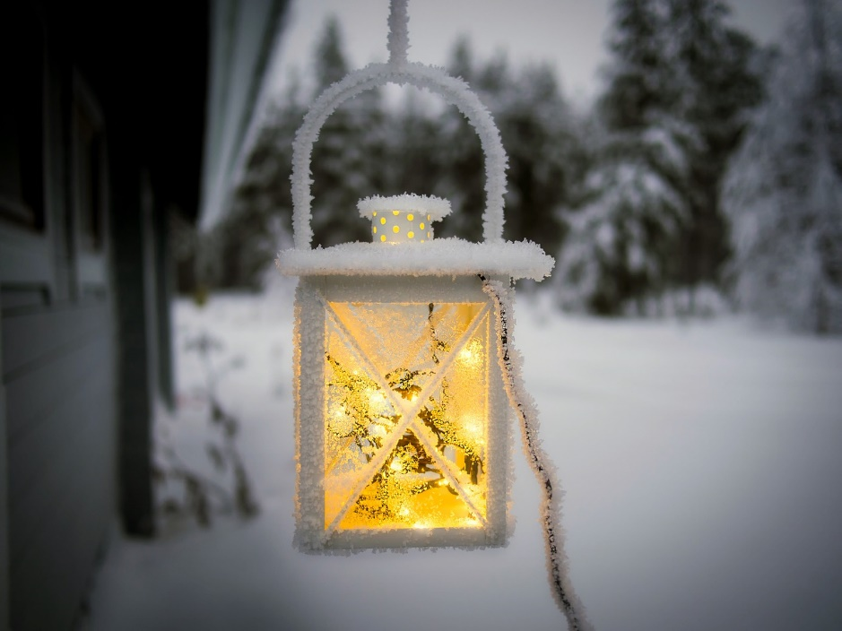
Day 15. Keep Hope Alive Against the Icy Odds
In her book Comfort Prayers, editor June Cotner shares a poem by Barbara Crooker titled: “Hope.”
Winter sunlight, fool’s gold, pours in the south window,
fails to warm. Weak as tea, pale as bone, insubstantial
as dust on a mantle, water falling over stone.
The ground outside, hard, white as the hospital bed
where my friend waits after her marrow transplant,
hoping her white count will rise. I watch
birds at the window –
sparrows, titmice, finches –
the plain brown, the speckled,
the ordinary, no flashy travelers up from the tropics,
where winter is a verb, not a state of the heart.
I go out to fill the feeder, feel silky grain slip
through my fingers: millet, proso, corn.
Little birds,
little angels, singing their small song of consolation.
A thin drizzle of sun slips through clouds,
a strand of hope against the icy odds.

Look around your winter environment today. Where do you see a strand of hope?

