PRIVATE
Swimming
Lessons
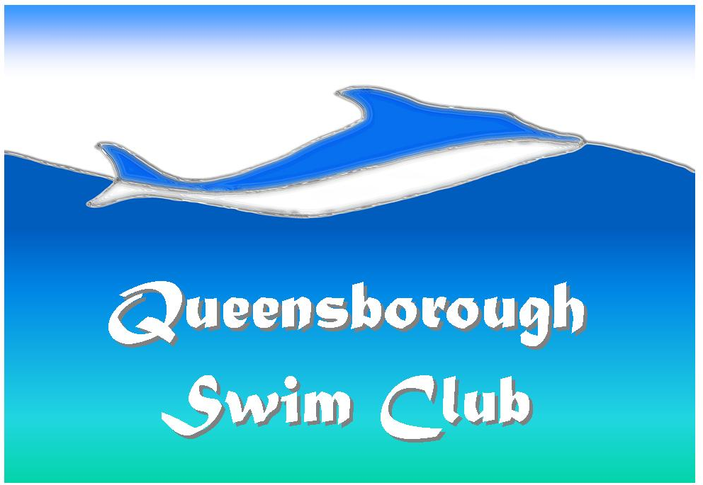
Queensborough Swim Club is located at 1138 Miller Ave., San Jose, CA 95129
Between Rainbow & Bollinger

Who: Ages 2 years to 99 years
What: Learn to Swim
Where: 1138 Miller Ave., San Jose, CA 95129
When: All year in heated pool! We accommodate your day/time needs
Cost: PRIVATE: $30/half hour, $50/hour
SEMI-PRIVATE (2-3 students/lesson): $20/half hour, $30/hour

For Complete Registration Information, visit www.qpool.org or email info@qpool.org or call us at 408-446-3921.

