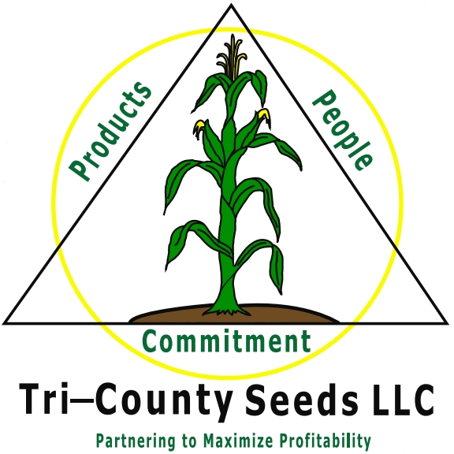
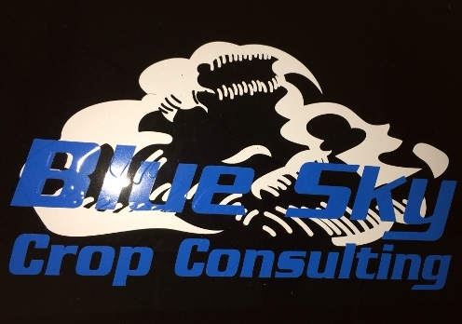
Blue Sky Crop Consulting
Summer Intern

Innovative and service oriented crop consulting company is seeking agronomic leaders for summer internship positions in the months of May through August. Internship positions require self-motivated people to assist in crop consulting. It is an excellent opportunity to apply classroom knowledge to practical experience the field. Interns will gain experience with a variety of crops, learn to identify weeds and insects, gain exposure to the use of Precision Ag, and learn the value of relationship building for business success.

This position will be headquartered in Kinsley, KS working with producers in South Central and Southwest Kansas.

The Successful Candidates Will Have:
- College Major in Agronomy, Crop Science, or other related field
- Solid farm background or experience
- Knowledge of corn, soybean and wheat crops; agricultural chemicals and fertilizer is helpful
- Excellent written and verbal communication skills
- Desire to learn and help others
- Attention to detail
- Outstanding work ethic
- Willingness to work 60+ hours per week during peak growing season
- Physical ability to walk fields in mud, heat and other adverse environmental conditions
- Ability to operate with little supervision
- Valid U.S. drivers license with good driving record

Salary and Benefits:
- Extremely competitive compensation program with bonus plan
- Vehicle for all work related activities
- Housing provided
- Potential for full-time employment upon graduation

For more information, contact Amy Gerdes at 620-338-7593 or email cover letter and resume to agerdes@blueskycropconsulting.com.

