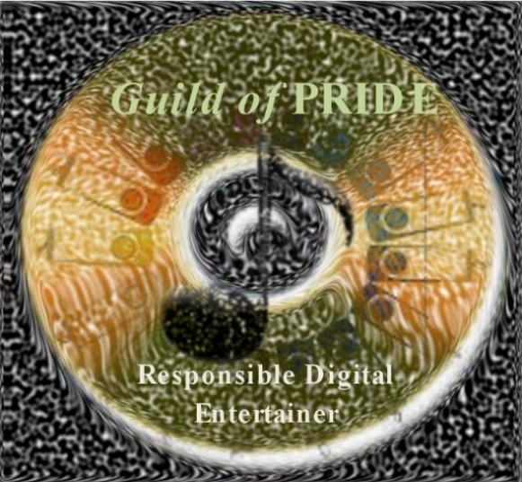
The Guild of PRIDE

A Special Invitation

Please accept this invitation to become a Member of The Guild of PRIDE. You have been invited to join other leaders dedicated to the promotion and preservation of dancing and music entertainment. PRIDE denotes “Professional Recorded Instrumental Digital Entertainers” who maintain ethical and responsible standards in regards to the music they use for teaching and entertaining.
The Guild of PRIDE’s mission is to proclaim, promote, and practice the most ethical and legal methods of acquiring, maintaining, and protecting one’s ownership in the use of recorded music for teaching and entertaining.
Membership in the Guild is voluntary, by invitation only, and the membership fee is only $15 for three (3) years or $20 for five (5) years. There is a two-step process to join The Guild. The first step is simply to support the mission as stated above. All Members will receive invitations to extend membership status to their peers, receive a membership card, and be listed on The Guild of PRIDE’s website as a “Responsible Digital Entertainer”.
Upon completion of the first step, Members will begin the process of thoroughly reviewing all music personally used in teaching and entertaining to be certain that the artist(s) and producer(s) responsible for its creation and distribution have been properly and completely compensated. Permanently maintaining one’s music with this standard qualifies the Member for Elite Status. Each Elite Member will receive a complimentary lapel pin.
To accept this invitation, join other leaders in your field of expertise, and set an ethical example for other recorded music entertainers, please complete an application and mail, fax, or email it to Sharon Frank, Executive Director of The Guild, at: Sharon@guildofpride.org. If you have questions or need additional information, please send her an email or call her at 1-314-839-0046. More information can be found on The Guild’s website at: www.guildofpride.org.

