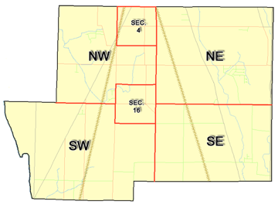 | Pleasant Township  Zoning Commission Minutes  1035 Owens Rd W.  Marion, Ohio 43302
Meeting called by: | Scheduled | Type of meeting: | Regular Monthly
Chairperson: | Mr. Holler | Secretary: | Tim Michael
Timekeeper: |  | Date: Jan. 16, 2020 | Time 7:30 pm
Call to Order by: | Mr. Holler Moment of silence followed by the pledge to the flag.
Roll Call: | Scott Ballenger, Jack Dean, Harry Holler, Tom Leib, Dwight Williams  Tim Michael Secretary / Alternate
Minutes: | Read and approve minutes from previous meeting. (May pass out earlier)  Motion to approve minutes by: Mr. Williams Seconded by: Mr. Dean Roll call: All approved
Attendees Address Board: Have sign in sheet on desk by door.
Type in attendees and addresses:
.
----- Agenda Topics -----
Business
Zoning Reports: | Zoning Inspector goes over reports and provides copy to board.
Unfinished:
New:
Announcements: | Next meeting will be: February 13, 2020 (Special Meeting)
Adjournment: | Meeting dismissed by Mr. Holler
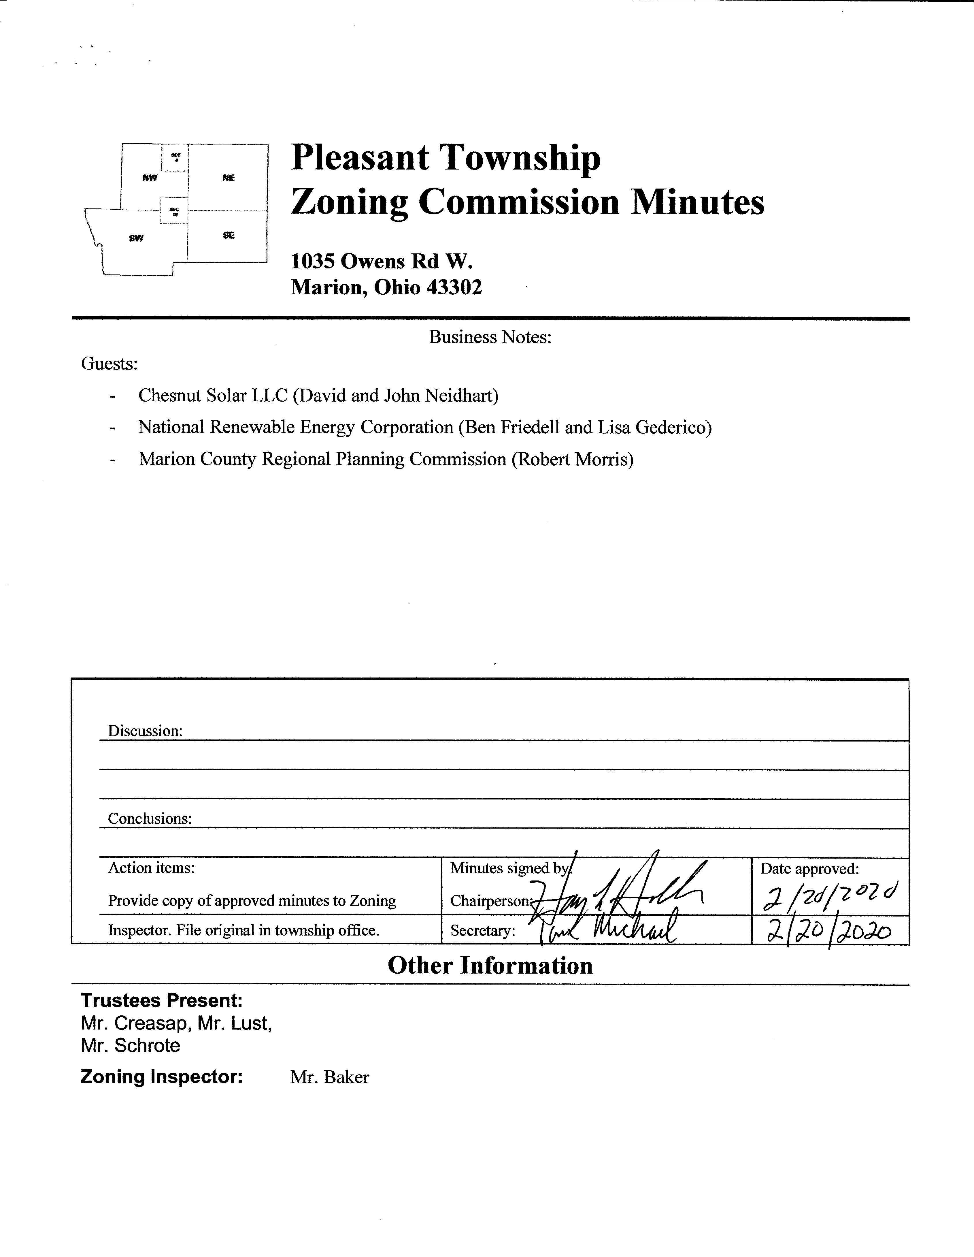

Minutes
- The Pleasant Township Zoning Commission met for their regularly scheduled monthly meeting on January 16th, 2020 at the Pleasant Township Trustee Office. Zoning Commission Board members present were: Mr. Ballenger, Mr. Dean, Mr. Leib, Mr. Williams, Chairperson Mr. Holler, and Secretary Mr. Michael. Township Trustees Mr. Creasap, Mr. Lust and Mr. Schrote, and Township Zoning Inspector Mr. Baker. Guests present were representatives of Chesnut Solar LLC (David and John Neidhart), National Renewable Energy Corporation (Ben Friedell and Lisa Federico), and Robert Morris of the Marion County Regional Planning Commission.
- Minutes were read from the November 21st 2019 regularly scheduled Zoning Commission meeting. There being no stated corrections a motion to approve the minutes was made by Mr. Williams and seconded by Mr. Dean. All members present agreed to passage of the minutes.
- Mr. Tom Baker Pleasant Township Zoning Inspector submitted the following inspection report for the month of December 2019 and January 2020: there was 1 permit for a new home, 2 permits for additions, and 1 permit for a fence. Dollar amount for new construction totalled $173,500.00, with income from permits totalling $353.20.
- Mr. Ben Friedell and Ms. Lisa Federico representatives of Narenco (National Renewable Energy Corporation) made presentation of a Planning Discussion for Chesnut Solar LLC (attached).
- As a result of the presentation made by Narenco the members of the Pleasant Township Zoning Commission began a discussion relative to the fact that the Pleasant Township Zoning Resolution currently has no provisions that would allow for the use of Solar Energy Production Facilities on a conditional basis in the A-1 and R-1 Districts of the township.

- Mr. John Neidhart of Chesnut Solar LLC made a motion to amend the Pleasant Township Zoning Resolution to include provisions for the use of Solar Energy Production Facilities on a conditional basis in the A-1 and R-1 Districts of the township. Motion was seconded by Zoning Commission member Mr. Williams. All Zoning Commission members agreed to passage of this motion.

- Mr. Robert Morris of the Marion County Regional Planning Commission presented a document to the members of the Zoning Commission which provided suggested language to be used for the amendment in question and the board agreed on a Special Meeting to be held January 13, 2020 for further discussion of this issue.
- There being no additional business for discussion Mr. Hollar dismissed this meeting of the Pleasant Township Zoning Commission. The next scheduled Zoning Board Meeting will be a special meeting held on February13th 2020 at 7:00 PM.

