REGULAR MEETING
OCTOBER 21, 2021

Four (4) Public Hearings and the Regular Meeting of the Town Board of the Town of Hampton, County of Washington and the State of New York was held at the Town Hall, 2629 State Route 22A, Hampton, New York, also via Zoom and live streaming on the You Tube Channel for “Town of Hampton New York” on the 21st day of October 2021.

Due to the Corona Virus, occupancy inside the Town Hall is limited at this time. Supervisor O’Brien did provide a link to join the meeting via Zoom.

PRESENT: David K. O’Brien------------Supervisor
Donald Sady-----------------Councilman - absent
Tamme Taran----------------Councilwoman
Andrea Sweeney------------Councilwoman
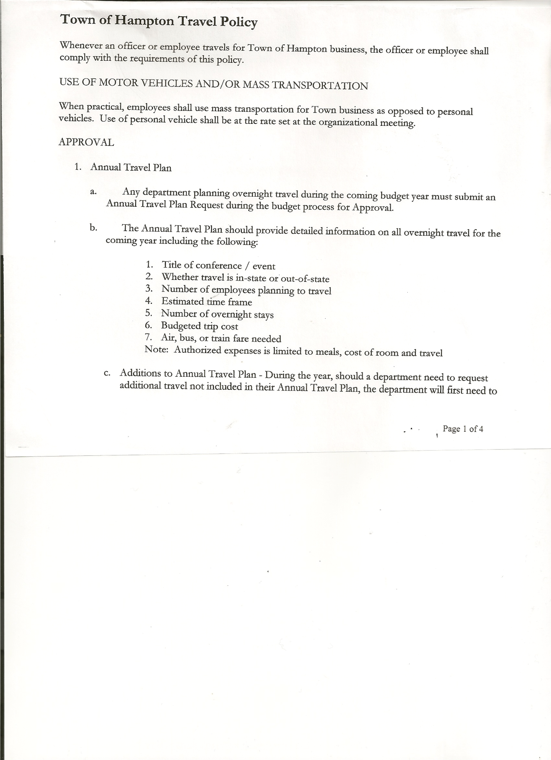
Michael Pietryka------------Councilman
Rebecca Jones---------------Town Clerk
Camilla Shaw----------------Tax Collector/Deputy Town Clerk
Herbert Sady, Jr.-------------Highway Superintendent
Kim Perry---------------------Budget Officer

Planning Board Member(s):… Bonnie Hawley, Chair
Others present at the Town Hall: See attached list

The FIRST Public Hearing was called to order by Supervisor O’Brien at 7:15pm

Town Clerk Rebecca Jones read the Legal Notice of Public Hearing (copy attached), which was published in the Manchester Newspapers to discuss the proposed contract with Hampton Fire Protection District 1. A 2% increase was given for a total of $44163.00.

All persons desiring to be heard, having been heard, the Public Hearing was closed at 7:18pm.

The SECOND Public Hearing was called to order by Supervisor O’Brien at 7:18pm

Town Clerk Jones read the Legal Notice of Public Hearing (copy attached), which was published in the Manchester Newspapers to discuss the proposed contract with Hampton Fire Protection District 2. A 2% increase was given for a total of $10404.00.

All persons desiring to be heard, having been heard, the Public Hearing was closed at 7:22pm

The THIRD Public Hearing was called to order by Supervisor O’Brien at 7:22pm

Town Clerk Rebecca Jones read the Legal Notice of Public Hearing (copy attached), which was published in the Manchester Newspapers to discuss the proposed local law to override the tax levy limit.

All persons desiring to be heard, having been heard, the Public Hearing was closed at 7:26pm.

The FOURTH Public Hearing was called to order by Supervisor O’Brien at 7:26pm.

Town Clerk Rebecca Jones read the Legal Notice of Public Hearing (copy attached), which was published in the Manchester Newspapers for the Preliminary Budget for 2022.

TOWN BOARD MEETING
OCTOBER 21, 2021 PAGE 2

As of 1/1/22 the Appointed Highway Superintendent will retain his benefits. A part-time person will be hired when needed.

All persons desiring to be heard, having been heard, the Public Hearing was closed at 7:30pm

REGULAR MEETING
The Regular Meeting was called to order by Supervisor O’Brien at 7:31pm, followed by the Pledge of Allegiance. Location of Fire Exits were given. Quorum of board members present.

RESOLUTION NO. 98-2021
APPROVAL OF THE MINUTES
On a motion of Councilwoman Taran, seconded by Councilman Pietryka, the following resolution was ADOPTED: AYES 4 O’Brien, Taran, Pietryka, Sweeney
NAYS 0
ABSENT 1 Sady
RESOLVED, that the Regular Town Board Meeting Minutes for September 16th , 2021, and the Special Town Board Meeting Minutes for September 30th, 2021 are approved.

PERMITS/SUBDIVISIONS
Bruce Jones, 2338 County Route 18 came before the board regarding a Subdivision, consisting of .7 acres and residence.

RESOLUTION NO. 99-2021
JONES - SHORT ENVIRONMENTAL ASSESSMENT FORM/NEGATIVE DECLARATION
On a motion of Councilwoman Taran, seconded by Councilwoman Sweeney, the following resolution was ADOPTED: AYES 4 O’Brien, Taran, Pietryka, Sweeney
NAYS 0
ABSENT 1 Sady
RESOLVED, that the Short Environmental Assessment Form is complete and to adopt a negative declaration and finding that there will be no adverse environmental impacts and to consider it a minor subdivision, therefore waving the public hearing.

RESOLUTION NO. 100-2021
JONES- APPROVAL OF SUBDIVISION
On a motion of Councilwoman Taran , seconded by Councilwoman Sweeney, the following resolution was ADOPTED: AYES 4 O’Brien, Taran, Pietryka, Sweeney
NAYS 0
ABSENT 1 Sady
RESOLVED, to approve the Jones subdivision.

Michael Montena, Darrah Land Surveying, LLC, Agent for Tim Cardinal, 1195 State Route 4 came before the board regarding a Subdivision, consisting of two lots. One lot would be 1.9 acres, the second lot would be 4.02 acres.

TOWN BOARD MEETING
OCTOBER 21, 2021 PAGE 3

RESOLUTION NO. 101-2021
CARDINAL - SHORT ENVIRONMENTAL ASSESSMENT FORM/NEGATIVE DECLARATION
On a motion of Councilwoman Taran, seconded by Councilwoman Sweeney, the following resolution was ADOPTED: AYES 4 O’Brien, Taran, Pietryka, Sweeney
NAYS 0
ABSENT 1 Sady
RESOLVED, that the Short Environmental Assessment Form is complete and to adopt a negative declaration and finding that there will be no adverse environmental impacts and to consider it a minor subdivision, therefore waving the public hearing.

RESOLUTION NO. 102-2021
CARDINAL- APPROVAL OF SUBDIVISION
On a motion of Councilwoman Taran , seconded by Councilwoman Sweeney, the following resolution was ADOPTED: AYES 4 O’Brien, Taran, Pietryka, Sweeney
NAYS 0
ABSENT 1 Sady
RESOLVED, to approve the Cardinal subdivision.

Larry Carman, Dog Control Officer submitted his report, which was read by Supervisor O’Brien, copy of report is attached.

Camilla Shaw, Tax Collector….no activity. Submitted Bank Statement to the Board for review and signatures.

Bonnie Hawley, Chair gave Planning Board Report……The Planning Board will be rewriting the Mobile Home Law to be the Manufactured Home Law. The same with the Mobile Home Park Law would need to be changed to Manufactured Home Park Law. The Town Attorney will be reviewing prior to coming before the Town Board.

The Planning Board meeting on October 10th was with people from the farming community. There was a lot of discussion getting to know what they do, weaknesses and challenges and what should be done to expand farming in Hampton. Copy of Planning Board Agenda is attached.

Herbert Sady, Jr., Highway Superintendent submitted his report, copy of which, is attached.

TOWN BOARD MEETING
OCTOBER 21, 2021 PAGE 4

SUPERVISOR’S REPORT/ COUNTY UPDATES/ COMMUNICATIONS

RESOLUTION NO. 103-2021
APPROVAL OF SUPERVISOR’S MONTHLY REPORT
On a motion of Councilwoman Sweeney, seconded by Councilman Pietryka, the following resolution was ADOPTED: AYES 4 O’Brien, Taran, Pietryka, Sweeney
NAYS 0
ABSENT 1 Sady
RESOLVED that, the Supervisor’s Monthly report be accepted as submitted for SEPTEMBER
8/31/21 9/30/21
ACCOUNT BALANCE RECEIPTS DISBURSEMENTS BALANCE
General Fund $ 81,480.04 $ 940.15 $ 7,581.61 $ 74,838.58
Highway Fund $114,681.36 $ 2.73 $ 15,550.10 $ 99,133.99
Equipment Reserve $ 79,915.44 $ 1.97 $ 0.00 $ 79,917.41
Fire #1 $ 21,648.50 $ 0.00 $ 0.00 $ 21,648.50
Fire #2 $ 5,100.00 $ 0.00 $ 0.00 $ 5,100.00
Cemetery $ 1,752.51 $ 0.70 $ 0.00 $ 1,753.21
Totals $304,577.85 $ 945.55 $ 23,131.71 $ 282,391.69
All Board Members present signed Supervisor’s Report.

PRELIMINARY BUDGET…..
Highway unexpended balance now $20,000 instead of $30,000.
Fire Department tax rate is down due to reassessment.
The overall budget is increased by 11.09%

RESOLUTION NO. 104-2021
APPROVAL OF THE 2022 BUDGET
On a motion of Councilwoman Sweeney , seconded by Councilman Pietryka, the following resolution was ADOPTED:
By Roll Call Vote: Supervisor O’Brien AYE
Councilwoman Taran AYE
Councilwoman Sweeney AYE
Councilman Pietryka AYE
Councilman Sady ABSENT
RESOLVED, that the 2022 Town Budget for the Town of Hampton is adopted.

RESOLUTION NO. 105-2021

MOTION BY: Councilwoman Tamme Taran
SECONDED BY: Councilwoman Andrea Sweeney

RESOLUTION ADOPTING A LOCAL LAW TO OVERRIDE THE TAX LEVY LIMIT ESTABLISHED IN GENERAL MUNICIPAL LAW SECTION 3-C

WHEREAS, pursuant to Section 3-c(5) of the New York State General Municipal Law, the Town Board (the “Board”) of the Town of Hampton (the “Town”) has the authority to adopt
a local law to override the real property tax levy limit as defined in General Municipal Law §3-c; and

TOWN BOARD MEETING
OCTOBER 21, 2021 PAGE 5

WHEREAS, a budget has been prepared for the Town of Hampton for fiscal year beginning January 1, 2022 and ending December 31, 2022 that exceeds the tax levy limit as defined in General Municipal Law §3-c; and

WHEREAS, a local law to override the tax levy limit in accordance with the provisions of General Municipal Law §3-c has been prepared; and

WHEREAS, the Board scheduled a public hearing to be held before the Town Board on October 21st, 2021 at the Offices of the Town of Hampton, 2629 State Route 22A, Hampton, New York 12837, to hear all interested parties regarding the adoption of the proposed Local Law; and

WHEREAS, notice of said public hearing was duly posted and then published in the Manchester Newspapers (The Granville Sentinel/The Whitehall Times), the official newspaper of the Town of Hampton pursuant to and in conformance with Section 20 of the Municipal Home Rule Law; and

WHEREAS, said public hearing was duly held and all parties in attendance were permitted an opportunity to speak on behalf of or in opposition to the proposed Local Law.

NOW, THEREFORE BE IT RESOLVED by the Town Board of the Town of Hampton as follows:

Section 1. The Town Board finds that the proposed Local Law is required pursuant to General Municipal Law section 3-c and is in the best interests of the residents, inhabitants and guests of the people of the Town of Hampton.

Section 2. The proposed Local Law, copies of which are attached hereto and made a part hereof, is hereby adopted.

Section 3. The Law shall take effect immediately upon its filing in the Office of the Secretary of State.

Section 4. This resolution shall take effect immediately.

DATED: October 21, 2021 Supervisor O’Brien AYE
Councilwoman Taran AYE
Councilwoman Sweeney AYE
Councilman Pietryka AYE
Councilman Sady ABSENT

TOWN BOARD MEETING
OCTOBER 21, 2021 PAGE 6

RESOLUTION NO. 106 -2021
AUDIT OF CLAIMS
On a motion of Councilwoman Taran, seconded by Councilman Pietryka the following resolution was ADOPTED: AYES 4 O’Brien, Taran, Sweeney, Pietryka
NAYS 0
ABSENT 1 Sady
RESOLVED that the bills have been reviewed by the Town Board and are authorized for payment in the following amounts.
General Fund No. 123 through No. 130 $ 1,091.90
Highway Fund No. 116 through No. 132 $137,190.73
Total both funds $138,282.63

The Town Clerk’s report for September 2021 was submitted to the Board. The Town Clerk had Board Members review and sign bank reconciliation statements for the Town Clerk Account and Special Clerk Account dated September 30, 2021.

RESOLUTION NO. 107-2021
MEETING ADJOURNED
On a motion of Councilwoman Taran, seconded by Councilman Pietryka, the following resolution was ADOPTED: AYES 4 O’Brien, Taran, Sweeney, Pietryka
NAYS 0
ABSENT 1 Sady
RESOLVED that the meeting adjourned at 8:48pm.

Respectfully submitted,

Rebecca S. Jones, RMC
Town Clerk

