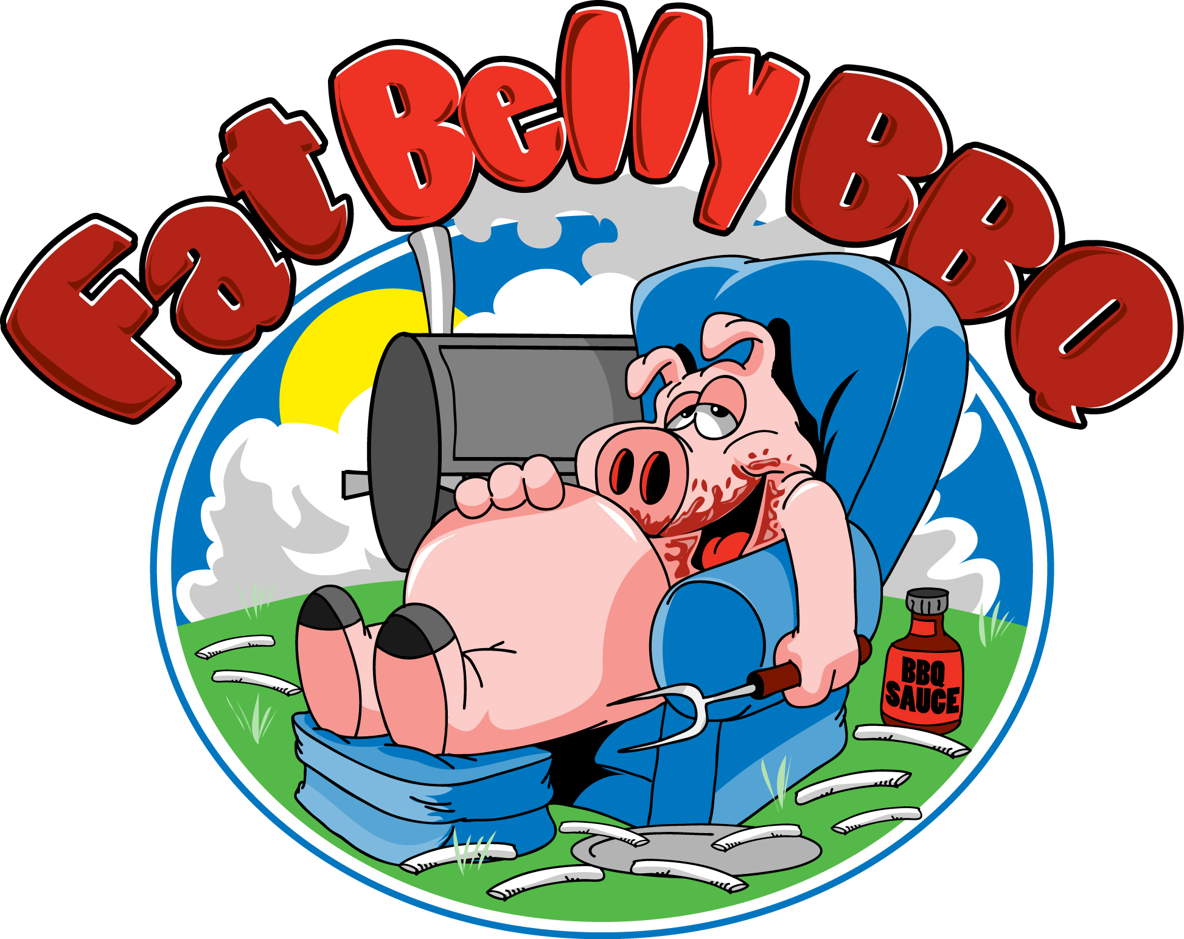
Call: (978) 476-2433
Email: BBQ711@gmail.com
kevin@fatbellybbq.com
www.fatbellybbq.com
Catering Menu
Choose 1, 2, or 3 meats and 3 sides

Pot Belly Fat Belly Belly Buster
1 meat plus 3 sides 2 meat plus 3 sides 3 meat plus 3 sides

$11.00 per person $16.00 per person $21.00 per person

Entrée must be the same for all guests in your party

Meats
♦ Smoked BBQ Pulled Pork ♦ Smoked BBQ Pulled Chicken ♦ Smoked BBQ Sausage ♦ *Smoked chopped or sliced Beef Brisket ♦ *The Pitmaster ♦ *BBQ Grilled Cheese ♦ Hot Dogs and/or Hamburgers ♦ *Smoked St. Louis Style BBQ Ribs ♦ **BBQ Beef Ribs (*add $2/ **add $3 to above prices to above prices) ♦

Sides (Additional Sides $2.00 pp)
♦ Mac & Cheese ♦ Smoked BBQ Baked Beans ♦ Fresh Coleslaw ♦ Potato Salad ♦ Macaroni Salad ♦ Veggie Pasta Salad w/ Italian Dressing ♦ Garden Salad ♦ Chips & Salsa ♦ Fries ♦ Cornbread ♦ Mashed Potatoes & Gravy ♦ Corn ♦ Green Beans ♦ *Corn on the cob ♦ *Watermelon (*available in season) ♦

Optional Menu Items (Additional $4.00 pp)
Homemade Chili, Smoked BBQ Chicken Wings, Grilled Cheese on Texas Toast, BBQ Flatbread Pizza, Texas Lollipops, Moink Balls, Veggie Burgers

Beverages
Fresh Squeezed Lemonade, Canned Soft Drinks, Bottled Water
Only $2.00 pp

Desserts
Assorted Cupcakes, Chocolate Chip Cookies or Brownies, Apple Crisp
Only $2.00 pp
Other Assorted Desserts available on request

**Prices above are for groups of 30-100 Self-Serve Buffet Style and includes set-up of buffet, rolls and/or buns, plastic or paper tablecloth, paper plates, plastic ware, napkins, serving utensils, and Barbecue Sauce.** Sterno & Chafing dishes rental included. Delivery charges may apply. On site Food Truck an additional cost. $350 minimum. All Prices subject to 7% MA Meal Tax and are subject to change. 72 hour notice is required.

FULL SERVICE CATERING: 50 person minimum, $8.00 Additional per person which includes full buffet set-up with One Server, Stainless Steel Chafing Dishes, Sternos, Fabric table cloths on buffet table. One server required for every 30 guests for 2 hours. Additional servers available @ $40/hr. Delivery charges may apply. Buffets, dining tables, chairs and tents are available from Fat Belly BBQ at an additional cost. 7 day notice is required.

