FINAL REPORT FOR 2017
ON THE CONDITION OF THE MUNICIPAL BEACHES
IN
THE TOWNSHIP OF UPPER, CAPE MAY COUNTY, NEW JERSEY
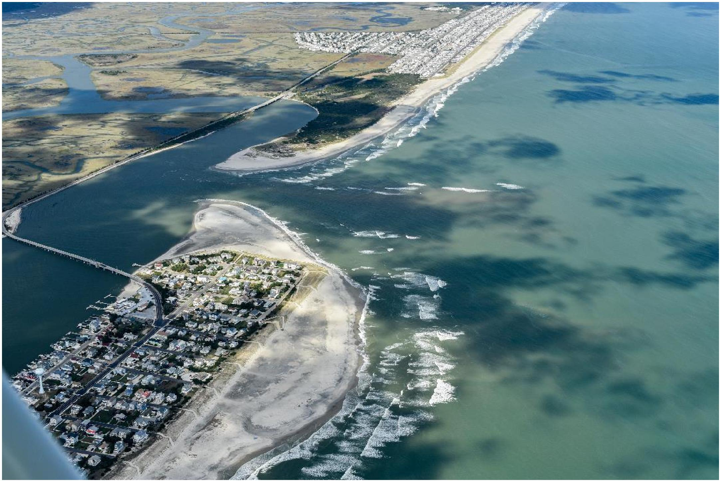
Above is an aerial view of Strathmere, taken September 29, 2017, showing the close proximity of the shoreline to the extreme northeast corner of the dune system at the northeast of the end of Seaview Avenue. There is evidence of the offshore deposits given by the waves breaking seaward of the entire northern segment of the Strathmere beach. (Photo by Ted Kingston).
PREPARED FOR: THE TOWNSHIP OF UPPER
PO BOX 205
TUCKAHOE, NEW JERSEY 08250
PREPARED BY: THE STOCKTON UNIVERSITY COASTAL RESEARCH CENTER
30 WILSON AVENUE
PORT REPUBLIC, NJ 08241
March 31, 2018

TABLE OF CONTENTS
Introduction 1
2017 Storm Activity 1
Engineered Beach Overview 1
Beach Monitoring Program Methodology 2
Figure 1. Specific Profile Site Descriptions 3
Individual Site Review 3
Table 1 Annual Sand Volume Changes December 2016 to December 2017 4
Seaview Avenue, UT-6 5
Figure 2 a-c. Photos of Survey Line UT-6 6
Figure 3. UT-6 Cross Sections 7
Williams Avenue, UT-5 8
Figure 4 a-c. Photos of Survey Line UT-5 9
Figure 5. UT-5 Cross Sections 10
Tecumseh Avenue, UT-4 11
Figure 6 a-c. Photos of Survey Line UT-4 12
Figure 7. UT-4 Cross Sections 13
Jasper Avenue, UT-3 14
Figure 8 a-c. Photos of Survey Line UT-3 15
Figure 9. UT-3 Cross Sections 16
2400 Commonwealth Avenue, UT-2 17
Figure 10 a-c. Photos of Survey Line UT-2 18
Figure 11. UT-2 Cross Sections 19
First Avenue, UT-1 (NJBPN #120) 20
Figure 12 a-c, Photos of Survey Line UT-1 21
Figure 13. UT-1 Cross Sections 22
Summary and Conclusions 23
Figure 14. March 6, 2018 Air Photograph of Northern Strathmere 24
i

Annual Report for 2017
To
The Township of Upper On the
Condition of the Municipal Beaches
Introduction
The Stockton University Coastal Research Center (CRC) surveyed the municipal shoreline quarterly, to document the annual changes for 2017. The survey comparisons provide data to evaluate seasonal shoreline and sand volume changes. The contract with Upper Township this year had the CRC continuing with the seasonal survey schedule of selected cross sections. To this end, the CRC surveyed six shoreline perpendicular transects formerly included in monitoring efforts at nine sites conducted prior to initial construction of the State and Local engineered beach project. Seasonal surveys at these six sites allow the Township to compare the as-built USACE project conditions to subsequent storm events and general changes to the Strathmere beaches independent of the USACE. Data collected at the six oceanfront beach profile locations cover the municipal beaches from Seaview Avenue to 1st Street. This coverage includes the US Army Corps of Engineers (USACE) engineered beach.
This report’s focus is on the beach system changes following completion of the USACE Ocean City to Townsends Inlet Shore Protection Project. The project initially placed approximately 1.54 million cubic yards of sand on the north end of Ludlam Island including Strathmere. An additional 4.09 million cubic yards of sand was placed on the southern Ocean City and Sea Isle City beaches. Introduction of this massive volume of sand has had a significant influence on sand budgets across this littoral system. This project was plagued by several storms during construction causing delays and re-nourishment to maintain the design beach template.
Hurricane Hermine was the first major storm to impact the project after completion. This event did not inflict major losses. Two storms, one in late January 2017 and a second on March 14, 2017 represented the worst of the winter weather. This was followed by a benign summer with beach accumulation at the majority of the sites and no passage of hurricanes of significance offshore the NJ coast. The fall was likewise relatively storm free.
Contained within the following pages of this report is a summary of the 2017 storm activity, an overview of the engineered beach, followed by the beach monitoring program methodology. Also, the annual sand volume and shoreline change table (from December 2016 to December 2017) is displayed and summarized. Photographs and seasonal cross-sections are used to show the detail within the individual site changes throughout this study period. The report closes with the summary and conclusion section on the 2017 survey cycle.
2017 Storm Activity
A northeast storm occurred January 23, 2017 on the anniversary of Jonas in 2016. This storm was less severe than Jonas and was followed by a mild event March 14, 2017, which ended the recorded northeast storms for the year. Periods of northeast winds did occur from time to time, but no coast impacting hurricanes passed by the NJ shore during 2017 in spite of catastrophic events in Texas, Florida, Puerto Rico and the US Virgin Islands. The mid-Atlantic hurricanes were distant from NJ and moving away toward the northeast and did no damage.
Engineered Beach Overview
The review below was first published in 2015, but bears repeating:
1. An initial beach nourishment project co-sponsored by the Township and the New Jersey Department of Environmental Protection (NJDEP) was completed in October 2001 that placed 461,000 cubic yards of sand on the beach.

1

- This initial project was followed by a more comprehensive joint project in August of 2009. The extent of the work ran from the municipal boundary at Corson’s Inlet State Park (100 feet north of Seaview Avenue) and extended south to the boundary with Sea Isle City. A total of 688,000 cubic yards (CY) of sand was used to construct dunes and berm on approximately 9,000 feet of Ludlam Island’s shoreline.
- Since completion of the 2009 project, there have been five Federal disaster declarations. The declarations include: November 2009 Northeast Storm (DR-NJ 1867); the March 2010 Northeast Storm (DR-NJ 1897); and a December 26, 2010 Northeast Storm (DR-NJ 1954). Following Hurricane Irene (DR-NJ 4021), there was yet another loss of 106,949 CY of sand from the Upper Township beaches. All individual disaster assessments were combined in 2011 and maintenance nourishment conducted in late fall of 2011 and completed in winter 2012.
- Hurricane Sandy had an impact on this newly completed work and resulted in another Federal disaster declaration, (DR-NJ 4086).
- This time the Ludlam Island Shore Protection Project under the control of the US Army Corps of Engineers (USACE) was implemented under Public Law 113-2. This project was authorized yet un-constructed as of Hurricane Sandy, so qualified for 100% federal funding under the congressionally approved emergency funding public funding approved by Congress in January 2013.
- Work commenced in 2015 in Strathmere and worked south toward Townsend’s Inlet.
- Northeast storm Jonas occurred January 23 & 24, 2016 and resulted in a federal disaster declaration in March 2016 (DR-NJ 4246) which allowed the USACE to return and touch-up the entire project with more sand derived from sites offshore.
The USACE project has provided over 3 million cubic yards of sand never previously present anywhere within the modern coastal zone either at the inlets or on the barrier island shoreline. This will provide a very large measure of long-term protection to this segment of the NJ coastline. There is an agreement to continue maintenance of the project for 48 additional years since its inception in 2015. The maintenance cycle will vary between 4 and 6 year intervals unless impacted by future major storms.
Beach Monitoring Program Methodology
The beach monitoring program extends back to June 1995 when the Township of Upper requested that the CRC design and establish a means to provide information on coastal zone management issues within the municipality. Initially, six sites were selected to survey and allow calculations to provide information on beach behavior. In 2009, three additional beach profile stations (UT-21, UT-31, and UT-7) were established in sections that did not have profiles to monitor sediment movement within groin compartments and along Corson’s Inlet. In 2009, it was decided to discontinue the 9 existing sites and monitor semi-annually the 200-foot spaced baseline cross sections used during construction of the 2009 Upper Township beach nourishment project to better quantify performance and meet monitoring requirements for FEMA category “G” engineered beach.
This process continued until the USACE took command of the project. FEMA always steps back from storm disaster reimbursement if the USACE is involved with shore protection projects, so the original six cross sections were resumed to provide the municipal governing body with direct information on beach performance since the USACE only monitors project annually IF funds are available. The following is a list of the surveys that are included in this report and the dates they were completed:
• | Survey 64 | February 23 & 24, 2017
• | Survey 65 | June 15 & 19, 2017
• | Survey 66 | September 7 & 8, 2017
• | Survey 67 | December 1, 2017

2

Specific Profile Site Descriptions
Figure 1 located below shows the locations of the 6 cross section locations used for this analysis.
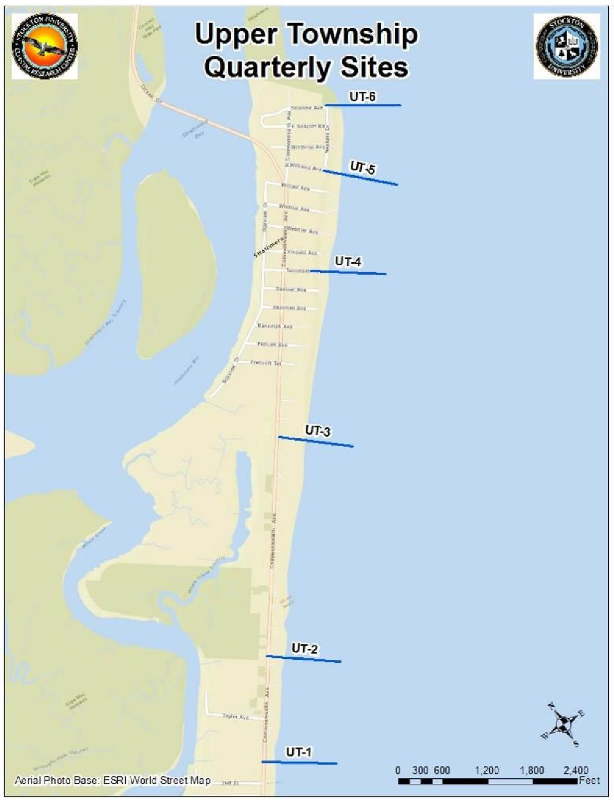
Figure 1. Locations of the 6 beach profile stations for the engineered beach in Upper Township.
Individual Site Review
Each of the six traditional survey sites is reviewed for changes in beach topography and modifications to the USACE profile established following the Jonas northeaster. Beach volume and shoreline changes were calculated from each seasonal change between December 2016 and December 2017. Photos for each site are included to show the beach conditions during specific time frames throughout the year. Table 1, below, shows the annual sand volume change at the six monitoring profile locations.

3

Table 1 - Annual Sand Volume Change at the 6 Monitoring Profiles
December 2016 to December 2017
Profile | Shoreline | Volume | Avg.Volume | Distance | Net Volume
 | Change | Change | Change | Between | Change
 | (feet) | (yds³/ft) | (yds³/ft) | (feet) | (yds³)

Southern Township Boundary
UT-1 | 11 | -3.72
 |  |  | 2.4 | 1,410 | 3,426
UT-2 | 38 | 8.58
 |  |  | 4.5 | 2,938 | 13,177
UT-3 | -25 | 0.39
 |  |  | 25.0 | 2,242 | 56,095
UT-4 | 24 | 49.65
 |  |  | -8.2 | 1,323 | -10,796
UT-5 | -166 | -65.97
 |  |  | -63.3 | 911 | -57,698
UT-6 | -34 | -60.70

Northern Township Boundary

The majority of the added sand took place along the middle of the study area at the Tecumseh Avenue site (49.65 yds³/ft.) with the vast majority of the sand being added below the zero NAVD 88 datum (44.21 yds³/ft.). At the northern boundary, the Williams and Seaview Avenue sites sustained erosional events since December 2016 with sand volume losses of 65.97 yds³/ft. and 60.70 yds³/ft. (average between the 2 profiles = -57,698 yds³/ft.). In addition, a considerable shoreline retreat of 166 feet was recorded at UT-5. For the annual comparison, the net volume change over the 6 monitoring profile stations amounted to a minimal gain of 4,204 yds³/ft.
 | Total Volume Change = | 4,204

4

◻ Seaview Avenue, UT-6
This site is located adjacent to Corson’s Inlet making it highly vulnerable to rapid beach changes from inlet dynamics and northeast storms. In 2008, extreme erosion of the inlet shoreline threatened homes that resulted with the emergency installation of a rock revetment from E. Seaview Ave. wrapping around the municipal/State Park boundary along the properties facing Corson’s Inlet. In addition to the revetment response the emergency eventually lead to the 2009 NJ State/local beachfill. Subsequent beach maintenance efforts had restored the dune and beach and prevented conditions of sand loss from reaching an emergency state.
With the federal project recently completed the dune and beach system continues to provide storm protection for the inlet and oceanfront facing properties. The beach template constructed here for the USACE project is actually narrower than the 2009 State design. As of September 2016, the dune crest elevation was at 15 feet NAVD88 and approximately 200 feet wide at the toe.
Between February and June a massive retreat occurred in the beachface location resulting in 151 feet of shoreline retreat. In addition vertical scour at the base of the beachface created an 8-foot deep pathway parallel to the beach for the tidal currents to move sand away from this segment of the shoreline. A sizable bar formed 500 feet offshore adding 43.90 yds³/ft. in new sand to the profile, but at a distance seaward to have no immediate helpful influence on the rate of sand loss at the beach.
The 151-foot shoreline retreat seen between February and June was reversed to a mere 4 feet of added retreat at the zero elevation position. An offshore trough became 350 feet narrower as well due to the advance of an enormous offshore bar coming within a hundred feet of the beachface by September 7, 2017. This bar added 57.37 yds³/ft. to the sand volume likely from that volume lost at Williams Avenue (UT-5) moved toward the inlet under the influence of southeast waves during the summer. The bar volume increase due to landward migration shows in the 34.23 yds³/ft. in far offshore sand loss seen seaward of the 1,050 foot location. This landward migration of the offshore bar continued through the December survey completely filling in the nearshore trough and adding material to the beachface. The shoreline advance at the zero datum amounted to 145 feet.

5

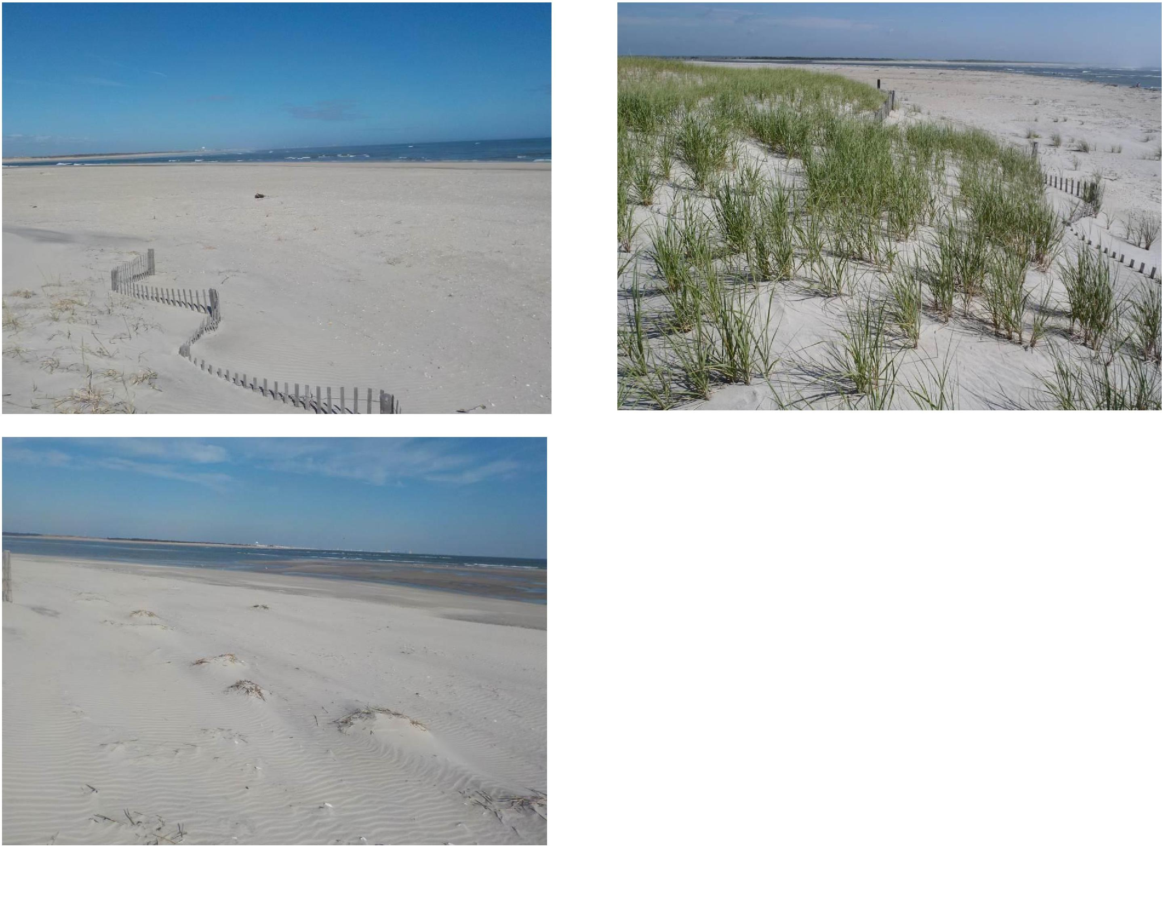
2c. December 1, 2017
2a. February 24, 2017
2b. June 19, 2017
Figures 2a to 2c. Seaview Avenue survey site. View to the north.
Photograph 2a shows the extent of the wider beach at the toe of the dunes.
Photograph 2b shows the same perspective in June with a healthy crop of dune grass present.
Photograph 2c was taken on December 1, 2017 and closest to Corson’s Inlet of the three pictures. Here the below datum sand flats are exposed at low tide.
6

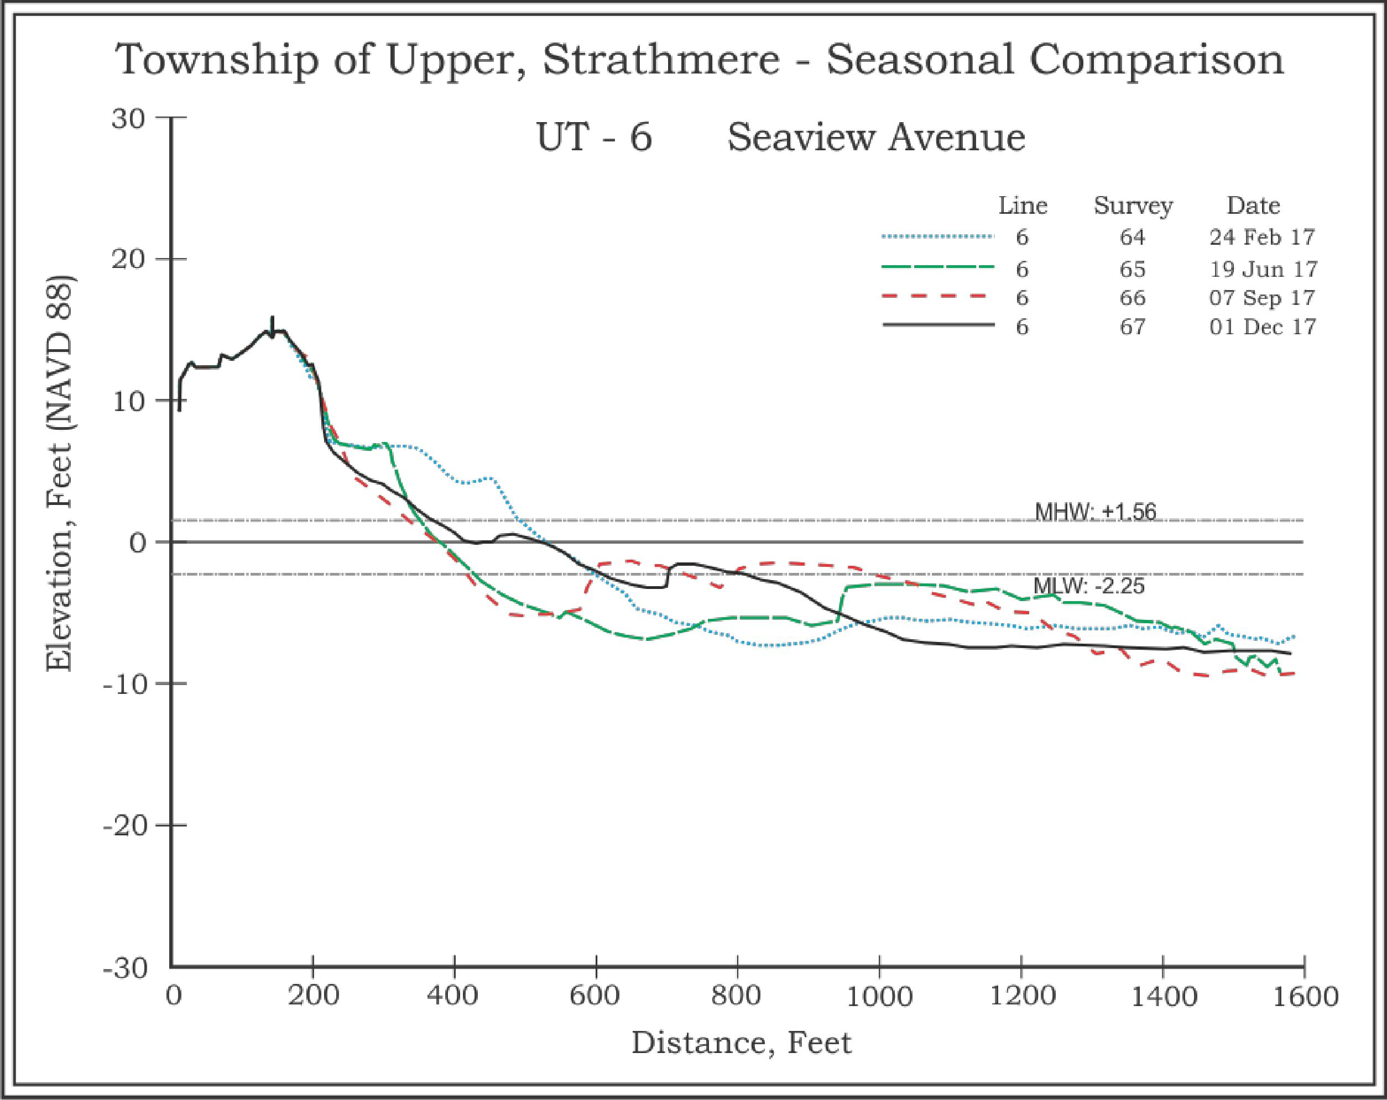
Figure 3. The first half of 2017 saw major losses in the recreational beach, beachface, and nearshore trough. This trend reversed itself by the second half of the survey year as the offshore bar continued to migrate landward, eventually welding onto the beachface by the December survey. However, from December 2016 to December 2017 the annual change was a -60.70 yds³/ft. loss in sand volume combined with a 34-foot shoreline retreat. However, during the past year, a tremendous sand volume was added offshore due to inlet current and wave refraction interactions bringing the sand to this site from the south.
7

◻ Survey Line UT-5, Williams Avenue, Strathmere
This site was initially nourished in 1984 and is located near the southern limit for direct inlet influences. The site has been monitored since 1986 as part of the NJBPN program and included in the municipal monitoring project. Sand is intermittently added to the beach in this region as tidal delta bars accumulate off adjacent ebb shoals and migrate landward under favorable conditions to attach themselves to the shoreline providing influxes of sand periodically. As a result the beach is typically wider in this location and supports modest natural dune growth.
The Williams Avenue site received limited fill volumes during the beach nourishment projects but has increased the beach width fairly consistently. Following all construction as of September 12, 2016, the beach extended 720 feet seaward of the dune toe to the MHW line with a dry recreational beach berm width of 640 feet. More recently this width has been reduced to a dry beach width of 475 feet between the dune toe and the berm crest.
Between June and September this year, the site reversed this process and lost 135 feet of dry sand beach as the beachface became very steep and a deep trough appeared immediately offshore. A small bar was moving landward at the 960-foot distance from the reference point. This feature added 18.93 yds³/ft. in sand volume well offshore. Very little sand added to the berm and dry beach over the summer leaving the beach retreat as the dominating feature. This zone alone lost 36.98 yds³/ft. split between the area above the datum (-12.12 yds³/ft.) and the offshore region (-24.86 yds³/ft.). Minor changes elsewhere reduced this big loss by a few additional cubic yards per foot (-28.90 yds³/ft.). The final quarter of 2017 marked the landward migration of the offshore bar material. The result was a filling in of the nearshore trough that was cut out over the summer months as well as an elevation increase in the berm.

8

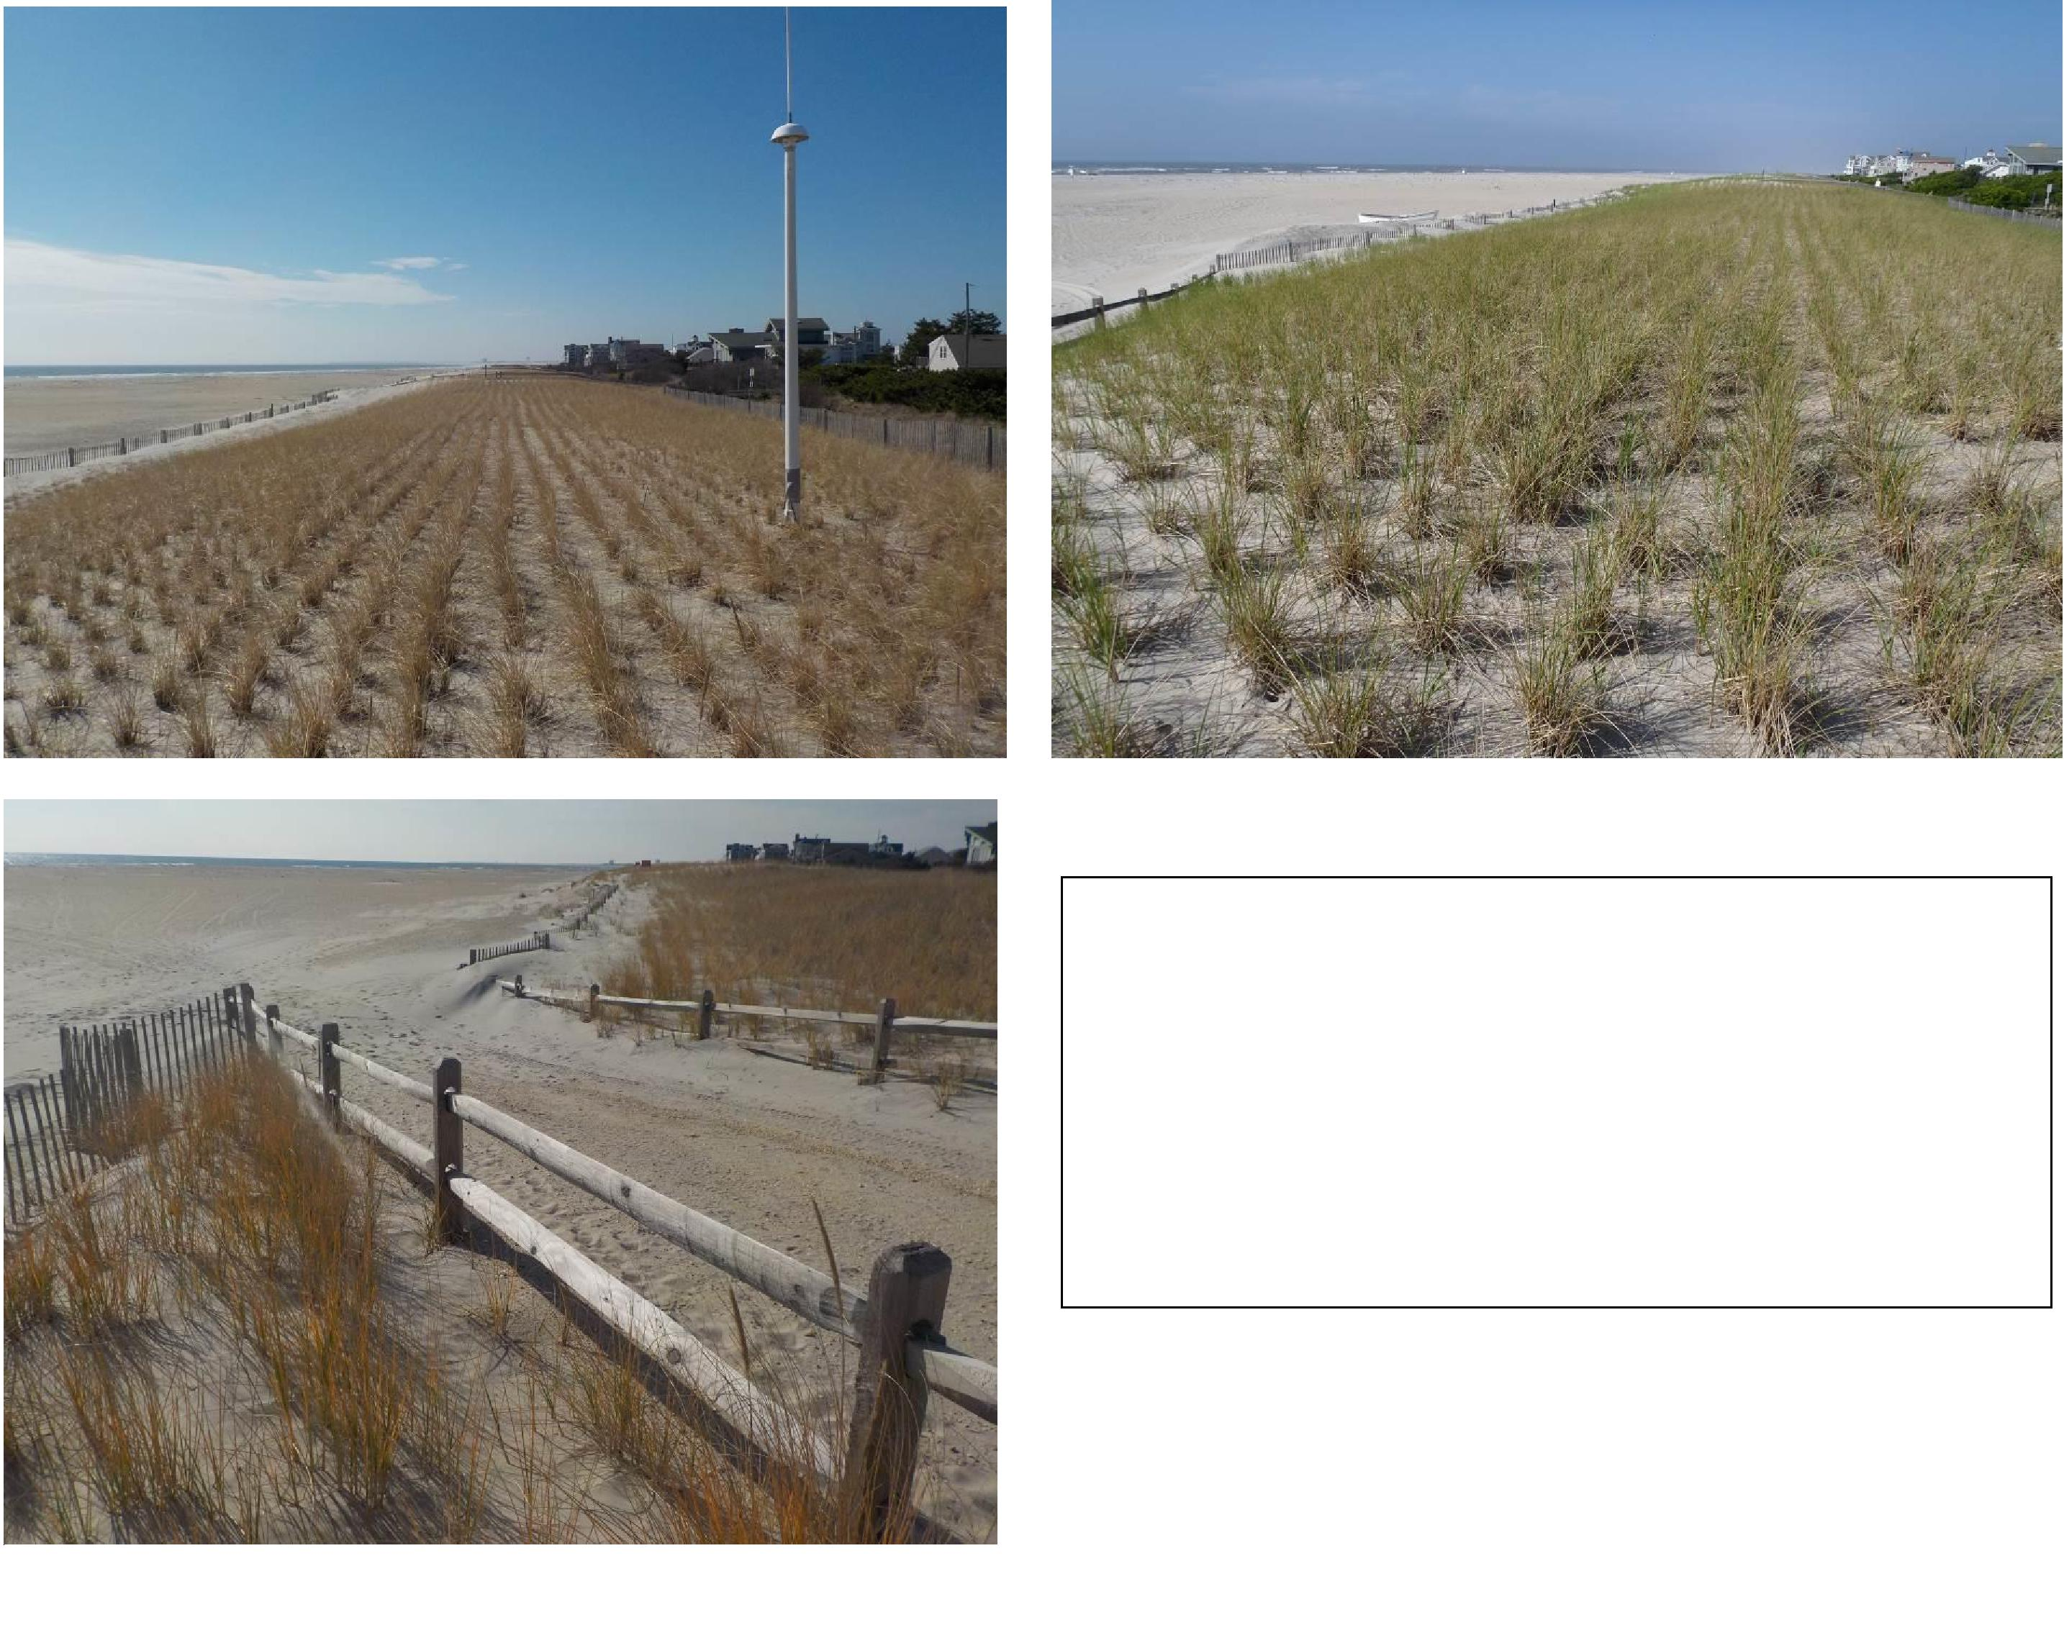
4a. February 23, 2017 4b. June 19, 2017
4c. December 1, 2017
9
Figures 4a to 4c. UT-5 survey site on Williams Avenue.
Figure 4a shows the winter beach from the seaward dune crest perspective.
Figure 4b was taken in June looking south from the dune.
Figure 4c shows the recreational beach at the accretional dune toe position looking south.

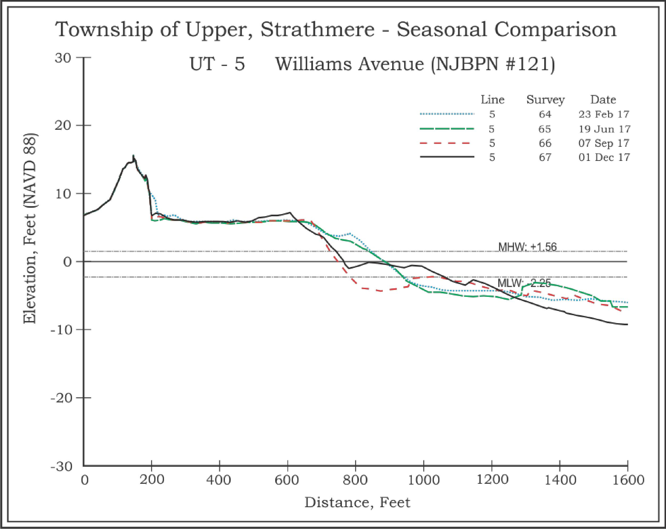
Figure 5. This site lies just south of the influence of the ebb-tidal delta for Corson’s Inlet, but not beyond the accretion generated by sand moving landward. Considerable losses in the beachface and nearshore regions were recorded between June and September 2017. However, the landward migration of materials had all but filled in the scour trough by December. Unfortunately, this was not enough as the annual comparison yielded a loss of 65.97 yds³/ft. while the shoreline retreated 166 feet.
10

◻ Survey Location UT-4, Tecumseh Avenue, Strathmere;
This profile location was established because the shoreline dynamics radically changed between Williams Avenue and Jasper Avenue sites due to the proximity of the Williams site to the ebb-tidal shoals of Corson’s Inlet. Jasper Avenue performs as any mid-island beach usually does with losses mainly directed toward the south with cross-shore sand distribution the major component of change. Tecumseh Avenue lies mid-way between the two different beach configurations and was surrounded by obsolete timber bulkhead and timber groin arrays. These structures had been installed during a past history of shoreline retreat that demanded their installation. Today, these decayed structures are basically buried in the beach project sand.
The USACE sponsored beachfill was completed by July 2015 which significantly extended and elevated the dune and beachface seaward. The berm and upper beachface began to show signs of erosion by November 2015. The USACE’s return to pump sand following NE Storm Jonas shows as a 106-foot advance in the berm position seaward due to the addition of 61.39 yds³/ft. in sand volume. Since June 2016, two subsequent surveys show marginal changes in either the sand volume or the shoreline position (Sept. 2016 to Dec. 2016 = -17.31 yds³/ft. and a retreat of 15 feet in the zero elevation position.
Over the 2017 year, Tecumseh Avenue gained 5.44 yds³/ft. above the zero datum, and also gained 44.21 yds³/ft. below the datum as sand was added from offshore between 1,000 and 1,400 feet from the reference. The shoreline gained over 24 feet from December 2016 to December 2017.

11

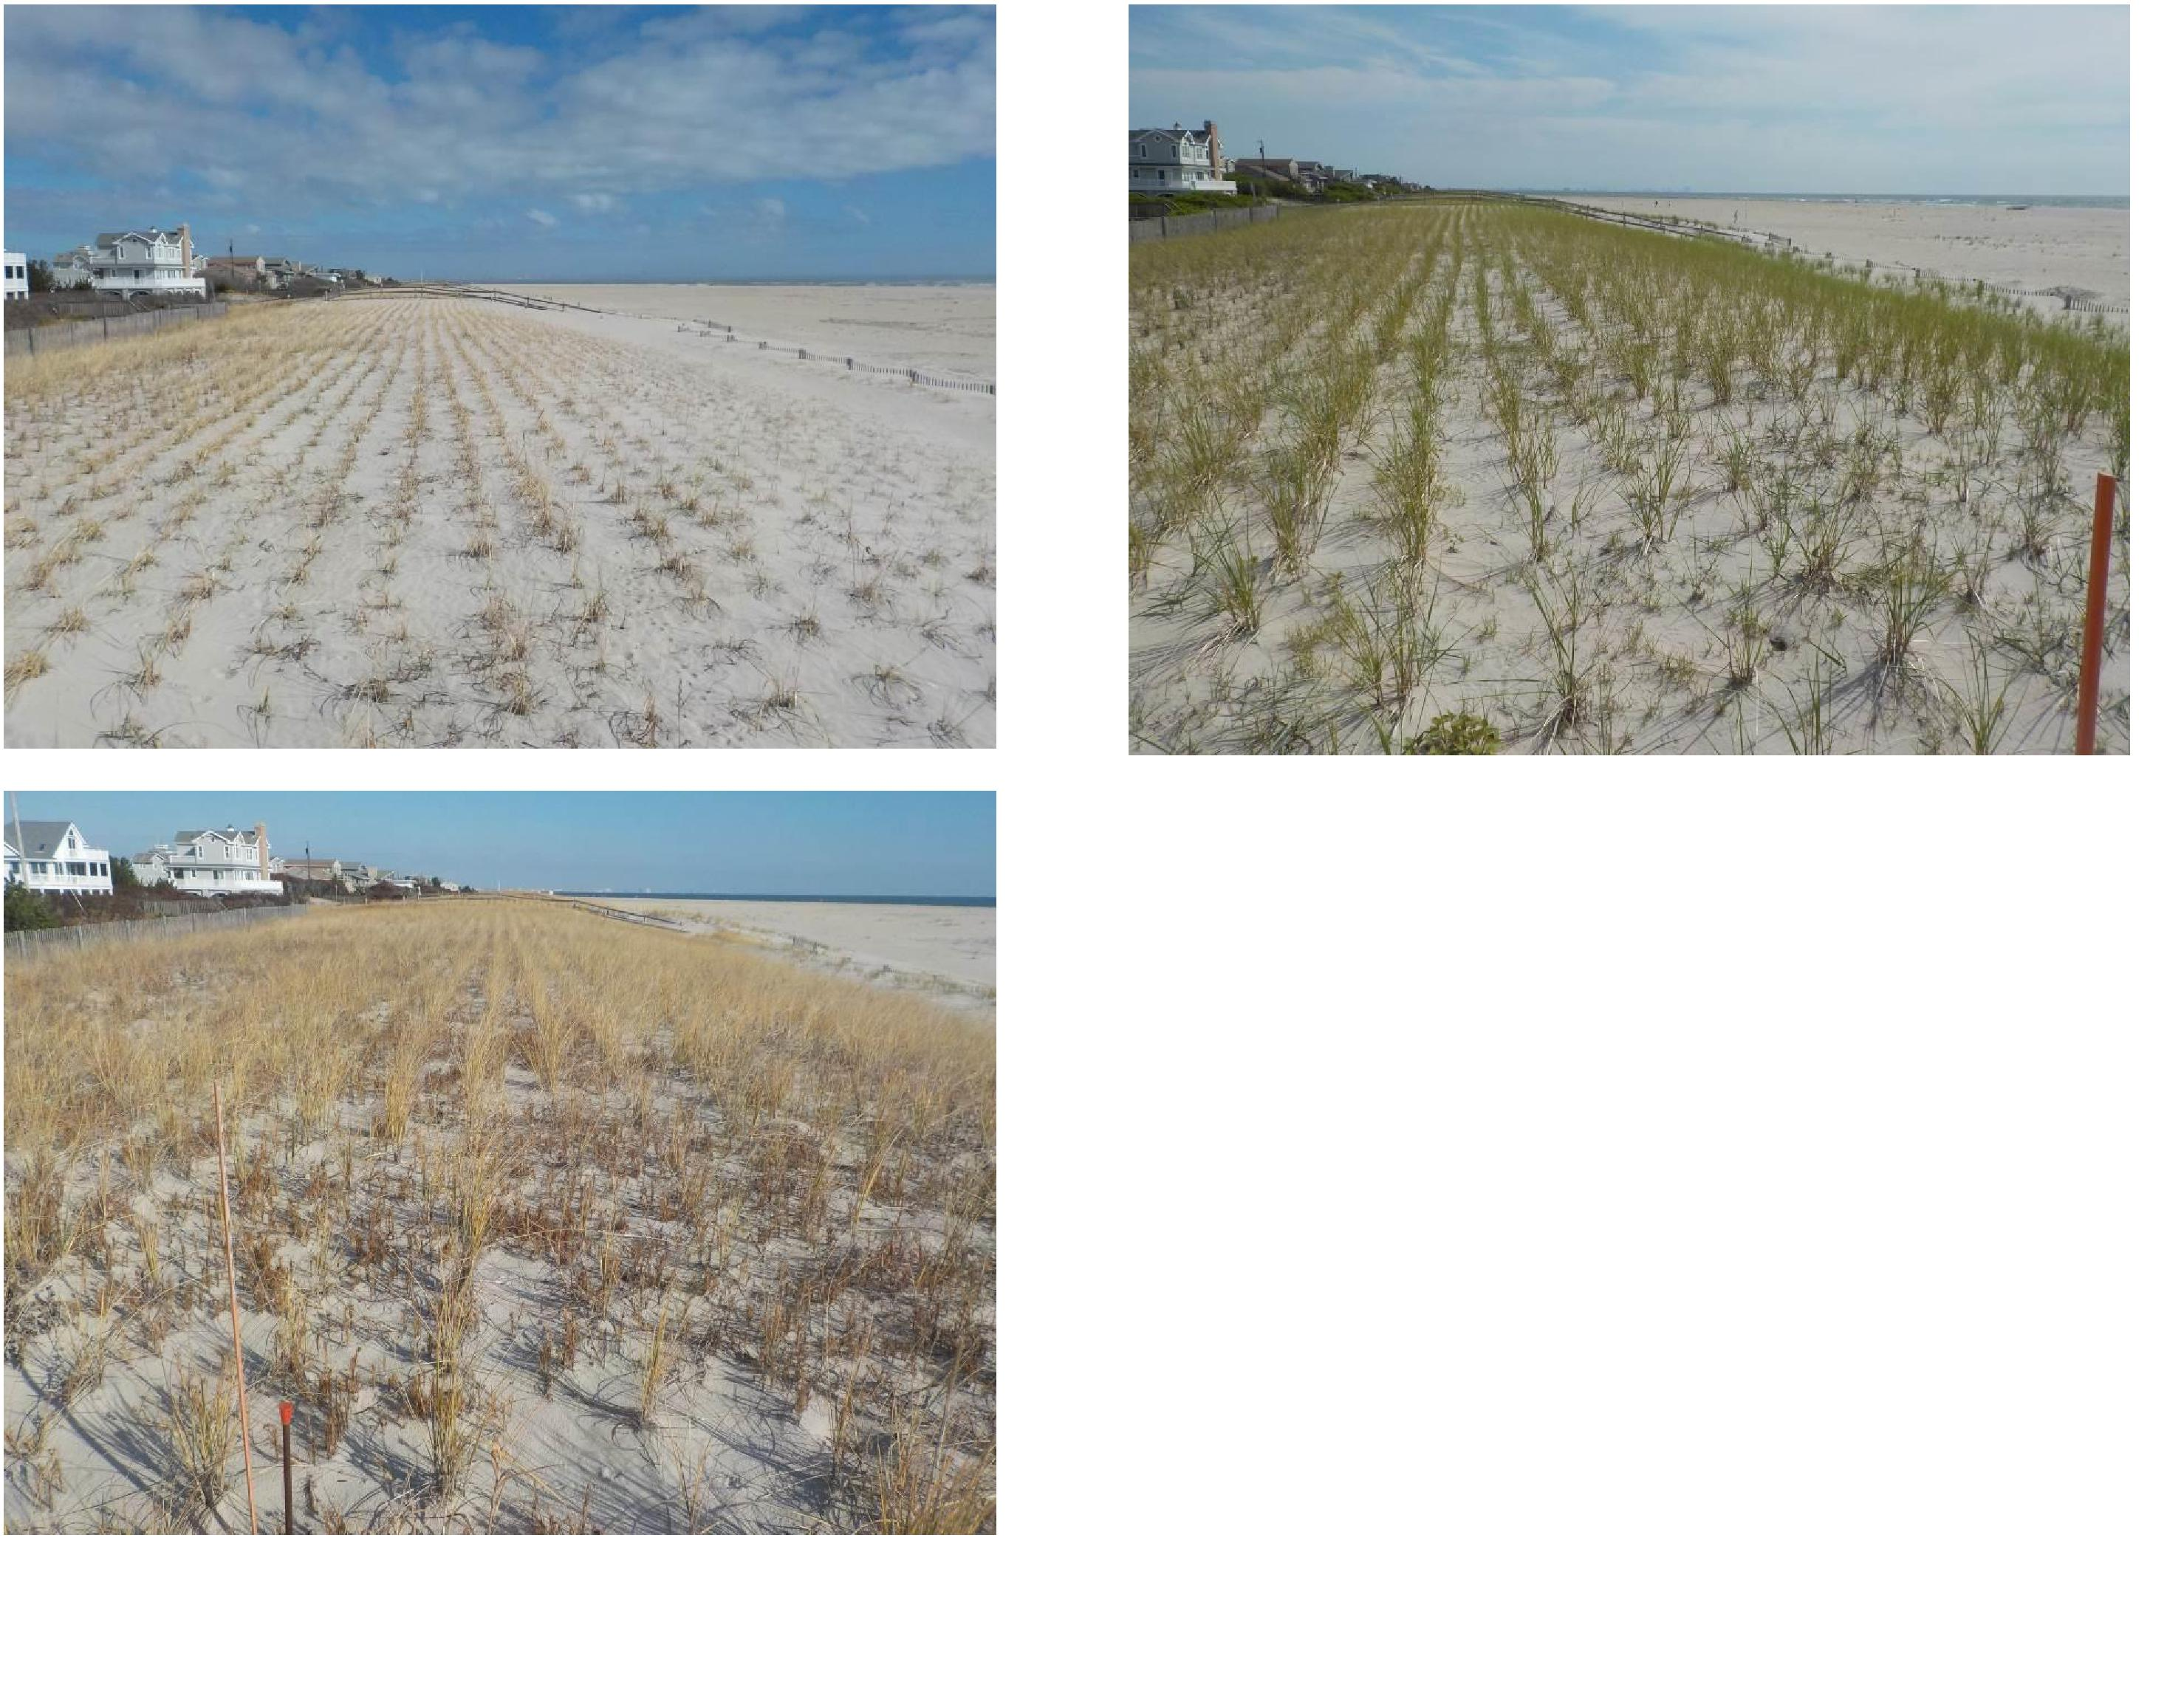
Figure 6a. February 24, 2017
Figure 6c. December 1, 2017
Figure 6b. June 15, 2017
Figure 6a is a view to the north along the dune crest during the winter.
Figure 6b shows the planted dune grass and stable recreational beach during the summer.
Figure 6c shows the same perspective by December 2017 fencing along the dunetoe virtually completely buried by accretional sands.
12

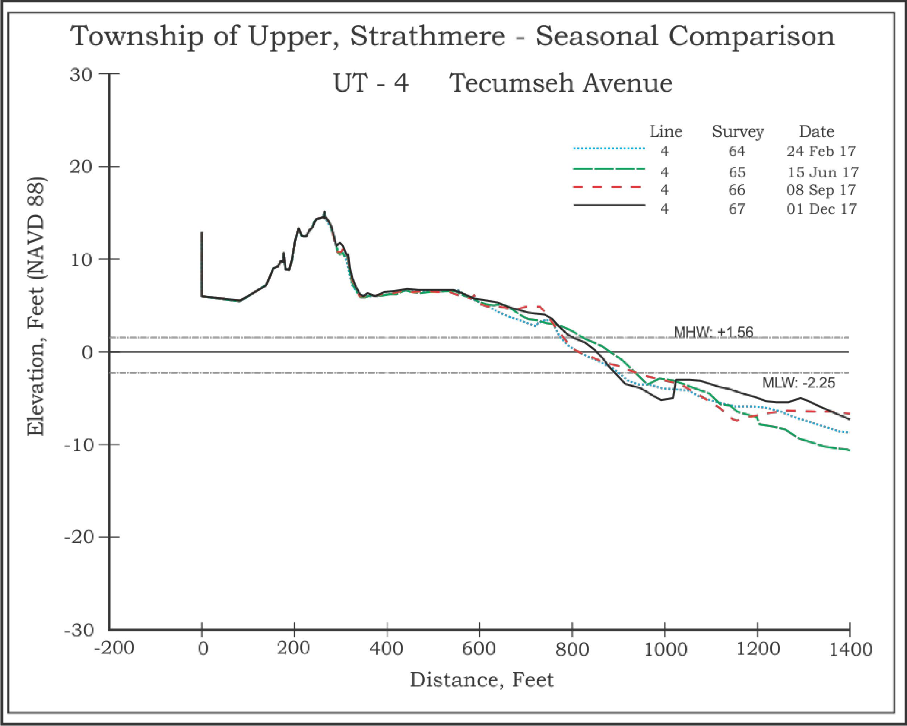
Figure 7. The dune and recreational beaches displayed no major changes in 2017, adding only minor sand to the foredune. The berm region fluctuated seasonally with its highest elevation recorded in September. The offshore bar showed a series of landward migrations to the nearshore and beachface. The annual comparison yielded a 49.65 yds³/ft. gain and a shoreline advance of 24 feet.

13

◻ Survey Line UT-3, Jasper Avenue, Strathmere;
Jasper Avenue is the first of three sites located along the traditional part of the island known as “Whale Beach”. This segment has been notoriously narrow and subject to repeated overwash to the bay. Storms through the 1990’s breached the dune here four times resulting in serious damage to a group of homes built east of Commonwealth Avenue immediately north and south of Jasper Avenue. Since the 2001 NJ State and local beach project, the situation has improved dramatically. Hurricane Sandy did not penetrate the dunes largely because of a final NJ State/local project in 2009.
By July 2015, the USACE sponsored beachfill was completed which elevated and extended the berm position seaward nearly 250 feet. Following June of 2016 the USACE had completed storm restoration and by September 2016, the beach extended 450 feet seaward from the dune toe to the MHW line.
Throughout the first 3 surveys conducted in 2017 the entire profile remained relatively consistent in topography. The minor exceptions were gains in the berm by September and the offshore bar gaining material and elevation by June that remained through September. However, by the December survey losses occurred in the beachface and offshore bar. The nearshore scour trough did record an elevation increase. For the annual comparison, the above datum losses amounted to -2.78 yds³/ft. and below datum gains were recorded as 3.17 yds³/ft.

14

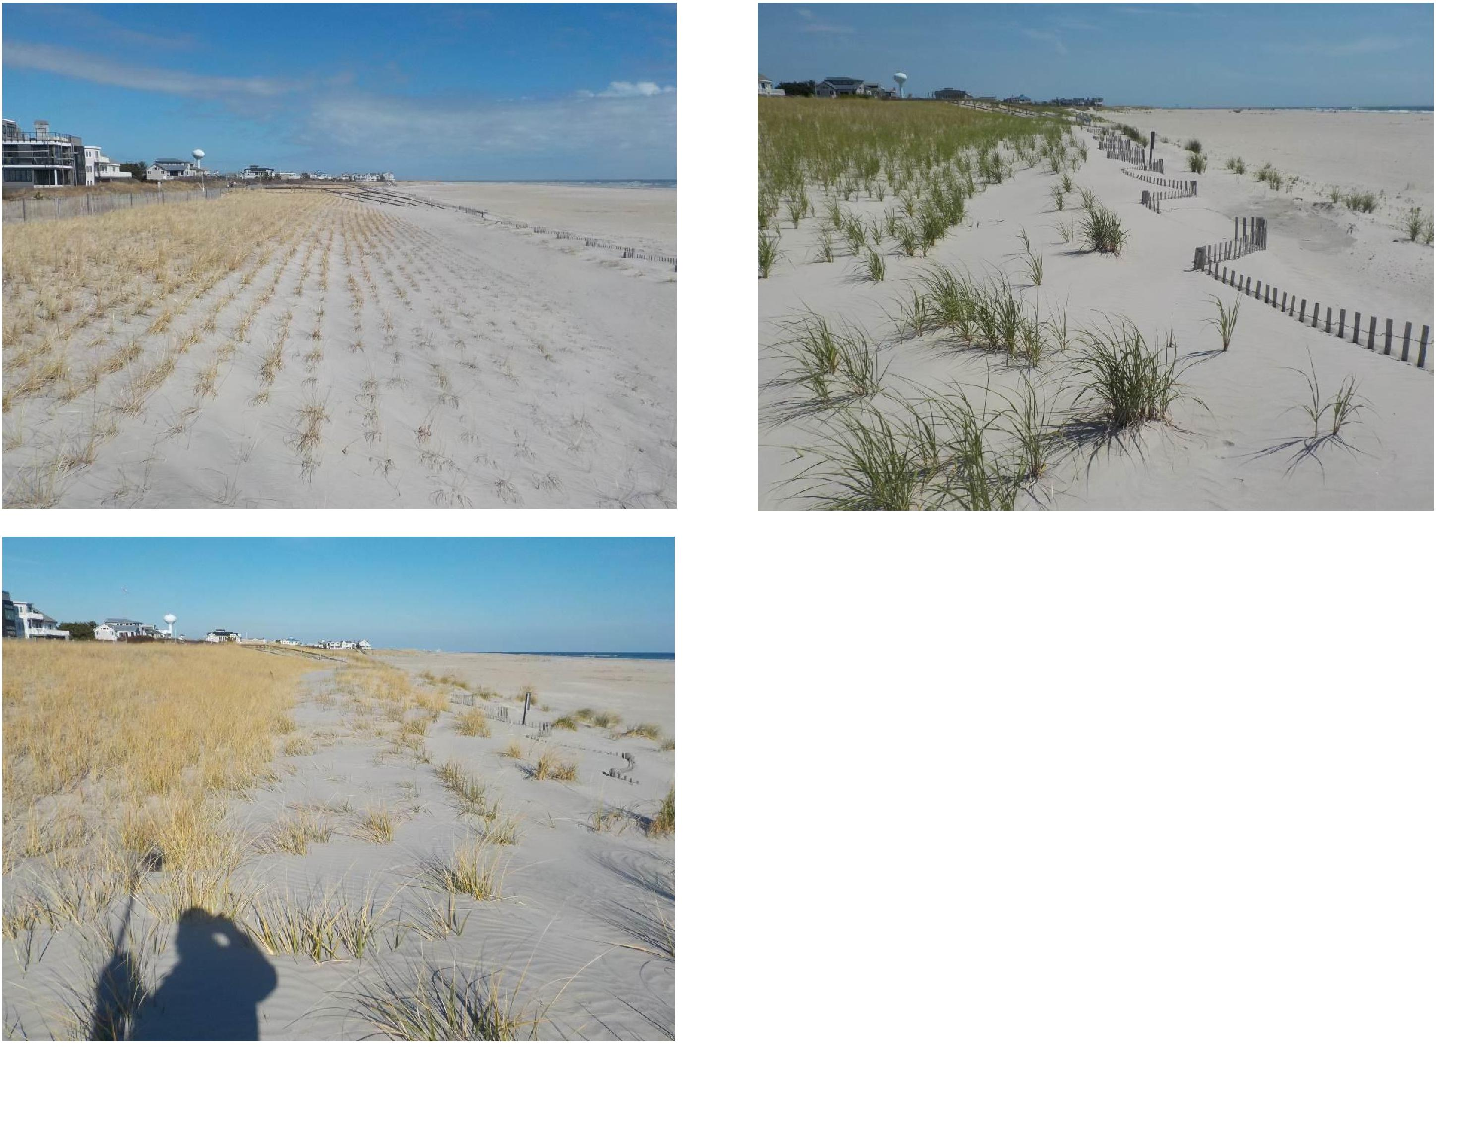
8a. February 24, 2017
8b. June 15, 2017
Photo 8a is a view to the north along the dune crest during the winter. The tops of the foredune fence are exposed at this time.
Photograph 8b shows the view to the north taken from the foredune perspective.
Photograph 8c shows the deposit at the foredune fence in one year. The foredune has built up to the point where it shows below on the cross section.
8c. December 1, 2017
15

Figure 9. At Jasper Avenue the berm crest developed at the seaward edge of the dry beach with an offshore bar in September similar to that measured in June. The shoreline retreated 25 feet for the year and negligible volume gains of 0.39 yds³/ft. were recorded.
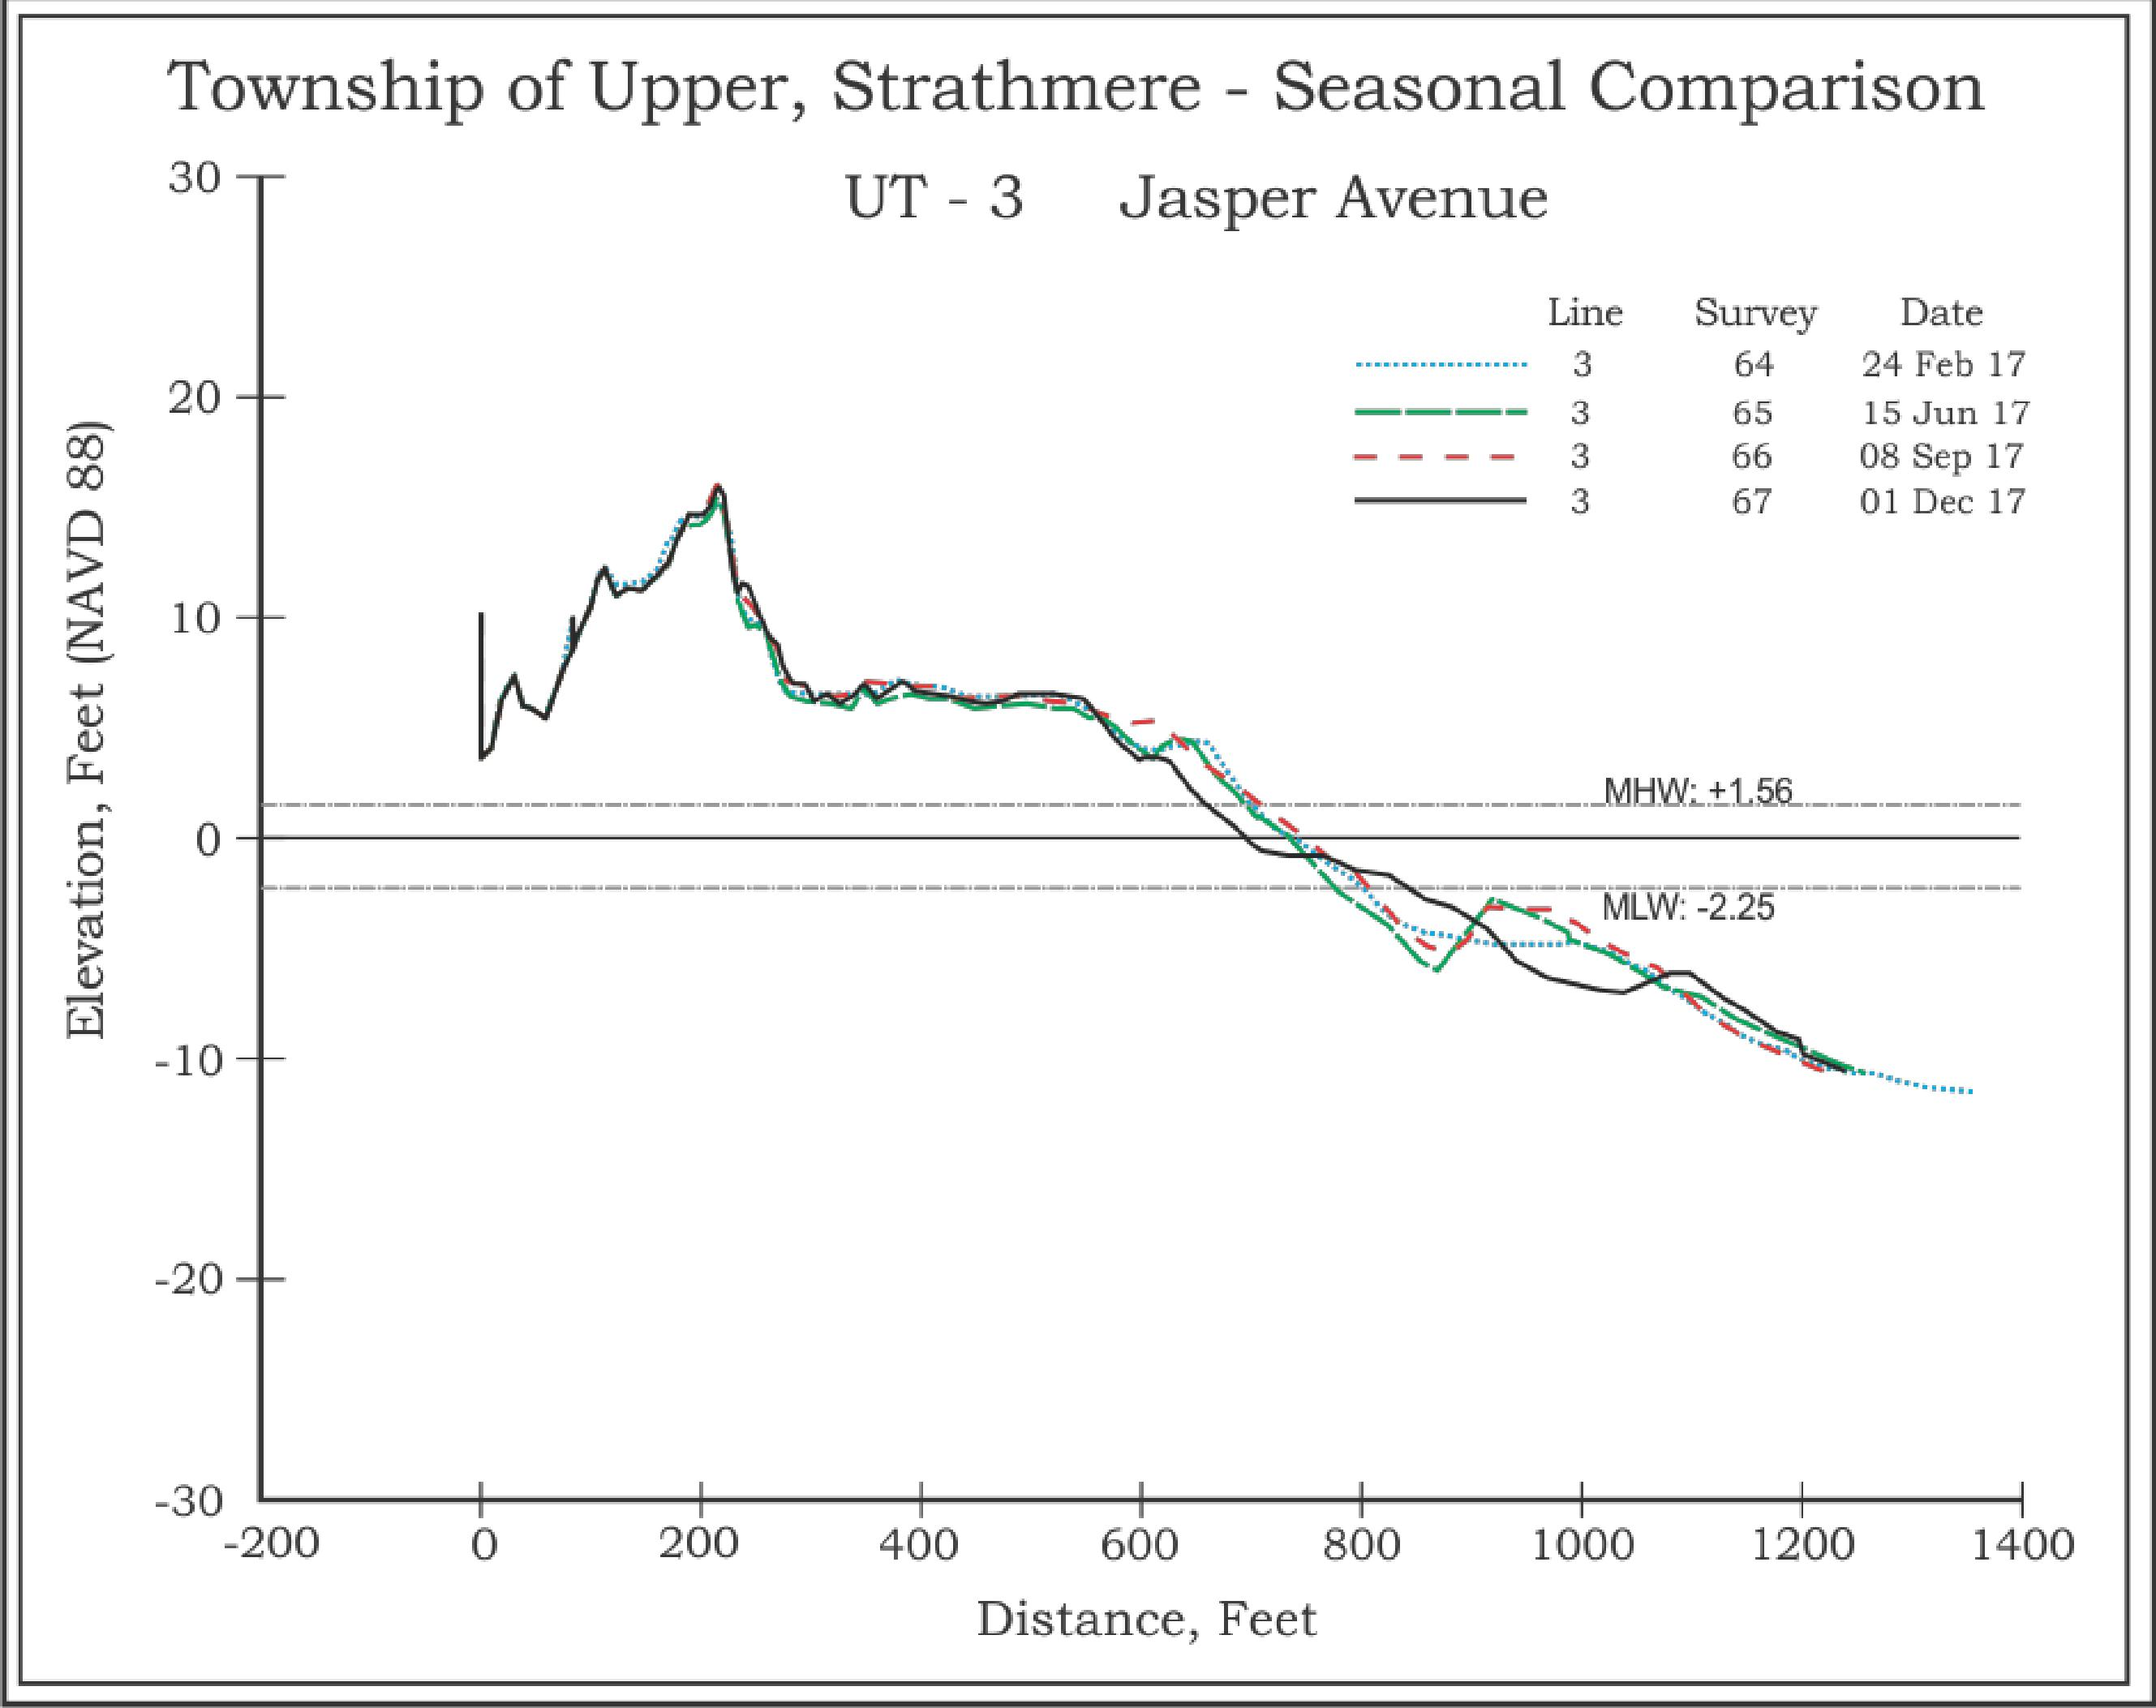
16

◻ Survey Line UT-2, 2400 Commonwealth Avenue, Strathmere;
This site is located directly seaward of the residence at 2400 Commonwealth Avenue in the southern segment of the Strathmere shoreline. This region has been more resilient than First Avenue with no documented episodes of dune breaching or overwash during the CRC monitoring for the Township. The state, local and federal beach nourishment efforts have significantly enhanced the beach and dune. Current dune crest elevation is 15 feet NAVD 88 and 160 feet in width at the toe. The beach extends an additional 300 feet seaward from the dune toe to the MHW line and the beach berm crest is maintained at 6 feet NAVD 88.
The USACE sponsored beachfill was completed by July 2015 which significantly extended and elevated the dune and beachface seaward. The berm and upper beachface showed signs of erosion by November 2015. The restoration was complete by June 2016 with a wider beach and an added 56.01 yds³/ft. placed at the site. The dune gained sand at the seaward toe while offshore little change occurred for the remainder of the 2016 survey year.
Between February and June this site saw very minimal changes gaining just 0.79 yds³/ft. above zero while losing 1.05 yds³/ft. below zero; however, the shoreline advanced 21 feet. By June 2017, the offshore bar moved landward adding to the sand supply near the shoreline. Between June and September, the site saw an addition of sand to the berm crest and to the beachface slope. Material added to the offshore bar as well. The offshore bar sand migrated landward by the final survey of 2017, elevating the nearshore scour trough.

17

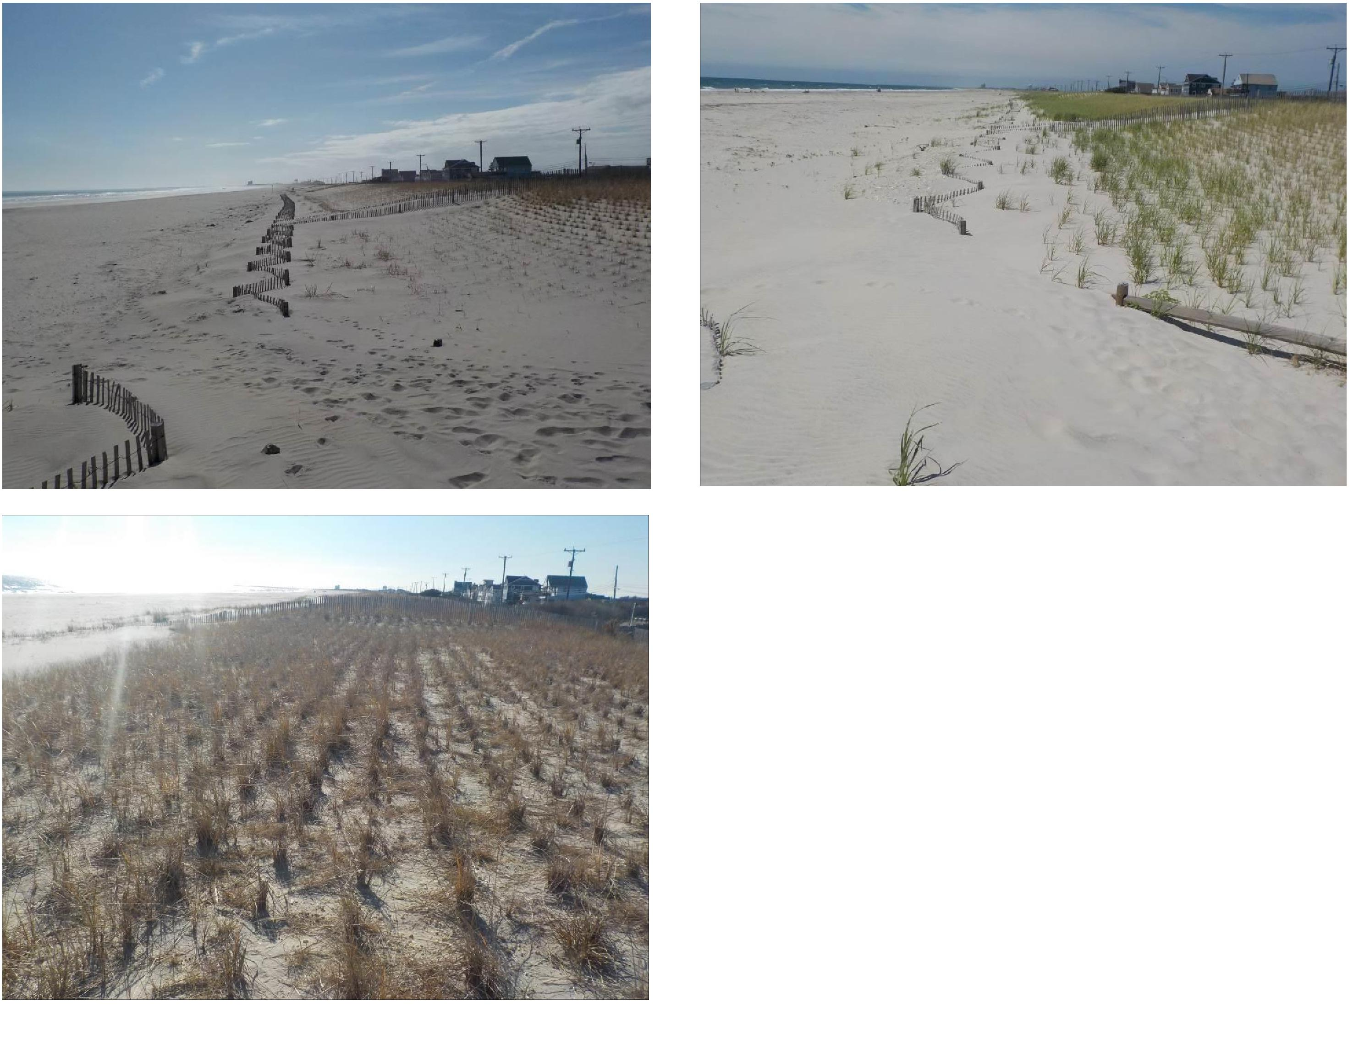
Figure 10b. June 15, 2017
Figure 10a is a view to the south along the dune toe displaying the growth of sand around the beach fencing and the recently installed dune vegetation.
Photograph 10b shows the dune toe in June with a substantial deposit of wind transported sand added at the fence. The plants are doing well with root extensions migrating seaward.
Photograph 10c is a view to the south along the seaward dune crest displaying the overall width of the heathy dune system. The foredune fence has enhanced this system by continuing to add wind transported sand.
10c. December 1, 2017
10a. February 24, 2017
18

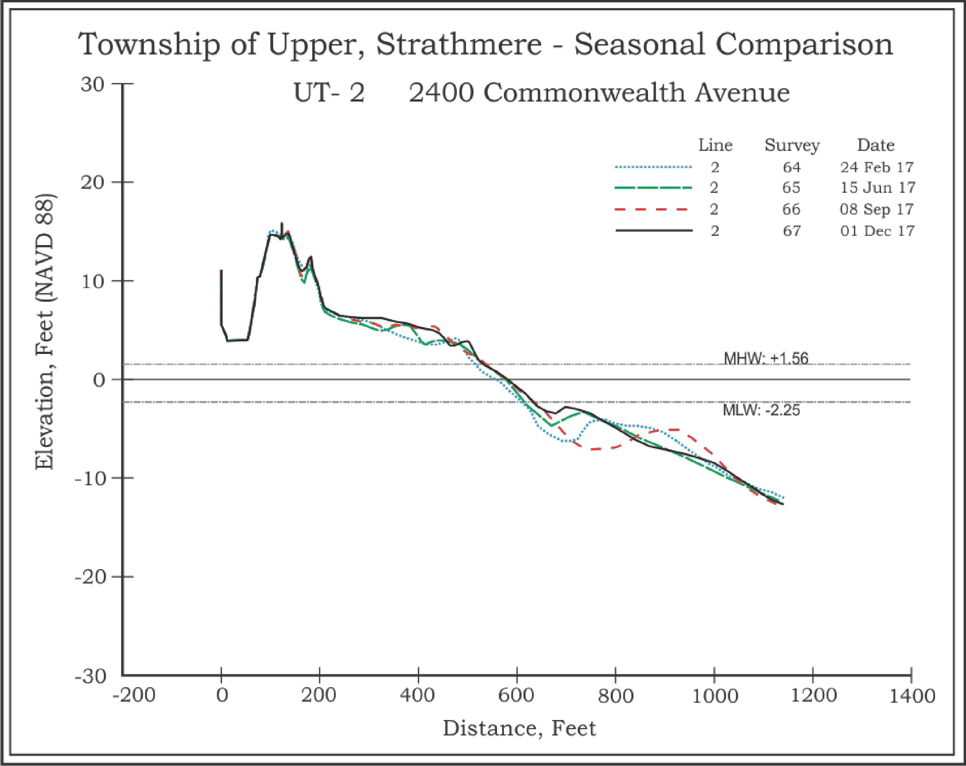
Figure 11. These cross sections display the growth of the foredune through wind transported material. The recreational beach and beachface have also
shown growth over the year. The final survey in December documents the landward migration of the offshore bar. For the year this site gained
8.58 yds³/ft. of sand and the shoreline advanced 38 feet.
19

◻ Survey Line UT-1, First Street (NJBPN #120), Strathmere;
This profile site is actually a few yards inside Sea Isle City, but was established in 1986 for a NJ State beach monitoring program. Acting as the southernmost site in Upper Township, this location was initially one where overwash could be expected during any moderate northeaster. In fact, the segment to the south of the site was so persistently over-washed, that the County undertook the installation of 10-foot diameter geo-textile tubes as dune core along 2,400 feet of the beach into Sea Isle City. Sandy made small breaches in the feature focused on the joints between the 300-foot long tubes. Sand was stripped off the crest of the tubes, but they did perform the best of any dune core yet constructed largely due to a 30-foot wide apron installed seaward of the geo-textiles as a deterrent to wave undermining of the large diameter geo-tubes. This apron had a small foot-diameter toe sock added to its seaward edge, filled with sand to hold the apron in place during periods of storm exposure to wave action.
The USACE sponsored beachfill was completed by July 2015 which significantly extended and elevated the dune and beachface seaward. The berm and upper beachface showed signs of erosion by November 2015. The restoration was complete by June 2016 with a wider beach and an added 26.86 yds³/ft. placed at the site. The dune gained sand at the seaward toe while offshore bar position shifted among the latest three profile surveys. The September position was closer to shore and higher in elevation, but the bar returned to an identical configuration to that seen in June by the December survey.
A substantial berm crest ridge developed this summer and the beach accumulated some sand resulting in a 4-foot advance in the shoreline position. Offshore, the volume gain equaled the onshore sand volume gain (7.06 yds³/ft. onshore versus 7.09 yds³/ft. offshore) as material accumulated on the offshore bar and on the beach side of the trough between the beach and the bar. Like the site to the north, the offshore bar formation shifted landward elevating the nearshore scour trough and adding sand to the berm region.

20

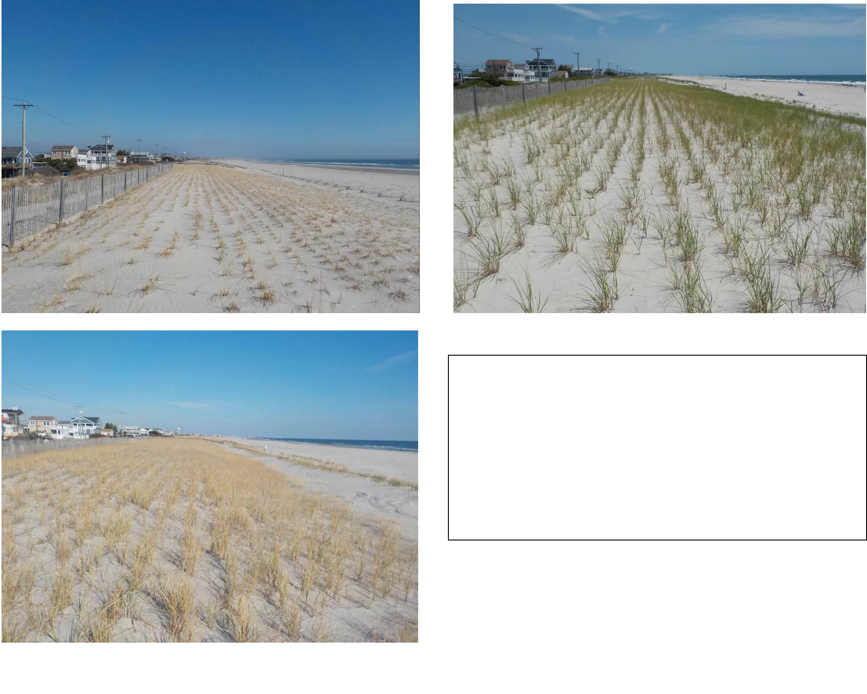
12a. February 23, 2017 12b. June 15, 2017
12c. December 1, 2017
21
Photograph 12a shows the dune fencing at the landward crest and seaward base of the USACE dune.
Photograph 12b shows the dune with grass plants and the deposition of wind transported sand covering the top of the 4-foot fence.
Photograph 12c provides the winter view to the north across the dune and onto the beach. The fence continues to be increasingly buried in new sand added to the dune toe.

Figure 13. Overall, this site remained relatively stable throughout the 2017 survey year. The annual changes recorded were a shoreline advance of 11 feet with cumulative volume losses of -3.72 yds³/ft. The recreational beach and berm both widened during this timeframe and additional sand was added to the seaward dune crest.
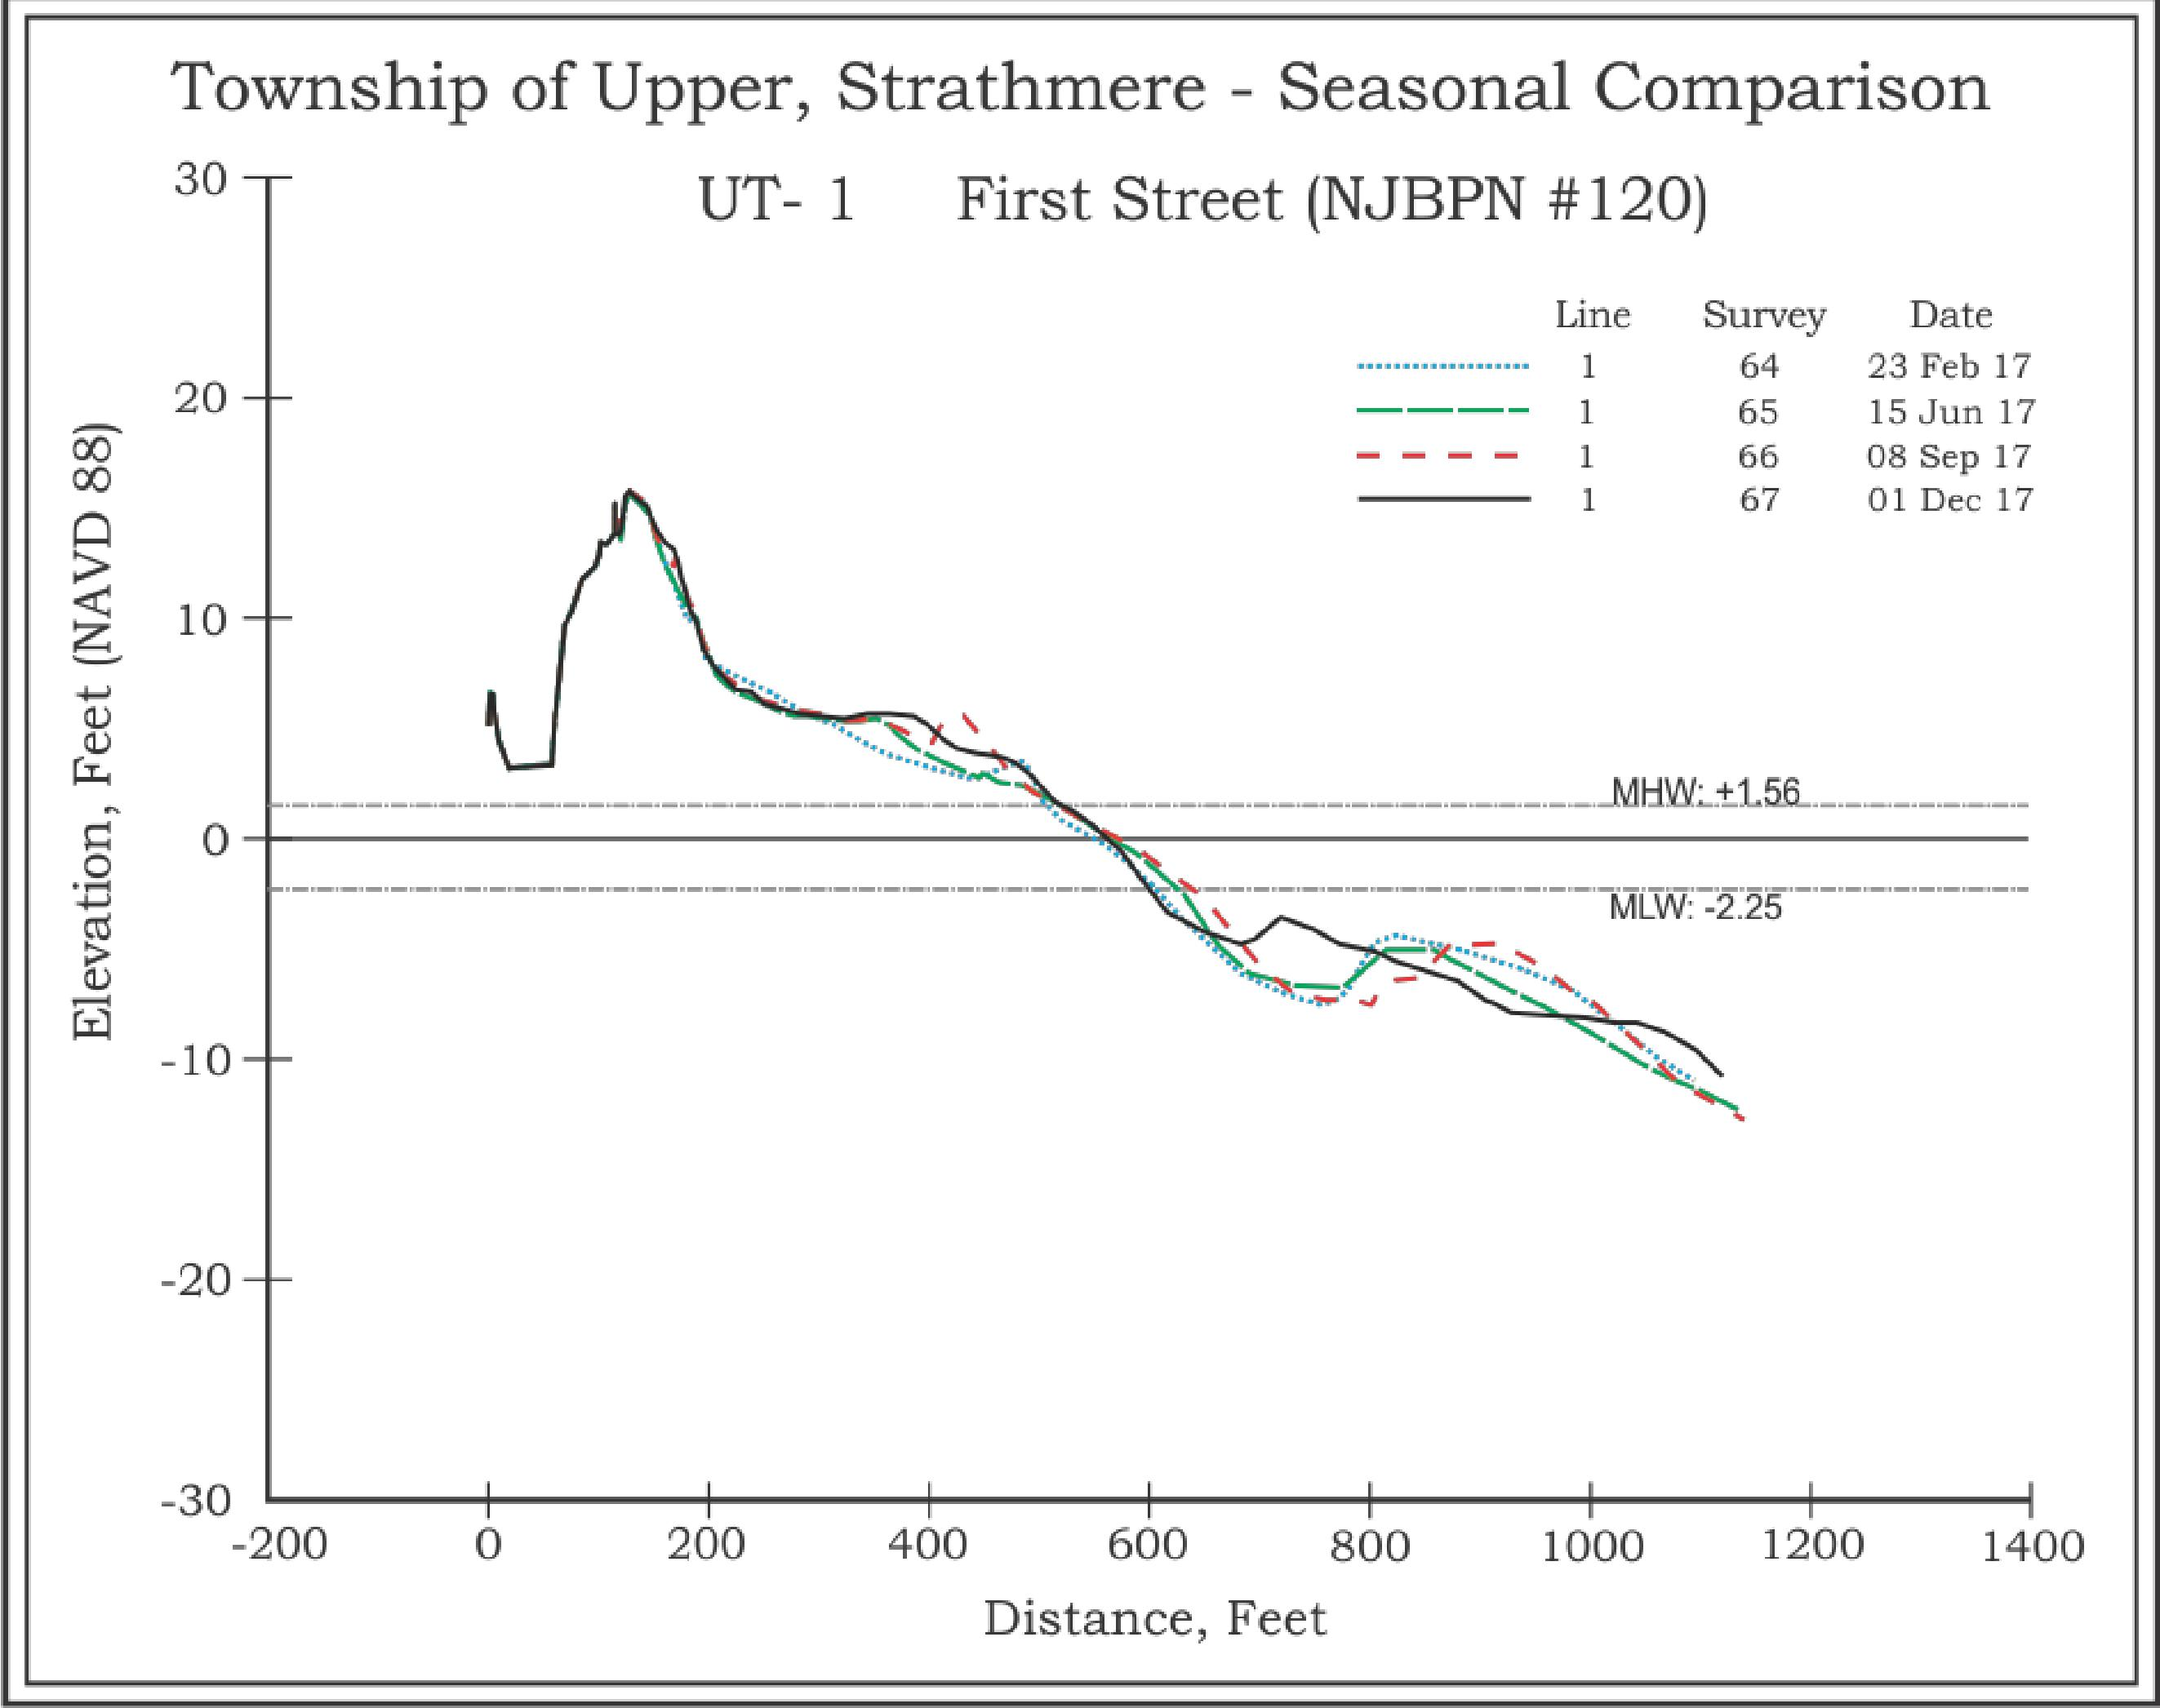
22

Summary & Conclusions
The federal project placed approximately 1.54 million cubic yards of sand on the north end of Ludlam Island, including the Strathmere oceanfront beaches. The USACE returned (following the 2015 federally sponsored US Army Corps of Engineers beach nourishment projects completion in Strathmere) to repair the storm damage from Jonas with sand derived from Corson’s Inlet ebb-tidal delta borrow zone. The restored beaches continued in as-repaired condition into 2017 with minimal changes seen as of the December 2016 survey. A one year Jonas anniversary northeast storm occurred January 24, 2017 without significant impact.
By mid-year 2017, the northernmost site at Seaview Avenue has rapidly fallen into an erosional state similar to that seen in years past. A site visit by Dr. Farrell on July 14, 2017 found that there was a 3-foot vertical scarp in the berm aligned with the channel in the immediate offshore allowing tidal flow ready access to the beachface and when combined with wave activity produces sand transport southeast toward Williams Avenue on an ebb tide and into the inlet channel during a flood tide. Public works personnel were moving sand onto the active beachface by pushing berm material over the scarp and onto the beach. It was suggested that instead of grading the scarp off as a linear feature, the sand should be pushed out onto the beach in lobes to create an irregular shoreline that would have two beneficial effects:
- The irregular shoreline would impede tidal current flow in either direction slowing sand scouring
- The irregular lobes on the beach would force the waves to break in irregular fashion and interfere with each other depositing sand from the lobes into the bays between sand lobes. The wave energy would be less along the beach and slow this process until the bar, at the time 361 feet from the zero elevation position gets closer reducing the tidal flow against the beachface
Over the past summer and into the fall, the Strathmere beaches reacted to mild wave conditions by adding sand to the beach from offshore except for the site at Williams Avenue which retreated significantly. However, the Seaview Avenue site did not lose sand volume during this timeframe in spite of a beach retreat that moved the break in slope almost to the toe of the dunes. The site gained a large volume of sand offshore as two bars combined to reach within 150 feet of the zero elevation position on the beachface. Above the zero datum, this site did lose 9.14 yds³/ft. from the beach, but gained 19.52 yds³/ft. offshore. The beachface retreat was just 9 feet from the June survey position of the zero elevation point.
Inlet tidal dynamics continue to play a significant role in shoreline stability in the vicinity of the Seaview Avenue site. On the Strathmere side, erosion occurred concentrated at the end of Seaview Avenue along the Park beach into the inlet channel. The high rate of loss to the Seaview Avenue site has slowed as of the September survey as sand from Williams Avenue appears to have moved north as offshore bars. The December survey showed that this beach has become wider as the sand added to both the shoreline and nearshore regions. As of the writing of this report, the first three months of 2018 have seen multiple individually minor northeast storms with a combined impact that shows in Mr. Kingston’s aerial photography. We include his most recent view of the northern Strathmere beach as of March 6, 2018.

23

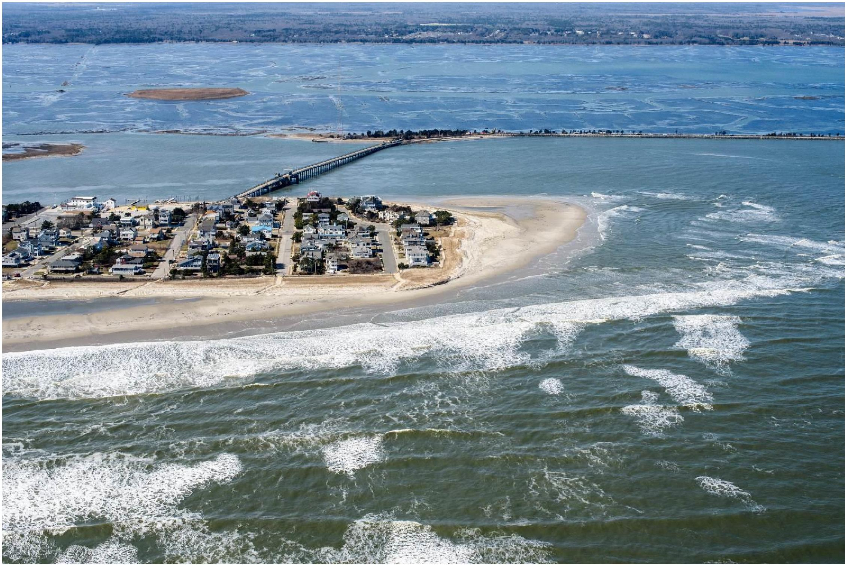
Figure 14. View March 6, 2018 as the second of four northeast storms to impact the NJ coast was getting underway during a spring tide. Note the flooded salt marshes in the bay. The very northeastern corner of the dunes at Seaview Avenue have been scarped, but offshore bar sand added to the beach in December is still present (photo by Ted Kingston).

24

