

**NAME**

**UKI PNW CLASSIC**

**DATE July 13-14 2019**

**Address**

27494 S GARD RD

MULINO, OR 97042

ONE RING, 70X132’, ON ARTIFICAL TURF

Entries Close:

Online: June 25, 2019

Mail in: July1, 2019

Enter Online: [www.UKAgilityInternational.com](http://www.UKAgilityInternational.com/)

Judge: Saturday Jim Massey

Sunday Barbara Sorg

Courses by Anna Hinze and Barbara Standiford

**Bitches in season are allowed to run at this show. Please see page 3 for details.**

# SCHEDULE OF AGILITY

(held under UK Agility International Rules & Regulations)

**CLASSES:**

**CLASSIC Pentathlon**

**CLASSIC Biathlon**

**Titling Classes**

**All levels all heights.**

**Competition Manager:**

**Jessica Fanslau and JuliAnna Munden**

[email](mailto:agilecockers@hotmail.com)

info@freerunacres.com

**Trial opens: 8:30am**

**Briefing: 9:15am**

**Judging Starts: 9:30am**

Checks made payable to

Mail Entries with Fees to:

Free Run Acres

5805 SW Rood Bridge Rd

Hillsboro OR 97123

**T-SHIRT ORDER FORMS ON THE LAST PAGE**

Free Run Acres

|  |  |
| --- | --- |
| **Trial Site & Information**  The show site is indoors on turf. Please bring your own crate, clean-up supplies, & water for your dog. **X-pens are NOT permitted at the show site.** Dogs must be kept on leash when not in the ring.  **Trial Site Rules**  Exhibitors are responsible for cleaning up after their dog(s). Any exhibitor failing to do so may be excused without benefit of refund if the Trial Committee deems the exhibitor to be in violation of this requirement. *Please NO SPIKE SHOES OR HEELS on the turf. Please wear/use clean, athletic footwear to preserve the flooring!*  **Food Services**  We will provide lunch for workers and available for donations to others.  **Tentative Event Schedule & Classes**  SATURDAY  Speedstakes Titling (all levels)  Classic Biathlon Jumping (Classic – all levels)  Classic Pentathlon Snooker (Classic – all levels)  Classic Biathlon Agility (Classic – all levels)  Classic Pentathlon Gamblers (Classic –all levels)    SUNDAY  Gamblers Titling (all levels)  Classic Pentathlon Agility (Classic – all levels)  Classic Pentathlon Jumping (Classic – all levels)  Jumpers Titling (Sr/Champ then Beg/Nov)  Classic Pentathlon Speedstakes (Classic –all levels)  **Questions?**  Regarding Entries to this show, please contact the UKI office – [info@ukagilityinternational.com](mailto:info@ukagilityinternational.com) For specific Show questions such as regarding the site etc…please contact the show manager SHOW MANAGER NAME & EMAIL  **Change of Handler:**  You must notify the show manager of any changes of handler as soon as possible and no later than the morning of the trial. If you know ahead of time, please email the show manger this information. You must provide the new handler number.  **Bitches in Season –** Are allowed to run and will run at the end of the class and must start on a mat at the startline. | **Event Time Table for Saturday & Sunday**  Crating opens at 8:15am (Please do not arrive early)  Briefing at 9:15 am  Walk Thru at 9:20 am  First dog on the line: 9:30am  Measuring will be at 9:00am each day.  **Directions:** Clear Mind Hall is easily found with GPS or smart phone mapping devices using the address below.  27494 S GARD RD  MULINO, OR 97042  **Helpers**  We depend on volunteers to make this a great event. Please sign up for jobs on the workers board.  **Hotels & RV information**  **Sorry NO RV Parking.**  **Accommodations:**  **Hotels - *We have not made arrangements with any hotels but provide this information for your convenience.***  Best Western  1900 Clackamette Drive  Oregon City, Oregon, 97045-1052,  US Phone: 503/655-7141Fax: 503/655-1927  Oxford Inn and Suites  75 82nd Drive  Gladstone, Oregon 97027  Phone: 503.722.7777Fax:503.722.8600  **Crating**  You may crate in the viewing loft. **There is no crating in the office in the arena or ring side**. Crating space is very limited–Pl ease s tack crates when possible. We will not be responsible for any lost or damaged items left a t the show site. NO EX PENS Allowed.  **Veterinarian on Call**  BerryHill Veterinary Services  418 S. Beavercreek Road  Oregon City, OR 97045  Tel: (503) 650-1667 |

**About UKI Agility**

|  |  |
| --- | --- |
| **Speedstakes Titling Program**  **SS Beginners**: For dogs that are not eligible for SS Novice, SS Senior and SS Champion levels in the Speed Stakes Program.  **SS Novice**: For dogs that have gained a minimum of 12 points in the SS Beginners classes. Or a newly registered dog who is eligible for Beginners, but the owner/handler currently runs a Champ level dog in the International Program.  **SS Senior**: For dogs that have gained a minimum of 20 points in the SS Novice classes.  **SS Champion**: For dogs that have gained a minimum of 36 points in the SS Senior classes. | **International Titling Program**  **Beginners**: For dogs that are not eligible for Novice, Senior and Champion levels in the International Program  **Novice**: For dogs that have gained a minimum of 12 points in Beginners classes. Of those points, 8 must be in agility classes. Or a newly registered dog who is eligible for Beginners, but the owner/handler currently runs a Champ level dog in the International Program.  **Senior**: For dogs that have gained a minimum of 20 points in the Novice classes. Of those points 12 must be obtained in agility classes, 4 from jumping, and 4 from games.  **Champion**: For dogs that have gained a minimum of 36 points in the Senior classes. Of those points 12 must be obtained in agility classes, 12 from jumping, and 12 from games. |

**Masters Series Tournament Rules**

The aim of the Masters is to encourage more competitive running in UKI classes and improve the overall standard of top level agility. The Masters has been created for dogs and competitors whose goal is to compete at both National and International level.

**General Rules** Open to all UKI Level dogs including Select heights. Separate competition for each height. Agility and Jumping rounds with results combined. Handlers must run in strict running orders, failure to do so will result in elimination. Either Agility or Jumping classes may run first. If a handler has 2 dogs entered within a jump height, they may move their first dog up so that there are as many dogs as possible between their dogs. If this is not possible, they will receive a 6 minute break. If a handler has more than 2 dogs within a jump height and the entry is not large enough for a large enough gap in between all their dogs, the first of their dogs drawn will be allowed to run in between a jump height change, if a jump height change is available before their height. If it is not, the final decision will be made by the judge and show manager, taking into consideration fairness to the competitor and other entrants in the Masters Class. Day of Entries must run first within the running orders of the first class. The second class must run in reverse order of placing from first class. The dog must run in the height that he will compete at in the Masters Final. The same dog and handler must run both rounds. Any extraordinary circumstances to be ruled by UKI.

**Scoring** Standard UK Agility Marking will apply. Faults converted into seconds. 5 faults = 5 seconds. Time faults treated the same as course faults. An elimination = 100 faults plus 60 second course time. An absent or NFC run = 1000 faults with a 60 second course time. Dogs with an absent or NFC run in either the Agility or Jumping will forfeit any Q’s or awards gained in the other round; in other words, both rounds must be run for competition. Dogs with double elimination will not be placed. An E in the individual round will not be placed in that round. Dogs with the lowest score will be deemed the winner. In the event of a tie, the Agility result will be the deciding factor.

**Final Qualification –** Final Qualification –2 ways to qualify for the Final to be held at the UKI US Open: A. Individual Winners (per height) of the Masters Agility **or** Masters Jumping class (even if an E is earned in the other round).   **B.** 1st & 2nd Overall (per height) (neither round may have an elimination). Only the handler who qualifies the dog through a Masters Heat, may run the dog in the Final.   A **Last Chance Masters Heat** will be available at the UKI US Open if you do not qualify at a local Masters Heat

**Prizes:** Of the Prize entry fee; $5.00 is placed in heat prize fund. Each height has its own prize fund and will be divided as per Masters "Prize Money Guide." $1 from each entry fee will be split & placed in the Final prize fund and Team USA WAO fund.

|  |  |  |  |  |  |
| --- | --- | --- | --- | --- | --- |
| **Number Entered in height** | **1st** | **2nd** | **Total fund** | **Fund percentage** | |
| 1 | $4.00 |  | $4.00 | 100% |  |
| 2 | $8.00 |  | $8.00 | 100% |  |
| 3 | $12.00 |  | $12.00 | 100% |  |
| 4 | $16.00 |  | $16.00 | 100% |  |
| 5 | $20.00 |  | $20.00 | 100% |  |
| 6 | $24.00 |  | $24.00 | 100% |  |
| 7 | $28.00 |  | $28.00 | 100% |  |
| 8 | $32.00 |  | $32.00 | 100% |  |
| 9 | $36.00 |  | $36.00 | 100% |  |
| 10 | $40.00 |  | $40.00 | 100% |  |
| 11 | $30.80 | $13.20 | $44.00 | 70% | 30% |
| 12 | $33.60 | $14.40 | $48.00 | 70% | 30% |
| 13 | $36.40 | $15.60 | $52.00 | 70% | 30% |
| 14 | $39.20 | $16.80 | $56.00 | 70% | 30% |
| 15 | $42.00 | $18.00 | $60.00 | 70% | 30% |
| 16 | $44.80 | $19.20 | $64.00 | 70% | 30% |
| 17 | $47.60 | $20.40 | $68.00 | 70% | 30% |
| 18 | $50.40 | $21.60 | $72.00 | 70% | 30% |
| 19 | $53.20 | $22.80 | $76.00 | 70% | 30% |
| 20 | $56.00 | $24.00 | $80.00 | 70% | 30% |

**UKI US Open 2019 Jacksonville Equestrian Center, FL Nov 7 – 11, 2019**

**Qualifying period – Oct 2, 2018 through Sept 29, 2019**

**Qualifying scores must be gained in the height you will run at the US Open**

**The same dog and handler team that gains the scores below can only run the events at the Open**

* **UKI Masters Series Final:** Individual Winners of the Masters Series Agility & Jumping classes or 1st & 2nd Overall qualify for the Final to be held at the USA Open (see Masters rules in the Premium for details). If you do not qualify at a local Masters Heat, there will be a last chance heat at the UKI US Open 2019. US UKI Masters Final qualifications must be obtained at a UKI trial only in the USA
* **UKI National Championship Final class Bye qualification for Rd 2:** Five (5) Agility clear rounds and Five (5) Jumping clear rounds & *2 of these results must be obtained on the same day (1agility and 1 jumping).* Two (2) Games class qualifying scores (Snooker, Gamblers, Snakes & Ladders, Power & Speed) and Two (2) Speedstakes clear rounds. Clear rounds have no time or course faults and can be obtained from current level dog is working at (not available for Nursery) including Masters Heat classes in either Canada or USA If you do not receive a Bye into Rd 2, you may still enter Rd1 without prequalification.
* **Games Challenge, Speedstakes Challenge, Agility Biathlon & UKI National Championship Round 1, Last Chance Masters Heat:** Do not require any prequalification to enter.
* **UKI USA Cup Overall Winners:** Each jump height will produce the best scoring dog from the overall results for the following events of Agility Biathlon, Masters Heat, Games Challenge & Speedstakes Challenge at each UKI USA Cup. The Winner will be granted an automatic spot in the 2019 National Championship Final and automatic entry into the Masters Final at the UKI US Open 2019.
* **UKI USA Cup Overall Reserve:** (the 2nd place dog in each jump height) will receive an automatic Bye into RD 2 of the UKI National Championship class at the UKI US Open 2019.
* **Classic Pentathlon Winners** – The Winners of the Speedstakes Final from the Pentathlon in each jump height will receive an automatic Bye into the Speedstakes Challenge Final at the 2019 UKI US Open.
* **All Clear Classic Biathlon Winners** - If the Winners of the Overall Placement of the Classic Biathlon in each jump height win with both Biathlon Jumping and Biathlon Agility being clear rounds (no course faults or time faults), they will receive an automatic Bye into Rd 2 of the UKI National Championship Class at the 2019 UKI US Open.
* **WAO tryout:** To tryout for the 2020 WAO team, you must run the Open events at the WAO height you will be trying out for. ***Please note the WAO 525 tryout height will be the 20 inch UKI height.***

WAO jump heights:

|  |  |  |
| --- | --- | --- |
| **WAO Jump Height Name** | **WAO Dog’s Height at Withers** | **UKI Jump Height at Which Dog Must Compete at UKI Open** |
| 300 | 12.60 inches & under | 12 inches |
| 400 | 16.14 inches & under | 16 inches |
| 525 | 19.69 inches & under | 20 inches |
| 600 | Any | 24 inches |

https://www.worldagilityopen.com/

*­*­­

**UKI Jump Height**

|  |  |  |
| --- | --- | --- |
| **Jump Height** | **Dog’s Height** | **A-frame Height** |
| 8 inches | 11” & under | 5’3” |
| 12 inches | 14” & under | 5’3” |
| 16 inches | 17.5” & under | 5’7” |
| 20 inches | 22 & under | 5’7” |
| 22 inches | Any | 5’7” |
| 24 inches | Any | 5’7” |
| Nursery & Select |  | 5’3” |

Entry Level / Move Up / Transfer Table to UKI – **based on Standard Agility level at time of UKI Handler Registration**

|  |  |  |  |  |
| --- | --- | --- | --- | --- |
| AKC/CKC | USDAA/AAC | CPE | UKI Speed Stakes  Program | UKI International  Program |
| Novice | Starters | Level 1, 2, 3 | SS Beginners | Beginners |
| Open | Advance | Level 4, | SS Novice | Novice |
| Excellent | Masters | Level 5, C | SS Senior | Senior |
| Masters | MAD | ----- N/A ----- | SS Champion | Champion |

After this time, **all new dogs** that **have not** competed at any listed organization at time of UKI registration are only eligible for Beginners with exception to Amendment June 1, 2015 unless that handler is currently competing with a International Program Champion level dog under their account, then the dog must start in Novice. All new dogs registered after handler registration may only transfer at the level they were competing at, on the date of the handler registration. Once a dog is registered with UKI, then no other organizations results have bearing on the dog’s level with UKI.

**UKI USA Classic - General Rules**

* This event is open to all dogs and handlers irrespective of their level in UKI and their organization affiliation.
* There is no pre-qualification necessary to enter classes.
* There is a separate competition for each jump height.
* Dogs and handlers need to be UKI members. Register online at [www.ukagilityinternational.com](http://www.ukagilityinternational.com)
* Dogs may only compete in one height throughout the whole event.
* Handlers who are collecting points for US Open Byes, must be the same dog and handler partnership that compete in these events and at the U.S. Open and must run in the height that the Q’s and Byes were gained at.
* A dog may only be run by one handler throughout the event.
* Classes will be run in strict running order unless otherwise specified. Running orders will be randomly drawn for the first round of each class of Biathlon, Pentathlon and Masters Series Heat.
* Classes will be run under UKI rules and regulations with additional rules detailed below. Any further amendments will be posted and or announced in the event confirmation letter.
* UKI reserves the right to rule at the event on anything not covered in these rules. Any amendments to these rules will be announced to competitors either in the confirmation information or general briefings.

**UKI Classic Pentathlon Winners** – The Winners of the Final from the Pentathlon in each jump height will receive an automatic Bye into the Speedstakes Challenge Final at the 2019 UKI US Open.

**All Clear Classic Biathlon Winners** - If the Winners of the Overall Placement of the Classic Biathlon in each jump height win with both Biathlon Jumping and Biathlon Agility being clear rounds (no course faults or time faults), they will receive an automatic Bye into Rd 2 of the UKI National Championship Class at the 2019 UKI US Open.

**UKI Classic Biathlon**

* Consists of a Jumping round and an Agility round with the results combined.
* Running order for Agility will be in reverse order of Jumping results.
* Cumulative scoring; least faults wins with time as tie breaker only, in all aspects of the Biathlon.
* In the event of a tie for the Agility Biathlon Winner, the scores from the Agility round will determine the winner. If there is still a tie, the dogs will compete in a run-off on the Agility course.
* Eliminations in the Jumping round will still progress to the Agility round with E’s running first in random order in the RO for the Agility round. Eliminations will score 100 faults
* Winners in each height with both rounds clear, will receive an automatic Bye into Rd 2 of the UKI National Championships at the 2019 US Open.

**UKI Classic Pentathlon**

* Consists of 4 preliminary classes with points allocated for placements in each class that are combined into one result to enable participation to run in the Final.
* The 4 preliminary classes include: Snooker, Gamblers, Agility & Jumping and are run and scored under UKI Rules & Regulations.
* The Final consists of a Speedstakes course and is run and scored under normal UKI Rules & Regulations.
* The tabulation for each of the 4 preliminary classes is based upon the number of dogs entered within each jump height in each event. The winner of the class (i.e. Snooker) will receive the highest points which is equal to the total number entered in that jump height. Example: If 12 dogs are entered in the 22 inch height then the winner will receive 12 points, 2nd place 11, 3rd place 10 and so on.
* Eliminations (dogs not stopping the timers by going over the finish jump in Gamblers and Snooker) will score 0 points
* Eliminations in Jumping or Agility will score 0 points
* A no show in any of the classes or if any of the classes are run for NFC - will result in a loss of eligibility to move onto to the Final, regardless of ranking in the other classes.
* The top 50% from the 4 preliminary rounds will progress onto the Speedstakes Final.
* Dogs with 3 or more 0 scoring results in preliminary classes will not progress onto the Final.
* The bottom 50%, including those that scored three or more zero’s, will move onto the Speedstakes Consolation Run that is scored under normal UKI Rules & Regulations.
* A tie at the 50% cut off will round up to move all tied dogs into the Final.
* The running orders for the preliminary classes will be random order.
* The running orders for the Final will be reverse order of the combined result of the preliminary score after the 4 rounds. If there is a tie for running order placement, the Agility placement followed by the Jumping placement, followed by the Gamblers placement will determine the running order.
* The running orders for the Consolation run will be in random order and are not strict.
* The winners of the Speedstakes Final will be given an automatic Bye into the Speedstakes Final at the 2019 US Open.

**UKI Progression points**

All clear rounds will count towards UKI level progression points towards the level the dog is currently working at.

All clear rounds will count towards the RD 2 Bye qualifications for the 2019 UKI National Championship Class at the US Open.

**Managing Conflicts for Handlers with Multiple Dogs in Non Seeded Classes**

In the initial classes of each event (non-seeded runs) a random draw will produce the running order. Handlers with more than one dog will have their running orders altered to achieve the following:

* A gap of 10 dogs (9 dogs between their runs) will be created by moving the first-drawn dog earlier in the running order.  If this does not achieve a 10-dog gap then the second-drawn dog will be moved down in the running order.
* If there are not enough dogs in the class to achieve the 10-dog gap the biggest gap possible will be created.  If this gap does not achieve the minimum 10 dog gap, then a break of 5 minutes will be given.  The 5-minute countdown will start as the handler’s first dog crosses the finish line; the handler must enter the ring with their second dog before the countdown is complete.
* Handlers with more than 2 dogs will have their dogs split using the 10-dog gap rule. If there are not enough dogs to achieve this, the dogs will be split evenly through the running order and the 5-minute rule will be adhered to. If a handler has dogs in different height divisions, and the 10 dog gap can not be achieved, the 5 minutes will run through while the jump heights are being changed.

**Multiple dog conflicts in Seeded classes:**

In the seeded classes a handler has earned their running order and the advantage this brings; therefore, their dogs will not be automatically moved to create a gap. Instead, they will be given 5-minute break between dogs.  However, a handler may choose to move their first dog to a spot earlier in the running order to create a gap of 10 dogs (9 dogs between their runs).  If this is unable to be achieved, the 5-minute rule will be used.

A handler must notify the results office within 30 minutes of the results being posted of the previous class in that particular event if they wish to move their running order for the next round. Failure to do so will mean they will be given a 5-minute break.

**By entering more than one dog in this event, handlers indicate their acceptance to comply with these rules.**

**NOTICE TO COMPETITORS**

**UK Agility International Rules and Regulations** apply to the whole event andall people and dogs must comply with these at all times. As a competitor it is your responsibility to be aware of the rules and regulations as they stand at the time of the show. This show will run under the Current Edition UK Agility International rules.

**All dogs and handlers must be registered with UK Agility International in order to compete.** UK Agility International’s official rules & regulations are given free on registration of Handler/Owner to UKI. If you or your dog is not already registered, fill out the UKI registration form included in this schedule and add the registration fee to your entry fee.

Competitors through submission of entry acknowledge that they are knowledgeable of **UK Agility International rules and regulations** including but not limited to the following rules regarding entry:

Dogs under 18 calendar months of age on the day of the Show are not eligible to compete in UK Agility International Trials, with the exception of dogs over 15 calendar months of age eligible to compete in Nursery Classes & Speed Stakes.

Entries without fees paid in full will be returned. Separate entry forms must be completed by each Competitor and must be signed by the Competitor or Guardian if the competitor is a minor. Entry forms must be accompanied with the appropriate fees. If you use a recorded delivery service, you must specify No Signature Required.

**Refund Policy** Entries will not be accepted, changed or altered after the closing date or capping level has been reached except for the purpose of moving to a higher level.A full refund is available for any membership that is not older than 14 days from the creation of the account date. A full refund is available before the closing date or capping level is met for any show. There will be no cost if refund money is to be left in your UK Agility International account. If money is to be returned then the following administration costs will be incurred. If payment was received by check or money order then a $4 administration fee will be incurred. If payment was received by credit card a 4% charge of the refund will be assessed, per transaction. If payment was received from a Pay Pal account, a 5% charge of the refund will be assessed, per transaction. Once a show has been closed and/or capped refunds of any kind for any reason will not be available. A partial entry may be available for injuries where a veterinarian note is provided. Contact the show management for details, NOT UKI.

A dog shall be withdrawn from competition without refund if it is: suffering from any infectious or contagious disease, interfering with the safety of any person or other animal or if it is likely to cause itself damage or suffering if it continues competing.

There will be no refunds for entries withdrawn and neither in the event a dog and/or handler is dismissed from the competition, regardless of the reason for dismissal providing this was within accordance of UK Agility International rules and regulations.

It is the competitor’s responsibility to be available for their class and running order. Handlers working more than one dog in a class **must ensure that the dogs compete in the sequence in which they are drawn**. Failure to do so will result in elimination.

It is expressly understood that **Competitors alone are responsible** for the behavior of their dogs, children and guests. Any competitor whose dogs, children, or guests create unnecessary disturbances or repeatedly engage in unsafe or disruptive behavior, may at the discretion of the show management, be asked to remove the offending dogs, children, guests from the event grounds. No refunds of fees will be made in such a case.

No person shall carry out punitive correction or harsh handling of a dog at any time within the boundaries of the show.

Should a judge be unable to fulfill the appointment to judge, the show management reserves the right to appoint another judge. Should circumstances so dictate the show manager, in consultation with the Judges, may alter arrangements as necessary. Such changes and the circumstances surrounding them must be reported to UK Agility International. In the event of abandonment of the show through circumstances beyond our control, the SHOW MANAGEMENT may defray such expenses from the entry fee to cover the cost of the show preparation. These accounts will then be made public.

All competitors **MUST** clean up after their dogs at all times. Failure to do so will result in competitors being asked to leave the Show.

Dogs left in hot cars, or dogs appearing to be in distress, will be dealt with as seen fit by the Show Management.

Returned checks do not constitute a valid entry. **There will be a $25.00 service charge for returned checks**. Payment of entry fees and service charges shall be made before a competitor may compete. Any unpaid fees or shortfalls to a UK Agility International account must be paid prior to the start of the event. Any fees not received within 30 days of notice shall be reported to UK Agility International. UK Agility International will suspend a dog’s/handlers registration until fees are paid in full. If your UK Agility International account owes money when we process the entries for this show your running orders may be withheld to encourage you to visit the secretaries tent at the show so that the account balance can be resolved.

All dogs are entered at this show at their owners risk and whilst every care will be taken the show management will not accept responsibility for loss, damage or injury however caused to dogs, persons or property whilst at the show.

**Bitches in season may run at this show.** You must notify the show secretary as early as possible to this fact. All BIS must run at the end of the class, after all jump heights have finished in that class and must use a mat on the start line, to be provided by the show. In season pants may be worn while running but handlers allow this at their own risk.

**UK Agility International Entry Form**

**PNW UKI CLASSIC**

**DATE July 13-14 2019**

**Entries Close: DATE June 25, 2019**

**Remember, you can enter online: www.UKAgilityInternational.com**

If this is a new registration with UKI, please write name & NAF (Number Applied For) in UKI number box

**UKI Number:**

**Handlers Name:**

|  |
| --- |
| PLEASE FILL OUT COMPLETELY AND LEGIBLY |
| Address: |
| City: State: Zip |
| Email: Phone: |

**Mail Entries with Fees to: Address**

|  |  |  |
| --- | --- | --- |
| **Total Number of Pentathlon Entries** __________ X $72.00 | |  |
| **Total Number of Biathlon Entries** __________ X $30.00 | |  |
| **Total Number of Regular / Special Entries** __________ X $15.00 | |  |
| **UKI New Handler & or Dog Registration** (cheaper done online) | |  |
| **Try Before You Buy Registration** – must have created online account. To keep registration please pay by **7 DAYS AFTER TRIAL** | $15.00 |  |
| Checks Payable to: **Total Enclosed** | | Circle for TBYB |
|  | |  |

|  |
| --- |
|  |

**Helpers** Please help out at our show?! Care will be taken to allow you plenty of time for your own dogs. We will have a sign up board at the trial

**Entry is not valid unless agreement is read and signed. Thank You for your Help!**

The person who signs this agreement represents that he/she is authorized to enter into this agreement on behalf of both the exhibitor and the owner of the participating dog. In consideration of acceptance of this entry: Exhibitor/owner certifies that any and every dog they bring to this facility, whether participation or not, is not a hazard to persons, dogs, or property and assume all responsibility, liability and expenses resulting from damages causes by their dog(s). Exhibitor/owner releases **UK Agility International, UK Agility Ltd**, and their agents, officers & members and Free Run Acres and Clear Mind and will defend them and hold them harmless from all present and future loss, injury, damage, claims, demands and liabilities involving your dog, and or others equipment. Without limiting the generality of the foregoing hold harmless provisions, exhibitor/owner hereby specifically assume sole responsibility for and agree to indemnify and save aforementioned parties harmless from any and all loss and expense (including legal fees) by reason of the liability imposed by law upon any of the aforementioned parties for damages because of bodily injuries, including death, at any time in consequence of my (our) participation in the event or training, howsoever such injury or death may be caused and whether or not the same may have been caused or may have been alleged to have been caused by negligence of the aforementioned parties or any of their employees or agents or any other persons. Exhibitor/owner acknowledge all hazards presented by the training facility, event and the event premises, including but not limited to, the condition of grounds, lighting, security, measures or lack of, electrical appliances, fittings, parking areas, fences or the ability for a dog to escape from the training area, the presence of unfamiliar animals and people, the possibility of another ill animal or your own getting ill, and agility equipment; exhibitor and owner assume the risk of any harm arising from and any and all of these including allowing their dogs to run wearing collars, stop pad protectors, bitch in season pants, or any similar items. Everyone must be very careful to watch their dogs on the property, clean up after yourselves and your dogs. We reserve the right to excuse any person for what we deem excessive harshness, or any dog we feel cannot safely perform the obstacles. We reserve the right to excuse any person for what we deem as aggressive or abusive towards another person or dog.

Signature of Exhibitor/Owner or of parent or legal guardian of minor: Date:

**Dog Entry Form**

UKI Handler #

Handler Name

**UKI PNW CLASSIC**

**DATE  July 13-14, 2019 Closes : June 25, 2019**

**You must submit the Handler Entry Form, (previous page) with the Dog entry Form. ENTRY NOT VALID WITHOUT #’S**



Dog Call/Pet Name

UKI Dog #

Breed

**Tick your Jump height** **Tick your dogs Level**

|  |  |  |  |  |  |  |  |
| --- | --- | --- | --- | --- | --- | --- | --- |
| **Jump Height** | | |  | **\*International Level** | *Tick only 1* | **Speedstakes Level** | *Tick only 1* |
|  |  | **Select Option** |  | Beginner |  | Beginner |  |
| **4 inch** |  |  |  | Novice |  | Novice |  |
| **8 inch** |  |  |  | Senior |  | Senior |  |
| **12 inch** |  |  |  | Champ |  | Champ |  |
| **16 inch** |  |  |  | \**International Program consists of Agility, Jumping and Games classes & dog must therefore run in the same level for those classes. Please be aware of the level you should enter (page 3) Entering an incorrect level will result in any scores being void.* | | | |
| **20 inch** |  |  |  |
| **22 inch** |  |  |  |
| **24 inch** |  |  |  |

**Classic Pentathlon & Biathlon and Masters Classes are multiple runs,**

**split over the weekend.**

|  |  |  |
| --- | --- | --- |
| **Class** | *tick to enter* | **Fee** |
| Classic Pentathlon (5 runs)  **(Saturday and Sunday)** |  | $72.00 |
| Classic Biathlon (2 runs)  **(Saturday)** |  | $30.00 |
|  |  |  |
| Speedstakes Titling  **(Saturday)** |  | $15.00 |
| Gamblers Titlling  **(Sunday)** |  | $15.00 |
| Jumper Titling  **(Sunday)** |  | $15.00 |

**Try Before You Buy! UKI Registration Details**

TBYB will allow you to enter your first UKI trial and pay for that entry either online or directly to the show but withhold paying for your membership for yourself and your dog until after you experience your first UKI trial. This option may **ONLY** be used by creating an account **ONLINE** so that you have both a handler and dog UKI numbers. These numbers MUST be submitted to the show directly if you have not entered the trial online.  If, after your first UKI trial, you would like to keep your membership with UKI, payment for registration will be due 7 working days after that trial and must be paid online in $USD. Your registration documents will follow. Once you have created the online account through our web page, then notify us by emailing [info@ukagilityinternational.com](mailto:info@ukagilityinternational.com)  stating your TBYB registration, you must also state the trial name and date. If membership is not paid within 7 days of the first show, all results, including US Open qualifiers/byes will be void. TBYB is only available for new handler accounts; and CANNOT be used by submitting a paper registration form.

**UKI Registration Form** NO PAPER REGISTRATIONS ALLOWED FOR TBYB

ONLINE REGISTRATION DISCOUNTED! [www.ukagilityinternational.com](http://www.ukagilityinternational.com)

**Handler Registration** **$USD 15.00** **5 Year Membership (16 year old & under: Free)**

**Only one handler per account Age if Junior: _________________**

|  |  |  |
| --- | --- | --- |
| **First Name:** | **Last Name:** | |
| **Address:**  **State:** | **City:**  **Zip:** | **Country:** |
| **Phone:** | **Cell:** | **Email:** |
| **Dog Registration**  **Lifetime Membership**  **$USD 15.00** | **Pet name:** | **Dog’s Registered (full) name:** |
| **List Breed or Mixed:** | **Sex:** | **Date of Birth: M/D/Y, estimate if unknown** |
| **Estimate height at shoulders (inches):** | **Organization name:** | **Highest standard Agility Level at other organization:** |
| **Dog Registration**  **Lifetime Membership**  **$USD 15.00** | **Pet name:** | **Dog’s Registered (full) name:** |
| **List Breed or Mixed:** | **Sex:** | **Date of Birth: M/D/Y, estimate if unknown:** |
| **Estimate height at shoulders (inches):** | **Organization name:** | **Highest standard Agility Level at other organization:** |
| **By signing this form I am agreeing that the information I have provided is correct to the best of my knowledge.**  **I also agree to abide by and uphold the rules and regulations of UK Agility International.** | | |
| **Signature:_____________________________________________ Date: ___________________** | | |
| **Signature of Legal Guardian for minor handler:___________________________** | | |
| **Please submit Membership fees with entry** | | **Total Payment: $USD** |

**TRY BEFORE YOU BUY MUST CREATE ONLINE ACCOUNT ONLY**

**T-Shirt Order Form**

**$20 pre order (Due June 25, 2019)**

**(Limited Quanity available at the trial for $25)**

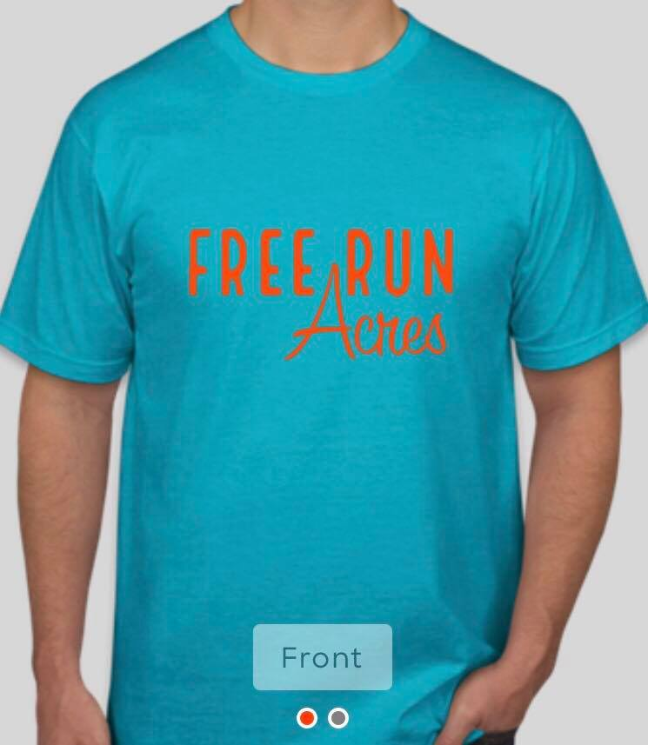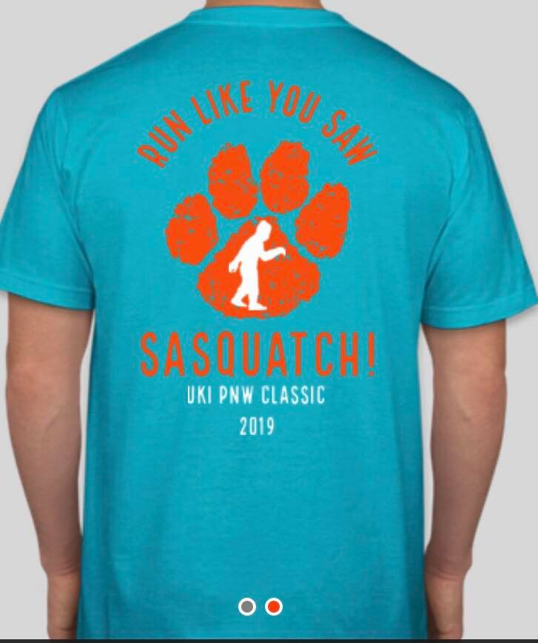

**Circle Size (unisex): XS S M L XL**

**Name:__________________________________________**

**Phone:__________________________________________**

**Email:___________________________________________**

**Mail and Checks payable to: Free Run Acres**

**5805 SW Rood Bridge Rd**

**Hillsboro OR 97123**

**Or Email order form and paypal** [**jessica@jessicafanslau.com**](mailto:jessica@jessicafanslau.com) **as “friends”**