Hello from the Humboldt Watershed CWMA! The HWCWMA was developed to address the invasive weed problem and subsequent decline in water quality within the entire 16,843 square mile watershed, which covers most of Northern Nevada. The primary function of HWCWMA has been to provide land managers, owners and weed control groups assistance in the areas of funding, agency and weed group coordination and cooperation.
Each month, the HWCWMA will be addressing a noxious weed that we are working on eradicating from the Humboldt River watershed. These invasive and hard to control weeds might even be on or adjacent to your property and it’s only a matter of time before they may become established on your land.
This month we would like to introduce you to one of Nevada’s state listed noxious weeds, Perennial Pepperweed (Lepidium latifolium). A native of southern Europe and western Asia, perennial pepperweed establishes rapidly and colonizes pastures, riparian habitats, and wet areas, as well as along roadsides, in rangelands and field crop situations. It degrades nesting habitat for wildlife and displaces desirable species in natural areas and hay meadows. It lowers digestibility and protein content of hay and inhibits grazing.
Perennial pepperweed generally grows 1 to 3 feet tall, but can reach up to 6 feet. It has many stems that emerge from a somewhat woody root crown with alternate, waxy leaves that have smooth or toothed margins and a prominent, whitish midvein. Basal leaves are lance-shaped and up to 12 inches long; they are attached by a stalk that can be almost as long as the leaf blade. Stem leaves are smaller, with shorter stalks. Perennial pepperweed's delicate, milky white flowers, which are sometimes collected for dry flower arrangement, grow in dense, rounded clusters at branch tips. Plants flower from June through September, producing small (1/16 inch) round or egg-shaped fruits. This plant spreads through profuse seed production and extensive, creeping roots. It has adapted to a wide range of habitats.
Mechanical control of this plant is very difficult because very small sections of root contain buds that will sprout into new plants. Plant tops are easily killed, but root and crown buds can sprout and continue the infestation. Small infestations may be hand-pulled or dug, but as much of the root must be removed as possible.
Chemical control of perennial pepperweed is best achieved by repeated applications for up to five years are necessary to starve the root system. To successfully manage perennial pepperweed with chemicals, competitive vegetation must be established immediately after its control to prevent reinvasion.
Herbicide | Site | Restrictions | Effectiveness
Telar®  (chlorsulfuron) | Noncrop  Industrial | Selective herbicide (will not harm most grasses), do not apply near water. | Excellent control for 1-2 years
Habitat® (imazapyr)  Stalker®® (imazapyr) | Riparian, Wetlands  Wildlands | Nonselective herbicide, do not apply near water. | Excellent control for 1-2 years. Treated areas typically remain void of any vegetation for 1-2 years after treatment.
Roundup® and others (glyphosate)  Rodeo®, Aquamaster® and others (glyphosate) | Wildlands  Aquatic | Nonselective herbicide. Rodeo® for areas near/in aquatic sites. | Effective unless infestation is dense. If dense, mow area and apply to resprouting plants.
Weedar 64®  (2,4-D) | Wildlands  Aquatic | Selective herbicide (will not harm grasses) | Somewhat effective unless infestation is dense. If dense, mow area and apply to resprouting plants.
Please notify the HWCWMA if you see perennial pepperweed growing along the Humboldt River. Our staff can provide the property owner or appropriate public agency with site-specific advice on how best to remove it. We have an opportunity to stop it from spreading if we act quickly. We map all known locations of regulated noxious weeds such as perennial pepperweed in order to help us and others locate new infestations in time to control them.
The Humboldt Watershed CWMA has also developed a website to serve as a clearinghouse for information on weeds in the Humboldt Watershed. Our website (http://www.humboldtweedfree.org) contains fact sheets for state listed noxious weeds in Nevada, Board of Director’s information, funding partner’s links, and many more features including a detailed project proposal packet that you can print, fill out and mail back to us at your convenience. We are looking to expand our project area outside of the Humboldt River and always welcome new funding opportunities.
If you have any questions, please feel free to contact Andi Porreca, HWCWMA Coordinator at (775) 762-2636 or email her at aporreca@humboldtweedfree.org. Or you may speak with Rhonda Heguy, HWCWMA President at (775) 738-3085, email: hwcwma@gmail.com.
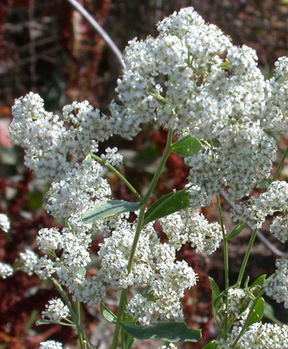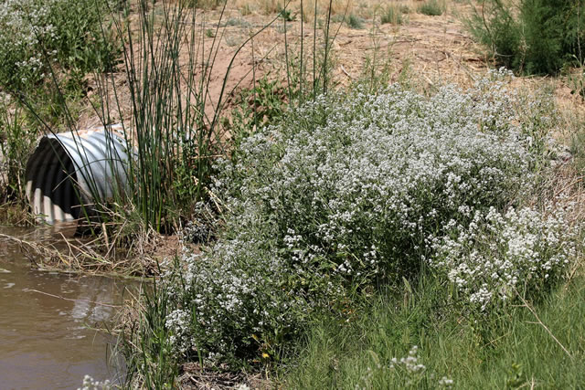
Perennial pepperweed in flower. Perennial pepperweed infestation.
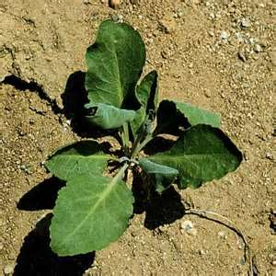
Perennial pepperweed rosette.

