Cedar Grove Rock Climbing
Kings Canyon National Park offers a beautiful landscape to explore and miles of quality rock to climb. Rock climbing is just one way in which visitors can have a serene wilderness experience within Kings Canyon National Park, pushing personal boundaries and exploring the landscape through the medium of rock climbing. Historically, rock climbers have advocated for preservation of public lands and been stewards of the land. Let’s keep it that way! There are no “approach” trails to routes, so practice minimal impact off-trail travel, limiting foot traffic to durable surfaces such as rocks and packed dirt. Avoid trampling plants to get to climbs. Likewise, avoid parking off-road and on plants. Park in either paved pullouts or durable worn surfaces without plant cover. Enjoy your climbing through the 100 million year old, glacially carved wonders of Kings Canyon!
Disclaimer: The route info provided here is a courtesy of Cedar Grove. Climbing is inherently dangerous, climb at your own risk. You are responsible for your own safety. The National Park Service does not maintain any fixed hardware (anchors, bolts, etc), and some routes may be equipped with outdated, unsafe hardware. Use caution and best judgement when determining if a route is safe to climb. Due to infrequent climber visitation, many routes may have loose rock or outdated fixed gear. Be prepared to retreat safely off of routes. There are likely more routes in the canyon than listed here, so if you find routes other than shown below, please contact Christian Black (cblack9488@gmail.com) with route info to be updated, and/or contribute route info to online resources.
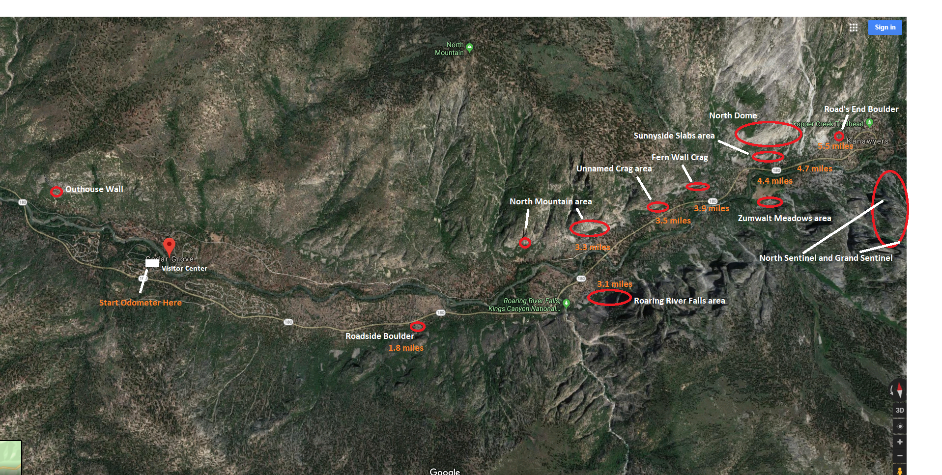Overview map:
Outhouse Wall:
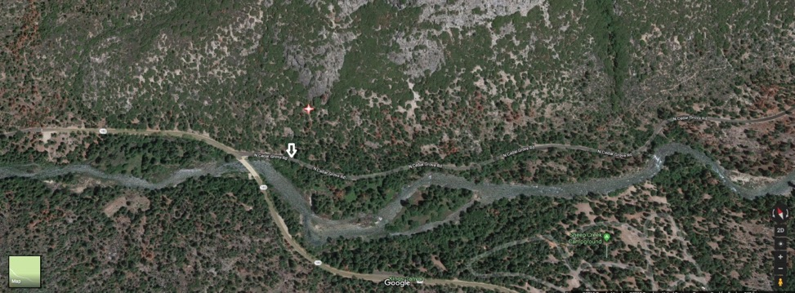
When driving towards Road’s End just after entering the park boundary, take a left onto North Side Drive just before crossing a bridge (South Fork Kings River) and park next to an outhouse on the side of the road. Head straight uphill from the outhouse to reach the climbs. See info on Mountain Project for more detailed descriptions.
Left route: 5.8, 8 bolts to a two-bolt anchor. Up and then trend left on good knobs. Full 35m pitch, 70m rope required, tie knots in end of rope.
Middle crack: 5.9+, up the first 3 bolts of Left Route, then up into the layback crack to a final traverse right to a ledge with a two-bolt anchor.
Right route: “The Gymnast” 5.11a Shares the first bolt of Left/Middle route, then follows a line straight up through 5 more bolts to the same two-bolt anchor and ledge of Middle Route. Ultra classic.
Further to the right about 50 yards there is another buttress that can be climbed. Scrambling up and around the right side of this buttress will take you to the top. There is one bolt for a TR anchor. Recommended to back up bolt with other gear.

Roadside Boulder:
Starting the Odometer at the turnoff to Cedar Grove Village/Visitor Center, stop at mile 1.8, just before Knapp’s Cabin at the large obvious boulder on the right side of the road. There is one known climb here.
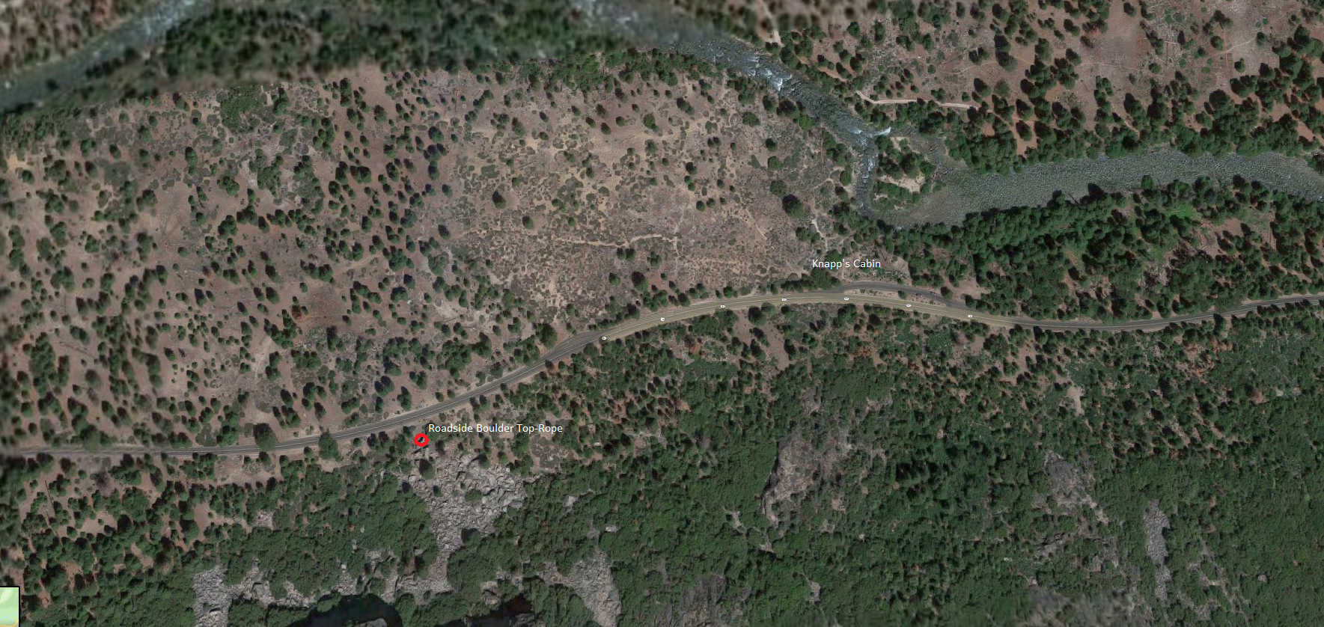
Roadside Boulder Top-rope: Grade Unknown. Scramble up and around the right side of the boulder to two bolts at the top to set up a top-rope on the face facing the road.
Roaring River Falls area:
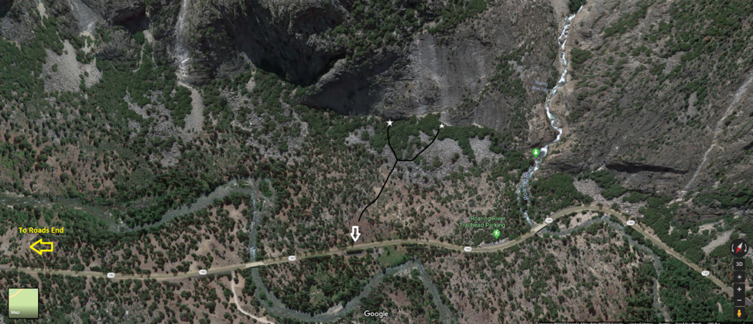
From the paved pullout show on the map at mile 3.1, head south towards the wall just East of Roaring River Falls, going up some talus along the way. For the route further East (left star in map-view), veer left towards a steeper portion of the wall until you see a splitter crack with two anchor bolts on top. For the western route (right star in map-view), head up the talus towards the base of the large slab-apron. This route starts at the base of wide white water stain. You should be able to see some the bolts on the first pitch from the ground.

Left Star: 5.10c, fingers to wide hands crack. Two-bolt anchor. ~70ft
Right Star: “Ocean King”. 5.10+ bolted slab climb, 6 pitches. First five pitches go at 5.9 or lower, last pitch is 5.10+. Two 60m ropes needed to rappel the route.
North Mountain area:
Turn off onto the “River Road/Motor Nature Trail” at 3.3 miles and park in the first pullout. Left and middle star routes are approached up-and-left up talus to the base of the cliff. For far Left star route, park next to NPS stables (do not park inside gate of stables, stay on River Road).
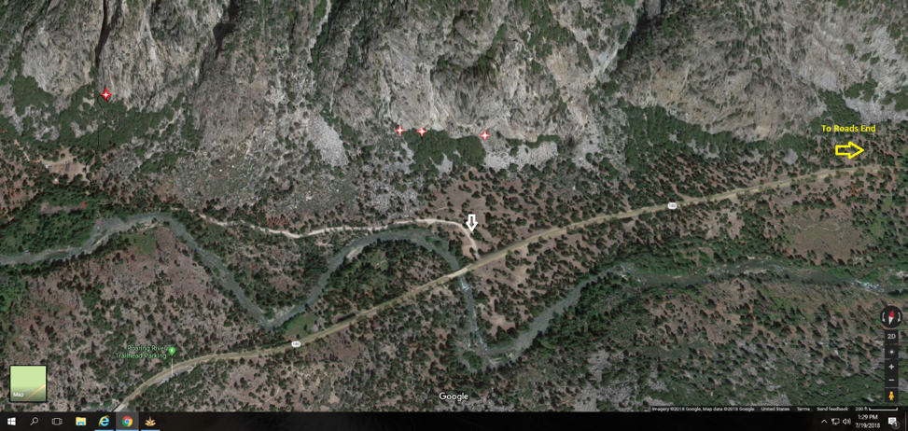
Far left star (Behind NPS horse stables): 5.11a “Nowhere to Run”. 6 pitches. See description on Mountain Project for more details
Left Star: 5.9 “Wish you were here”, 1 pitch, 70ft. Start up a crack to a bolt on a face, traverse right past the bolt and up an easy fingercrack to a two-bolt anchor.
Middle Star: 5.12+ Tips crack project, 90ft. Can be set up on TR from “Wish you were here”. Climb the very thin, improbable looking crack just to the right of “Wish you were here” to a two-bolt anchor.
Right star: 5.10 “The Spider”, 6 pitches. See info on Mountain Project for more details.
North Dome: See Mountain project for “North of Eden”, 9 pitches 5.10+ and see the Moser Guidebook at Roads End for other route info.

Sunny Side Slabs area: (Sub-cliff directly below North Dome)
Park at Zumwalt Meadows parking area (mile 4.4) and head right down the road until the sub-cliff steepens. There are 3 routes here, unknown grade and hardware condition. Please report conditions to ranger Christian (email is above).
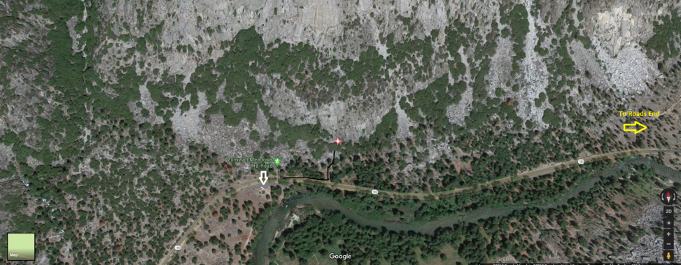
Zumwalt Meadows area:
Park at Zumwalt Meadow trailhead (mile 4.4) and take the Zumwalt Meadows trail until you cross a bridge, then take a left until you hit a junction. Taking a left will take you onto the boardwalk, but instead take a right towards the talus side of the meadows until you come across a very obvious, large, house-sized boulder on the left side of the trail. There are two climbs on the boulder and one climb on the cliff uphill from it. See Mountain project for more detailed descriptions.
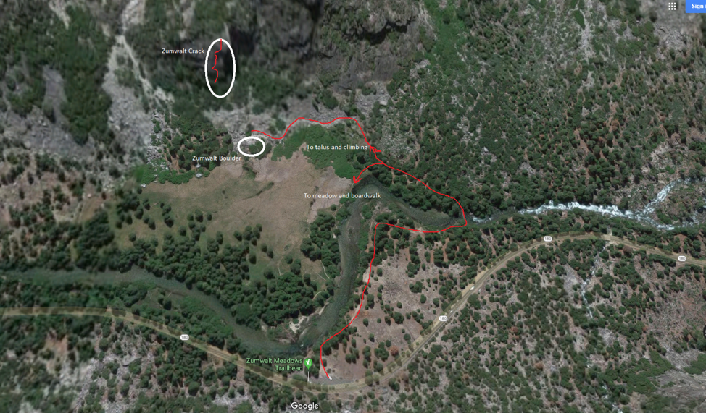
Zumwalt Boulder Arete: 5.9, climb the bolted arête on the right side of the boulder for 4 bolts to a 2-bolt anchor. You can also scramble around the backside of the boulder to set up a top-rope.
Dyno-licious: 5.12a, Climb the face to the left of the arête, making two awesome dyno moves along the way. 2 bolts to a 2-bolt anchor. There are no hangers on the lead bolts as of 2018, so it can only be TR’d unless hangers are installed.
Zumwalt Crack: 5.10+ An excellent 3 pitch wide crack climb. Uphill from Zumwalt Boulder, hike up to the obvious semi-continuous crack that leads to the top of the buttress. See Mountain Project for a more detailed description. The 3rd pitch is mostly wide climbing, and you’ll need a #6 for the first pitch unless you are very comfortable in chimneys. Doubles to #5, one #6. Walk off to the east or rappel the route with two ropes. No bolted anchors.
Unnamed Crag:
Just past the River Road/Motor Nature Trail turnoff, at mile 3.5, park in a paved pullout on the south side of the road. Walk a hundred yards or so towards roads end then head up the cliff, aiming for an obvious, slightly overhung hand crack in a corner.
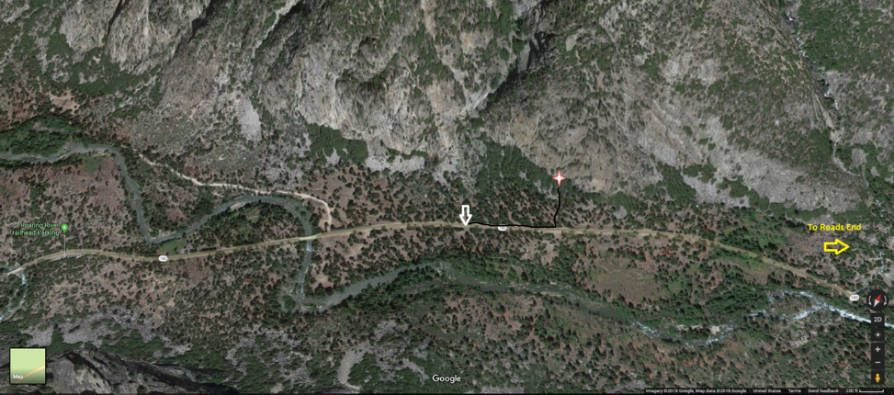
Sport route: ~5.10c/d? Directly ~50ft left of the obvious hand crack in the corner. Bolts to a 2-bolt anchor.
Hand crack route: ~5.10c. Climb the somewhat dirty corner to get into the awesome hand crack, up to a wide, flaring pod with an old (unsafe) bolt next to it. The hand crack corner continues up until it is possible to traverse to the right. However, the route has no known anchor bolts, so a downclimb or bail gear will be needed for retreat.
3 Sport routes: Unknown grades/conditions. To the right and downhill of the hand crack route there are 3 bolted routes.

Fern Wall area:
Just past Unnamed Crag and about 0.5 miles before the Zumwalt Meadows parking area (mile 3.9 from Visitor Center turnoff). Park just before the heavily ferned area in a hard-packed dirt pullout on the left. Walk up the road until a Y-shaped Black Oak tree and cut left towards the wall, aiming for an obvious pillar sticking out from the wall with a splitter crack going up the middle/top half. You should be able to use a system of downed logs as bridges to reach the wall to cross the ferns. Avoid trampling the ferns.
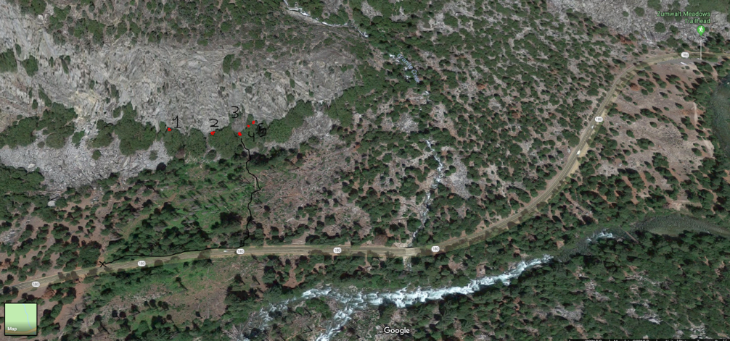
Climb 1: 5.7/5.8 Lay-back crack in a corner to a two-bolt anchor, gear up to 4”.
Climb 2: 5.9 mixed bolted and gear route. Start up a slab to a bolt, put gear below the roof and continue up and through the 5.9 roof, placing more gear and then reaching a second bolt. One more bolt and gear to a two-bolt anchor.
Climb 3: “Fingerin’ it Out” 5.11c PG13. This is the line up the obvious pillar. Start an up-and-left trending layback fingercrack to a small roof. Once above the roof place small fiddly gear up and right, following the very thin crack. Traverse back left on face holds to reach a series of fingerlocks and lay-backing through the crux, placing very small gear for the crux (PG13 section). Once above the crux, enjoy the splitter 5.10+ fingercrack to the top to a two-bolt anchor. 95 feet.
Climb 4: Unknown grade, 5.9? A straight-in jamming handcrack corner just to the right of Fingerin’ it Out. Unknown anchor information.
Climb 5: Unknown grade, 5.10+? The next corner just right of climb 4, a fingers lay-back up a corner. Unknown anchor information.

Roads End Boulder:
Drive all the way to Road’s End and park at the 3rd large parking area just before you come to the end of the turnaround (mile 5.5). Walk from the NW corner of the lot about 50 yards to a large obvious house-sized boulder. There are two routes on this boulder.
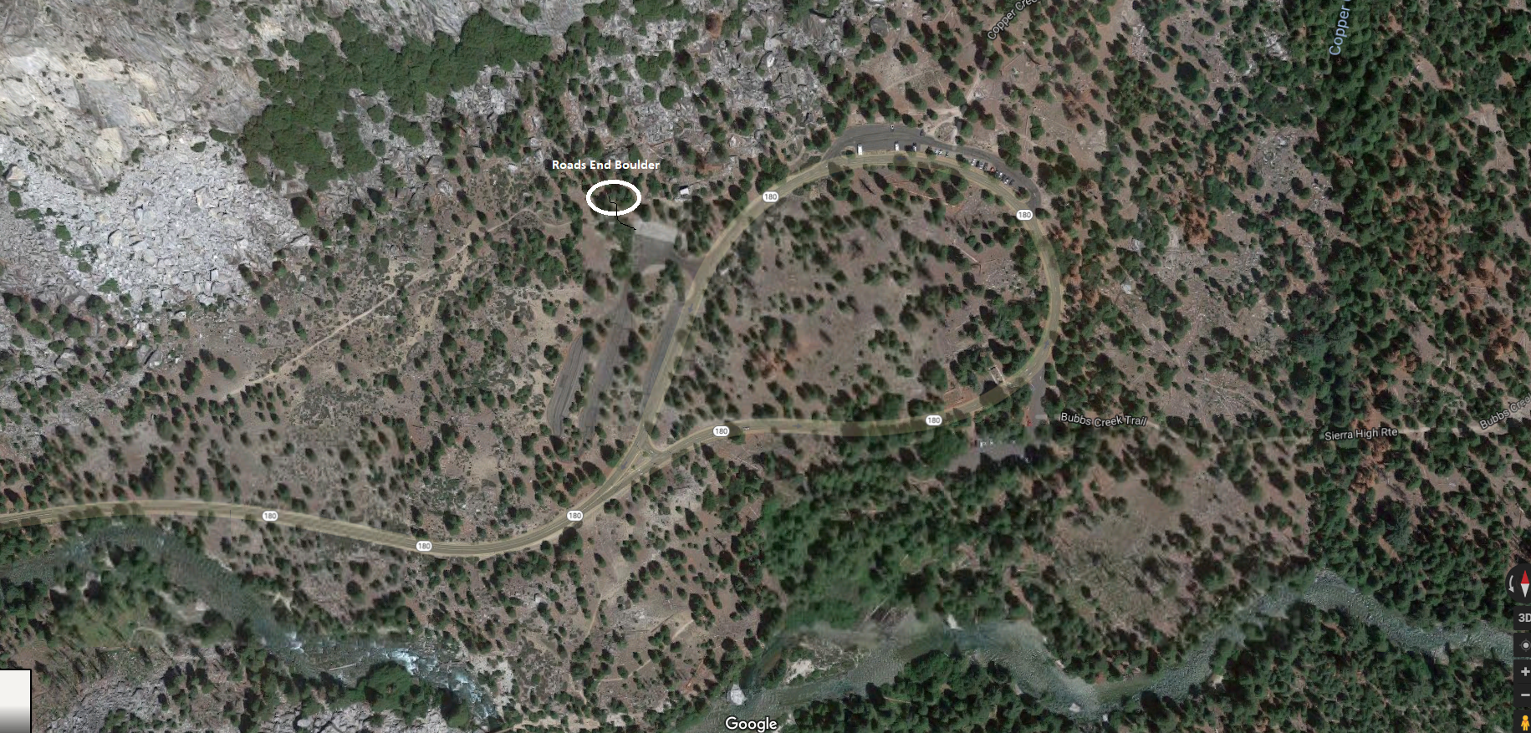
Roads End Boulder Arete, 5.11c? Climb up through 4-5 bolts on the right side arête to a two-bolt anchor atop the boulder. Can also be set up as TR by walking to top of boulder from behind.
Roads End Boulder Practice Aid route/5.12? There is another set of bolts to the left of the Arete climb. This line follows the obvious right-leaning thin crack up to these anchors. Alternatively, set up a top-rope and climb the steep face directly beneath the anchor bolts. Grade unknown, maybe 5.12+.
North Sentinel and Grand Sentinel: See sekiclimbing.com for routes on North Sentinel, see Moser Guidebook at Roads End for routes on Grand Sentinel
Bouldering in Cedar Grove:
There is also endless bouldering in Cedar Grove. There are excellent boulder fields below North Dome, at Road’s End, along the River Trail, near Roadside Boulder, and below North Mountain. There is additional info for Cedar Grove Bouldering on Mountain Project.

Other climbing near (but outside of) Cedar Grove
Pullout 127.5 climb: 5.10b?, 9 pitches all bolted anchors. Route is about 50% bolted and 50% gear, rack up to #2 camalot. Can be rapped with a single 70m rope. Park at pullout just past mile marker 127.5 (if heading away from Cedar Grove towards Grant Grove). Then walk back down the road 40-50ft to find 2 bolts on a clean slab next to a drainage pipe just below the road. Rap into the climb.
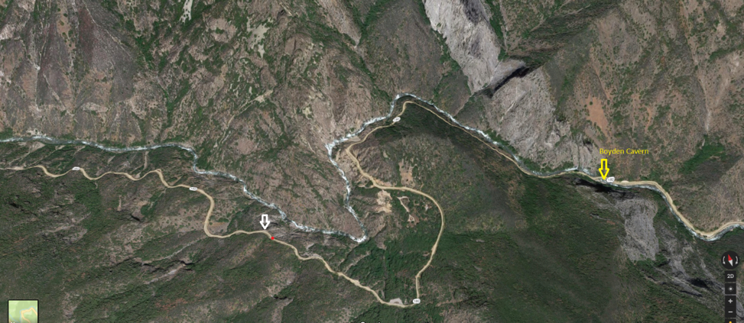
Boyden Cavern: See sekiclimbing.com for more info
Chrome Dome: See sekiclimbing.com for more info

