THEMED TABLE SETTING
COMPETITION

“FRESH FROM FLORIDA”
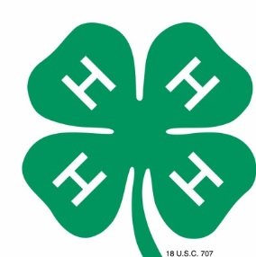

Create a table setting for four (4) using a “Fresh From Florida” theme.

Rules:
- Entries may be submitted by 4H & FFA groups ONLY.
- Entries will be judged and awarded Ribbons and Cash Prizes.
- Placing/Awards will be awarded as follows:
1st Place – Blue Ribbon & $100.00 Cash Reward
2nd Place – Red Ribbon & $50.00 Cash Reward
3rd Place – White Ribbon & $25.00 Cash Reward
- Square card table, coverings, decorations, menu & tableware are all the responsibility of the entrant
- Tables MUST BE square & standard card size (34x34), no larger and NO ROUND TABLES
- No chairs or benches allowed
- Table decorations must last for the duration of the fair & should be limited to table top only
- Menus are required
- Electricity will not be available
- Please provide an index card with the name of group, contact person & phone number. Place card under one of the plates on your table. Your name can not appear anywhere else on your display
- Displays with fresh flowers, plants or other perishable items will be disqualified
- Registration forms must be turned into Penny Buckles by March 31, 2018. You can email to flaglerctyfair@bellsouth.net
- All tables will be on display at the fairgrounds during the upcoming Flagler County Fair & Youth Show
- Entrants shall assume all liability for table decorations placed on tables. The Flagler County Fair and its staff are not responsible for any damage or loss.

Judging Criteria: 100 POINTS
General Appearance – 40 Points
Originality – 30 Points
Theme Conformance – 20 Points
Correct Table Setting – 10 Points

Important Dates & Deadlines:
- April 2nd, 2018 (10am-8pm) – Groups will be allowed to set their tables up
- April 3rd, 2018 - Judging
- April 8th, 2018 after 6pm - April 9th between 5pm–7pm – Take down table setting

Contacts for this Competition:

Penny Buckles, Fair Manager 386-931-6597 or Ennasea Coute 386-627-4122
Email: flaglerctyfair@bellsouth.net
Website: www.flaglercountyfair.com

FLAGLER COUNTY FAIR & YOUTH SHOW, INC.

2018 THEMED TABLE SETTING COMPETITION
REGISTRATION FORM

THEME: “FRESH FROM FLORIDA”

NAME OF ORGANIZATION ______4H _______FFA
GROUP NAME______________________________________________________
CONTACT PERSON__________________________________________________
PHONE NUMBER___________________________________________________
ADDRESS_________________________________________________________

Signature :_________________________________________Date____________

TABLE #_____________(fair use)

