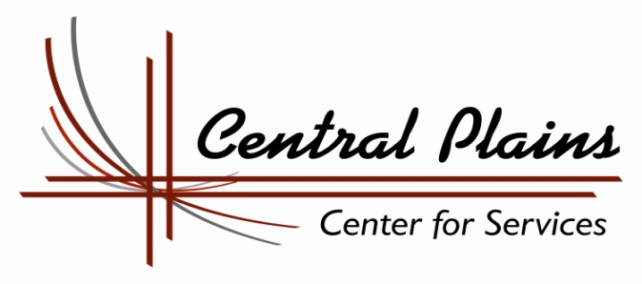

Education & Training Voucher Program - ETV

Central Plains Center for Services, through a contracted partnership with the Nebraska Department of Health and Human Services, administers the Education and Training Voucher (ETV) Program. This program provides financial assistance for tuition, fees and books, as well as one-on-one support, for current and former state wards to attend college.
Am I eligible?

Yes…if you have graduated from high school or obtained a GED and meet one of the following criteria:
- State or Tribal wards who are age 17 or older.
- Youth who were in the State or Tribe’s custody and received guardianship or adopted status at the age of 16 or older and have yet to reach age 21.
- Youth who were in the State or Tribe’s custody on their 17th birthday and are now between the ages of 17 and 21.
- Youth participating in the ETV Program on their 21st birthday, are eligible until they turn 23 years old, as long as they are enrolled in a post-secondary education or training program and are making satisfactory progress toward completion of that program.

  - Youth must be attending public or private four-year colleges or universities, two-year community colleges, vocational-technical schools or specialized non-profit trade schools as defined in the Higher Education Act of 1965.
How can ETV help me?

You can receive up to $2,000.00 per year (an individual shall not exceed the lesser of $2,000.00 per year or the total cost of attendance).

ETV funds can cover the following school related expenses:

- Tuition and Fees
- Books
- Application Fees

How do I apply?

You must complete an application and return it to us. You can get an application at:

- Website: www.central-plains.org
- Your local HHS Office
- By calling us at 308-872-6596
How do I know if I have been accepted into the ETV Program?
- Once your application is received at our office, our Youth Education Specialists, Andra White or Jessi Mason, will contact you by phone to review the application as well as review with you the services ETV will be able to provide.
- For questions please contact Central Plains Center for Services at (308) 872-6595 or by email at centralplains6176@msn.com.

EDUCATION & TRAINING VOUCHER APPLICATION

Part A- Applicant Information

Today’s Date: _______________

Name: _________________________________________________________________________
Birth Date ________________________ Telephone # _________________________________
Current Address (both mailing and street) ____________________________________________
City ___________________________ State ___________________ Zip _________________
Email Address ___________________________________________________________
Date of dismissal from State’s Custody _______________ Age at time of dismissal _______

Or, if applicable: Date of expected dismissal from State’s Custody _____________________
Tribal Ct. Jurisdiction at time of dismissal (if applicable) __________Date of dismissal_____
Social Security # _______________________________________________________________

Desired date of college/school entrance? ___________________________________________

Required demographic information (current)
Age ____ Gender_____ Race/Ethnicity __________ Tribal Affiliation (if any) ____________
Special Needs, please specify _____________________________________________________
Married? Yes, _____ No,______ Are you a parent? Yes ______ No ______
If yes is the child living with you? Yes ___ No___; If not are you paying support? Yes__ No___
Are you employed? Yes ___ No____ If so, is it considered part time _____ or full time _____

A. PROTECTION AND SAFETY WORKER INFORMATION (IF APPLICABLE)
P&S Worker: ________________________ Phone (_____)_____________________________
Office Location (City) ____________________________________________________________
For PSW: Please indicate what the youth’s permanency and independent living plan is:
______________________________________________________________________________
PSW Signature: ________________________________________________________________

By signing this Education and Training Voucher Application, I authorize the school I am attending to release all requested information to Central Plains Center For Services. In addition, I agree to comply with my outlined Education Plan and verify that the information in this application is accurate.

Applicants Signature: ___________________________________________________________
Date: _________________________________________________________________________

Education and Training Voucher Application
Part B – Education and Training Plan

The purpose of this plan is to ensure that your educational needs are met. It is very important that as a participating youth, you have applied for admissions, been admitted, and have enrolled at your chosen school.

The following is a list of steps to complete prior to applying for the Education and Training Voucher Program:
- Apply for admissions if necessary
- Complete admission testing if necessary
- Complete the Free Application for Federal Student Aid (FAFSA)
- Register for classes
- Gather billing statement for tuition and fee charges
- Gather book costs for classes (this information is available at the campus book store or on the college website)

Please complete Part A of this application and return it to us with the following documents:
Class schedule
Bill for tuition and fees
Exact cost of books needed for classes
Financial aid award letter from the college; or FAFSA confirmation page

Please submit your application and required documents to:
Central Plains Center For Services
908 South E Street
Broken Bow, NE 68822
Fax: 308-872-6596 Email: centralplains6176@msn.com

Have questions? Please contact one of our Education Specialists:
Andra White Jessi Chandler Mason
awhite@central-plains.org jmason@central-plains.org
308-872-6595 308-749-2580

Once your application is received at our office, an Education Specialist will be in touch with you by phone within 2 days.

