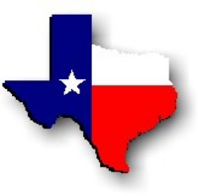Texas History with Mr. Brown Name _______________________________________ Period _____

Ch 17 Section 2 Review: The Cattle Trails

Directions: Use your study guide to answer the following questions.
1) After the Civil war the demand for ________________________ increased.
2) What allowed beef to be shipped to markets in the north and east?
3) Where did Joseph McCoy build the first Cow Town?
4) What happened in Cow Towns?
5) The Chisholm Trail was the first great __________________________________________________.
6) How many long horns were driven from Texas to Abilene, KS?
7) Why were cattle branded?
8) How long would a cattle round up take?
9) What did a scout do?
10) What was the pointers job?
11) What responsibility did the flankers have?
12) Why would cowhands take several horses on the trail?
13) What did most cattle trail chuck wagon meals consist of?
14) The ________________ would ride ahead in the chuck wagon to the next campsite and have dinner ready for the cowhands.
15) Often cowhands would gather around the campfire at night and ______________________.
16) The sad ballads of cowhands contributed to the development of _______________________.
