Teacher Notes for "Death on The Needle” by Chris Kersey

Overview

This novel study can be cross curricular with exciting small and large group activities or simply a literary experience that highlights Character Education or Civics Studies. The following classroom management and learning ideas are for a two to three week study with the Guided Reading component taking approximately 1/2 hour followed by any of the other activities you wish to use based on your class size, your facility, student achievement, and student interest. The teacher resources and samples you will need are at www.chriskerseybooks.com. Please photocopy for free.

The student’s study worksheet can be made into a booklet or each sheet can be individually photocopied to suit your purposes. There is a cut out at the bottom of each page for teachers needing a way to accumulate points for an on-going classroom program or points for the "Survivor Rarotonga Tribes" which is one of the terrific activity options I discuss later on.

Please share your "Death on The Needle” successes and projects on youtube remembering to send your link to me at ck@netscape.ca I will post it on my website for all to enjoy and to be inspired. Please include “Death on The Needle” somewhere in the title of your youtube submission. Community, kindness, wisdom, co-operation, and leadership are attributes demonstrated by your willingness to share ideas. Thank you.

Finally, I have modified the worksheets to reflect the different approaches to Character Education currently taught in Canadian Public, Catholic, and Christian schools along with the Six Pillars used in the United States. I hope you will find a template that suits your needs regardless of your location or setting. Home School Education is another approach I am anxious to support with my teacher resources and welcome any ideas that work in the home school setting. Please send your ideas to ck@netscape.ca

Kia orana,
Chris Kersey-Member of Ontario College of Teachers

Classroom Preparation (based on cross curricular study)
DAY ONE- Since you are accessing students’ prior knowledge and setting them up to read the first chapter, this lesson goes over 30 minutes.

STEP ONE: TEACHER-DIRECTED…..(Find graphic for smart board or power point on www.chriskerseybooks.com under Teacher Resources then click on Media and Haka)

Present the front cover of the novel before distributing the books.
Chart #1 is a “T” chart with the heading "death on the needle” as presented on the front cover.
Have the students brainstorm what they think the story will be about.
List all their ideas on the left side of the “T”

STEP TWO: TEACHER-DIRECTED or small group option
Distribute a copy of the novel or open the electronic version to the BACK COVER.
Have the students read the description on the back cover, examine the graphics.
* (You can lead the next step or let the students break into small groups to share what they have discovered)
Ask them to tell what knowledge they have learned from the back cover.
Fill in the right side of the chart and stroke out anything on the left side that is incorrect about the story.

STEP THREE: Chart #2 is to list as headings all the key words on the
back cover. As the novel progresses more info can be added under each of the headings either by the students or the teacher.
Under each heading have the students share what they already know about the topic.
CANNIBALISM..TRIATHLETE..CYCLONE..RAROTONGA

STEP FOUR: Another “T” chart for Maori words on the left and the English translation on the right. As the students find Maori words in the story, they can be added to the chart with the meaning.

STEP FIVE: Hand out the complete study booklet or Chapter One sheet
(If you have already defined the attributes of Character education to your students in previous lessons/months, you may simply draw their attention to the border around the worksheet. Tell them to be aware of characters demonstrating one of the attributes in this chapter.
If your students are not familiar with the character attributes you’ll be focusing on, then you can wait till you have read the first chapter and then discuss them)

The next 15 lessons are easily followed on the individual worksheet for each chapter. This will take you to the end of the novel study. Encourage students to continue writing their answers on the back of the daily sheets if there isn’t sufficient space in the lines provided.

CROSS CURRICULAR ACTIVITIES, ENRICHMENT QUESTIONS, RESEARCH IDEAS

Here are QUESTIONS to be used in small groups or in a reflection journal at the end of each chapter or at the end of the novel.
TEXT to SELF
What does this story remind you of?
Which character in the story do you relate to why?
Has anything happened in the story that reminds you of your own life?
TEXT TO TEXT
Does this story remind you of another book you’ve read or a movie you have seen?
How is this text different or similar to other books you have read?
TEXT TO WORLD
What event in this story is similar to events that have happened in the real world?
How are they different?
Compare true facts about the Cook Islands to the ones in the story.

CROSS CURRICULAR ENRICHMENT & FUN
Quick overview of subject areas
Math-metric measurement, integers
Science-fresh/salt water, bike technology/engineering, cyclones, reversed constellations
Geography-migration, reversed seasons
History-Captain Cook, Captain Bligh, cannibalism, Christianity
Music-creating music and video for Emma’s song, Haka( Teacher Resources on www.chriskerseybooks.com under Graphics Haka)
Art-Tattoos around the world, Tribal logos, posters, postcards, travel brochure,
Physical Ed.-games, floor hockey, divide triathlon run into accomplishable parts for each gym period, triathlons, Ironman competitions
Citizenship-random acts of kindness, identifying character attributes and internalizing the information, group work, team decision making

SURVIVOR RAROTONGA
Make your study memorable by using this idea. You can begin immediately or wait until Chapter 8 to set up the tribes. With groupings of less than 6, each tribe accumulates points by doing the activities listed below and any that you wish to include.
Divide your class into TRIBES. They can choose a Maori word from the novel as their Tribe name or use the name of an island in the Cook Islands.

Once the names are chosen, they can make headbands from construction paper and print their names and graphics on each. These will be used when playing the games listed below. They can also make a flag and if time permits a chant or cheer.

Make a CHART with the names of the tribes listed across so points can be tracked. Post this where they can see their totals and strategize how to gain more points.

ACTIVITIES for Gaining Points.
DAILY POINTS...At the bottom of their daily chapter study sheet there is an option to cut off a reflection on Character Education. This can be handed in at the end of the lesson or placed in a wooden bowl or some container that represents Rarotonga. Each person who submits the bottom of the page receives a point for his/her TRIBE.
At the end of the day, the teacher can draw three or four of these entries for bonus points or for prizes. READ THEM ALOUD if you wish to model examples or for class discussion.

FRIDAY or MIDWEEK ACTIVITIES
Activity #1 COCONUTS (a knowledge of integers is needed)
Each tribe is given a sheet on which to write the five W questions.
This activity can be 15 minutes or as long as you can come up with questions and keep the students’ interest.
Who?
What?
Where?
Why?
When?
Based on the reading of the week, the teacher will ask questions on the contents of the novel. The teacher announces the type of question. Each tribe decides how many coconuts they think they can wager based on the type of question.
10-means you are absolutely certain you will be able to answer
1-means you don’t think you can answer at all.

(For example, a “Where” question might seem easy for the tribe to answer so they wager 9 coconuts)
They print the amount beside the “Where”
Where? (9 coconuts)
The teacher generates the question.
The tribe whispers amongst the group to formulate the answer and decide what to write down on the sheet beside their wager.
Once all tribes have written their answer beside their wager
the teacher gives the correct answer.
If CORRECT the tribe puts...................................................................9
at the side of the sheet.
If they are incorrect it is -9.

They continue to wager coconuts based on the type of question the teacher is going to ask.

COCONUT Values
10-means you are absolutely certain you will be able to answer
1-means you don’t think you can answer at all.

You can model this chart on the board and have each tribe make their own .

Teacher “ The first question is a “what” question”
(below is an example of the students’ sheet)
What ?......5.........................................................
Teacher “Decide as a tribe how many coconuts you think you can earn”
Teacher “Ready? Here is the question. What is the length of the running component of the triathlon?”
Students write down their answer after discussion.
What?....5.............39km
Teacher “The answer is 42.2 km”
Teacher “ If you are correct put the amount of coconuts you earned on the right side of your page. If you are wrong put minus the amount you wagered.
What?....5.............39km........................................................-5
Continue asking the W5 questions. At the end each team tallies the score and it is put on the SURVIVOR RARO chart.

Activity #2 CYCLONE (half an hour to 40 minutes)

These activities are to be done in the GYM. Most games use wind to accomplish a task. Ask the students to come up with some as well using their knowledge of lift and aerodynamics.

The tribes wear their headbands and sit along the perimeter of the gym. Let’s say you have 6 tribes of 5 students.
Each tribe chooses one person to do the task.

Task #1(materials...masking tape, pizza box, dozen eggs raw or boiled, one minute timer)
Place a square of masking tape at on the gym floor. This is the target
Place a line of tape about 3 metres from the target.
The contestant must use a pizza box or large cardboard square to fan air at the eggs and move three raw eggs or hard boiled eggs across the gym floor and into the square in one minute.
If they succeed they earn points(determined by the teacher) for their tribe.
Each tribe takes their turn. Keep score.

Task #2(materials... small, light feathers)
The contestant chosen must keep two feathers in the air at all times for one minute by blowing air from their mouths.
This looks easy but it is not. You can use three feathers and if all three are still in the air give bonus points of 6. If two are left 4 and if one is left 2 points. It’s up to you.

Task #3 (materials.... an empty tissue box with small opening, put a rope through it so the box can be tied to the back of the contestant’s waist with the box opening facing out, 5 or 6 ping pong balls)

Tie the box around the waist with the knot at the front of the contestant and the box opening facing out from his/her back. Place 5-6 ping pong balls in the tissue box. In one minute, the contestant must jump up and down, back and forth in an effort to have all the ping pong balls jump out of the box and to the floor. You can assign points for how many ping pong balls are removed from the box by their contortions.

Task #4..(materials... 6 plastic pucks)Puck Head.... This does not use wind but is related to hockey.
The contestant must hold 3 pucks in each hand and try to place all six on his/her forehead balancing them until all six are in place. They have one minute.

Task #5..(materials...foam discs)Cyclone Debris Throw foam discs in Frisbee fashion to tag members of the opposite tribe. It’s a type of dodge ball without the ball. This is a two – three minute game between two tribes until all tribes have participated. Points go on chart for each tribe.
Cut disks from a foam sheet or order below.
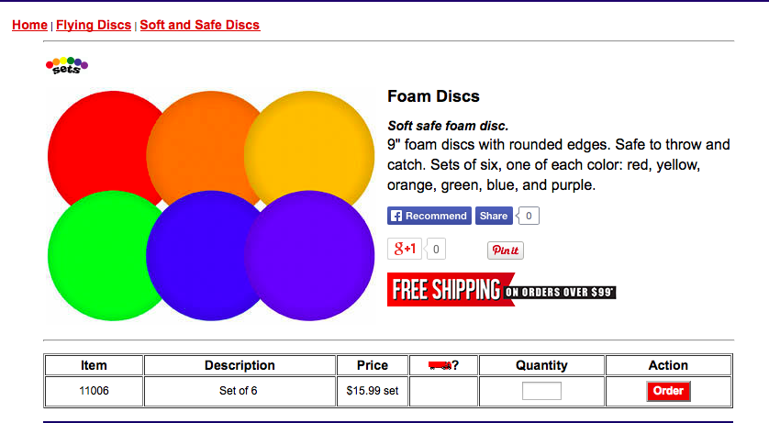

These discs are from Palo Sports

Below is a Win it in a Minute kit from S & S Worldwide supplier of Phys. Ed equipment. Your facility may already have the kit
featured below.

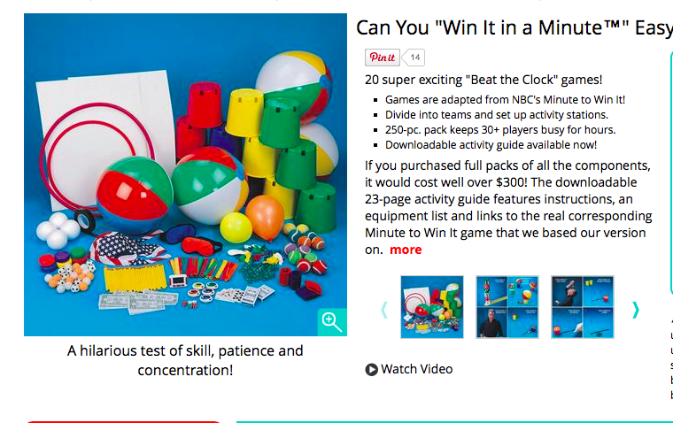

Task #6 HOCKEY IN PARADISE
This is simply floor hockey. You’ll need 8-10 sticks, two nets and either a plastic puck or tennis ball. This activity would require a full gym class period.
Two tribes at a time will play for 2 to 3 minutes attempting to score a goal.
You will put one player in goal and 3 to 4 players trying to score and defend their net.
Keep track of the winning tribes each week and at the final competition have the most winning teams play for the championship.
Assign points for each goal or for wins and losses.

RESEARCH TOPICS and more

Student independent inquires with oral or concrete reports to the class might include the following topics
- Kids of Steel
- Captain Cook
- Famous Triathlete Olympians and Ironmen
- Tattoos
- Cannibalism
- The Cook Islands
- Emma Grace Stewart
- Cyclones

MUSIC
Use the lyrics from the song Jackson wrote for Emma on pages 78-79 and create the music to match it. Put your music and vocal on youtube then put send your link to this email address ck@netscape.ca
I will post your video on my website to be shared with other students and teachers.

ART
Create a poster for a triathlon on Rarotonga.
Create a poster for the Emma Franklin Photography Competition using the Rarotonga Flycatcher motif.
Draw a postcard of a scene from the novel to represent the beauty of Rarotonga.
Create a TRAVEL brochure for the Cook Islands.
Make a poster of the love song using an appropriate border and using calligraphy or similar computer font.

WRITING
In the middle of the novel and at the end of the story, write a letter to Tip that you think would help him with his life choices.
Write a letter to the author Chris Kersey
Write a letter to Jackson.
Write a headline and newspaper article reporting on the murder.
Write a headline and newspaper article reporting on the events of Cyclone Pam.

