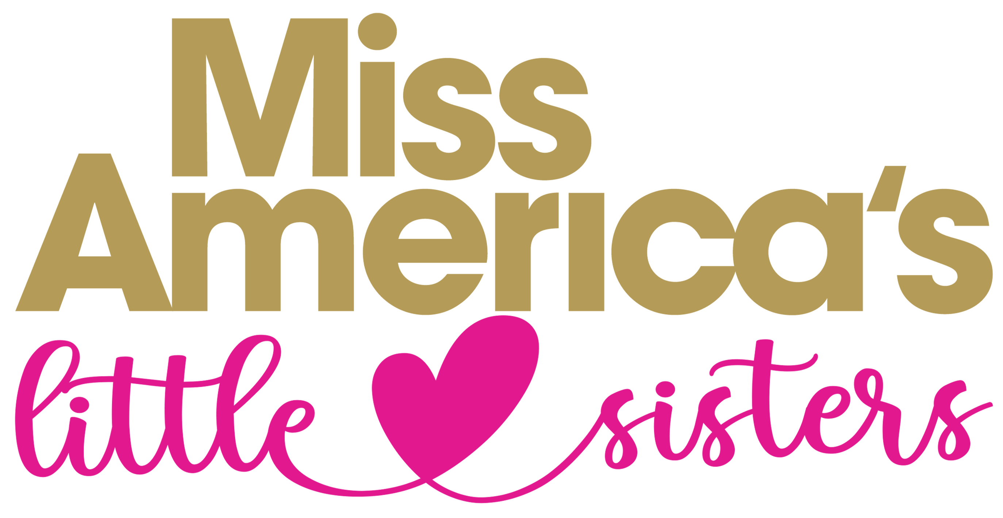

WHO: Young ladies ages 3-12
WHAT: Blackhawk Valley Besties is a non-competitive youth mentoring program through the Miss Blackhawk Valley Organization as part of the Miss America’s Little Sisters Mentoring Program. Each participant will receive an official sash, tiara, and t-shirt. During the Miss Blackhawk Valley competition, she will learn and perform a dance, model a dress, and be crowned a Blackhawk Valley Bestie on stage. She will learn the dance and walking pattern the day of the competition. Various events (not mandatory) will be held throughout the year to allow these young ladies opportunities to spend time with the Miss Blackhawk Valley Miss and Teen titleholders, build friendships with peers, learn valuable life skills, perform in front of audiences, and grow as an individual. The goal of this program is to provide a mentoring relationship with older delegates and titleholders, teach well-rounded speaking skills, develop performance skills, and learn about the Miss America Opportunity. Should she choose, there will be an opportunity to attend Miss Illinois in June as part of their Little Sister program during a week filled with many fun events and activities. This is NOT mandatory. Additional fees will apply.
WHEN: The coronation of Blackhawk Valley Besties will take place during the Miss Blackhawk Valley competition on Sunday, November 5th. Schedule of Events for this day TBA, but likely will need to arrive early afternoon to begin rehearsal. Nicole, BHV Besties Director, will inform you of details as we approach this date as well as any changes that may occur. Additionally, you will keep in contact with Nicole throughout the year to discuss appearance opportunities and upcoming events.
WHERE: Rockridge High School in Taylor Ridge, IL. The address is as follows:
14110 134th Ave W, Taylor Ridge, IL 61284
HOW: To participate in the program, there is a $125 entry fee (cash or check) due the day of the Miss Blackhawk Valley competition. Please make the check payable to the Miss Blackhawk Valley Scholarship Program. Each participant will also need to have an entry form submitted.
**A dance will be taught and performed on stage during the Miss Blackhawk Valley competition. The attire for this will be the t-shirt provided by our program, white pants, and shoes of your choosing (easy to dance and walk in).
**Your participant will model a WHITE dress on stage. This can be whatever style she wishes to wear but MUST be WHITE per Miss America guidelines. Her coronation will be in this dress.
If you have any questions, email Nicole Munoz at bhvmentorprogram@gmail.com

Revised 9/22/23

