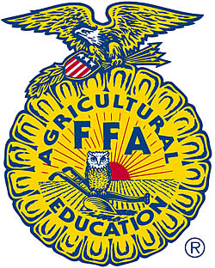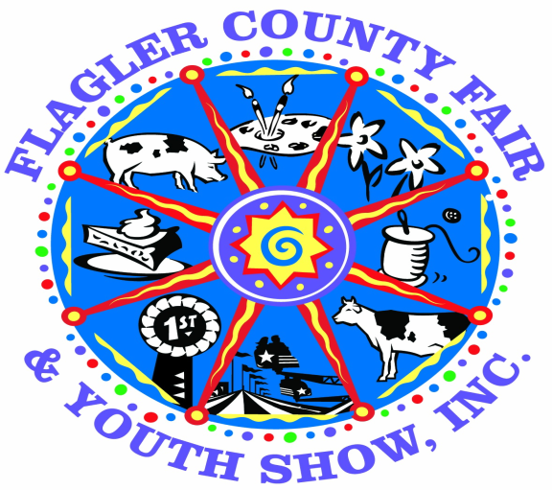

**4-H and FFA Youth Pullet Project and Show**

**Entry Deadline: October 1st, 2018**

**BRING REGISTRATIONS TO THE CATTLEMANS HALL FROM 4 PM TO 8 PM**

**PULLET DIVISION OPEN TO CLOVERBUD, JUNIOR AND INTERMEDIATE 4H AND FFA MEMBERS**

**Superintendent: Jeanette Jones**

Receiving for pullets will be April 2, 2019 from 3 pm to 6 pm. at the Livestock Barn. Showmanship and Judging will begin at 5:30 pm on the Wednesday April 3rd at 5:30 pm prior to the Steer and Goat Show. Removal will be Sunday April 7th after 6:00 P.M.. Please use entrance from Sawgrass Road to drop off animals. The State Inspector will be available during these times only to inspect birds. Birds that arrive at any other time will be asked to leave the premises. The Fair Association reserves the right to refuse entry to any fowl that appears to be sick, diseased or infected with lice or mites. Any fowl disqualified by the judge, must be removed immediately by the exhibitor. All other entries must remain for the duration of the Fair. Exhibitors must make their own arrangements for delivery.

* Poultry will be limited to the first 25 entries. They will be date and time stamped.
* Poultry must be brought to the fair in a ventilated container and may not be removed until the inspection is completed, then may be placed directly into their cages by the Exhibitor only. All storage containers must be removed from livestock barn during the fair. Exhibitors must make their own arrangements for delivery and pick up of the birds.
* Once the birds have been received, exhibitors may not relocate their birds.
* Exhibitors may not handle birds during the operating hours of the fair.
* ALL BIRDS WILL BE AUCTIONED AND SOLD. NO EXCEPTIONS!
* Your birds will be auctioned off in the livestock arena prior to the livestock sale. You will be required to follow the rules for proper attire that are in the livestock rules.
* No signs or unauthorized cards are to be placed on the cage except by the official superintendent**.**
* NEW FOR 2019! YOU ARE REQUIRED TO CLEAN YOUR CHICKEN CAGE, UNDER YOUR CAGE AND DISMANTLE PEN ONCE CHICKENS ARE REMOVED AFTER FAIR. A PENALTY OF $50.00 WILL BE IMPOSED IF YOUR PEN IS NOT CLEANED AND WILL BE DEDUCTED FROM YOUR PROCEEDS

**PULLET EXHIBITION CLASS**

Exhibitors will be limited to showing female birds under the age of 6 months- DO NOT BRING ROOSTERS!

All pullets must be purchased through the Fair Board

**ROSETTES AND AWARDS**

**Awards will be given on April 2nd after judging.**

* All entries will receive participation ribbons.
* Best of each Breed will receive a Rosette.
* Best of Show will receive $50.00 and a Rosette.
* Showmanship awards will be given to each age division and will receive $50.00 and a Rosette.
* No rosettes will be given to Cloverbuds – they will receive participation ribbons.
* Record Book awards will be given to each age division and will receive $100.00 and a Certificate. (Must score 80 points or higher)

**Rules: Pullet Division**

1. Eligibility of Exhibitor: Qualified 4-H and FFA Members, 5 to 18 years of age (as of September 1, 2018). 4-H and FFA members must be enrolled in good standing by October 1, 2018.
2. Eligibility of animal: Exhibitors must have purchased their pullets from the Fair Board in October, 2018. Rules for judging will be strictly adhered to. Each exhibitor will pick one specific breed when they turn in their registration form. Due to limited space, birds will be accepted on a first come first served basis. Because of their pugnacious disposition, roosters will not be accepted.
3. Entry forms: Completed and signed Official Entry form must be received no later than October 5, 2018 to ensure entry into the shows. Incomplete, unsigned and late entry forms will be declined.
4. All eggs laid during the show become the property of the fair association.
5. Health Requirements: Poultry will be tested by a state livestock inspector on receiving date and animals received after that time will be denied entry into the fair. State Health and USDA requirement will supersede any other rules or health requirements.
6. Removal Date: All pullets must be removed from the barn on Sunday April 7th after 6:00 p.m. The Flagler County Fair will not be held responsible for any animal left in the barn.
7. Records Books: are required for all age divisions.
8. Fair Board will feed and water the pullets during the fair.
9. Exhibitors may bring any excess feed left over to feed pullets during the fair.

**A PULLET CLINIC WILL BE HELD ON OCTOBER 27th AT 9:00 A.M. AT THE BUNNELL FEED AND SUPPLY. ALL EXHIBITORS AND A PARENT MUST ATTEND TO BE ELIGIBLE TO PARTICIPATE IN THIS PROGRAM..**

**SHOWMANSHIP**

1. Entries must be a Pullet Exhibitor and show a pullet they have entered in the fair.
2. All entries are required to participate in showmanship.
3. Exhibitors will demonstrate showmanship on an individual basis to the Judge.
4. Rosettes and $50.00 will be awarded in each age division for showmanship winner.
5. Cloverbuds are not eligible for Rosettes.
6. Showmanship is scheduled for April 3rd at 5:30 p.m.
7. Proper 4H and FFA Attire is required (see attached guidelines)

**RECORD BOOKS**

1. Record books will be required on all pullets.
2. Record Books due at the County Extension Office no later than May 1st at 4:00 p.m.
3. Certificates and $100.00 will be awarded in each age division. (Must score 80 points or higher)

**SALE OF PULLETS**

1. The pullets will be live auctioned off in the livestock arena prior to the livestock auction on April 5th. Each exhibitor will be required to bring pullet into the ring for sale.
2. Pullets will be sold to the highest bidder during the auction.
3. Pullets must remain at the fairgrounds until Sunday April 7th After 6 PM
4. Exhibitors should make arrangements with their respective buyers on issues concerning pick- up and delivery. The pullets cannot be removed from the fairgrounds prior to 6 PM on Sunday

April 7th. NO EXCEPTIONS!

**Appropriate Attire**

1. **Attire:** Exhibitors will be REQUIRED to show and sell in appropriate 4H or FFA clothing. Exhibitors will **NOT** be allowed in the ring if not appropriately dressed. The guidelines are included in the rules, for any additional questions see your 4H Agent or FFA Advisor.

**FFA –** White shirt with white collar, Dark black jeans or slacks, appropriate tie or scarf as outlined in FFA guidelines.

**4H –** Black pants, belt, white shirt with collar, 4H insignia, 4H jacket

No hats, caps or headgear.

Closed toe shoes or boots (dark in color) **TENNIS SHOES ARE NOT ALLOWED.**

Clothes should be well fitted, with pants worn at the waist. No baggy, gaudy or otherwise inappropriate clothing allowed in the show/sale ring (including bling)

Shirts must be tucked into pants.

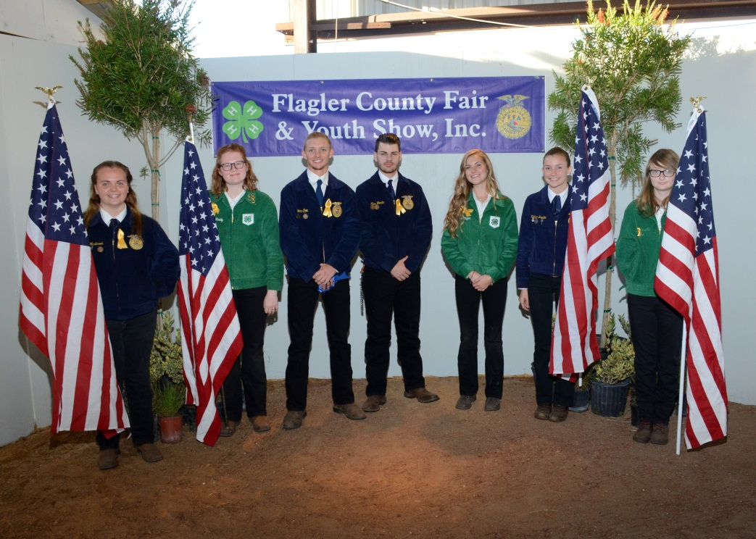

**Dorothy Wright Bullard Award**

**The purpose of this award is to:**

* ***Encourage more youth participation and increase entries in the Flagler County Fair and Youth Show’s other divisions.***
* ***Encourage currently participating youth to explore other divisions***

**All livestock exhibitors are required to participate. Including chapter animals.**

**Requirements:**

1. **Must be a resident of Flagler County or attend a Flagler County School AND be a member of an appropriate Flagler County 4H Club or FFA Chapter. *Exhibitor must meet minimum membership requirements of the respective club/chapter as accepted by the Flagler County Fair and Youth Show***.
2. **Age Requirements AS OF SEPTEMBER 1, 2018**

**Junior 8 to 10 years Intermediate 11 to 13 years Senior 14 to 18 years**

1. **Any youth participating in any livestock exhibition (including rabbits and chickens) must participate in at least 3 or more of the following programs:**
   1. **Horticulture**
   2. **Home and family Division (a list will be provided of each division within this division - you can enter this division numerous times)**
   3. **Shoe Box Float –**
   4. **Country Critter**
   5. **Skillathon – To be determined**
2. **All non-perishable entries must be turned in Sunday March 24, 2019 from 1 pm to 8 pm at the cattleman’s hall. All perishable food items must be turned in on Monday April 1st from 5 pm to 8 pm. (Please see the rules for each division you are entering in.) If you have not met this requirement, you will not be permitted to show or sell your animal.**
3. **All entries must be picked up on Sunday April 7th after 6 pm**
4. **Points awarded based on placing in each division**

**For example:**

**1st place – 20 Points**

**2nd Place – 15 Points**

**3rd place – 10 points**

**Best in Show 50 points**

1. **Cash Awards for each age division**

**Best in Show $50.00 1st Place $20.00 2nd Place $10.00 3rd Place $5.00**

**Buyers Letters**

* Exhibitors are expected to distribute individual letters to prospective buyers in order to encourage their participation in the Flagler County Fair and Youth Show Livestock Sale. You are also required to provide a minimum of 5 prospective buyers addresses to the Fair Board.
* The Flagler County Fair provides each prospective buyer with an information packet and a VIP pass if they are a previous buyer. If they need entrance passes, please contact the fair board.
* The exhibitor is responsible for developing their own list of potential buyers along with their correct addresses by Friday February 15, 2019. (The Flagler County Fair or its representatives will not provide any exhibitor with a list of potential buyers.)
* Suggestions:

**Who to Send to:**

Family Friends Family Business Contacts

Local Businesses Relatives

Producers Any one you think might consider participating in the sale

**What to include:**

Personal Information (Name, Age, etc)

Project Information (Types, Breed, Age, Current or Projected Weight)

Fair Times & Dates (Show, Sale)

Invitation to attend and participate

Optional:

Years experience

Skills learned

Plans for profits (for example: expand project, college, etc)

**Tips**

* Most buyers respond better to handwritten letters.
* Pictures help buyers identify with your project.
* Invite buyers to view your project or meet you before the sale.
* **Have a parent, leader, agent, or advisor proofread your draft copy for errors.**

Buyer’s names and addresses are due at the Fair Board by ***Friday, February 15, 2019*** We will be mailing out buyers passes and an information packet.

Please remember to include your name, the buyer’s full name, and their complete and verified address. (The Bunnell Post Office will not deliver to a street address unless there is a mailbox. We have spent several days trying to hand deliver returned mail in past years because the exhibitors did not use the correct Post Office Box.) It would be very helpful if your addresses were in Microsoft Excel (or almost any table format) and e-mailed to flaglerctyfair@bellsouth.net

* (If you must submit addresses hand written, please be sure they are easily read.)

**FLAGLER COUNTY FAIR**

**4-H AND FFA PULLET ENTRY FORM**

**Entry deadline: October 1st , 2018**

**EXHIBITOR:_________________________________AGE:__________DOB:__________________**

**GROUP/CLUB NAME:________________________INDEPENDENT/FFA/4H (CIRCLE ONE)**

**ADDRESS:__________________________CITY:__________________STATE:________ZIP________**

**TELEPHONE:______________________ EMAIL:_______________________________________________**

**PARENT SIGNATURE__________________________________________________________________**

**PLEASE CHECK AGE DIVISION: ( AS OF SEPTEMBER 1, 2018)**

**( ) 4H cloverbud – 5 to 7 years ( ) 4H/FFA junior 8 to 10 years ( ) 4H/FFA Intermediate 11 to 13 years**

**BREED SELECTION (select 1 breed per exhibitor): Please mark a 1st choice and a 2nd choice**

**___Gold Lace Weyandotte _____Barred Rock ____Buff Orpingtons**

Please make $30.00 check payable to Flagler County Fair. This fee includes a starter kit for your chicks.

**BRING ALL FORMS WITH CHECK TO THE CATTLEMANS HALL ON OCT. 1ST FROM 4 PM TO 8 PM**

Flagler County Fair and Youth Show’s

Parent/4H and FFA Leaders

Code of Conduct

1. I will be responsible for my behavior as well as for the behavior of those who attend the fair as my guest.
2. I hereby pledge to provide positive support, care and encouragement for my child participating in Fair Events by following this code of conduct
3. I will encourage good behavior by demonstrating positive support for all exhibitors, fair board members and volunteers at fair events.
4. I will place the emotional wellbeing of my child ahead of personal desire to win.
5. I will be in control of my emotions.
6. I will remain in the spectator area during all shows and sale.
7. I will support the fair board members and volunteers working with my child, in order to encourage a positive and enjoyable experience for all.
8. I will not advise the Fair Board and Volunteers on how to do their job.
9. I will remember that the fair and youth show is for the youth and that participation in the shows and sale is a privilege and not a right.
10. I will ask my child to treat other exhibitors, fair board members, volunteers and judges with respect, regardless of race, age, sex, creed or ability.
11. I will not make insulting comments to other exhibitors, fair board members, judges or volunteers.
12. I promise to help my child enjoy the youth show experience by doing whatever I can to make the event a more positive experience.
13. We are all volunteers, if you have a disagreement, please bring it to the attention of a Fair Board member and not discuss with others, as this causes a lot of undue stress during a very stressful event.
14. You must respect the volunteers who put their time and efforts into this event.
15. Children need encouragement. Criticism and negativity will cause your child to be less enthusiastic.

The Flagler County Fair and Youth Show Fair Board will not tolerate inappropriate behavior. Consequently at any event, a person verbally abuses, attempts to intimidate, becomes rude, lacks control over their language and/or lacks control of actions towards an exhibitor, volunteer, judge or fair board member; That person will be asked to leave the fair grounds and possibly be banned from future events.

______________________________________________ _________________

Parent/4H or FFA Leaders Signature Date

______________________________________________

Printed Name of Parent/4H or FFA Leader

This form is a “required” form in order for your 4H group, FFA leaders and all exhibitor parents are required to turn in with your animal registration.

2018-2019 Flagler County Fair and Youth Show

Exhibitor and Parent/Legal Guardian Release

For good and valuable consideration, including being permitted to participate in activities on the fairgrounds and participate in the Flagler County Fair and Youth Show, I, for myself, and if applicable for my minor child, my and his or her successors, heirs, assigns, executors, administrators, legal representatives, employees, agents and affiliates (collectively referred to as Exhibitor) forever release and discharge the Flagler County Fair and Youth Show, Inc. and each of its officers, trustees, directors, employees, agents, and affiliates (collectively referred to as Flagler County Fair) from all claims, demands, losses, costs, expenses (including attorneys’ fees and costs), suits, damages, obligations, liabilities, causes of action and judgments whatsoever, in law or in equity, against any of the foregoing, which the Exhibitor ever had, now has or which they hereinafter can, shall or may have for, upon, or by reason of any matter, cause or thing whatsoever including, without limitation, personal injury or death, damage or destruction to property, or theft or other loss to property, arising out of Exhibitor’s participation and involvement in the Flagler County Fair and Youth Show, the Flagler County Fair, or any other event held at the fairgrounds. Exhibitor agrees to and does hereby assume any and all risks of personal injuries to Exhibitor, including death, and damages or other loss to Exhibitor’s property, whether such injury, death or loss of property is caused by negligence of the Flagler County Fair or not. From time to time, photos will be taken of exhibitors and their activities, etc. The fair reserves the right to use these photos for news releases, the fair website, fair related videos and slide presentations, marketing purposes, etc.

The fair will allow members of the media to take pictures of exhibitors and events for publication. At times, AT THE DISCRETION OF THE FAIR. Photographer’s will take photos for resale and make them available to Exhibitors’ and parents. The fair feels that these are legitimate opportunities for the exhibitors to be in the “limelight” and promote the fair.

THE EXHIBITOR, OR HIS OR HER GUARDIAN IS OVER THE AGE OF EIGHTEEN (18) YEARS, HAS READ THE FOREGOING RELEASE AND INDEMNIFICATION AND HAS HAD THE OPPORTUNITY TO SEEK LEGAL ADVISE REGARDING INTERPRETATION, AND HAS SIGNED FREELY AND VOLUNTARILY.

The undersigned acknowledges that the exhibition and care of livestock involved inherent risk of injury and the undersigned, on behalf of themselves and the exhibitor do hereby assume all risk of injury, death or property damage.

This Release was signed on ________day of ______20_____

Printed name of exhibitor:__________________________________

Parent/Guardian signing release for exhibitor.

___________________________ ______________________

Signature of Father/legal Guardian Printed Name Father/legal Guardian

___________________________ ______________________

Signature of Mother/legal Guardian Printed Name Mother/legal Guardian

State of ____________County of _________________

The foregoing instrument was acknowledged before me this________Day of _______, 20____.

Personally Known_________or Provided Identification Shown___________________________

My Commission Expires/Commission Number_______________________________________

**THIS FORM MUST BE NOTARIZED AND SUBMITTED FOR EVERY EXHIBITOR**

**Flagler County 4-H Youth Development Program**

**Exhibitor Requirement Record**

As of September 1, 2008 all Flagler County 4-H members will adhere to the following policies:

***The Flagler County Fair Board states that in order to show an animal in the Flagler County Fair & Youth Show, you must be enrolled in the Flagler County 4-H Youth Development Program by October 1st and be a member in good standing as related to the policies stated below.***

In order to show a market animal in the Flagler County Fair & Youth Show, 4-H members must attend at least 5 club meetings. In the event that a 4-H member needs a make up opportunity, an alternate activity may be assigned to you by the Fair Board. This may include: a community service activity, an extra club responsibility, or a public speaking event. You are allowed one makeup. It is your responsibility to communicate in a timely manner (within one week) with the Fair Board if you miss a meeting to discuss how you can make it up. And it is each member’s responsibility to ensure they have met these requirements.

If 4-H members are enrolled as an independent member, they must meet with the 4-H Agent 5 times before the fair. In the absence of a 4-H Agent, independent members must meet with the Livestock Agent. Clubs meet monthly and so independent members must also meet monthly. If you are enrolled as an independent member, you will need to meet with the agent at least once per month at the Extension Office beginning September and ending in March. Independent members must obtain the 4-H Project Book that relates to their chosen project. The project books available are: Beef, Cattle, Meat Goat, Poultry, and Swine. You must obtain your books from the 4-H office in September, complete one activity per month and discuss what you have learned during your monthly agent meeting. You must also have the agent sign off on your progress using this sheet. Independent members do not have the opportunity for alternate activities as make ups.

If you fail to meet these requirements, you will be denied the opportunity to show your animal in the fair. **This form is due to the Fair Board by April 2, 2019.**

**Exhibitor Requirement Record**

|  |  |  |  |
| --- | --- | --- | --- |
| Monthly 4-H Club or Agent Meeting | Date of Meeting or  Alternate Activity Completed | Leader or Agent Initials | Date |
| Meeting 1 |  |  |  |
| Meeting 2 |  |  |  |
| Meeting 3 |  |  |  |
| Meeting 4 |  |  |  |
| Meeting 5 |  |  |  |
| Alternate Activity |  |  |  |

I agree that all requirements have been met.

Exhibitor: ________________________________________________ Date: ____________

Parent: __________________________________________________ Date: ____________

Leader/Agent: ____________________________________________ Date: ____________

IMPORTANT DATES TO REMEMBER

2019 FLAGLER COUNTY FAIR

APRIL 3, 2019 THROUGH APRIL 7, 2019

PLEASE NOTE: ALL LIABILITY WAIVER AND CODE OF CONDUCT FORMS MUST BE TURNED IN WITH YOUR LIVESTOCK/SMALL ANIMAL APPLICATIONS

October 1, 2018 Swine, Pullet and Rabbit reservation deadline

4 to 5 pm at Cattlemans Hall at fairgrounds

October 27, 2018 Pick-up Pullets at Bunnell Feed

November 8, 2018 Steer Weigh In 3 pm to 6 pm Bring registration

Liability waiver forms to weigh in. Must be

Turned in prior to unloading your animal. If you

Do not have it with you, you will not be able to

Weigh your animal.

Rabbit pick up to be determined.

December 1, 2018 Swine selection Time tbd

December 13, 2018 Mandatory Exhibitor Workshop 6 pm to 8 pm

All exhibitors required to attend including Clover

Bud.

January 25, 2019 Blue Jeans and Bling Fundraiser Cattleman’s Hall

February 15, 2019 Buyers add on lists due to Fair Board.

January 4, 2019 Official Certification of Veterinary inspection

(OCVI) cannot be obtained until after this date

Must be done within 90 days of fair

March 23, 2019 Fair Workday Clean up of barn area and set up

Arena

March 24, 2019 Dorothy Wright Bullard Turn in at Brown

Building – Exhibitor building. (non perishable

Food items as well)

March 31, 2019 Fair Workday Set up of Cattleman’s Hall

Time to be determined.

April 1, 2019 Dorothy Wright Bullard perishable foods turned

From 5 pm to 8 pm

April 2, 2019 All livestock including pullets and rabbit must

Be turned in from 3 pm to 6 pm

April 3, 2019 Rabbit and Pullet Show begins at 5:30 pm

Heifer, Steer and Wether shows begin at 7:00 pm

Heifer, Steer & Wether exhibitor meeting at 6 pm

April 4, 2019 Swine show begins at 7:00 pm

Exhibitor meeting begins at 6 pm

April 5, 2019 Exhibitor Meeting in Barn 6 pm

Pullet, Rabbit, Swine and Steer sale begins 7 pm

April 7, 2019 Removal of animals after 6 pm

Removal of Dorothy Wright Bullard and

Exhibits in Hall can be removed after 6 pm

April 14, 2019 All pens must be cleaned or will be fined

May 1, 2019 Record Books Due at extension office by 5 pm

PLEASE NOTE: ALL LIABILITY WAIVER AND CODE OF CONDUCT FORMS MUST BE TURNED IN WITH YOUR LIVESTOCK/SMALL ANIMAL APPLICATIONS

The Flagler County Fair and Youth Show reserves the right to make changes to the dates and times of each event.

IF YOU NEED ANY ADDITONAL INFORMATION YOU CAN CONTACT ONE OF OUR OFFICERS OR DIRECTORS

Walton Cowart, President 386-931-5384

Penny Buckles, Vice President and Fair Manager 386-931-6597

Sterling Westbrook, Assistant Fair Manager 386-264-1994

Jeanette Jones, Secretary 386-931-9013

Tonya Gordon, Treasurer 386-523-5036

Mike Boyd, Board Member and Livestock Superintendent 386-503-4134

Dan Cody, Board Member and Barn Superintendent 386-503-5335

Kellie Worley 386-931-7916

Craig Barton 386-931-3113

Dowlin Cody 386-569-8256

Ennasea Coute, Dorothy Wright Bullard 386-627-4122