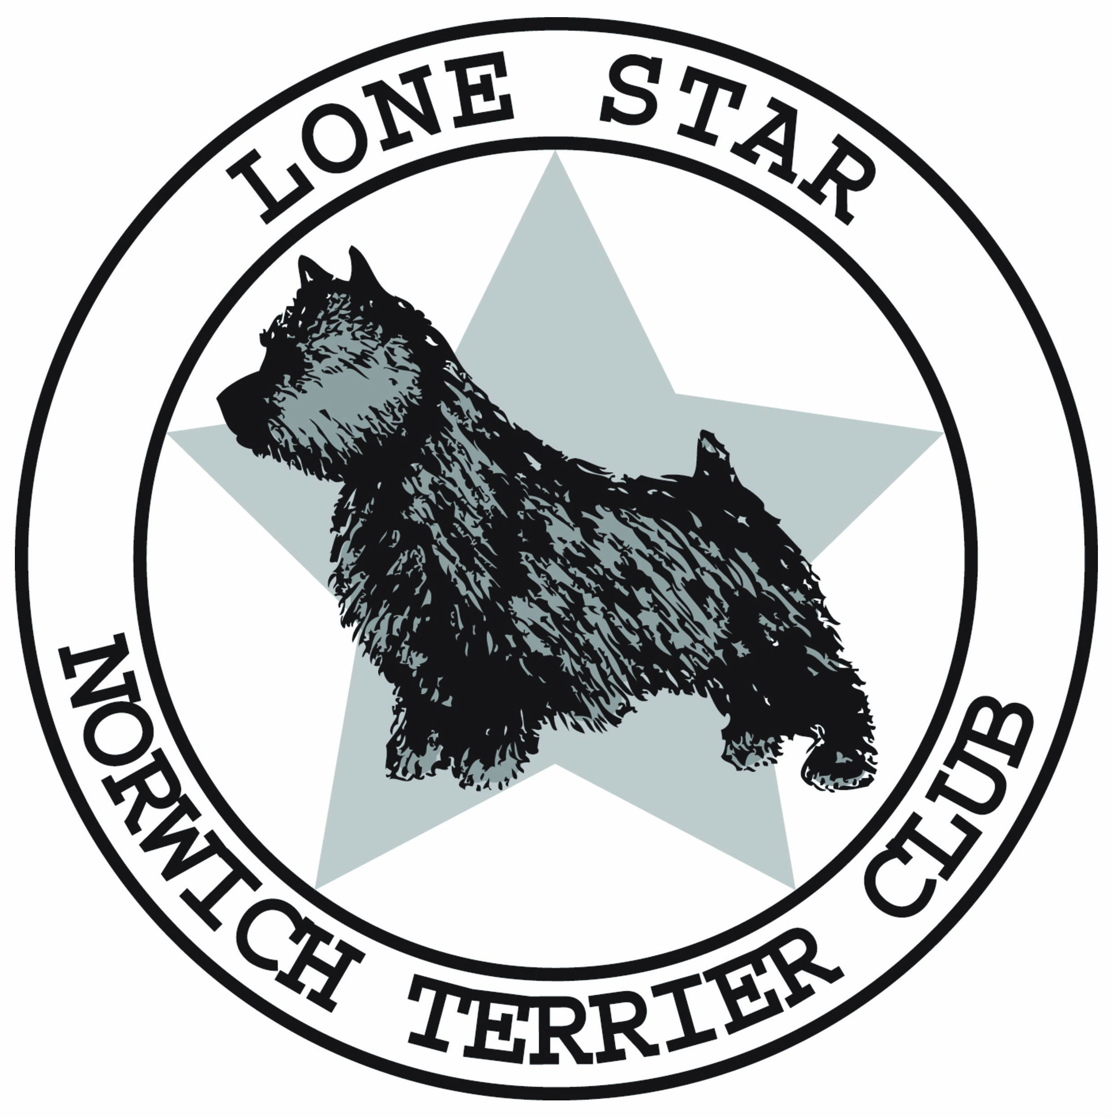

LONE STAR NORWICH TERRIER CLUB
Membership Application
Please Type or Print

Today’s Date_______________
Applicant Name #1 _____________________________________Occupation___________________

Applicant Name #2 _____________________________________Occupation___________________

Kennel Name (for breeders) __________________________________________________________

Mailing Address ___________________________________________________________________

Home Phone____________________________ Cell Phone ________________________________

Email Address____________________________ Email #2_________________________________

Select One Membership Type:

▢ $20.00 - Associate Membership: Entitled to all club privileges except voting and office holding (offered to individuals who live outside of the club’s area; also offered to individuals who live in the club’s area but are not active).

▢ $30.00 – Regular/Individual Membership: Enjoys all club privileges including the right to vote and
hold office.

▢ $40.00 - Household Membership: Two (2) adult members residing in the same household, each eligible to vote and hold office.

About sponsors: LSNTC requires applicants have two sponsors to join. Sponsors must be LSNTC members in good standing who have known the applicant for two years.
Sponsor Name #1 (please print)_______________________________________________________
Sponsor Name #2 (please print)_______________________________________________________

Do you own a Norwich terrier? Yes___ or No___

If yes, how did you acquire your Norwich terrier (s)?
A) A breeder_____ if yes, list breeder __________________________________________________

B) Rescue/rehome/other____ if yes, list name of rescue service or former owner_________________

How many and how long have you owned Norwich? _______________________________________

Please put an “X” by what best describes your activities now and during the past three years.
▢ DO Dog Owner
▢ E Exhibitor in Conformation
▢ O Obedience
▢ A Agility
▢ ED Earth Dog
▢ OTHER____________________
▢ B Breeder
▢ J AKC Judge
▢ R Rally
▢ T Pet Therapy
1. How did you learn about the club?
Breeder _____Friend ____Internet _____Veterinarian _____ Club Member____Other_______
2. Is your Norwich Terrier registered with the American Kennel Club (AKC)? Yes___ No ______

3. Are you a current member of the Norwich Terrier Club of America (NTCA)? Yes____ No _____
4. Are you a member of any other dog clubs? Yes ___No____ If yes, please list:

_______________________________________________________________________________

5. What other breeds do you have?________________Do you breed them?________

If yes, how many litters of breeds other than Norwich have you bred? ____________ AKC Reg? Y / N
6. Are they shown in Conformation____ Agility____Obedience____ Other________
7. How do you house your dogs? ______________________________________________________

8. If you are a breeder of Norwich, how long have you had your breeding program?_______________

How many litters of Norwich have you bred ? ____________________________________________
9. What would you like to learn from the club? Social____ Health Topics of Norwich____Training ___

Conformation____ Breeding ___ Nutrition____ Other (please list)_____________________________

10. Would you be able to volunteer to help the club? Yes____No_____
11. If yes, how could you help the club? Fun Days_____ Auction/Raffle____ Ways & Means ____

Conformation Shows ____Club Photographer _____ Meet the Breeds _____ Website ____

Other____________________________________________________________________________
The LSNTC Constitution and By-Laws, the NTCA Code of Ethics, the AKC Code of Sportsmanship, and the Official Standard of the Norwich Terrier can all be found at lsntc.com

Do you agree to abide by the Constitution and By-Laws of LSNTC ? ⃞ Y ⃞ N

Do you agree to abide by the rules and Code of Sportsmanship of the AKC? ⃞ Y ⃞ N
Have your American Kennel Club privileges ever been suspended or revoked? ⃞ Y ⃞ N
If yes, please explain.
____________________________________________________________________________
Have you read the NTCA Code of Ethics? ⃞ Y ⃞ N
Do you agree to govern your conduct by its terms and spirit ⃞ Y ⃞ N
I / We agree as per the Bylaws of the LSNTC to receive electronic communications (email). Communications will be limited to general mailings and announcements. This is a revocable agreement and I/we agree to release the LSNTC, its Board,and Officers from any liability should communications be received late or not received by the member due to circumstances beyond the control of the LSNTC. (A $10 fee is charged for communications sent by USPS.)

Applicant Signature #1_________________________________________________DATE_________

Applicant Signature #2_________________________________________________DATE_________

★ Membership application is to be submitted independently from two Sponsor forms
★ Membership application must be accompanied by dues payment

Please make check payable to LSNTC. Please mail application and check to:
Claire Johnson, Secretary
2405 Grandview Forest
Canyon Lake, TX 78133

For club use only
Received Date:_______________ 1st reading ______________ 2nd reading ______________

Check # ______________

Approved 07-13-2018

