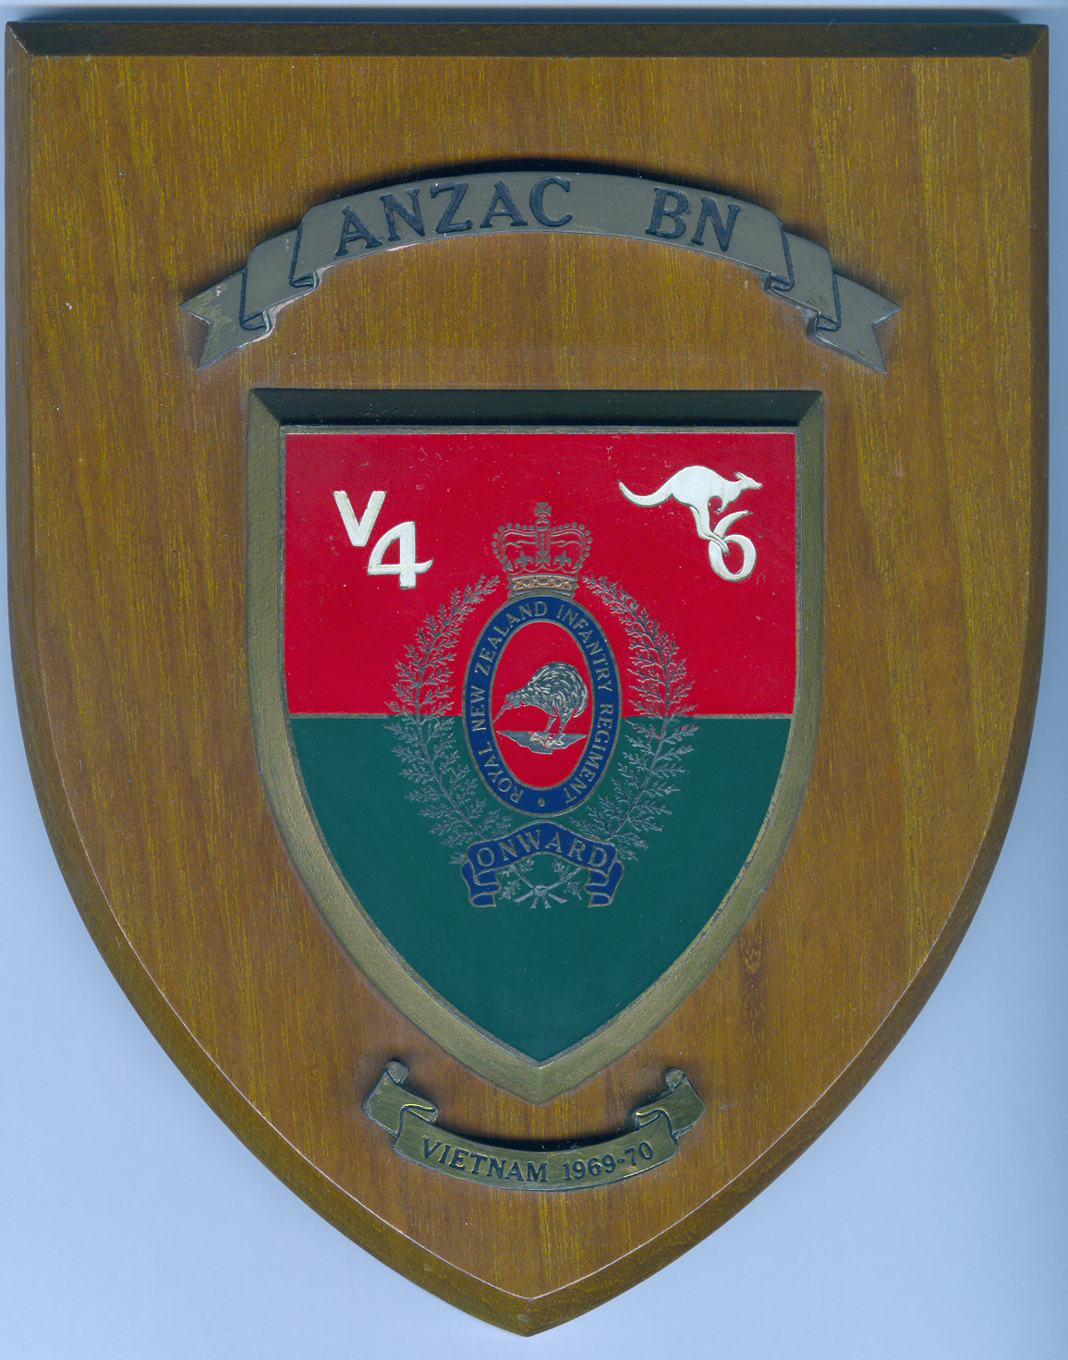
VICTOR 4 COMPANY REUNION
In conjunction with 6RAR
Secretary:
Gordon Nairn
64 Panorama Drive
Welcome Bay
RD5
Tauranga 3175
Ph. 027 5442882
Waiouru
2017

Name: ………………………………………………………………

Address: ……………………………………………………………
…………………………………………………………….
…………………………………………………………….

Contact Ph Number: ………………………….

Number attending the 2017 Reunion: …………………….

Names of others attending: ………………………………………
………………………………………
………………………………………
………………………………………
………………………………………
Accommodation requirements:
Single rooms……..
4 Person room…….
8 person room……..
Campervan site……

Payment can be by cheque to the above address or by direct credit into the reunion account at the BNZ acct number 02-0856-0000403-000

