SCOTT’S MILL HYDRO, LLC

February 8, 2018
The Honorable Kimberly Bose, Secretary
Federal Energy Regulatory Commission
888 First Street, NE
Washington, DC 20426

RE: SCOTT’S MILL HYDROELECTRIC PROJECT
FERC PROJECT NO. 14867
INFORMATION NEEDED TO PROCESS REQUESTED CONSULTATION WAIVERS

REFERENCE: Commission Letter Dated January 26, 2018

Dear Secretary Bose:

In response to the Federal Energy Regulatory Commission’s (Commission) letter dated January 26, 2018, Scott’s Mill Hydro, LLC (Scott’s Mill) hereby transmits the following information:
- Audio recording of the of the December 2, 2015 joint agency meeting (10 files) and joint meeting summary (1 file);
- Draft Study Plans (2 files), Comments on the Draft Study Plans (USFWS, VDCR, VDEQ, VDGIF, City of Lynchburg, James River Association, and VDEQ meeting notes; 7 files) and Final Study Plans (1 file);
- Draft License Application (2 files); and
- Updated Distribution List (1 file).

A complete list of the agency comments on the draft study plan can be found in Appendix A of the draft license application. If you have any questions, feel free to contact me at (540) 320-6762 or Wayne Dyok at (916) 719-7022.

Sincerely,
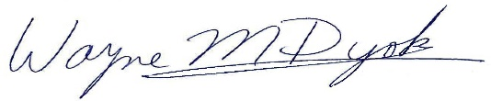 for
Mark Fendig, Managing Member

Note – VDHR stated they supported the cultural resources study plan in a March 17, 2016 email which is included in the draft license application.

