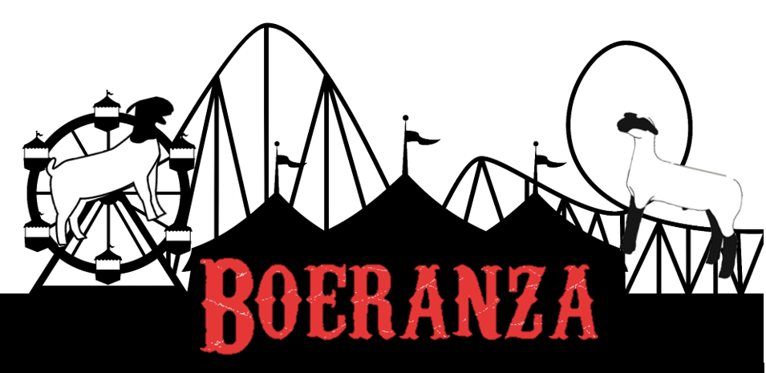

Schedule of Events
JABGA
Friday November 30th
Check in 2 pm – 10 pm
Saturday December 1st
Check in 7 am – 9 am
Sullivan’s Fitting Demo- 8:15am
JABGA Fitting Contest- 9 am
JABGA Public Speaking, Sales Talk, Skill-a-Thon Opens-10am-2pm
Followed by JABGA Breeding Show (starting with Showmanship)
At conclusion of Breeding Show we will take a one hour break at which time we will hold the Judging Contest
Following the hour break will be the JABGA Wether and Commercial Doe Show
JABGA online fundraising auction
JABGA fundraiser activities noon – 6 pm
7 pm Tentatively JABGA Awards Banquet

