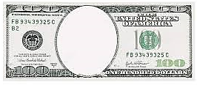
Bessemer
Process
J.P.
Morgan
Arab
Oil
Embargo
Pacific
Railway
Act
Standard
Oil
Model
T

