**THE WORD OF GOD – Part Three**

**Sermon – January 27, 2019**

We have spent the last several weeks looking at the Word of God and the importance of reading it daily. I have spoken of my change of heart regarding reading it daily and how putting this practice of reading the Bible daily has had a profound and positive effect on my life. But not all Americans, including those of the Christian faith, see the Bible as relevant to their lives as others such as I do. So before I once again get into the importance of reading the Scriptures I want to provide you with a perspective of what most Americans think of the Bible, how often they read it (if at all), and why it is or is not important to them.

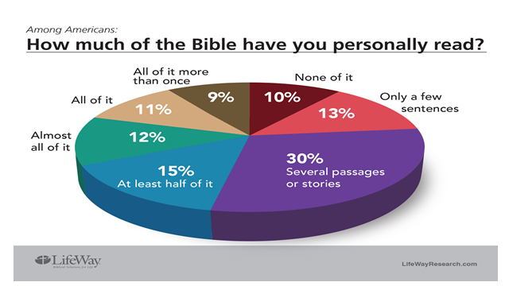

In Matthew 4:4 Jesus said this: “*Man does not live by bread alone* *but by every word that comes from the mouth of God.”* All of us would certainly agree that bread and water is needed daily to sustain our lives. Yet, for various reasons, we choose not to eat - perhaps to lose weight or perhaps to fast from certain foods like sugars or gluten. But these are only temporary. Once they attain their purpose we end the fast and start eating regularly again.

Now if Jesus said that we don’t live by bread alone but by every word that comes from the mouth of God, why do so many people fast from the word of God? If bread is so important to our health why don’t we consider God’s word equally as important to our heath? How can we consistently neglect to eat the word of God and still expect to have a healthy spiritual life? And yet many maintain the false expectation that spiritual growth can still be attained without daily spiritual sustenance.

According to the American Bible Society, nine out of ten households (87 percent) own a Bible, and the average household has three. Those with evangelical beliefs are more likely (49 percent) to read a little bit each day than those without evangelical beliefs (16 percent). Protestants (36 percent) are more likely to read every day than Catholics (17 percent).

The more often Americans attend church the more likely they are to read the Bible daily. Thirty-

nine (39) percent of those who attend worship services at least once a month read a bit every day, while only thirteen (13) percent of those who attend services less than once a month pick up a Bible daily.

Men are more likely to skip Bible reading than women. Thirty-nine (39) percent of men say they do not read the Bible on their own, compared to thirty-one (31) percent of women. Folks in the Northeast (48 percent) are more likely to never pick up a Bible than those from other regions.

The Lifeway Research group asked people what their opinion of the Bible was and why they did not read it more often. Here are their responses:

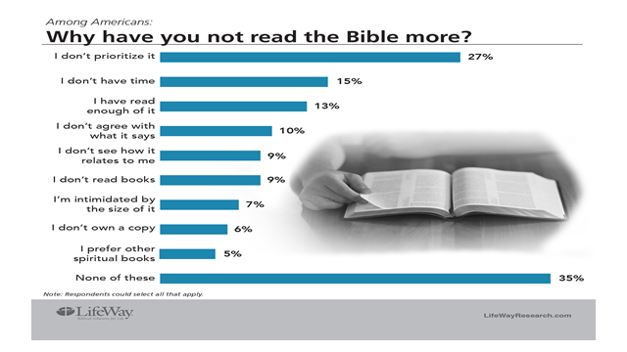

If someone were to ask you how they could avoid going to jail most of us would answer obey the laws of the land. If they replied that they did not know the law of the land then we would say they need to become familiar with it. Hopefully they would study the laws of the land and feel prepared then to avoid jail. Yet some don’t do as much when it comes to their eternal destiny. God’s laws are clearly spelled out yet some, even most, refuse to read it. Unfortunately, like our laws, they will be held accountable anyway.

Can you imagine someone telling an officer of the law or a judge that they didn’t prioritize knowing what the law said? That they didn’t have time to avid jail; had read enough of the law already. That they didn’t agree with the law and so disobeyed it, that they preferred other laws rather this one? They would have no excuse. Sentence would be passed in spite of and because of their ignorance. And yet some do the same with the word of God.

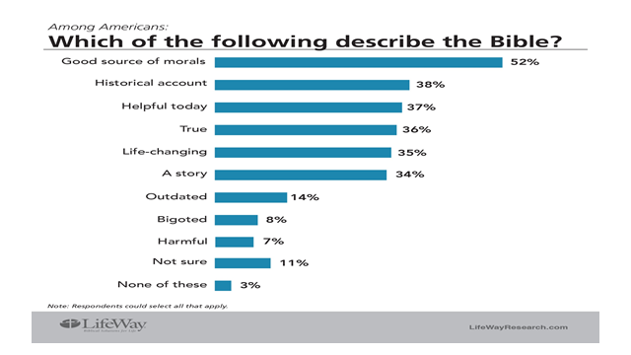

According to Scott McConnell, the Executive Director of Lifeway Research:

*“Americans treat the Bible a little bit like exercise. They know it’s important and helpful but they don’t do it.”*

*“Most Americans don’t know first-hand the overall story of the Bible – because they rarely pick it up. Even among worship attendees less than half read the Bible daily. The only time most Americans hear from the Bible is when someone else is reading it.”*

*“Scripture describes itself as ‘living and effective’, according to the book of Hebrews. Those who have a habit of reading through the Bible a little each day say they have experienced this helpful, life-changing quality. Those who approach the book differently tend to say the Bible is positive but much less personal.”*

Our opinion of the Bible – what we think it is and what we think it can do for us – will determine whether or not we hold it in high esteem. The less we think of it the less we desire to read it. The more we value it, the more we value time spent reading it; But what of God’s opinion of His word? What value or importance does God place on His own word? We find the answer to that in Deuteronomy. When God initially gave His commandments to the Israelites in the desert He spoke of the importance of keeping His word close to their hearts and in the forefront of their minds. He spoke of passing down the word of God to future generations and gave them some helpful hints on how to keep His word ever in front of them.

DEUTERRONOMY 6:5-9

*“Love the Lord your God with all your heart and with all your soul and with all your strength. These commandments that I give you today are to be on your heart.”*

*“Impress them on your children. Talk about them when you sit at home and when you walk along the road, when you lie down and when you get up. Tie them as symbols on your hands and bind them on your foreheads. Write them on the doorframes of your houses and on your gates.”*

After they entered the Promised Land those who were devout Jews would literally tie the word of God as a symbol on their hands and on their foreheads. They would do so using phylacteries which were two small leather boxes (called tefillin today) attached to a strap. Inside these boxes were placed Hebrew texts on vellum. They were worn by Jewish men at morning prayer as a reminder to keep the Law. Here is a picture of how the Jews place the scriptures on their hands and on their foreheads using these phylacteries.

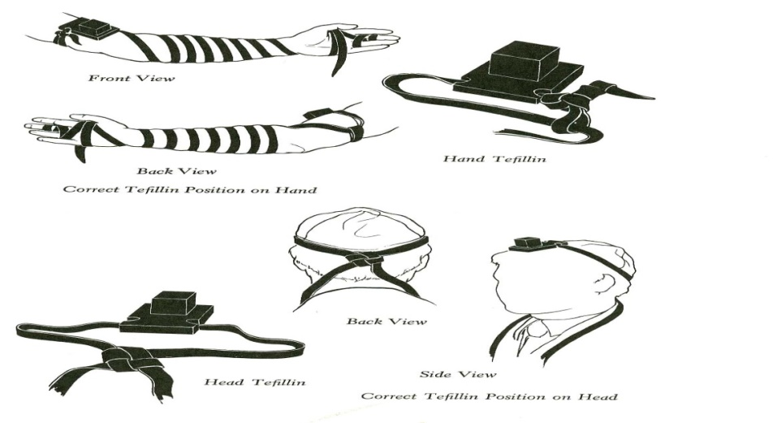

Though this started out as a command of God it soon turned into a means of impressing others with your piety. Jesus made mention of the negative side of taking this practice literally when he spoke of the Scribes and Pharisees in Matthew 23.

MATTHEW 25:2-7

*“The Scribes and Pharisees have seated themselves in the chair of Moses; therefore all that they tell you, do and observe, but do not do according to their deeds; for they say*

*things and do not do them…*

*“They tie up heavy burdens and lay them on men’s shoulders, but they themselves are unwilling to move them with so much as a finger. But they do all their deeds to be noticed by men…*

*“for they broaden their phylacteries and lengthen the tassels of their garments They love the place of honor at banquets and the chief seats in the synagogues, and respectful greetings in the market places, and being called Rabbi.”*

In the first century the use of Phylacteries had developed into a symbol of piety for the Scribes and Pharisees who were more interested in the outward appearance of religiosity than the inward humility of the heart. I personally don’t think God cares whether we literally wear His word on our heads and forearms any more than He cares if we put Scripture verses on the walls of our homes or on our clothing. God wants us to be reminded of His word in whatever way works for us.

But God does have an issue with pretending to care and obey His word while only using His word to appear righteous before men. Belief in His word is what makes us righteous, not the wearing of His word. We may wear T-shirts and sweatshirts that have Bible verses on them and we may hang pictures in our homes depicting beautiful scenes with supporting Scriptures but if the words we wear or hang on our walls fail to penetrate our heart God is not pleased. The very words that are meant to bring life to our souls can become useless and bring a false sense of piety when all we care about is how we appear before men rather than how we appear before God. What we do with God’s word only matters if we allow His word to penetrate our hearts.

As an example of this I want to look at the Parable of the Sower which Jesus spoke of in Mathew chapter 13. This story tells of seeds being sown on four different types of soil and how the different soils affected the ability of the seeds to grow.

MATTHEW 13:3-9

*“(Jesus) spoke many things to (the crowds) in parables, saying, ‘Behold, the sower went out to sow; and as he sowed, some seeds fell beside the road, and the birds came and ate them up…*

*“Others fell on the rocky places, where they did not have much soil; and immediately they sprang up, because they had no depth of soil. But when the sun had risen, they were scorched; and because they had no root, they withered away…*

*“Others fell among the thorns, and the thorns came up and choked them out. And others fell on the good soil and yielded a crop, some a hundredfold, some sixty, and some thirty. He who has ears, let him hear.”*

A parable is a simple story used to illustrate a moral or spiritual lesson. In His earthly ministry Jesus used many parables to illustrate what the kingdom of God was like. He did so for two reasons. The first was to make the gospel easy to understand. Using everyday language and situations familiar to people of the time, Jesus was able, through the use of parables, to illustrate what the kingdom of God was like and how it operated. These parables helped those with ears to hear and eyes to see to understand the mysteries of God. The second reason Jesus used parables was to hide the mysteries of God’s kingdom from those who used religion for personal gain; those who did not have eyes to see or ears to hear because their hearts were dull, their eyes were closed, and their ears could scarcely hear what God had to say (Matthew 13:15). As a result they could not understand with their heart the message of God. Jesus described these people as those who honored Him with their lips but their hearts were far from Him (Matthew 15:6).

The disciples asked Jesus to explain the Parable of the Sower and here is what He said:

MATTHEW 13:18-23

*“When anyone hears the word of the kingdom and does not understand it, the evil one comes and snatches away what has been sown in his heart. This is the one on whom the seed was sown beside the road…*

*The one on whom the seed was sown on the rocky places, this is the man who hears the word and immediately receives it with joy, yet he has no firm root in himself, but is only temporary, and when affliction or persecution arises because of the word, immediately he falls away...*

*“And the one on whom the seed was sown among the thorns, this is the man who hears the word, and the worry of the world and the deceitfulness of wealth choke the word, and it becomes unfruitful…*

*And the one on whom the seed was sown on good soil, this is the man who hears the word and understands it; who indeed bears fruit and brings forth, some a hundredfold, some sixty, and some thirty.”*

This is a nice story and very interesting, but what does it mean? And what does this parable have to do with the word of God and our ability (or lack thereof) to read it? I’ll tell you. We all have different soils in our heart right now. Some of us have roadside soil, some have rocky soil, some have thorny soil, and some have good soil. The type of soil we have will either inhibit or promote the growth of God’s word in our lives.

I believe we all start out with roadside soil. We were all lost as we traveled life’s road and at some point we heard the gospel message but failed to understand what it meant. It was not until later that the word of God began to make some sort of sense. That’s’ when we moved into being rocky soil. We accepted a little of God’s word but did not have a good grasp on it. Then the more we thought about it the more it began to make sense. Perhaps it was our need for it to make sense that caused the shift in our thinking, but nevertheless it soon caused our soil to move from rocky to thorny. Once the word of God began to penetrate, it was in danger of being lost; but perseverance and tenacity soon caused our soil to move from thorny to good soil. It was then that fruit was finally able to be harvested.

My point is this: There are four types of people who hear the word of God.

1. Those who do not understand the word of God
2. Those who have no firm root in the word of God
3. Those who allow the worry of the world and the deceitfulness of riches to choke the word of God
4. Those who hear and understand the word of God

The type of soil these people have in their hearts determines the effectiveness of God’s word. If those whose heart has been trampled on throughout their life have done nothing to soften its negative impact then the soil of their heart has grown hard. When they hear the word of God they do not understand it because it cannot penetrate the soil of their heart. They have hardened themselves against the good news and so it is easy for Satan to come and snatch away what little hope has been sown in their life. The evil one does not want them to have hope. He comes to steal the seed and destroy any hope of it growing.

Those hearts whose soil is rocky are initially happy when they hear the word of God. They receive it with joy and look forward to the benefits of belief. But as soon as they encounter difficulties or are mocked because of their belief they abandon their faith. The soil of their heart does not allow deep penetration to establish roots because it is filled with rocks. These rocks are insecurity, self-doubt, and unbelief. They have not taken the time to weed out the rocks of this world planted in their hearts soil by disappointment and insecurity. With no deep soil in which to grow the word of God planted in their heart is unable to establish firm roots and so it quickly withers away.

The heart of those whose soil contains thorns finds that the word of God is able to grow; but it grows among the thorns. Eventually the thorns overtake the word of God choking the life out of it. The thorns that grow in this heart are the thorns of worry and the deceitfulness of wealth. Even when wealth is accumulated this heart worries about not having enough or that what they do have will soon disappear. This over attention to worry and riches does not allow the heart to trust in God’s provision for their future. They spend more time with worry and riches than they do with the word of God. As a result the word of God is overcome and the life it was intended to bring is choked out and left to die. The seed which could have produced fruit is neglected in favor of time spent on worry and

riches.

In contrast to the previous three, the heart which has good soil is able to understand the word of God. This soil is free of weeds and rocks. It has been cultivated and tilled so that it is ready to receive the seed which is planted. This soil has no competition for growth. Seeds grow easily, producing fruit which is thirty, sixty, even a hundredfold more than that which has been planted. This is the type of soil that God wants each of us to have in our hearts.

Here is a short review of what we have just learned.

1. The one who does not understand the word of God
   * Gives Satan the opportunity to snatch the word away
2. The one who has no firm root in God’s word
   * Falls away when affliction or persecution arises
3. The one who worries and seeks after riches
   * Chokes the word of God
4. The one who hears and understands
   * Brings forth fruit (some 100, some 60, some 30)

So here is the final question for today: What type of soil is in your heart? Is it roadside soil, rocky soil, thorny soil, or good soil? This is an important question for me to ask and for you to answer; because if you have any desire for the word of God to produce fruit in your life you must pay attention to the condition of the soil of your heart. Roadside soil, rocky soil, and thorny soil will not produce fruit. Only good, cultivated, rock and thorn-free soil will produce fruit.

If the fruit that is promised in the word of God is to happen it must be planted in good soil; and it must be watered by the word of God. For this to happen we must become people of the word, people who read and understand what God is saying in His word. By so doing we will eventually develop a mind that understands all the truth that God has revealed in His word. Unlike those who worry or fear persecution and fall away from the living God, we will develop a heart that falls in love with the God who shows Himself on every page.

Lord, may you grant us a desire to read Your holy word. Build the flame and fan the fire to do the things that You require. Grant us this desire we pray. Amen. (Sing song)

###### MAKE US A PEOPLE OF YOUR WORD

##### Make us a people of Your Word

##### With a mind that understands

All the truth that You’ve revealed from age to age

Make us a people of Your Word

With a heart that falls in love

With the God who shows Himself upon each page

Lord grant a desire

To read Your Holy Word

Build the flame, fan the fire

To do the things that You require

##### Grant us this desire

##### Make us a people of Your Word

##### With a mind that understands

All the truth that You’ve revealed from age to age

Make us a people of Your Word

With a heart that falls in love

With the God who shows Himself upon each page

### Help us to discern

### The meaning of Your Word

So that we may not stray

From the straight and narrow way

Living truth each day

##### Make us a people of Your Word

##### With a mind that understands

All the truth that You’ve revealed from age to age

Make us a people of Your Word

With a heart that falls in love

With the God who shows Himself upon each page

### And when others come

### With a new wisdom

Grant us faith so that we might

By Your Word that shines with light

Know the wrong from right

##### Make us a people of Your Word

##### With a mind that understands

All the truth that You’ve revealed from age to age

Make us a people of Your Word

With a heart that falls in love

With the God who shows Himself upon each page

Words and Music by Dan Burris, © 1997 Dan Burris, Administered by J.C. Lord and Company, CCLI #829565

*Unless otherwise noted all scriptures have been taken from the New American Standard Bible®, Copyright © 1960, 1962, 1963, 1968, 1971, 1972, 1973, 1975, 1977, 1995 by The Lockman Foundation. Used by permission.*