HOME

BUSINESS WEEKLY

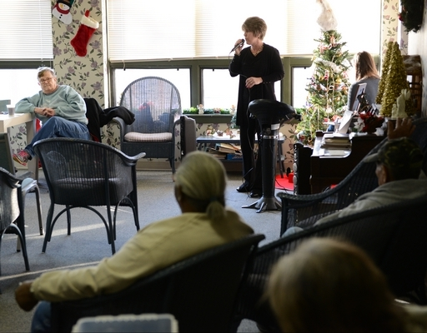
Reading Eagle: Tim Leedy | Kelly Buss gives a musical performance at Reading Elderly Housing as she works to promote her new in-home care business.

Starting a business on the right note
Tuesday January 7, 2014 12:01 AM
By Ford Turner
Kelly Buss' ability to carry a tune may help carry her into the crowded market for in-home care providers.
In December, Buss gave a free vocal performance of Christmas music - her numbers included "The Little Drummer Boy" and "The First Noel" - to about 20 residents at Reading Elderly Housing on North Front Street. They applauded, sang along and, afterward, praised Buss' voice.
"They loved it," said Tania Evans, social services coordinator.
Buss, who lives in Maidencreek Township, recently started her own in-home care business, Family Matters Home Care Ltd. A mother of three grown children, she previously worked for another in-home care agency.
After being promoted twice, she became dissatisfied with her employer's approach.
Longtime friend Jennifer Freeze, a Caron Treatment Centers office manager who moved from Berks County to Texas several years ago, said Buss has an excellent chance of success on her own.
"She is a very passionate person," Freeze said. "Helping people is one of her passions."
Another is singing. Buss was in the chorus and was named a Hempfield Singer, a distinguished position for vocalists, at her alma mater, Hempfield High School in Lancaster County.
She has sung at weddings and has been known to do some karaoke during outings with friends and family. The concept of giving free singing performances as she spread the word about her business seemed like a natural.
"Mostly it was thinking that if this is the people you are going to pull from, you should show you are willing to give something," Buss said. "It is me giving back to the community that I want to work in."

A recent free performance at the Mennonite Home in Lancaster County was broadcast on the home's in-house television channel. And Evans said that at the 201-unit, 16-floor Reading Elderly Housing complex, free performers are always appreciated.
Gaining clients for a new in-home care business is not guaranteed.
Statistics provided by the state Department of Health show there are 1,498 licensed home care agencies - those limited to nonmedical care - in Pennsylvania. Beyond that, many unlicensed individuals also provide in-home care.
"I think it is extremely tough competition, from the business side of it," said Buss' husband of 23 years, Glenn, a business owner himself. "There are a lot of players in it. There are big businesses in it."
Glenn Buss helped Kelly set up Family Matters. He said his wife spent thousands of dollars to secure insurance and paid about $500 for initial fees and state licensing.
She had to submit to background checks and the prospect of regular state audits.
They never seriously considered skipping the license.
"There are a lot of things you have to do that are consumer protection things, associated with the license," he said. "If you do it on your own, it is very unregulated and very vague as to who is responsible for what."
Glenn Buss has operated Maidencreek Marine and RV Sales and Service in Richmond Township for 24 years. He has eight employees.
When he set out, he said, business was far from a sure thing.
"I had distributors tell me I was out of my mind for starting this here, because this area was so packed with competition," he said.
Likewise, he said, his wife's approach to business is built on the pleasure she gets in caring for people, not just a quest for profit.
"People recognize legitimacy," he said. "People recognize that you are doing it for the right reasons."
Contact Ford Turner: 610-371-5037 or fturner@readingeagle.com.
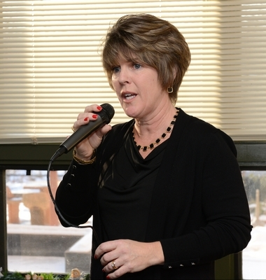
Reading Eagle: Tim Leedy | Kelly Buss

