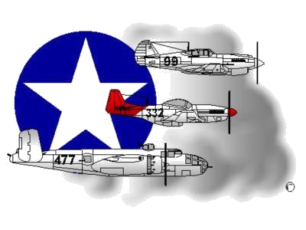
BIOGRAPHY
__________________________________________________________
A DOCUMENTED ORIGINAL TUSKEGEE AIRMAN

Tuskegee Airmen Inc. Public Relations, P.O. Box 830060
Tuskegee, AL 36083
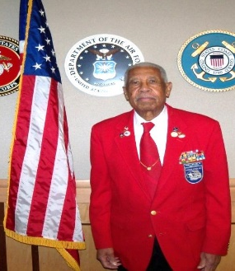

Grant S. Williams, Sr.

Grant S. Williams, Sr. was born May 26, 1920 in Clover, VA. In May 1938, he graduated from Halifax County Training School, Halifax, VA. He entered the Army Air Corps (AAC) at Ft Dix, NJ in 1942 and completed basic training at Tuskegee Army Air Field (TAAF), AL.

He was then assigned to the Headquarters 96th Maintenance Group (MX Gp) where he performed clerical duties. He was later detailed to the 318th Air Base Group HQ as the MX Gp was re-designated the 96th Air Service Group (ASG) and it began operating as such. He then served in the 96th Group HQ’s as Morning Report Clerk and later as Assistant Sergeant Major. In April 1943, the 96th ASG and the 332nd Fighter Group were transferred to Oscoda, MI for further training. SSG Williams, then serving as HQ Squadron Section First Sergeant, was promoted to the rank of First Sergeant, 1 June 1943. The 96th ASG and the 332nd FG were ordered overseas and departed from Newport News, VA, on 4 Jan 1944, for Italy. During the voyage, 1st Williams was reassigned to Group HQ as Group SGT Major and was promoted to MSgt on 1 April 1944. Soon thereafter, the 96th ASG was split into two ASGs, the 523rd and 524th. MSgt Williams was assigned to the 524th and served as Group SGT Major until his return to the CONUS in October 1945. During that period, he was awarded the Bronze Star Medal for meritorious service in connection with military operations in Italy from August 1944 - May 1945. He was honorably discharged on 1 November 1945 and enlisted in the Reserves the same day.

MSgt Williams was recalled to active duty 4 August 1950 and for the next 24 years served in administrative posts at various stateside and overseas bases in Japan, Turkey, and Vietnam. During this period, he completed numerous correspondence courses and did further study at Shaw University, Raleigh, NC and Washington University, St Louis, MO. For his Vietnam duty, CMSgt Williams was awarded the Bronze Star Medal (FIRST OAK LEAF CLUSTER) for meritorious service while serving with friendly forces engaged in an armed conflict against an opposing armed force during the period 8 March 1971 to 22 February 1972. His last assignment was at Hq Tactical Air Command, DCS Logistics, LAFB, VA from March 1972 to June 1975. During his 30-year military career, he was assigned to 9-different units and ultimately achieved the rank of Chief Master Sergeant (Air Force). For meritorious service in Italy and Vietnam, he received 2-Bronze Star Medals.

As a Documented Original Tuskegee Airmen (DOTA) and Speakers Bureau Chairman, CMSgt Williams was an active Tide-water Chapter Tuskegee Airmen, Inc. member, and often spoke at LAFB, schools/businesses and other Military Service Branches. On 29 March 2007, he and other DOTAs were cited for the Congressional Gold Medal at the US Capitol when President Bush conferred the distinct honor on all of the individuals who participated in the Tuskegee Airmen Program. In September 2010, CMSgt Williams became the first and only Tuskegee Airmen to ever be inducted into a U.S. Air Force “CHIEFS” Room. The event occurred at LAFB, VA. In May 2012, CMSgt Williams, and four other Tidewater Chapter-based DOTAs received honorary Doctorate Degrees in Humane Letters from Old Dominion University, Norfolk, Virginia.

CMSgt/Dr. Williams was first married to Cecelia A Lyons, (deceased), the mother of his three children (Grant, Jr., Cecelia Roberson and Paulette Williams, the latter two who are active Tidewater Chapter Members). Later, he married his second wife, Mary M. Satterfield (deceased). CMSgt/Dr. Williams joined the Lonely Eagle Chapter on June 22, 2014. To learn more about CMSgt/Dr. Grant S. Williams, Sr., the Tidewater Chapter’s Speakers Bureau and other activities that he articipated in, please visit the Tidewater Chapter’s Website at the following location: www.TAI-TidewaterChapter.Com.
