SPECIAL MEETING
DECEMBER 28, 2023

A Special Meeting (The End of the Year Meeting) of the Town Board of the Town of Hampton, County of Washington and the State of New York was held at the Town Hall, 2629 State Route 22A, Hampton, New York on the 28th day of December 2023.

PRESENT: David K. O’Brien------------Supervisor
Donald Sady----------------- Councilman
Tamme Taran----------------Councilwoman
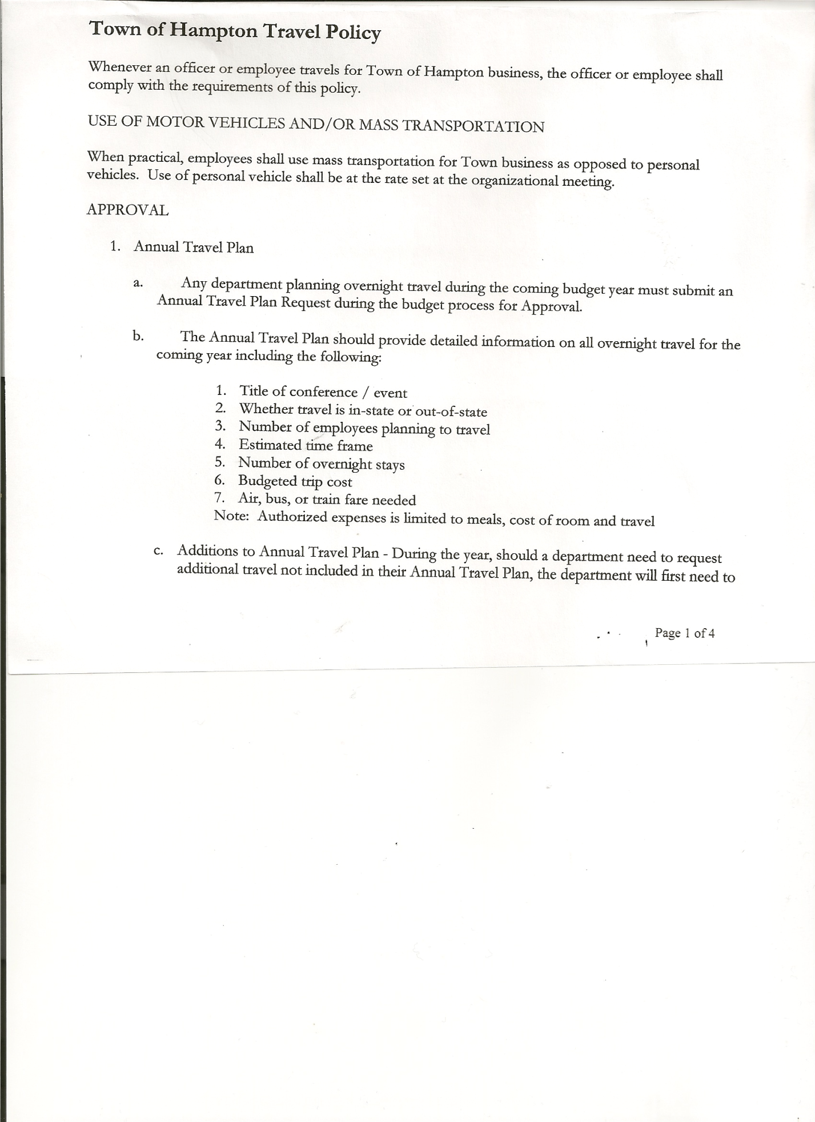
Michael Pietryka------------Councilman
Andrea Kugler-------------- Councilwoman
Rebecca Jones---------------Town Clerk
Camilla Shaw----------------Deputy Town Clerk-absent

Planning Board Member(s): none present
Others present at the Town Hall: Artie Pratt

The Special Meeting was called to order by Supervisor O’Brien at 7:00pm, followed by the Pledge of Allegiance. Location of Fire Exits were given. Quorum of board members present.

RESOLUTION NO. 112-2023
SUPERVISORS REPORT
On a motion of Councilman Sady, seconded by Councilman Pietryka, the following resolution was ADOPTED : AYES 5 O’Brien, Sady, Taran, Pietryka, Kugler
NAYS 0
RESOLVED, to accept the “Corrected Supervisor’s Report” for November as presented.

NEW BUSINESS
Attorney Fees….current Town Attorney Firm raising rates for 2024. Supervisor will contact and discuss options.
Election Law Changes….NYS changing from odd to even year elections for local elections
Senior and Low Income Disabled Exemptions….may consider changing annual income levels to match the County level

RESOLUTION NO. 113-2023
AUDIT OF CLAIMS
On a motion of Councilman Sady, seconded by Councilwoman Taran, the following resolution was ADOPTED : AYES 5 O’Brien, Sady, Taran, Pietryka, Kugler
NAYS 0
RESOLVED, that the bills have been reviewed by the Town Board and are authorized for payment in the following amounts.
General Fund No. 157 through No. 158 $ 525.03
Highway Fund No. 154 through No. 156 $ 17,736.13
Total both funds $18,261.16

RESOLUTION NO. 114-2023
CLOSE THE BOOKS FOR 2023
On a motion of Councilwoman Taran, seconded by Councilwoman Kugler, the following resolution was ADOPTED : AYES 5 O’Brien, Sady, Taran, Pietryka, Kugler
NAYS 0
RESOLVED, to Close the Books for 2023.

RESOLUTION NO. 115-2023
MEETING ADJORNED
On a motion of Councilwoman Kugler, seconded by Councilman Sady, the following resolution was ADOPTED : AYES 5 O’Brien, Sady, Taran, Pietryka, Kugler
NAYS 0
RESOLVED, that the meeting adjourned at 7:13pm.

Respectfully submitted,

Rebecca S. Jones, RMC
Town Clerk

