saundersstreetclinic
37 Jackson Street, Wynyard, TASMANIA. Phone 6442 1700
Newsletter May 2019
Opening hours
Monday - Thursday 9am-1230 pm, 2pm-5 pm
Friday 9am-1230 pm, 2.30pm-5 pm
Saturday, Sunday, Public Holidays closed
Doctors: Jim Berryman, Chris Hughes, Yas Sanli, Ali Johnson, Sarvin Randhawa, Lou Sykes, Jessie Andrewarthur, Tim Andrewarthur and Bradley Williams.
Registered Nurses: Fiona Munday (nurse manager) and Belinda Townsend.
We are mindful that patients who work office hours have trouble being seen because we also work office hours. Make an enquiry as often your GP may be at work early or be prepared to stay

New treatments can cure hepatitis C
While there’s no vaccine for hepatitis C, new easy treatments can cure more than 95 per cent of people living with the disease.
New tablets are affordable and can be prescribed by GPs.
New shorter Hep C treatment involves one tablet a day, no injections and fewer, mild side effects.
If you’ve ever injected drugs or had a home tattoo, you could have Hep C – so get tested.
Live Hep C free … talk to your GP.
Visit the Live Hep C free website for more info.
https://www.dhhs.tas.gov.au/news/2018/new_treatments_can_cure_hepatitis_c
Constipation
Most people have experienced being blocked up from time to time, whether it's while travelling, after taking painkillers, or when you've let your diet go.
But some people will experience constipation more often, and for longer periods.
Chronic constipation is generally defined as a problem that has persisted for six months or more. It can mean you have hard or lumpy stools that you're straining to pass, or are passing fewer than three stools per week — or both.
Constipation is sometimes related to the rate at which food moves through the colon in order to be expelled as poo. This process is known as colonic transit.
Some people have normal colonic transit, but become constipated because of other factors, such as harder stools. This is called functional constipation.
Others have conditions of the rectum, such as narrowing or tearing or an inability to relax the anal sphincter, that make it difficult to evacuate the waste.

What is the ideal poo form?
Poo should ideally be in a sausage form with cracks, or a smooth sausage form. Using the Bristol stool chart, this is type three or four.
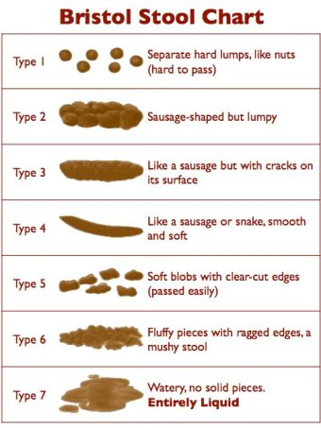
But if this doesn't describe your usual poo, don't worry: a good proportion of people don't pass these stool types regularly and are perfectly healthy.
In terms of how easy it should be to pass, the goal is to prevent undue straining. Passing stools in the squatting position or with an elevated foot rest may make it easier.
At the extreme end of the spectrum, some people with rectal evacuation disorders find it so difficult to empty their bowels, they often need to resort to digital manual evacuation. This involves using a gloved, lubricated finger to remove the stool.
https://www.abc.net.au/news/2019-04-22/what-causes-constipation-and-how-to-identify-the-perfect-poo/11035694

