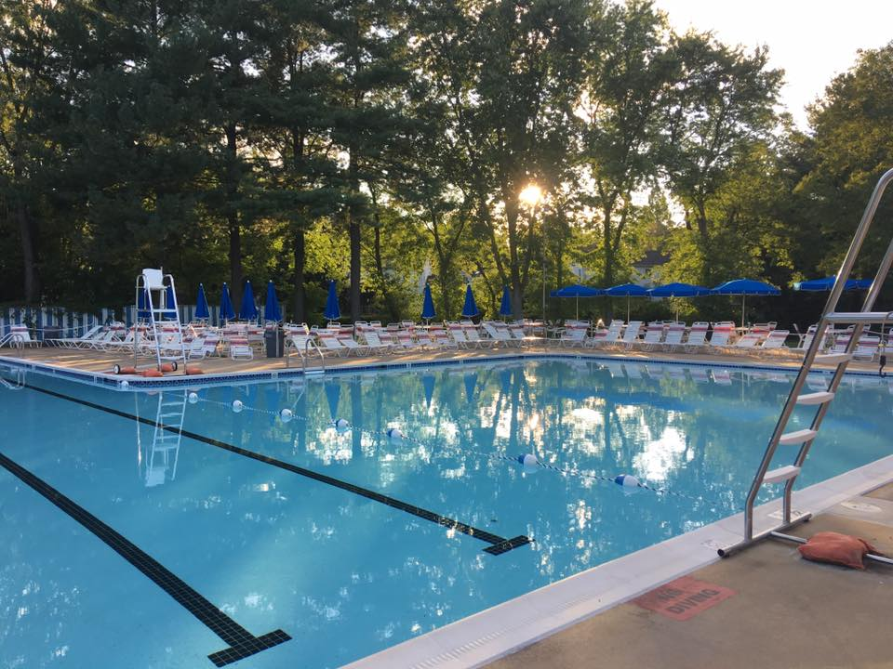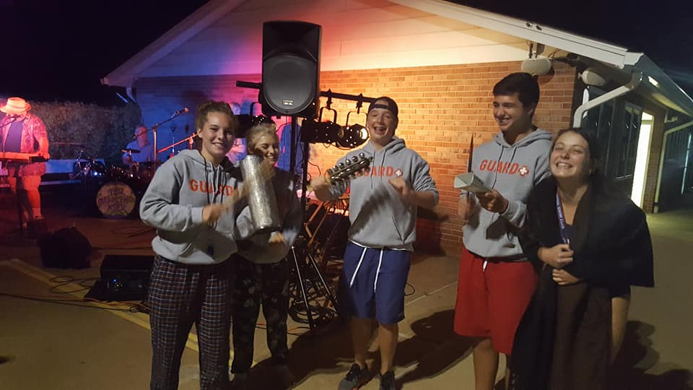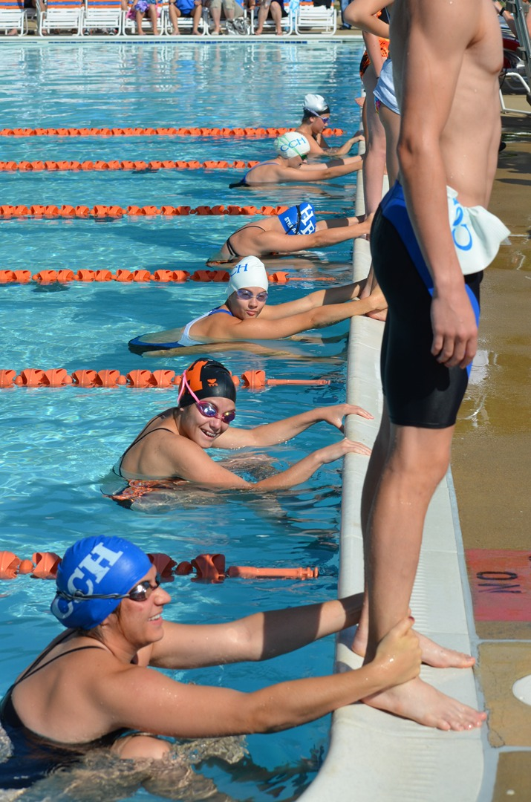

The 2017 financial year ended on September 30, with the pool reporting a total income of $298,469.56 (including $23,150 from Fairfax County re: stormwater management project) and total expenses of $306,486.75 (including a transfer of $29,000 to the investment fund). The expenses included $52,100 on general maintenance, new doors, and snack bar renovations, among other things. The table below shows the 2017 income and expenses as well as the closing balances for the pool’s BB&T checking account and investment fund.

|  |  |
| --- | --- |
| **Oct. 1, 2016 – Sept. 30, 2017** | |
| **Income** | $298,469.56 |
| **Expenses** | $306,486.75 |
|  |  |
| **Closing Balance** |  |
| BB&T checking account | $43,607.00 |
| Blackrock multi-asset income fund | $71,713.80 |

-Stephen Redhead, Treasurer

# 2017 Financial Report

The HFSC Annual Meeting will be held at 7:30 p.m. on Tuesday, October 30, in the Hayfield Elementary cafeteria. All shareholders are invited to attend.

All shareholders are invited to vote for candidates to the HFSC Board. Board members are elected to a two-year term. You can vote online or with a hard-copy ballot that can be turned in at the HFSC Annual Meeting on October 30. Electing members is one of the many ways our shareholders can participate in keeping our pool running smoothly!

### Vote for your

### HFSC Board!

What an awesome summer season we had. Thanks for a great year!

### Hello fall!

Hayfield Farm Swim Club

# Annual Meeting October 30

Fall 2017

We continue to maintain a strong membership and lease lists.  Our waiting list to purchase a share continues to have about a 4 year wait, with 63 families on it.  We sold/transferred 25 shares in 2017. Of our 425 pool shares, 147 shares were leased this season and we sold 35 additional Late Summer Passes.

Our keytag check-in system continues to help management account for pool attendance.  Please keep your keytags to use next summer.  If you paid your dues in 2016 and haven’t been issued a keytag or have lost it, please email the Membership Chairperson at [info@hayfieldpool.com](mailto:info@hayfieldpool.com) to arrange for one to be prepared for you.

**PLEASE NOTE:  It is important that you update your**

**e-mail addresses and other contact information when there are changes to your account.  You may do that by using the website to send an update to our e-mail account, or send an e-mail directly to**[**info@hayfieldpool.com**](mailto:info@hayfieldpool.com)**.**

-Elke McLaren, Membership Chair

### Drive Safely

Even though the pool is closed, please remember to drive slowly through the neighborhood, especially as utility work has begun on Hayfield Road. The speed limit in Hayfield Farm is 25 MPH. Thank you for your consideration to our friends and neighbors!

### Attention Dog Walkers

Please clean up after your pets, especially on the lawn in front of the pool and the area at the end of Hayfield Road behind the barricade, even when the pool is closed! It is county law to clean up after your pets!

Get Your News by E-mail!

Thank you for allowing us to communicate with you by e-mail.  We are up to 405 memberships receiving their information by e-mail.  Please make sure you keep your e-mail address CURRENT by sending updates to[**info@hayfieldpool.com**](mailto:info@hayfieldpool.com)**,** or by filling out the online form on the website.

Please note, we have been having delivery issues with AOL/Verizon emails.  If you have an AOL.com or Verizon.net email address and have not been receiving emails from the [info@hayfieldpool.com](mailto:info@hayfieldpool.com) account in the past couple months, please email us so we can work to ensure you are informed of shareowner/membership updates.

# Operations

We had a great summer under the leadership of Manager Jamie Potts and the assistant managers, David Brighton, Zack Koons, Andrew Ryan, and Tim Strausser.

Everyone worked hard to keep the pool clean and above all keep our members safe.

We are always looking for enthusiastic, hardworking, certified lifeguards. If your son or daughter would like to work at HFSC, please keep an eye on the website and your e-mail inbox in January.

-Tom Ryan, Operations Chair

# Membership

1. Old snack bar cabinets and countertops removed

2. New stainless steel cabinets and sink installed

3. New snack bar wall with 120 volt receptacles installed

4. Two new 120 volt circuits installed in snack bar

5. New marine plywood sheathing installed and painted behind snack bar back wall

6. Double doors for the pump room and lower shed replaced

7. Single doors for the women's and men's restrooms replaced

8. New public address system installed in the office

9. Three urinals replaced in the men's restroom

Future Needs

1. Front doors need replacement

2. Sliding glass door in office needs replacement

3. New security cameras system

-Mark Burnell, Maintenance Chair

Facilities and Maintenance

Swim and Dive Teams

The Hayfield Seahawks Swim and Dive teams had another great season!

The Seahawks brought team spirit to a whole new level this season!  Our amazing crew of coaches brought on the fun!  Each week the number of kids who put up “best times” increased as we saw all of our Seahawks (including our awesome Minihawks) grow into stronger swimmers.  The highlight of the season was winning the Division Sportsmanship award, we were all very proud of our team!

Our dive team did very well and had tough competition and some very close meets.  All of the kids practiced hard, learned new dives and had a great time.  We had a whole new crop of young divers to make one of the biggest teams we have had in years.

A shout out to our amazing kids for raising $4000 for Team Mathias - a local charity that supports family who have children that are battling cancer.

Our Team hosted Divisional relays this season and our team of parent volunteers were given high praise for the friendly and helpful atmosphere of our pool.

Lastly, NCAP Swim Club again offered a full swim scholarship to a member of the Hayfield Farm team and after reviewing some very worthy applications, Emily Davis, one of our enthusiastic 9-10 swimmers, was selected to receive the Jim King Memorial Scholarship.  Colin Blake was the runner up, and received a partial scholarship.  We were happy to be able to award this scholarship in memory of Jim King.

If your child is interested in participating in our spring swim or dive program at Lee District (Sundays Jan – May) please contact [hayfieldswim@gmail.com](mailto:hayfieldswim@gmail.com).  This is a great way to get in shape for summer swim/dive.

Hayfield Pool also has a pre-swim team program called Minihawks.  This program is geared towards swimmers who are not quite ready for competitive swimming, but are interested in the team in the future. Unlike swimming lessons, we focus on skills such as stream lining, starting dives and stroke technique. To register for Minihawks, swimmers must be four years old as of June 1, 2017.

Stay tuned for registration information for both Swim and Dive and Minihawks!

-Kim Wilson, Swim & Dive Chair

# Nominees for the 2017 Board

**Lewis Blocker:** Longtime Hayfield resident and pool member, interested in serving the Community. I attended Hayfield Elementary and Secondary school as a kid and have been a homeowner in Hayfield Farm since 2000. I work for First Service Residential in the property management field, I interact daily with Communities and their Boards, I am familiar with Bylaws and how to utilize them to the maximum enjoyment of the patrons. My family and I enjoy the pool and I would like to give back to the pool and community when I can. Thank you for the consideration.

**Anne Charboneau:** My family and I have been pool members and residents of Hayfield Farm for five years. My son is a third grader at HES and just finished his first season on the swim team. My daughter is turning four next week and can’t wait to be a Mini Hawk next summer! I have served two years on the board as social chair, and look forward to serving the community for another term.

**Susan Grunder:** My family have been members of the pool for over 10 years and our children have grown up poolside. Our daughter is a longtime member of the swim team and also has worked as a lifeguard and mini-hawk coach. It has been my privilege to serve the swim team in a variety of capacities and as a member of the HFSC board for the past 6 years. My family has truly appreciated being members of the HFSC community.

**Elke McLaren:** I have been a Hayfield resident, HFSC member for 16 years, and the HFSC Membership Chair for 6 years. My family and I enjoy being active with the Hayfield Farm swim and dive team, Hayfield community events, scouts, and Hayfield high school drama and sports programs. I look forward to serving the HFSC community for another term and appreciate your support.

**Stephen Redhead:** Steve and his family have been members of the pool for 28 years, since they first moved to Hayfield Farm in the summer of 1989. His younger daughter, Alice, was a member of the swim team from 2002 to 2012 and helped establish and run the Mini Hawks developmental program. Steve served as the head timer for the swim team from 2005 to 2013. He joined the board in October 2011 and has served as the treasurer over the past six years, during which time the board has spent over $200,000 upgrading the pool.

**Cathy Seybold:** Resident of Hayfield Farms since 2008, Married to Cris and have 2 daughters, Caroline is in college and Cate is in 10th grade. I spent 26 years in the Coast Guard, I was the president of the Fleet Reserve Association, Chief of the Cape May Chiefs and an active participant in the Coast Guard Chief mess and other charitable associations. I was a brownie leader for 2 years here in Hayfield.