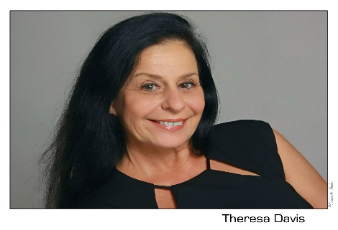 Alzheimer’s Disease is not only preventable, but did you know that it can be reversed? 10 Things Your Doctor Will Not Tell You About Reversing Alzheimer’s Disease
From Marie Theresa Davis, LMT,
Cranial Sacral & Manual Lymphatic Therapist

10 Things Your Doctor Will Not Tell You About Reversing Alzheimer’s
#1: Alzheimer's Is Preventable With the correct diet and application of Cranialsacral Therapy, you can minimize the risk factors associated with this disease.
#2: Alzheimer's Is Reversible. There is a growing body of evidence that shows neuronal repair is possible. New research into glial cell connections, which make up 90% of brain matter, support this statement. Watch this interview with Research Professor Jeffrey Iliff on the Glymphatic System and Alzheimer’s to learn more about glial cells:
http://PreventingAlzheimers.com/videos/.
#3: 40% of people with Alzheimer's have diabetes. In my survey of nursing homes and as part of the initial research on Cranialsacral Therapy and Dementia, we found that a surprising number of patients also exhibit Diabetes along with their Dementia See why at Web M.D.: “Alzheimer's and Diabetes: What's the Link?”
#4: Many Functional Medical Doctors Call Alzheimer's “Type 3 Diabetes.” Functional Medicine, which believes that the properties of a proper diet play a large part in the healing process, has helped to coin this phrase. Read these books for more information: Mark Hyman’s The Blood Sugar Solution and David Perlmutter’s Grain Brain.
#5: Alzheimer’s may have a genetic basis, but it is a very small part of the picture. Your genetic expression can be changed by diet and exercise. The new science of epigenetics believes that one can ‘turn off’ the genes detrimental to our health and ‘switch on’ those genes which are supportive to health and longevity Read my Huffington Post article: “Epigenetics”.
#6: Inflammation in the brain, which is one of the prime causes of Alzheimer’s, is typically proceeded by inflammation in the body Extensive research into inflammatory processes in the body-as reflected in the many symptoms of autoimmune disease-is also thought to be a prime cause of inflammation in the brain-which many researchers feel helps to create the amyloid plaques found in Dementia and Alzheimer’s Be sure to read my blog post: “Defining the Players of a Healthy Brain.”
#7: For decades prior to the onset of diabetes, many diseases of aging show up. Research on nursing home patients show that often for decades, many of the ‘diseases of aging’ are present: diabetes, cardiovascular disease, osteoporosis, scoliosis, chronic fatigue, arthritis and digestive disorders. Read my blog post: What Is Normal Aging Anyway?
#8: The flow of cerebrospinal fluid often diminishes with age. Research by Dr. John Upledger, developer of Cranialsacral Therapy, and others point to the diminishment of the flow of Cerebral Spinal Fluid or CSF as we age. Why is this important? CSF provides valuable neurotransmitters to the central nervous system and helps drain toxins from the brain. Read My Huffington Post Article: “ Prevention and Reversal of Alzheimer’s — a 3-Act Play”.
#9: In people with Alzheimer's and senile dementia this flow of cerebral spinal fluid is often 75% less than in a normal adult. With decreased flow of Cerebral Spinal Fluid (CSF) it is more likely that amyloid plaques and neurofibrillary tangles, which are hallmark indicators of Alzheimer’s and Dementia, will manifest in the brain.
#10: CranialSacral therapy is one technique that helps restore this flow cerebral spinal fluid back to normal level Our research into the Cranialsacral Stillpoint -- one technique that is easily learned and administered -- shows improvement in memory and behavior in those at risk, with early onset and mid-stage dementia.
#11: Bonus point: You can do something NOW, regardless of your age, to prevent the onset of Alzheimer’s disease The House of Chi Longevity Prescription-Cranialsacral Therapy, changes in Diet, and exercise-can help change the direction of your health towards increased cognitive performance and enhanced longevity.

Go to Marie Theresa Davis.com for further Cranial Sacral Therapy information & Case Study. Suggested exercises for the prevention of Alzheimer’s and Diabetes.

Thank you.
Marie Theresa Davis

