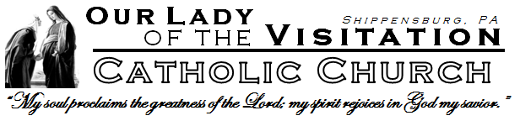
Feb 17, 2019
Sixth Sunday in Ordinary Time
305 N. Prince St.  Shippensburg, PA  17257-1321  Church: 532-2912  Campus: 477-1244  Fax: 532-3905  Office Hours:  Mon. – Thurs.  9:00 AM-4:00 PM  Website:  www.OLVShippensburg.org | 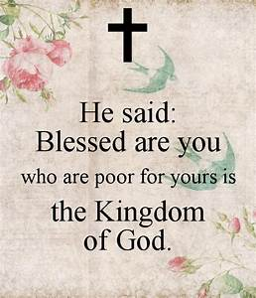 | Scripture Readings:  Jeremiah 17:5-8  I Corinthians 15:12, 16-20  Luke 6:17, 20-26  Page 1150 in the Hymnal
Our Mission
To Proclaim the Kingdom of God
for the Salvation of Souls
Rev. Dwight Schlaline | Pastor and Campus Minister
Nichole Schneider |  | Catholic Campus Minister - ncschneider@ship.edu
Tracy Plotner  Jolene Cramm | Office Manager – tplotner@hbgdiocese.org  Religious Education Coordinator – jcramm@hbgdiocese.org
Weekend Masses - Saturday 5:00 PM; Sunday 8:30 & 11:00 AM
Daily Mass – 8:30 AM Monday – Saturday (Rosary starts at 8:00AM)
Holy Day Mass - Check www.olvshippensburg.org click on “Liturgical Schedule.”
Reconciliation – Saturdays,3:30-4:30 PM; First Fridays of the Month, 7:30AM-8:20AM and upon request
Adoration of the Most Blessed Sacrament – 7:30 AM – 8:30 AM First Friday of the Month
Bible Study – Wednesdays January 16 – April 24 from 6:30-8:00PM-in social hall
Intentional Disciples Group- 3:00PM in the church on Feb. 24, Mar. 10 & 24,
Apr. 7 & 14, May 5 & 19.
Religious Education- Sundays 9:45AM-11:00AM
Bulletin Deadline: Tuesday 9:00AM. Email proposed bulletin and lector announcements to the Office Manager at tplotner@hbgdiocese.org

PRAISE AND WORSHIP HOLY HOUR ON MONDAY, FEBRUARY 18th 7:30PM-8:30PM IN THE CHURCH. ALL ARE WELCOME!!
PRO-LIFE GROUP: The next scheduled meeting is Tuesday, March 12th at 7PM in the social hall. Please contact Joanne Meehan at (717) 491-6495 or jcmeehan@comcast.net for more information.

WILD FLOWERS:
The Wild Flowers meet the second Monday of the month from 6-7:30PM in the social hall.
To find out more about Wild Flowers and scheduled events please contact Jill Lear at jilllear@hotmail.com

BOOK DISCUSSION GROUP:
The Book Discussion Group meets the second Tuesday of the month after the 8:30 AM Mass. We are discussing “Humility Rules” St. Benedict - 12 Steps to Genuine Self-Esteem by J. Augustine Wetta, OSB. For more information, contact Signe Kelker at 717-532-7353

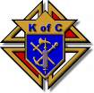Knights of Columbus & Ladies Auxiliary
The next Knights meeting will be Thursday, Feb. 21st at 7:00PM in the parish hall.
For more information contact Brian VanScyoc at 717-658-3767 or bkvanscyoc@att.net
The next Ladies meeting will be Tuesday, March 5th at 7:00PM in the parish hall..
For more information, please contact Donna Bonitz at 717 532-5369 or ddbonitz@gmail.com

The Intentional Disciples Group will meet Sunday, Feb. 24th at 3PM in the church. All are welcome!

You are invited to join us for a pilgrimage to the Oberammergau Passion Play. In 1633, the town of Oberammergau, Germany promised God to perform a play of Christ's passion every 10 years for all time if he spared them from the bubonic plague. Oberammergau was spared. We will be going May 20-30, 2020. Trip will also include Budapest, Vienna, and Prague. For more information, please contact Travis Detwiler at travisedetwiler@gmail.com or 717-809-0672. REGISTRATION DEADLINE IS FEB. 28TH 2019

In Mary’s Kitchen
The coffee hour hosts are:
Feb. 17th 8:30AM – Maurer 11:00AM - Nye
Feb. 24th Safety Committee will host 8:30 & 11:00

Contributions for Feb. 9-10
Ordinary Income
Weekend Collection | $4,062.50
Votives/Coffee Hour | 67.90
Building Improvements | 46.00
Parish Youth Education | 25.00
Eastern Church | 25.00
Poor Missions | 1,206.80
Propagation of Faith | 217.55
TOTAL INCOME | $5,650.75

Forty Hours Eucharistic Devotions 2019!
May 5-7, 2019
7:00 PM each evening
Preacher = Reverend Philip Burger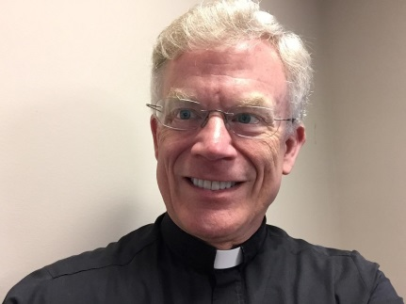
Pastor of Good Shepherd Catholic Church,
Camp Hill, PA

Divine Mercy in the Second Greatest Story Ever Told
6:30PM on Wednesdays, January 16 - April 24
Join us for a ten-part video series with Fr Michael Gaitley discussing the significance of the message of Divine Mercy, the historical events leading up to it, and its witness in the pontificate of St John Paul II and the message of our Lady of Fatima. For questions or to check for weather-related cancellations, ask Sarah and Jev Voight at JevVoight@gmail.com

C H U R C H C A L E N D A R
Saturday  Feb. 16 | 8:30 AM Mass  3:30-4:30 PM  5:00 PM Mass | In Memory of Judith Stroup  Confession  In Memory of Michael Best
Sunday  Feb. 17 | 8:30 AM Mass  11:00 AM Mass  Noon-2:00 PM | In Memory of the Stewart-Gelas Family  Intentions of Father Dwight Schlaline  CCM Small Group Study – (Social Hall)
Monday  Feb. 18 | 8:30 AM Mass  7:30-8:30 PM | In Memory of Edith Hayes  Praise & Worship Holy Hour – (Church)
Tuesday  Feb. 19 | 8:30 AM Mass | Intentions of Rachel Diaz
Wednesday  Feb. 20 | 8:30 AM Mass  6:30-8:00 PM | Intentions of Edna Spisak  Divine Mercy Bible Study
Thursday  Feb. 21 | 8:30 AM Mass  7:00 PM | In Memory of the Marasigan Family  Knights of Columbus Meeting
Friday  Feb. 22 | 8:30 AM Mass | In Memory of Patricia Stroughair
Saturday  Feb. 23 | 8:30 AM Mass  3:30-4:30 PM  5:00 PM Mass | Intentions of Susan Spevack  Confession  In Memory of Molly Best
Sunday  Feb. 24 | 8:30 AM Mass  9:45-11:00 AM  11:00 AM Mass  Noon-2:00 PM  3:00 PM | People of the Parish  Religious Education  In Memory of Steven Grezner  CCM Small Group Study – (Social Hall)  Intentional Disciples Group Meeting – (Church)

Liturgical Minister Schedule

Feb. 16-17 | 5:00 PM | 8:30 AM | 11:00 AM
Lectors: | Mike Hess | Cheryl Bannon | Ed Pfister
Ushers: | Dan Marshall | Randy Prue | Leonard Joy
 | Frank Kerch | Brian VanScyoc | Ed Kutlik
Altar Servers: | Mary Lindsey &  Matthew Lindsey | Micheal Righter &  Volunteer | Gavin Ott &  Volunteer

Feb. 23-24 | 5:00 PM | 8:30 AM | 11:00 AM
Lectors: | Roger Waters | Sheryl Rose | Angela Myers
Ushers: | Dan Marshall | Tom Wright | Leonard Joy
 | Frank Kerch | Bob & Sue Kiley | Ed Kutlik
Altar Servers: | Travis Detwiler &  Sebastian Sweger | Hunter Parks &  Volunteer | Xavier Rodriguez &  Volunteer

On Tuesday, March 5 at 7:00PM the Ladies Auxiliary will host speaker, Kent Thompkins on "The 125 Things That Must Be Done on the Worst Day of Your Life". Ken will talk about the decisions you need to make and the documents you will need when a spouse or other loved one passes away. All members of the Parish are invited to attend.
CRAB CAKE SALE:
The Knights of Columbus are taking orders for the annual homemade Crab Cake sale. The sign up sheet will be in the back of the church until the weekend of February 23rd and 24th. The cost is $5 per crab cake and they will be available for pick up the weekend of March 2nd and 3rd after each Mass in the social hall kitchen.

With these trying times for our faith, it is imperative that we continue to push forward with the Health, Safety and Security Committee. One of the first aspects that the committee suggested was to have Greeters for each mass, with duties differing from Ushers. During this time, the church really needs to have parishioners available to greet and welcome fellow parishioners and visitors/guests to our church. Thank you to everyone who has already signed up to be a Greeter, but we are still in need of more, if you are interested in assisting in this ministry, please complete the information and either return to the parish office or drop in the collection basket and member of the committee will contact you. NOTE: This form and the pew cards serve different purposes, but you can list Greeter as an interest on the pew card.
Name: ____________________________________________________________________________
Contact Number: ___________________________________________________________________
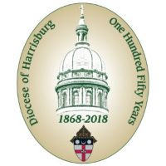
Closing Mass for the 150th Anniversary of the Diocese – Please join Bishop Ronald W. Gainer as Celebrant and Homilist to conclude the 150th anniversary celebration of the founding of the Diocese of Harrisburg. A reception, featuring a sampling of ethnic foods from various ethnic and cultural groups that comprise the faithful of the Diocese, will be held immediately following the Mass. The Closing Mass will be held at Good Shepherd Church at 3:00PM on March 3, 2019. For additional information, visit www.hbgdiocese.org/150

Rite of Election
Sunday March 10, 2019
4:00 PM
St. Patrick Cathedral
Harrisburg, PA
St. Patrick Cathedral Harrisburg, PA
On Sunday March 10, 2019, our catechumens will travel to Harrisburg to be formally chosen by the Church as members of the "elect." These catechumens have chosen to embrace Jesus Christ and His Church. Now the Church formally chooses them in this special ceremony entitled the "Rite of Election." All are invited to attend the ceremony!

The Corpus Christi Council of Catholic Women is hosting a “Women’s Lenten Afternoon of Reflection” on Saturday, March 9, 2019 in the Corpus Christi Parish Center, 279 North Main Street, Chambersburg, PA17201. It promises to be a wonderful time of spiritual enrichment, prayer, fellowship and Sacrament in preparation for the Season of Lent. Doors open at 12:30 p.m., it begins at 1:00 p.m. and will end at 3:45 p.m. There is an opportunity for confession from 3:45 p.m. - 4:45 p.m. and Mass at 5:00 p.m., both in the Church. The afternoon will be led by Jim Gontis, Director of Evangelization and Catechesis for the Diocese of Harrisburg. The theme is "God is Calling”; Cost is FREE and includes light refreshments. Please bring a rosary. Advance registration is requested to ensure adequate accommodations and refreshments. To register, please contact Angela Danko at 301-302-6511 or email at AJDanko@comcast.net. The Registration Deadline is March 4, 2019

2018 Donation statements for registered parishioners will be issued upon request. You may contact the parish office by email at tplotner@hbgdiocese.org or complete the form below and drop it in the collection basket.
Name: ____________________________________________________________________
Address: ___________________________________________________________________
The 2019 Diocesan Annual Campaign, previously known as the Bishop’s Annual Lenten Appeal, will kick off in a few short weeks. The theme for this year is Faith Forward. During these challenging times, our faith is central to who we are. Just like the Disciples, we are called to remain faithful, demonstrate our commitment to our faith by word and deed, and spread the Good News. You will be receiving a letter from Bishop Gainer as well as me asking for your support. I have pledged to Bishop Gainer my assistance in achieving our Parish goal. As you prayerfully consider your pledge in support of both our Parish goal and the overall Diocesan goal, I hope you will join me in supporting these important ministries and services that the Diocese provides to our Parish, parishioners and community.
Monies collected by our Parish support the programs and ministries that are Diocesan led, Parish implemented and Parishioner supported. No funds given to the Diocesan Annual Campaign are directed to the Survivors Compensation Fund nor legal fees. Any funds collected in excess of our Parish goal will be returned to our Parish to use at our discretion.

Attention all soup makers! The Ladies Auxiliary is looking for people to make soup for our soup sale on February 23 and 24. Bring your soup to the church kitchen between 10-2 on Saturday, February 23 or at 4:30 before Saturday night Mass. Please list the soup's ingredients on your label. Soup containers are available this weekend on a table in the Social Hall. We will sell pints for $4 and quarts for $8 after all Masses the weekend of February 23 and 24.

Wednesday March 6, 2019
​8:30 AM Mass
9:30 AM -5:30 PM- Eucharistic Adoration in the Church (sign-up sheet in church lobby)
​6:00 PM Mass

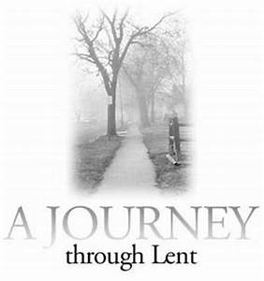
Shippensburg University Students:
Don’t journey through Lent alone.
Join a small group!

Have you tried to pray more or read Scripture for Lent, only to fall short of your goal? A small group gives us supportive and encouraging communities that can make your Lent much more meaningful.
There are no teachers in small groups. Trained students facilitate conversations. The groups will
- Discuss life and faith
- Reflect on God’s Word together – applying the readings to daily life
- Seek God together

- Pray for and with one another

Lent groups meet for 8 weeks, beginning the week of February 24^{th.}
Interested? Please reach out to Nichole via Catholic@ship.edu and she will connect you with a small group leader. Also, keep an eye out for small group leaders’ announcements at Mass in the coming weeks!
“Let us consider how to stir up one another to love and good works.” Hebrews 10:24

2018 Donation statements for parishioners who have donated to the CCM “Catholic Campus Ministry” will be issued upon request. You may contact the CCM office by email at jmreinsfelder@ship.edu, or complete the form below and drop it in the collection basket.
Name: ____________________________________________________________________
Address: ____________________________________________________________________

Bishop Gainer invites all members of Our Lady of the Visitation Parish to attend a Listening Session on Monday, February 25th at 6:30PM at the Corpus Christi Parish, 320 Philadelphia Ave. Chambersburg, Pa 17201. During this session, Bishop Gainer will address concerns regarding the Grand Jury Report, the Diocese’s response to abuse, our path forward, and any other questions or concerns from parishioners. If you are unable to attend this or any other Listening Session, but would still like to ask Bishop Gainer a question, please email your question to AskBishopGainer@hbgdiocese.org

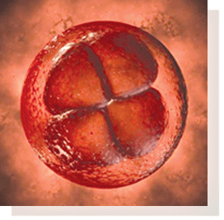
Stages of Human Life – Month 1

“My heart started beating today!” During this first amazing month of life the baby grows to 10,000 times his/her size at conception. (S)he is totally dependent upon his/her mother. Between mother and child lies the vital organ called the placenta. Here vessels from mother and baby intertwine without joining, highlighting this newly formed relationship – mutual, nourishing and deeply connected. By the third week the baby’s tiny heart begins to beat. © 2001 Linda Brenegan Used with permission.
Visit the back of the church and check out the poster to see what I look like at 1 Month. There are also brochures detailing the entire nine months of development.
RETREAT: June 7-9, 2019. Power & Purpose Conference at Franciscan University. The Power and Purpose Conference will introduce you to and draw you deeper into relationship with the Holy Spirit and empower you to live in freedom and joy. Discover a purpose for your life. Experience freedom and healing from past wounds. The Evangelization Committee of St. Francis Xavier parish in Gettysburg is a registered Ambassador for this conference. We are working with all registered to insure the drive to Ohio does not keep anyone from attending this life-changing experience. For more information, email Eileen Pabody at pabodyt@gmail.com. To register with our group: http://bit.ly/Eileen-Pabody-PPC2019 Early Bird Registration through 2/28/19.

Bishop's Annual Scout Recognition Mass, June 16, 2019, at 2:00 p.m., Good Shepherd Church, Camp Hill. All Girl Scouts, Boy Scouts, American Heritage Girls, and Trail Life USA Members are invited to attend.
Scouts who have completed any of the Catholic religious emblems in the past year will be recognized at Mass. All scouting families are encouraged to attend. Register online at www.hbgdiocese.org until June 1, 2019. For more information contact: Office for Youth and Young Adult Ministry, 717-657-4804 ext 327.

Confirmation will be here at Our Lady of the Visitation Church with Bishop Gainer on Sunday, March 17th at the 11:00 Mass. All are welcome to attend.

.

